**--** Create database

**CREATE** **DATABASE** library_system



-- Creating table

**CREATE** **TABLE** library_report (

book_id **INT** **PRIMARY** **KEY** **AUTO_INCREMENT**,

title **VARCHAR**(100) **NOT** **NULL**,

author **VARCHAR**(100) **NOT** **NULL**,

borrowed_date **DATE**

);



-- Adding book

**INSERT** **INTO** library_report (title, author, borrowed_date)

**VALUES**

('The Book of Bill', 'Alex Hirsch', '2024-05-13'),

('Gravity Falls: Journal 3', 'Alex Hirsch and Rob Renzetti', '2024-05-18'),

('The Race Across America', 'Elisabetta Dami', '2024-07-23'),

('Roblox Top Adventure Games', 'Roblox', '2024-07-28'),

('Silat Boy', 'Ben Wong', '2024-09-21');

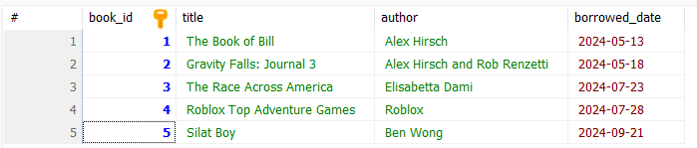

-- List all books

**SELECT** * **FROM** library_report;

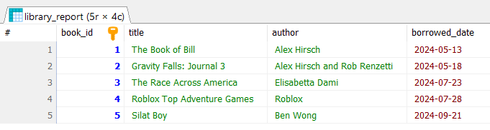

-- Find books from author: Roblox

**SELECT** * **FROM** library_report **WHERE** author = 'Roblox';

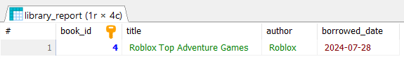

-- Find books at specific date

**SELECT** * **FROM** library_report **WHERE** borrowed_date = '2024-05-13';

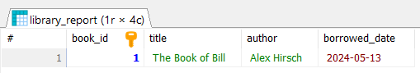

-- Find books after a date

**SELECT** * **FROM** library_report **WHERE** borrowed_date > '2024-05-18';

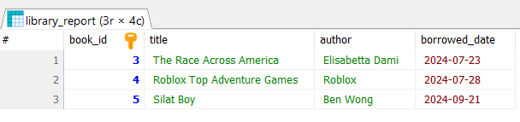

-- Update borrowed date

**UPDATE** library_report

**SET** borrowed_date = '2024-12-01'

**WHERE** title = 'The Book of Bill';



-- Deleting a book

**DELETE** **FROM** library_report **WHERE** title = 'Roblox Top Adventure Games';

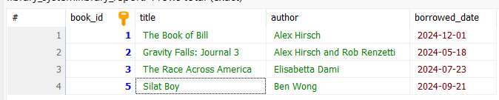

-- Re-add a Deleted Book

**INSERT** **INTO** library_report (title, author, borrowed_date)

**VALUES** ('Roblox Top Adventure Games', 'Roblox', '2024-07-28');

