Brian Santana

Linux Administration

**Lab Containers**

**CentOs**

**Installing docker**

First we need to install dependencies we do that by typing sudo yum install -y yum-utils



Next we need to add the docker repository type sudo yum-config-manager \--add-repo \https://download.docker.com/linux/centos/docker-ce.repo



Then we install docker with sudo yum install docker



If your having issues installing docker with conflicting requests run sudo yum install –nobest docker-ce –allowerasing to let the install go through

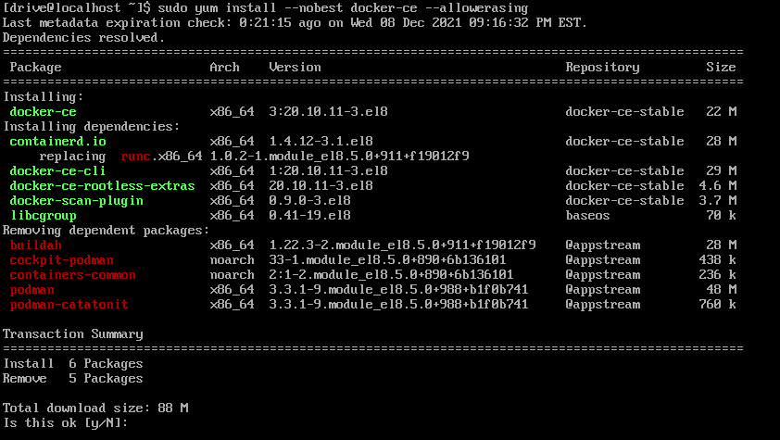

After the installation we start docker with sudo systemctl start docker



Then we enable docker with sudo systemctl enable docker



To check if you got docker up and running type sudo systemctl status docker

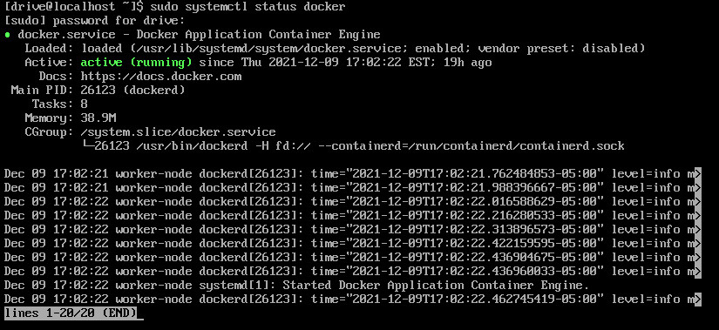

That will wrap up the docker portion

**Install Kubernetes**

First we need to add the Kubernetes repo we do that by typing

cat <<EOF > /etc/yum.repos.d/kubernetes.repo

[kubernetes]

name=Kubernetes

baseurl=https://packages.cloud.google.com/yum/repos/kubernetes-el7-x86_64

enabled=1

gpgcheck=1

repo_gpgcheck=1

gpgkey=https://packages.cloud.google.com/yum/doc/yum-key.gpg https://packages.cloud.google.com/yum/doc/rpm-package-key.gpg

EOF

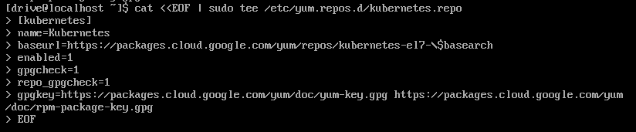

Once the repository is added we install Kubernetes with



Then enable kubelet with sudo systemctl enable kubelet



After enabling kubelet we start kubelet with sudo systemctl start kubelet



The next step is adding host nodes type in either of the nodes below

sudo hostnamectl set-hostname master-node

sudo hostnamectl set-hostname worker-node1

After adding the nodes we need to add firewall rules type in all the firewall rules below

sudo firewall-cmd --permanent --add-port=6443/tcp

sudo firewall-cmd --permanent --add-port=2379-2380/tcp

sudo firewall-cmd --permanent --add-port=10250/tcp

sudo firewall-cmd --permanent --add-port=10251/tcp

sudo firewall-cmd --permanent --add-port=10252/tcp

sudo firewall-cmd --permanent --add-port=10255/tcp

then reload the firewall with sudo firewall-cmd --reload

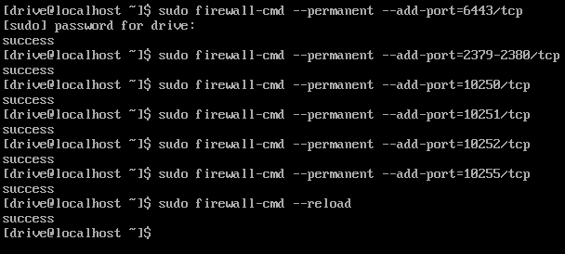

Next is updating ip tables type

cat <<EOF > /etc/sysctl.d/k8s.conf

net.bridge.bridge-nf-call-ip6tables = 1

net.bridge.bridge-nf-call-iptables = 1

EOF

Then run the command below to reset

sysctl --system

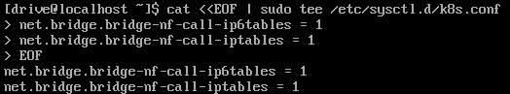



Once we finish updating the ip tables and resetting the system we need to disable SElinux by typing in this command

sudo setenforce 0

sudo sed -i ‘s/^SELINUX=enforcing$/SELINUX=permissive/’ /etc/selinux/config





To finish with kubernetes we need to disable swap by typing the commands below

sudo sed -i '/swap/d' /etc/fstab

sudo swapoff -a

**Install Minikube**

To start off we need to install with curl

curl -LO <https://storage.googleapis.com/minikube/releases/latest/minikube-linux-amd64>

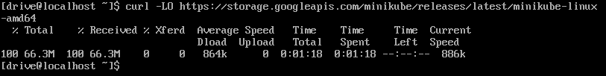

After your installation finishes we need to give minikube excute permissions with chmod type

chmod +x minikube-linux-amd64



Then we need to move minikube to another directory with

sudo mv minikube-linux-amd64 /usr/local/bin/minikube



To finish we need to check if minicube installed properly with minikube version

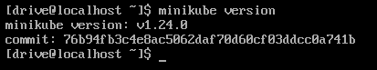

**CentOS Summary**

To conclude centos gave me a bit of trouble with the installing docker but that’s mainly due to me downloading from wrong/outdated repositories and having multiple of the same packages from mishaps then needing to sort it out with the –nobest and – allowerasing other than that it wasn’t to bad.

**Ubuntu Server**

**Installing docker**

To start off we need to update our system with sudo apt update

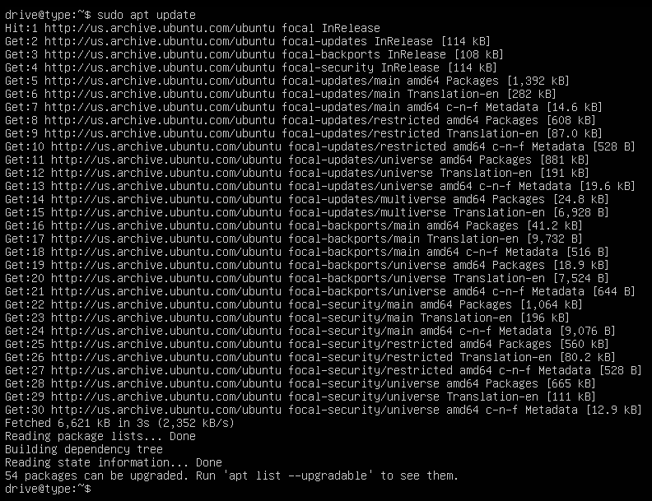

Next we install some dependencies with sudo apt install apt-transport-https ca-certificates curl software-properties-common then hit yes to install

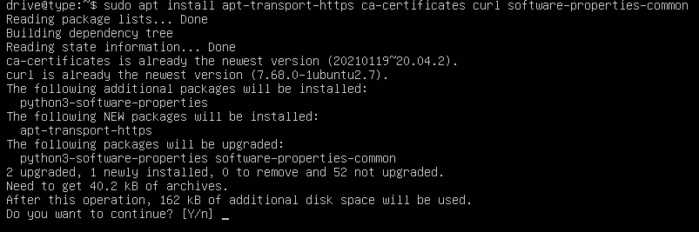

After the dependencies finish we need to add the pgp key with curl -fsSL https://download.docker.com/linux/ubuntu/gpg | sudo apt-key add –



Once we have the key we add the docker repository with sudo add-apt-repository "deb [arch=amd64] https://download.docker.com/linux/ubuntu focal stable"

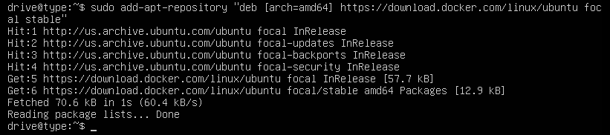

Next we type apt-cache policy docker-ce to double check if we’re installing from the docker repo instead of the default ubuntu repo



Afterwards we install docker with sudo apt install docker-ce then type y to continue

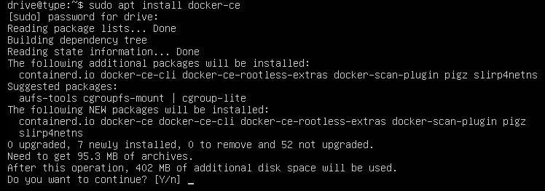

To make sure docker installed properly we run sudo systemctl status docker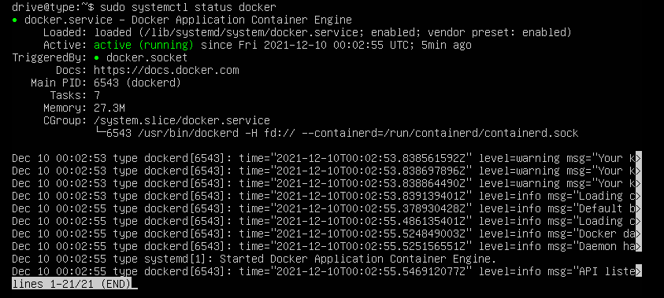

That finishes up docker

**Install Kubernetes**

To start of with Kubernetes we need to add a gpg key with

curl -s https://packages.cloud.google.com/apt/doc/apt-key.gpg | sudo apt-key add



Next we add the Kubernetes repository sudo apt-add-repository "deb http://apt.kubernetes.io/ kubernetes-xenial main"

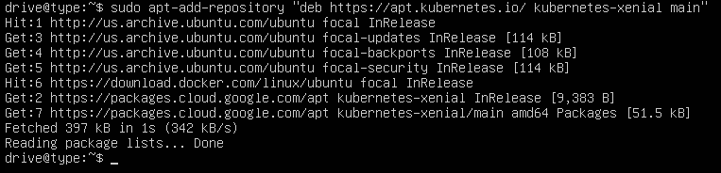

After we add the repository we install Kubernetes with sudo apt-get install kubeadm kubelet kubectl

Then hit y to continue the download

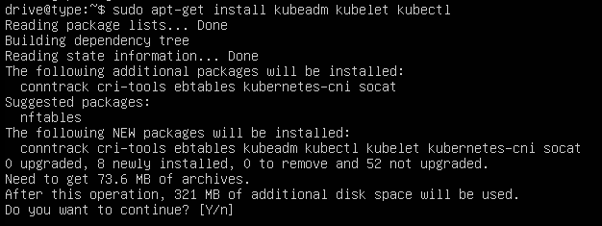

Then we check the version to make sure the install finished without issue with kubeadm version

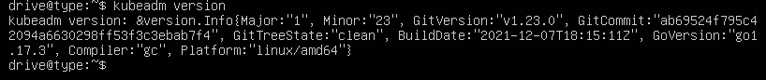

To finish up with Kubernetes we turn off swap with sudo swapoff -a



**Install Minikube**

To start off we’re going to install a virtual box extension to make running minikube easier to run type sudo apt install virtualbox virtualbox-ext-pack



You’ll be asked if you want to install type y to continue

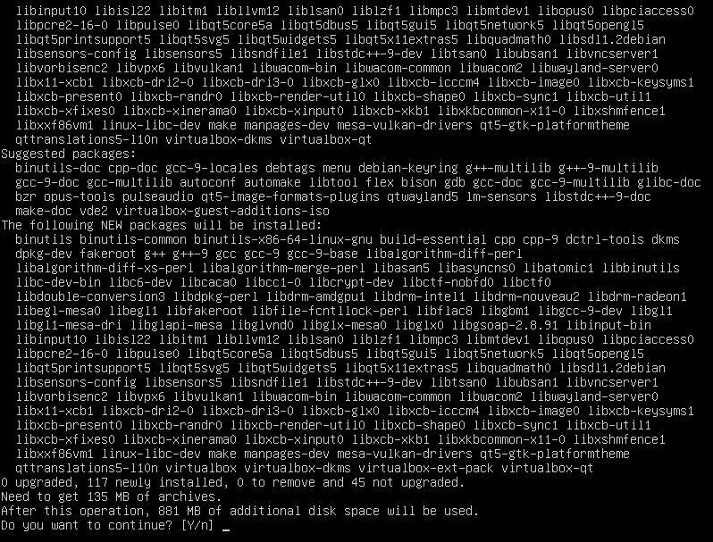

Once this finishes you’ll be brought to a vm box press tab then enter afterwards a do you accept the terms prompt will appear use your arrow keys to hover over yes then hit enter and finish installing

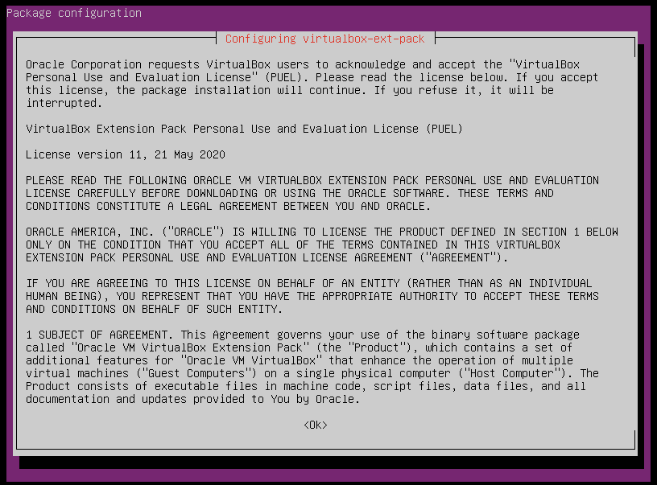

Now we download minikube with

wget <https://storage.googleapis.com/minikube/releases/latest/minikube-linux-amd64>

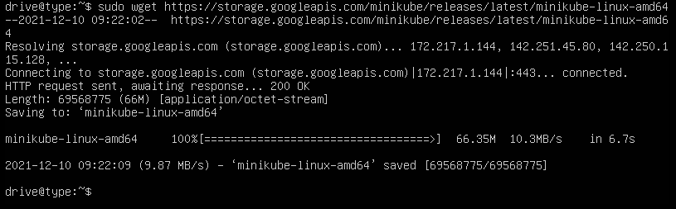

Then we copy over the file to another directory with sudo cp minikube-linux-amd64 /usr/local/bin/minikube



After copying it over we need to give executeable permissions with

sudo chmod 755 /usr/local/bin/minikube



Now we make sure it installed properly by running minikube version

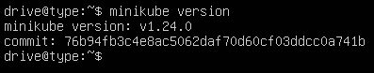

That finishes minikube

**Ubuntu Server Summary**

Ubuntu went a lot smoother than centos and I didn’t have any issues this time around.