November 30, 2015

MetalCow: Lego in 3D

# Introduction

What is your very first memory? Could you draw it?

Imagery is a very powerful communication medium. Some images stick with us throughout our whole lives. Pictures are a way of capturing a moment in time. Not only are the events captured to film, but the atmosphere and emotions can be captured as well. When a powerful image is shared with others it can become a ‘cultural icon’, an image that everyone can recognize.

Consider some images that are ‘iconic’ to you. What are some pictures that you and you friends would instantly recognize? Are they pictures you captured… or are they scenes from a music video or film?

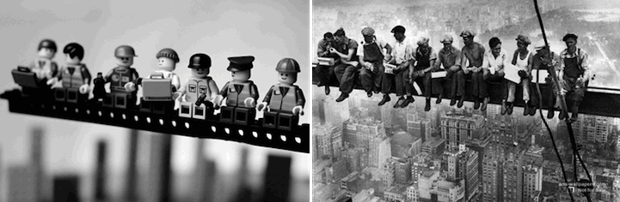

Figure : https://www.flickr.com/photos/balakov/

# Project Description

For this project you will each find an image that is iconic to you, and recreate it in Lego using Autodesk Maya. Consider: complexity, focal point, color, balance, and flow to make and interesting image.

Schedule:

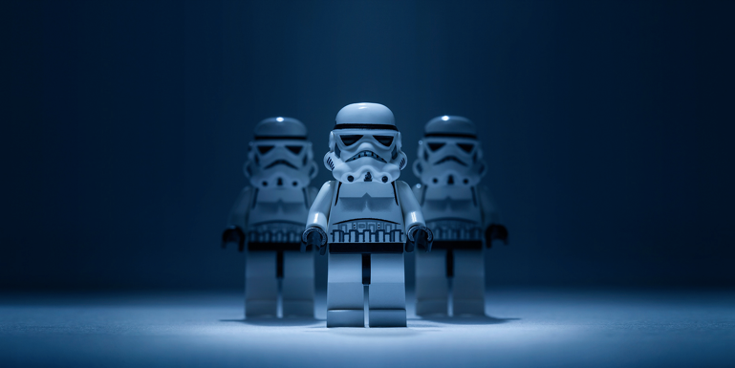

Figure : Dale May, 'Lego Wars'

Day 0: approved reference image/scene  
Day 1: start primary models  
Day 2: primary models  
Day 3: primary models, showcase  
Day 4: texture primary models  
Day 5: finish texturing, showcase  
Day 6: lighting & shadows  
Day 7: final adjustments, showcase   
Day 8: final render and showcase