

**1 Dashboard**

**Overview**

The *Monitoring → Dashboard* section, similar to the dashboard on your car, displays a summary of all the important information.

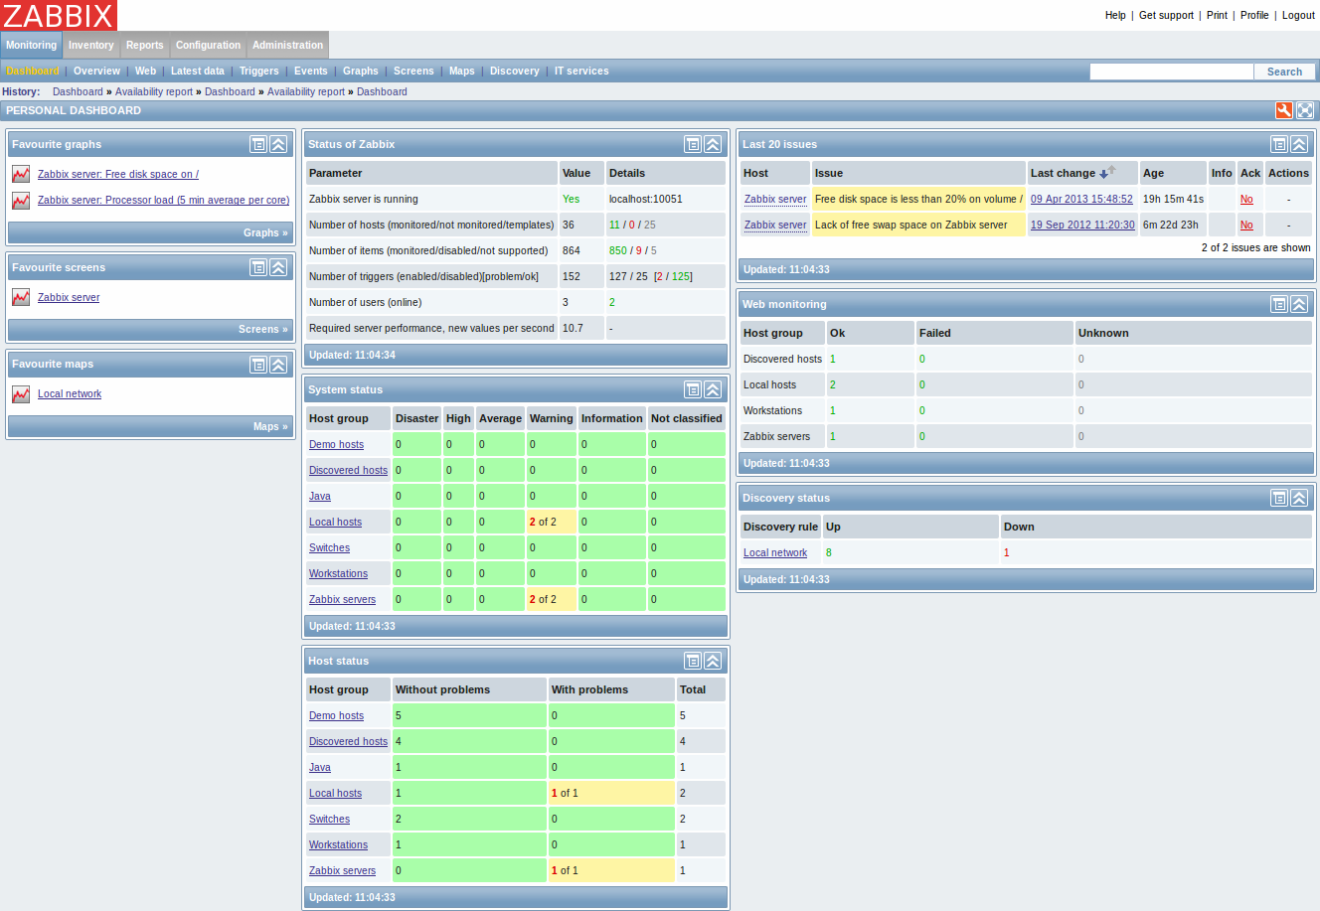

**Favourites**

On the left, there are some widgets for favourites. You can create quick shortcuts there to your most needed graphs, custom graphs, screens, slide shows and maps.

Just click on the Menu button in the widget, select to add, for example, some screen and then select from the configured screens. The selected screens will be displayed as shortcuts in the favourites widget.

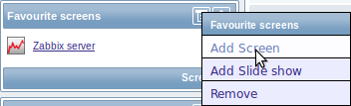

**Status widgets**

In the centre, a number of status widgets - Status of Zabbix, System status, Host status, Last 20 issues, Web monitoring, Discovery status each display a summary of the respective data.

As you may have noticed from the screenshot, the widgets can be arranged in up to three columns. Additionally, all widgets can be freely moved around. Just grab a widget by its title bar, drag and drop wherever you would like it.

**Dashboard filter**

Clicking on [https://www.zabbix.com/documentation/_media/2.2/manual/web_interface/inactive_dboard_filter.png](https://www.zabbix.com/documentation/_detail/2.2/manual/web_interface/inactive_dboard_filter.png?id=2.2%3Amanual%3Aweb_interface%3Afrontend_sections%3Amonitoring%3Adashboard)in the Personal dashboard title bar allows you to access the dashboard filter.

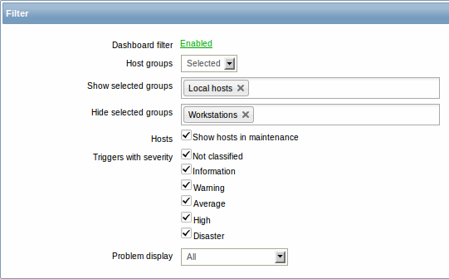

By enabling the filter you can limit what hosts and triggers displayed in the dashboard and define how the problem count is displayed.

|  |  |
| --- | --- |
| Parameter | Description |
| Dashboard filter | Click the link to enable/disable the dashboard filter. |
| Host groups | Select to display host data from: **All** - all host groups **Selected** - selected host groups. |
| Show selected groups | This field is available if Selected is chosen in the Host groups field. Enter host groups to display. This field is auto-complete so starting to type the name of a group will offer a dropdown of matching groups. Host data from these host groups will be displayed in the Dashboard. If no host groups are entered, all host groups will be displayed. |
| Hide selected groups | This field is available if Selected is chosen in the Host groups field. Enter host groups to hide. This field is auto-complete so starting to type the name of a group will offer a dropdown of matching groups. Host data from these host groups will not be displayed in the Dashboard. For example, hosts 001, 002, 003 may be in Group A and hosts 002, 003 in Group B as well. If we select to show Group A and hide Group B at the same time, only data from host 001 will be displayed in the Dashboard. |
| Hosts | Mark the Show hosts in maintenance option to display data from hosts in maintenance in the Dashboard. |
| Triggers with severity | Mark the trigger severities to be displayed in the Dashboard. |
| Problem display | Display problem count as: **All** - full problem count will be displayed **Separated** - unacknowledged problem count will be displayed separated as a number of the total problem count **Unacknowledged only** - only the unacknowledged problem count will be displayed. |

If dashboard filtering is applied, it is indicated by an orange filter icon: [https://www.zabbix.com/documentation/_media/2.2/manual/web_interface/active_dboard_filter.png](https://www.zabbix.com/documentation/_detail/2.2/manual/web_interface/active_dboard_filter.png?id=2.2%3Amanual%3Aweb_interface%3Afrontend_sections%3Amonitoring%3Adashboard).

### 2 Overview

#### Overview

The Monitoring → Overview section offers an overview of trigger states or a comparison of data for various hosts at once.

The following display options are available:

* select horizontal or vertical display of information in the Hosts location dropdown
* select all hosts or specific host groups in the Group dropdown
* select all applications or specific ones in the Application dropdown (this dropdown is available since Zabbix 2.2; by selecting an application, the selection of triggers/items will be narrowed down to those of the selected application)
* choose what type of information to display (triggers or data) in the Type dropdown

**Overview of triggers**

In the next screenshot Triggers are selected in the Type dropdown. As a result, trigger states of two local hosts are displayed, as coloured blocks (the colour depending on the state of the trigger):

### 

Note that recent trigger changes (within the last 30 minutes) will be displayed as blinking blocks.

Clicking on a trigger block provides links to trigger events, the acknowledgement screen or a simple graph/latest values list.

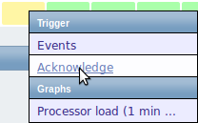

**Overview of data**

In the next screenshot Data is selected in the Type dropdown. As a result, performance item data of two local hosts are displayed.

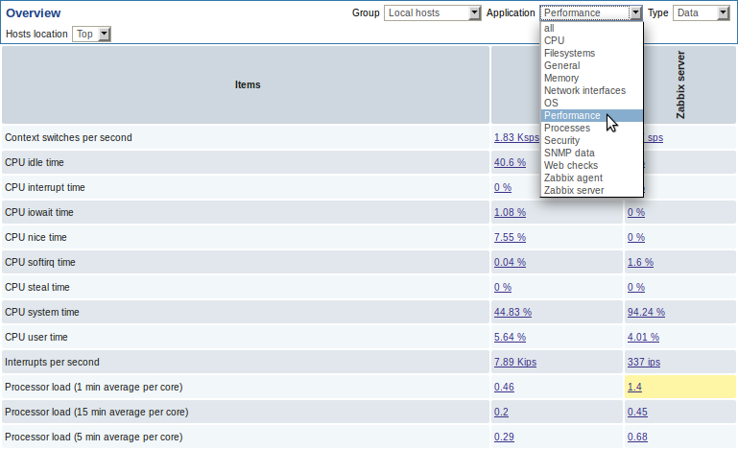

Clicking on a piece of data offers links to some predefined graphs or 500 latest values.

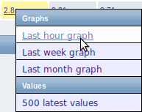

### 

### 3 Web

#### Overview

In the Monitoring → Web section current information about web scenarios is displayed.

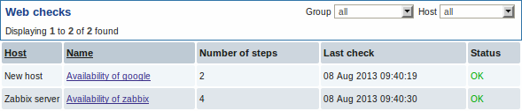

The scenario name is link to more detailed statistics about it:

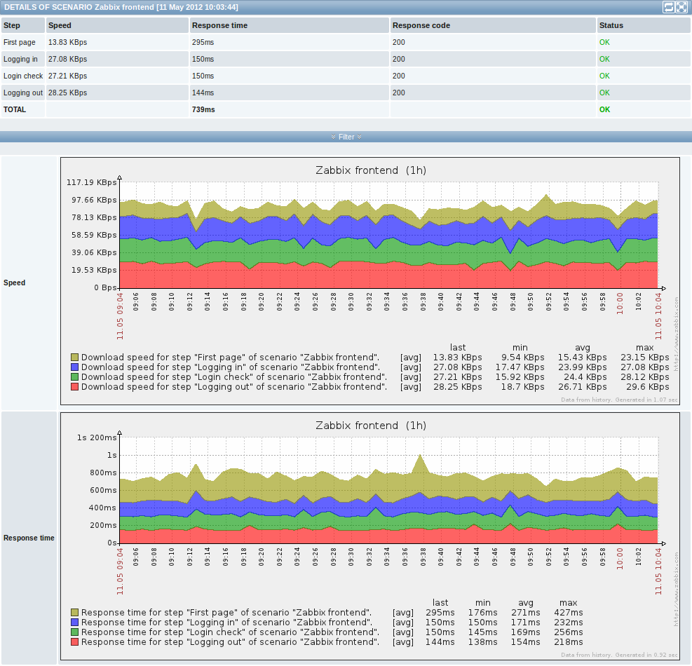

### 4 Latest data

#### Overview

The Monitoring → Latest data section displays the latest values gathered by items.

Just click on '+' before a host and the relevant application, and the items of that host and application will be displayed with their latest values.

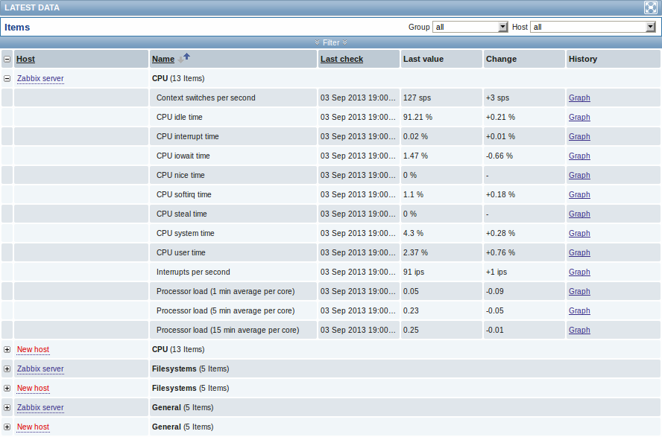

You can expand all hosts and all applications, thus revealing all items by clicking on '+' in the header row.

Note: The name of a disabled host is displayed in red (in both the host dropdown and the list). Data of disabled hosts, including graphs and item value lists, is accessible in Latest data starting with Zabbix 2.2.0.

Items are displayed with their name, last check time, last value, change amount and a link to a simple graph/history of item values.

**Using filter**

You can use the filter to display only the items you are interested in. The filter link is located above the table in the middle. You can use it to filter items by a string in the name; you can also select to display items that have no data gathered.

Moreover, Show details allows to extend displayable information on the items. Such details as refresh interval, history and trends settings, item type and item errors (fine/unsupported) are displayed. A link to item configuration is also available.

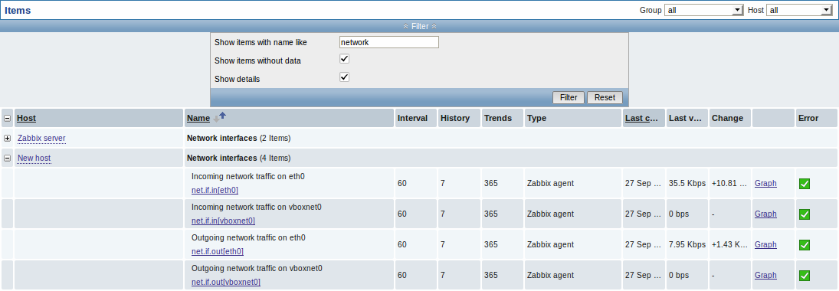

**Links to value history/simple graph**

The last column in the latest value list offers:

* a **History** link (for all textual items) - leading to listings (*Values/500 latest values*) displaying the history of previous item values.
* a **Graph** link (for all numeric items) - leading to a simple graph. However, once the graph is displayed, a dropdown on the upper right offers a possibility to switch to *Values/500 latest values* as well.

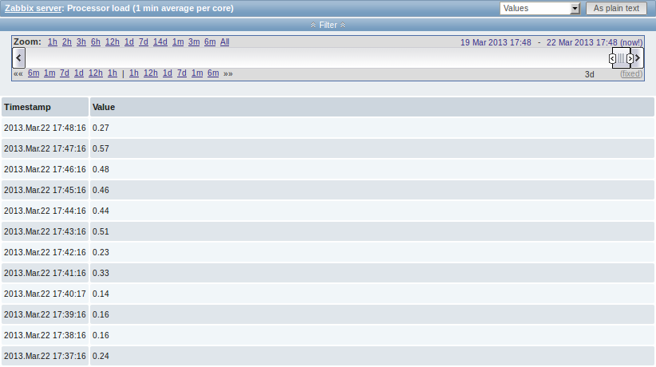

The values displayed in this list are “raw”, that is, no postprocessing is applied.

### 5 Triggers

#### Overview

The Monitoring → Triggers section displays the status of triggers.

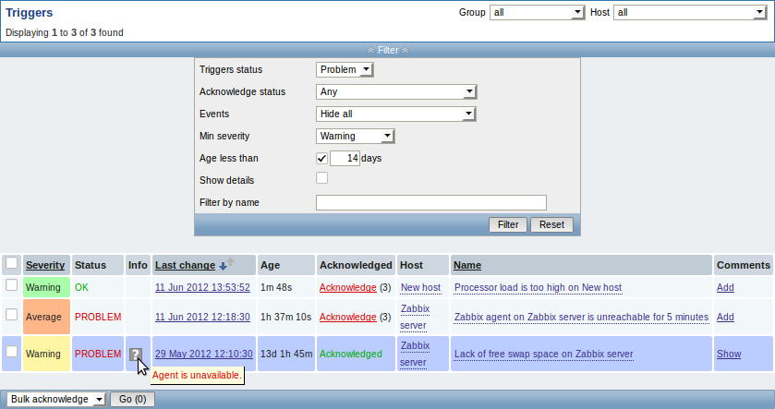

|  |  |
| --- | --- |
| Column | Description |
| Severity | The trigger severity is displayed. The color of the severity is used as cell background for problem triggers. For OK triggers, green background is used. |
| Status | The trigger status is displayed - OK or PROBLEM. By default, it will be blinking for 30 minutes for triggers that have recently changed their state. Additionally, triggers that have recently changed their state to OK, will be displayed for 30 minutes even if the filter is set to show only problems. Text color and blinking options can be configured in Administration → General → Trigger displaying options. |
| Info | |  |  | | --- | --- | |  | A grey icon with a question mark indicates that there is some relevant information to be displayed. If you move your mouse pointer over it, the message will be displayed. | |
| Last change | The date and time of last trigger status change is displayed. |
| Age | The age of last trigger status change is displayed. |
| Acknowledged | The acknowledgment status of the trigger is displayed: **Acknowledged** - green text indicating that the trigger is acknowledged. A trigger is considered to be acknowledged if all events for it are acknowledged. **Acknowledge** - a red link indicating unacknowledged events. If you click on the link you will be taken to a bulk acknowledgement screen where all events for this trigger can be acknowledged at once. Note: If you wish to acknowledge a single event only, go to Monitoring → Events. **No events** - if there are no events for the trigger. Displaying this string is supported since Zabbix 2.0.4; prior to that these triggers were displayed as Acknowledged. |
| Host | The host of the trigger is displayed. It is also a link to the defined custom scripts, latest host data and host screens. |
| Name | The name of the trigger is displayed. It is also a link to the trigger event list and the trigger configuration page, as well as to a simple graph of item data. The link list may also contain a custom trigger URL, if one is defined in trigger configuration. |
| Comments | |  |  | | --- | --- | |  | A link to comments about the trigger. | |

**Using filter**

You can use the filter to display only the triggers you are interested in. The filter link is the blue bar located above the table.

By default the filter is set to display triggers in problem status, also including the triggers that have only very recently changed from 'Problem' status to 'OK'. You can switch to display triggers in 'Any' status, however, the next time you return to this page, problem triggers will again be selected by default.

### 6 Events

#### Overview

The Monitoring → Events section displays latest events

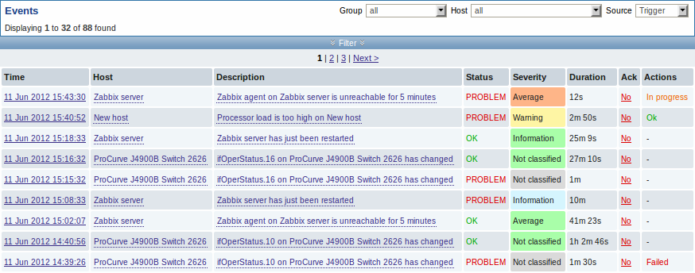

In the last dropdown to the right you can select trigger or discovery based events.

Currently displayed events can be exported to a CSV file. Look for the Export to CSV button to the right on the title bar.



Clicking on the timestamp in the first column of trigger events will take you to event details.

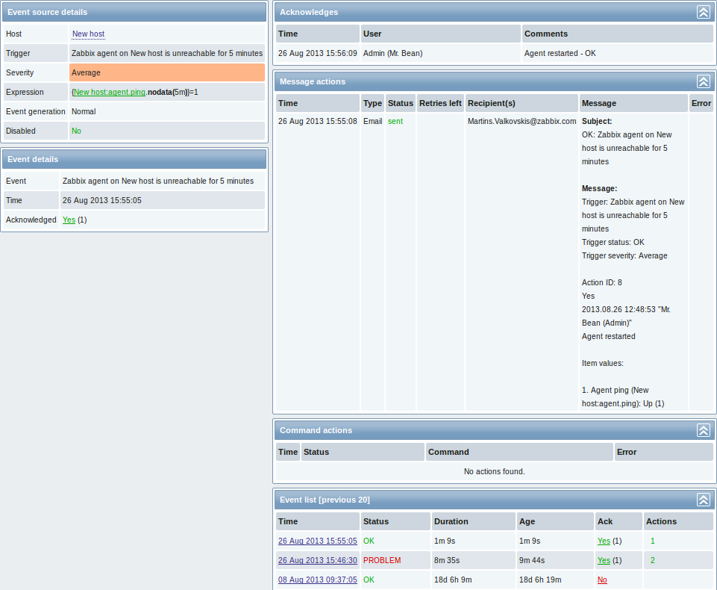

Details about the event, its source, acknowledgments, actions taken (messages, remote commands) and previous similar events are displayed.

### 7 Graphs

#### Overview

In the Monitoring → Graphs section any custom graph that has been configured can be displayed.

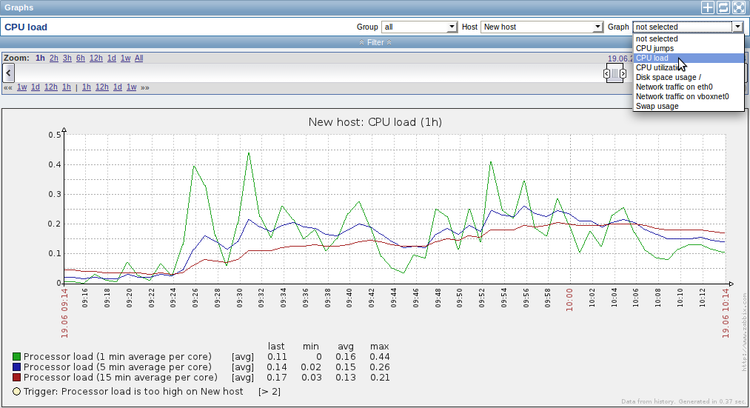

To display a graph, select the host group, host and then the graph from the dropdowns to the right.

*Note*: In the host dropdown, a disabled host is highlighted in red. Graphs for disabled hosts are accessible starting with Zabbix 2.2.0.

**Time period selector**

The filter section above the graph contains a time period selector. It allows you to select the desired time period easily.

The slider within the selector can be dragged back and forth, as well as resized, effectively changing the time period displayed. Links on the left hand side allow to choose some often-used predefined periods (above the slider area) and move them back and forth in time (below the slider area). The dates on the right hand side actually work as links, popping up a calendar and allowing to set a specific start/end time.

The **fixed/dynamic** link in the lower right hand corner has the following effects:

* controls whether the time period is kept constant when you change the start/end time in the calendar popup.
* when *fixed*, time moving controls (« 6m 1m 7d 1d 12h 1h | 1h 12h 1d 7d 1m 6m ») will move the slider, while not changing its size, whereas when *dynamic*, the control used will enlarge the slider in the respective direction.
* when *fixed*, pressing the larger **<** and **>** buttons will move the slider, while not changing its size, whereas when *dynamic*, **<** and **>** will enlarge the slider in the respective direction. The slider will move by the amount of its size, so, for example, if it is one month, it will move by a month; whereas the slider will enlarge by 1 day.

Another way of controlling the displayed time is to highlight an area in the graph with the left mouse button. The graph will zoom into the highlighted area once you release the left mouse button.

**Controls**

Three control buttons are available in the title bar:

* [https://www.zabbix.com/documentation/_media/2.2/manual/web_interface/frontend_sections/monitoring/add_to_fav.png](https://www.zabbix.com/documentation/_detail/2.2/manual/web_interface/frontend_sections/monitoring/add_to_fav.png?id=2.2%3Amanual%3Aweb_interface%3Afrontend_sections%3Amonitoring%3Agraphs)- add graph to the favourites widget in the Dashboard
* [https://www.zabbix.com/documentation/_media/2.2/manual/web_interface/frontend_sections/monitoring/reset.png](https://www.zabbix.com/documentation/_detail/2.2/manual/web_interface/frontend_sections/monitoring/reset.png?id=2.2%3Amanual%3Aweb_interface%3Afrontend_sections%3Amonitoring%3Agraphs)- reset graph display to the original setting of displaying the last hour data
* [https://www.zabbix.com/documentation/_media/2.2/manual/web_interface/frontend_sections/monitoring/full_window.png](https://www.zabbix.com/documentation/_detail/2.2/manual/web_interface/frontend_sections/monitoring/full_window.png?id=2.2%3Amanual%3Aweb_interface%3Afrontend_sections%3Amonitoring%3Agraphs)- use the full browser window to display the graph

### 8 Screens

#### Overview

In the Monitoring → Screens section any configured screen or slide show can be displayed.

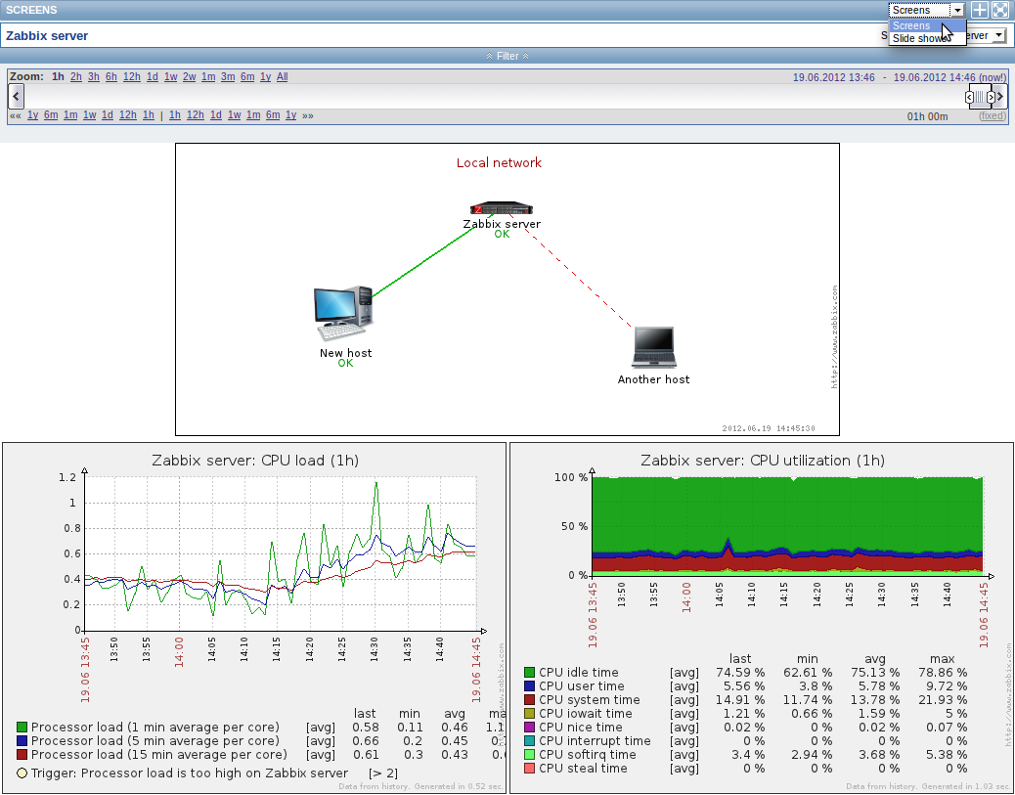

Use the dropdown in the title bar to switch between screens and slide shows.

**Time period selector**

The filter section above the screen/slide show contains a time period selector. It allows you to select the desired time period easily, affecting the data displayed in graphs etc.

**Controls**

Three control buttons are available in the title bar:

* [https://www.zabbix.com/documentation/_media/2.2/manual/web_interface/frontend_sections/monitoring/add_to_fav.png](https://www.zabbix.com/documentation/_detail/2.2/manual/web_interface/frontend_sections/monitoring/add_to_fav.png?id=2.2%3Amanual%3Aweb_interface%3Afrontend_sections%3Amonitoring%3Ascreens)- add screen/slide show to the favourites widget in the Dashboard
* [https://www.zabbix.com/documentation/_media/2.2/manual/web_interface/frontend_sections/monitoring/full_window.png](https://www.zabbix.com/documentation/_detail/2.2/manual/web_interface/frontend_sections/monitoring/full_window.png?id=2.2%3Amanual%3Aweb_interface%3Afrontend_sections%3Amonitoring%3Ascreens)- use the full browser window to display the screen/slide show
* [https://www.zabbix.com/documentation/_media/2.2/manual/web_interface/frontend_sections/monitoring/menu.png](https://www.zabbix.com/documentation/_detail/2.2/manual/web_interface/frontend_sections/monitoring/menu.png?id=2.2%3Amanual%3Aweb_interface%3Afrontend_sections%3Amonitoring%3Ascreens)- slow down or speed up a slide show

### 9 Maps

#### Overview

In the Monitoring → Maps section any configured network map can be viewed.

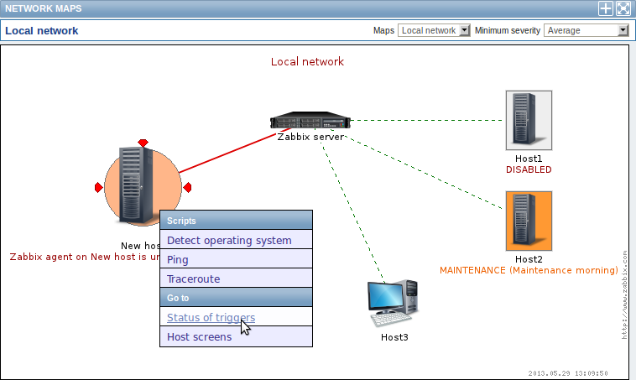

You can use the dropdowns in the map title bar to:

* switch between different configured maps
* select the lowest severity level of the problem triggers to display. The severity marked as *default* is the level set in map configuration. If the map contains a submap, navigating to the submap will retain the higher-level map severity.

**Icon highlighting**

If a map element is in problem status, it is highlighted with a round circle. The fill colour of the circle corresponds to the severity colour of the problem trigger. Only problems on or above the selected severity level will be displayed with the element. If all problems are acknowledged, a thick green border around the circle is displayed.

Additionally, a host in maintenance is highlighted with an orange, filled square and a disabled (not-monitored) host is highlighted with a grey, filled square. Highlighting is displayed if the *Icon highlighting* check-box is marked in map configuration.

**Recent change markers**

Inward pointing red triangles around an element indicate a recent trigger status change - one that's happened within the last 30 minutes. These triangles are shown if the *Mark elements on trigger status change* check-box is marked in map configuration.

**Links**

Clicking on a map element opens a menu with some available links.

**Controls**

Two control buttons are available in the title bar:

* [https://www.zabbix.com/documentation/_media/2.2/manual/web_interface/frontend_sections/monitoring/add_to_fav.png](https://www.zabbix.com/documentation/_detail/2.2/manual/web_interface/frontend_sections/monitoring/add_to_fav.png?id=2.2%3Amanual%3Aweb_interface%3Afrontend_sections%3Amonitoring%3Amaps)- add map to the favourites widget in the Dashboard
* [https://www.zabbix.com/documentation/_media/2.2/manual/web_interface/frontend_sections/monitoring/full_window.png](https://www.zabbix.com/documentation/_detail/2.2/manual/web_interface/frontend_sections/monitoring/full_window.png?id=2.2%3Amanual%3Aweb_interface%3Afrontend_sections%3Amonitoring%3Amaps)- use the full browser window to display the map

### 10 Discovery

#### Overview

In the Monitoring → Discovery section results of network discovery are shown. Discovered devices are sorted by the discovery rule

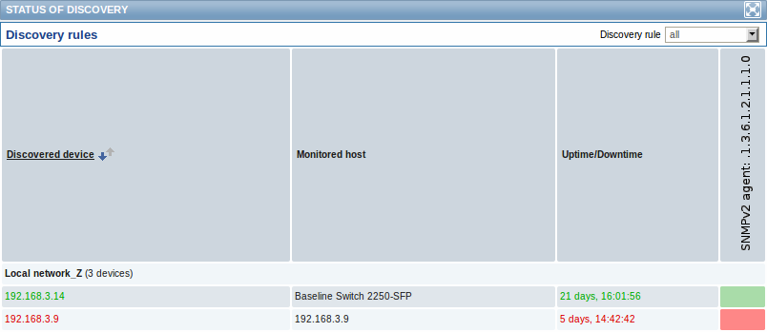

If a device is already monitored, the host name will be listed in the Monitored host column, and the duration of the device being discovered or lost after previous discovery is shown in the Uptime/Downtime column.

After that follow the columns showing the state of individual services for each discovered device. A tooltip for each cell will show individual service uptime or downtime.

### 11 IT services

#### Overview

In the Monitoring → IT services section the status of IT services is displayed.

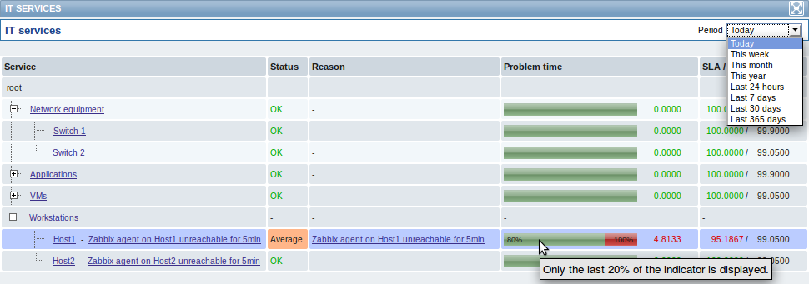

A list of the existing IT services is displayed along with data of their status and SLA. From the dropdown in the upper right corner you can select a desired period for display.

Displayed data:

|  |  |
| --- | --- |
| Parameter | Description |
| Service | Service name. |
| Status | |  |  | | --- | --- | |  | Status of service: **OK** - no problems **(trigger colour and severity)** - indicates a problem and its severity | |
| Reason | Indicates the reason of problem (if any). |
| Problem time | |  |  | | --- | --- | |  | Displays SLA bar. Green/red ratio indicates the proportion of availability/problems. The bar displays the last 20% of SLA (from 80% to 100%). The bar contains a link to a graph of availability data. | |
| SLA/Acceptable SLA | Displays current SLA/expected SLA value. If current value is below the acceptable level, it is displayed in red. |

You can also click on the service name to access the IT Services Availability Report.

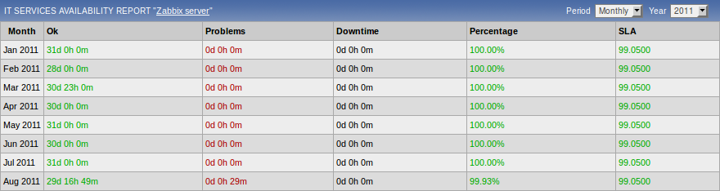

Here you can assess IT service availability data over a longer period of time on daily/weekly/monthly/yearly basis.