CSC 222 Final Project Capstone — Project Proposal Template
Use this template to create your project proposal for Week 11. Fill out each section completely before submitting to Canvas and uploading to GitHub. You may delete the example text after replacing it with your own information.

1. Company Name and Description
Blue Ridge Car Rental – Local car rental company that rents out cars and trucks for customers to use. The program will track vehicles, add vehicles, track if vehicle is sold and no longer a part of the fleet, track if a vehicle is currently rented out

2. Program Purpose
The program will manage vehicles, add vehicles, track if vehicle is sold and no longer a part of the fleet, track if a vehicle is currently rented out, and export inventory to a CSV file.

3. Planned Features (3–5)
List the main features your program will include. You should plan 3–5 features. Be realistic — these will be implemented in Weeks 12–14.
Example Features:
- Add a new vehicle
- Remove vehicle
- Check if vehicle is rented out
- List all vehicles
- Search for vehicle by name or type
- Export vehicle data to a CSV file

4. UML Class Diagram

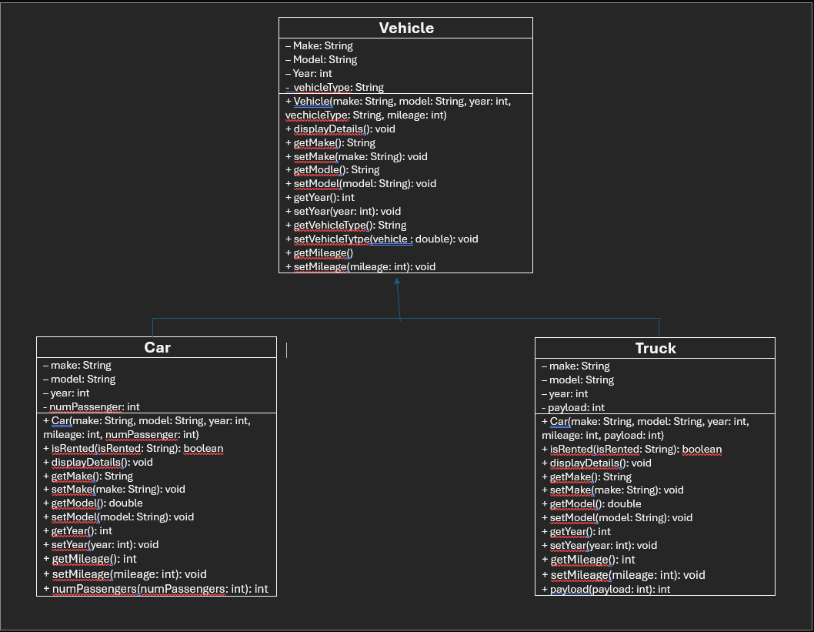

5. GitHub Repository Setup
Repository name: csc222-finalproject-LastnameFirstname
Example: csc222-finalproject-SmithJordan
Paste your repository link here after you create it:

