

IPMV-Experiment-4

Lab 2 Blending with OpenCV

课程名称： 图像处理与机器视觉

实验地点： 嘉定校区智信馆131

指导教师： Lei Jiang， Rui FAN

姓 名： 姚天亮

学 号： 2150248

**Task**

Try to implement and test blending algorithm.

**Simple linear blending**

cv::Mat linearBlending(const cv::Mat& img_1, const cv::Mat& img_2, const cv::Mat& weights)

{

return weights.mul(img_1) + (cv::Scalar(1.0, 1.0, 1.0) - weights).mul(img_2);

}

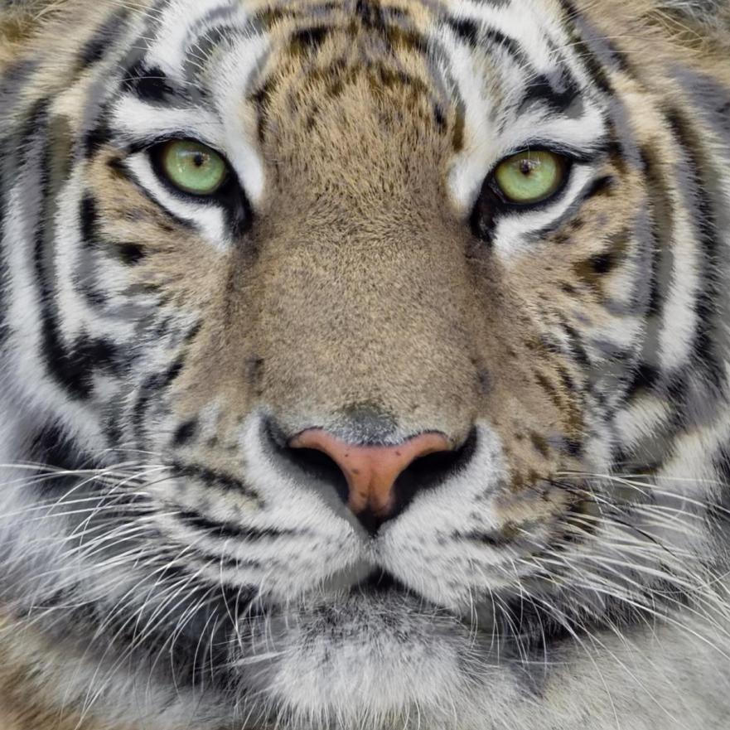

**Laplace blending**

**Construct a Gaussian pyramid**

std::vector<cv::Mat> constructLaplacianPyramid(const cv::Mat& img)

{

std::vector<cv::Mat> gaussianPyr = constructGaussianPyramid(img);

std::vector<cv::Mat> laplacianPyr;

for (size_t i = 0; i < gaussianPyr.size() - 1; i++)

{

cv::Mat expanded;

cv::pyrUp(gaussianPyr[i + 1], expanded, gaussianPyr[i].size());

cv::Mat diff = gaussianPyr[i] - expanded;

laplacianPyr.push_back(diff);

}

laplacianPyr.push_back(gaussianPyr.back());

return laplacianPyr;

}

**Construct a Laplacian pyramid**

std::vector<cv::Mat> constructLaplacianPyramid(const cv::Mat& img)

{

std::vector<cv::Mat> gaussianPyr = constructGaussianPyramid(img);

std::vector<cv::Mat> laplacianPyr;

for (size_t i = 0; i < gaussianPyr.size() - 1; i++)

{

cv::Mat expanded;

cv::pyrUp(gaussianPyr[i + 1], expanded, gaussianPyr[i].size());

cv::Mat diff = gaussianPyr[i] - expanded;

laplacianPyr.push_back(diff);

}

laplacianPyr.push_back(gaussianPyr.back());

return laplacianPyr;

}

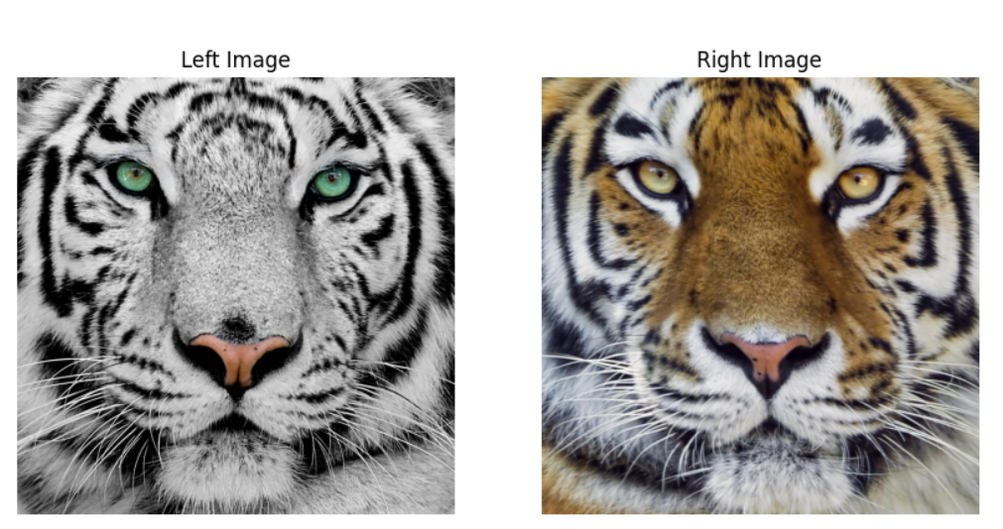

**Reconstruct an image by collapsing a Laplacian pyramid**

cv::Mat collapsePyramid(const std::vector<cv::Mat>& pyr)

{

cv::Mat result = pyr.back();

for (int i = pyr.size() - 2; i >= 0; i--)

{

cv::Mat expanded;

cv::pyrUp(result, expanded, pyr[i].size());

result = expanded + pyr[i];

}

return result;

}

**Perform the Laplace blending**

cv::Mat laplaceBlending(const cv::Mat& img_1, const cv::Mat& img_2, const cv::Mat& weights)

{

// Construct a gaussian pyramid of the weight image.

// TODO: Finish constructGaussianPyramid().

std::vector<cv::Mat> weights_pyr = constructGaussianPyramid(weights);

// Construct a laplacian pyramid of each of the images.

// TODO: Finish constructLaplacianPyramid().

std::vector<cv::Mat> img_1_pyr = constructLaplacianPyramid(img_1);

std::vector<cv::Mat> img_2_pyr = constructLaplacianPyramid(img_2);

// Blend the laplacian pyramids according to the corresponding weight pyramid.

std::vector<cv::Mat> blend_pyr(img_1_pyr.size());

for (size_t i = 0; i < img_1_pyr.size(); ++i)

{

// TODO: Blend the images using linearBlending().

blend_pyr[i] = linearBlending(img_1_pyr[i], img_2_pyr[i], weights_pyr[i]);

}

// Collapse the blended laplacian pyramid.

// TODO: Finish collapsePyramid().

return collapsePyramid(blend_pyr);

}

