

IPMV-Experiment-5

Lab Camera geometry with eigen

课程名称： 图像处理与机器视觉

实验地点： 嘉定校区智信馆131

指导教师： Lei Jiang， Rui FAN

姓 名： 姚天亮

学 号： 2150248

**Task**

Background

In this experiment, we need to project world points into the images.

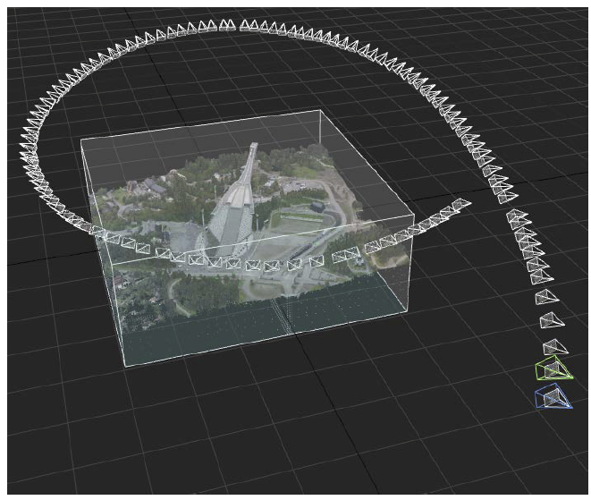

We are going to use Holmenkollen dataset.

110 images taken from helicopter.

For each image, consists:

Intrinisc calibration

Helicopter pose in geographical coordinates

Camera pose relative to helicopter

The coordinate systems are shown as below:

helicopter

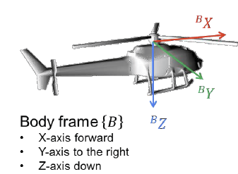

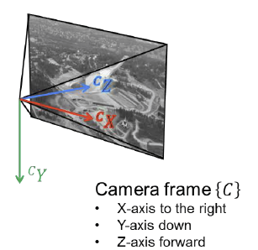

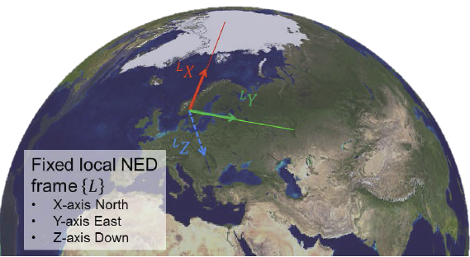

#include "camera_pose_solution.h"

#include "dataset.h"

#include "local_coordinate_system.h"

#include "viewer_3d.h"

#include "opencv2/highgui.hpp"

#include "opencv2/imgproc.hpp"

CameraPoseSolution::CameraPoseSolution(const std::string& data_path)

: data_path_{data_path}

, window_name_{"World point in camera"}

{}

void CameraPoseSolution::run()

{

// Set up dataset.

Dataset dataset{data_path_};

// Define local coordinate system based on the position of a light pole.

const GeodeticPosition light_pole_position{59.963516, 10.667307, 321.0};

const LocalCoordinateSystem local_system(light_pole_position);

// Construct viewers.

cv::namedWindow(window_name_);

Viewer3D viewer;

// Process each image in the dataset.

for (DataElement element{}; dataset >> element;)

{

// Compute the pose of the body in the local coordinate system.

const Sophus::SE3d pose_local_body = local_system.toLocalPose(element.body_position_in_geo,

element.body_attitude_in_geo.toSO3());

// Add body coordinate axes to the 3D viewer.

viewer.addBodyAxes(pose_local_body, element.img_num);

// Compute the pose of the camera relative to the body.

const Sophus::SE3d pose_body_camera(element.camera_attitude_in_body.toSO3(),

element.camera_position_in_body.toVector());

// Compute the pose of the camera relative to the local coordinate system.

const Sophus::SE3d pose_local_camera(pose_local_body * pose_body_camera);

// Add camera coordinate axes to the 3D viewer.

viewer.addCameraAxes(pose_local_camera, element.img_num);

// Construct a camera model based on the intrinsic calibration and camera pose.

const PerspectiveCameraModel camera_model{element.intrinsics.toCalibrationMatrix(),

pose_local_camera,

element.intrinsics.toDistortionCoefficientVector()};

// Undistort image.

cv::Mat undistorted_img = camera_model.undistortImage(element.image);

// Project world point (the origin) into the image.

const Eigen::Vector2d pix_pos = camera_model.projectWorldPoint(Eigen::Vector3d::Zero());

// Draw a marker in the image at the projected position.

const Eigen::Vector2i pix_pos_int = (pix_pos.array().round()).cast<int>();

cv::drawMarker(undistorted_img, {pix_pos_int.x(), pix_pos_int.y()}, {0.,0.,255.}, cv::MARKER_CROSS, 40, 3);

// Add the camera frustum with the image to the 3D viewer.

viewer.addCameraFrustum(camera_model, undistorted_img, element.img_num);

// Show the image.

cv::imshow(window_name_, undistorted_img);

// Update the windows.

viewer.spinOnce();

cv::waitKey(100);

}

// Remove image viewer.

cv::destroyWindow(window_name_);

// Run 3D viewer until stopped.

viewer.spin();

}

#include "perspective_camera_model.h"

#include "opencv2/core/eigen.hpp"

#include "opencv2/imgproc.hpp"

#include "opencv2/calib3d.hpp"

PerspectiveCameraModel::PerspectiveCameraModel(const Eigen::Matrix3d& K,

const Sophus::SE3d& pose_world_camera,

const Vector5d& distortion_coeffs)

: K_{K}

, pose_world_camera_{pose_world_camera}

, distortion_coeffs_{distortion_coeffs}

{

camera_projection_matrix_ = computeCameraProjectionMatrix();

}

Sophus::SE3d PerspectiveCameraModel::getPose() const

{

return pose_world_camera_;

}

Eigen::Matrix3d PerspectiveCameraModel::getCalibrationMatrix() const

{

return K_;

}

PerspectiveCameraModel::Matrix34d PerspectiveCameraModel::getCameraProjectionMatrix() const

{

return camera_projection_matrix_;

}

PerspectiveCameraModel::Matrix34d PerspectiveCameraModel::computeCameraProjectionMatrix()

{

return K_ * pose_world_camera_.inverse().matrix3x4();

}

Eigen::Vector2d PerspectiveCameraModel::projectWorldPoint(Eigen::Vector3d world_point) const

{

return (camera_projection_matrix_ * world_point.homogeneous()).hnormalized();

}

Eigen::Matrix2Xd PerspectiveCameraModel::projectWorldPoints(Eigen::Matrix3Xd world_points) const

{

return (camera_projection_matrix_ * world_points.colwise().homogeneous()).colwise().hnormalized();

}

cv::Mat PerspectiveCameraModel::undistortImage(cv::Mat distorted_image) const

{

// Convert to cv::Mats

cv::Mat K_cv;

cv::eigen2cv(K_, K_cv);

cv::Mat dist_coeffs_cv;

cv::eigen2cv(distortion_coeffs_, dist_coeffs_cv);

// Undistort image.

cv::Mat undistorted_image;

cv::undistort(distorted_image, undistorted_image, K_cv, dist_coeffs_cv);

return undistorted_image;

}

