# Instructions for participants

## General instructions

* Sit as still as possible
* Blink as little as possible

## The experiment

In this experiment, you will learn to control a cursor on the screen via your brain signals. On the screen, you will see two oval shapes, one on the left marked LH and one on the right marked RH. These shapes are the targets that you should try to hit. Between the two ovals is a smaller oval, which is the cursor that you will control.

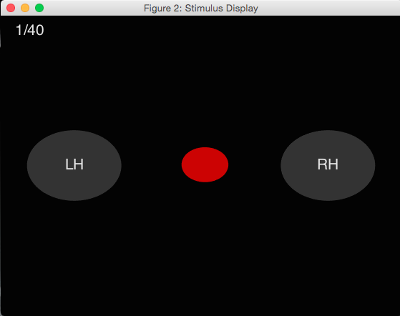

## Practice and calibration blocks

In the practice and calibration phases, each trial (repetition) will start with one of the ovals turning green. As long as the oval is green, you must make ‘minimal movements’ with your hand. By minimal movement we mean:

**You should lightly press your index finger to your thumb approximately every second, but make your movement so small that somebody watching you cannot see it.**

If the LH oval is green, make these minimal movements with your left hand. If the RH oval is green, make these minimal movements with your right hand.

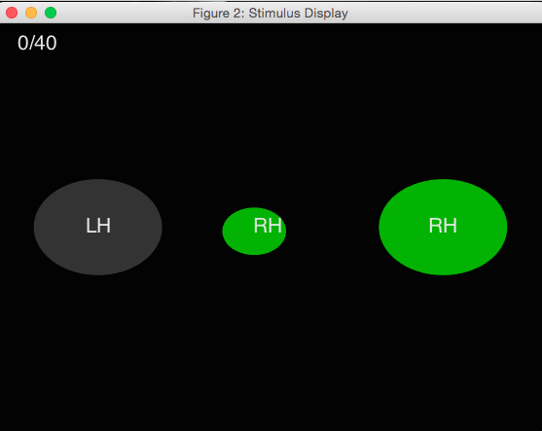

## Performance evaluation block

In the performance evaluation block, the task is the same as during the calibration block. While you perform the task, a classifier will try to predict whether you are making minimal movements with your left hand or right hand. At the end of the trial, the oval corresponding to the prediction made by the classifier will turn blue.

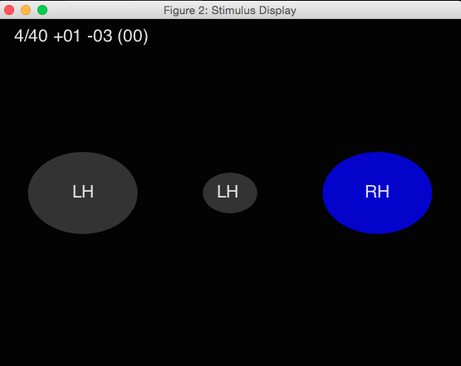

## Continuous feedback blocks

In the continuous feedback blocks, you must try to move the cursor towards the green oval.

To move the cursor towards the LH oval, make minimal movements with your left hand. To move the cursor towards the RH oval, make minimal movements with your right hand.

The cursor will be red as long as the target has not yet been hit. Once you hit the target, the cursor will turn green.

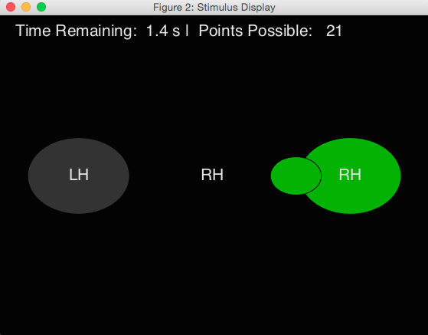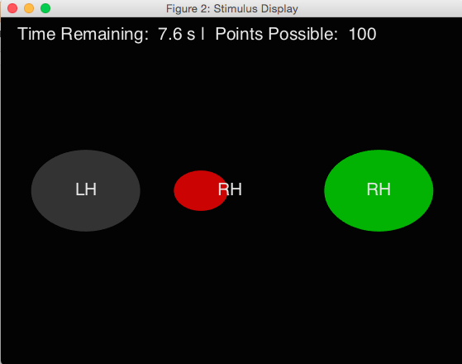

### 

### Low time pressure condition

If you hit the target at any point during the trial, you will receive 100 points. If you do not hit the target, 10 points will be subtracted from your total. The time remaining is displayed at the top of the screen throughout the trial.

### High time pressure condition

You will receive points for hitting the target, but the number of points depends on the moment you hit the target. The faster you hit the target, the more points you will receive. The maximum number of points you can get per trial is 100. If you hit the target too late or not at all, 10 points will be subtracted from your total. The time remaining and the number of points left at that moment are displayed at the top of the screen throughout the trial.