
Psychotropic self-assessment tool – a template for recording information for consumers receiving psychotropic medications

Version 2.1
Updated 21 September 2021

Recording psychotropic medication
The Aged Care Quality and Safety Commission (Commission) is committed to reducing the inappropriate use of restrictive practices in residential aged care settings.
Under the Commission’s risk-based approach to assessment and monitoring, there is a focus on the use of psychotropic medications in aged care, including where they are used as chemical restraints.
Completion of this tool is not mandatory. The tool aims to enable providers to capture information about all consumers who are receiving psychotropic medication(s), including for PRN (as needed). This assists providers to understand how these medications are used at their service and identify where further assessment/action may be required, including opportunities to reduce or remove these medications for consumers. It can further assist providers with governance and management of high-risk medications
The description list details the scope of information that will be collected by this tool. Rationale and supporting documentation, including consent, to use medication as a chemical restraint for any consumer should be set out in the consumer’s behaviour support plan and explained if requested.
The Commission may request information from the tool to assist with quality and monitoring activities.
Description
A. List all psychotropic medication(s), including dose and frequency.
B. Reason (clinical indication) the medical practitioner or nurse practitioner has prescribed psychotropic medication(s), including for PRN use.
C. For PRN medications, describe the circumstances in which the medication may be administered.
D. Date the provider was last notified by the prescriber that informed consent had been obtained, and how this information was communicated. If requested, providers should be able to produce a record of this communication.
E. Does the provider consider that the medication is used as a chemical restraint? Rationale for this decision should be explained if requested.
F. Has a behaviour support plan been developed and implemented for the consumer? If yes, providers must be able to show evidence if requested.
G. Is the consumer being monitored for responsiveness to the medication including effectiveness and any side effects? Providers must be able to show evidence if requested. This information must be communicated to the prescriber and the person who consented.
H. Date of last medication review by a medical or nurse practitioner, or pharmacist, to determine if ongoing use is or may be required, and if so, if the dose and frequency remain appropriate. If requested, evidence of this review must be provided.

Surname | First name | Date first prescribed (approx. if unknown) | A.  Name of medication, dose and frequency | B.  Reason for prescribing | C.  If PRN, circumstances  for use | D.  Date and how prescriber last communicated informed consent had been obtained | E.  Is the medication use identified  as a restraint?  Yes/No | F.  Behaviour support plan developed and implemented.  Yes/no  If yes, date behaviour support planning commenced | G.  Is monitoring occurring for effectiveness and side effects?  Yes/no | H.  Date of last formal medication review
Date last updated:

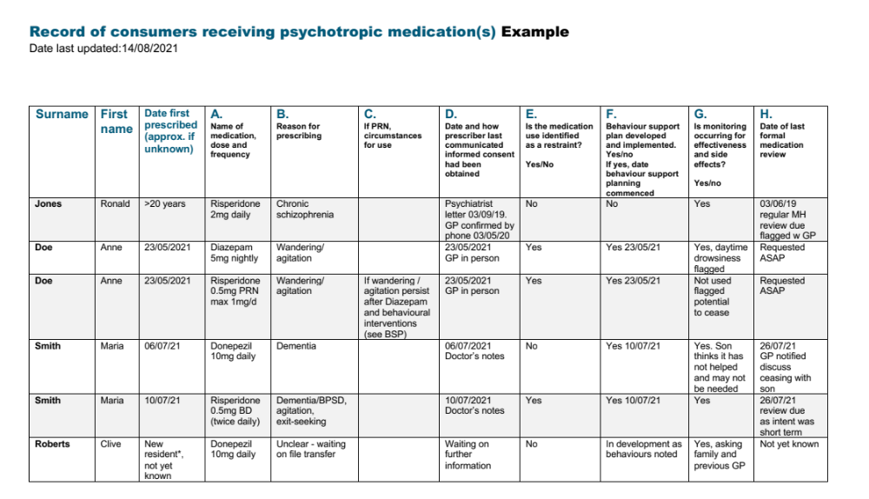

Example

The above aged care consumers are fictional and with the exception of Clive, are featured in our restrictive practices scenarios. The scenarios
involving Ronald and Maria are on page 5, and Anne on page 7. This is intended as an example only and should not be relied upon as an authority.
Where psychotropic consent communication occurs by GP to provider by phone or in person, this conversation is recorded by the provider in the clinical
notes or in some other appropriate system, for example, consent register, consent record form. The record should be readily accessible.
*Clive is a new resident and this information should be obtained as soon as possible after admission.

