ESM 270 Assignment

YOUR NAME

# Original Flower Plot

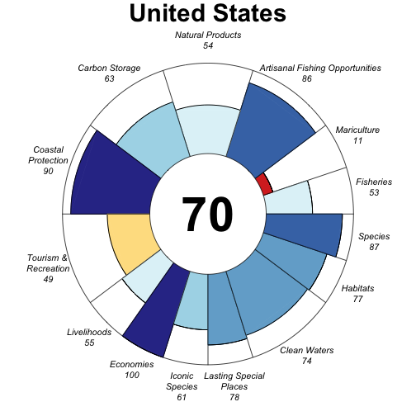

# Modification 1: Goal weight

I changed the weight of goal X to XX. Here are my comments about what this did to the scores.

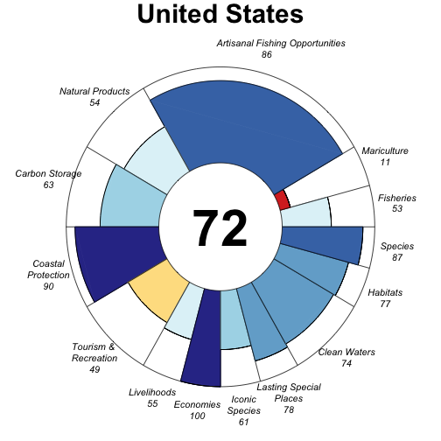

# Modification 2: Reference Point

I set the Lasting Special Places referece point to Y. Here are my comments about what this did to the scores.

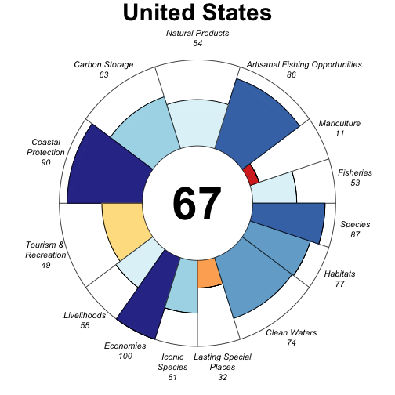

# Final thoughts

Here are my overall reactions. Here are some thoughts about what this means for scoring ocean health.