**FreeCAD Connector for NVIDIA Omniverse**

Documentation & Guide

**Raska R Soemantoro**

*The University of Manchester, UK*

*UK Atomic Energy Authority, UK*

[*raska.soemantoro@manchester.ac.uk*](mailto:raska.soemantoro@manchester.ac.uk)

Contents

Introduction 3

Installation 3

Installation of the Omniverse Launcher 3

Setting up a local Omniverse Nucleus server 4

Basic installation (automated script) 4

Manual installation 5

System 7

User interface 8

How-to guide 9

Establishing a connection with Nucleus 9

Uploading and downloading assets from Nucleus 9

Assembly tools 9

## Introduction

For the field of computer-aided design (CAD), NVIDIA Omniverse presents an opportunity to improve on the workflows currently in place for both the initial design and continuous improvement of engineering components. Mainly, Omniverse serves as a shared 3D model exchange where contributors can create, view, and analyse the same model all while simultaneously conducting simulations in a true-to-life virtual environment [1].

The creation and analysis of engineering components in the context of Omniverse can be done using third-party connectors. Connectors offer real-time synchronisation between Omniverse and design and simulation tools currently in use. Due to Omniverse’s open platform, several Omniverse connectors have been developed such as for Unreal Engine, ParaView, and Autodesk Maya, with the potential of developing further connectors through the Connect library [2].

FreeCAD is a general-purpose 3D computer-aided design tool. While not necessarily the main industry standard for CAD, its’ open-source nature and modular architecture has allowed for introduction of numerous third-party ‘workbench’ tools expanding to a wider range of uses around engineering. For example, FreeCAD has previously been used to parse the nested structures and complicated surfaces associated with Monte-Carlo neutronics calculations for magnetic fusion devices [3].

Currently, NVIDIA does not offer a connector between Omniverse and FreeCAD. Fortunately, the development of such a connector is made straightforward due to the availability of both open Omniverse Connect and FreeCAD Workbench platforms.

## Installation

### Installation of the Omniverse Launcher

The Omniverse Launcher is a piece of software that is required as a first step for setting up a local Omniverse Nucleus server. The provision of the software is free (at the time of writing of this document in May 2024) and allows access to NVIDIA’s suite of Omniverse connected applications.

1. Navigate to the Omniverse main page at [nvidia.com/omniverse]. Under Software Development Kit (SDK), click Download now.

1. A prompt to register for the download will appear. Enter the user’s details and select Submit to begin the download.

1. A file (omniverse-launcher-win.exe) will begin to download. Execute the file and complete all the necessary steps in the installer.
2. The launcher will display after the installation is done. The user may need to log in to the launcher – this is done through an NVIDIA account that the user has to setup.

### Setting up a local Omniverse Nucleus server

The developed software relies on a connection with an Omniverse Nucleus server. Network clients requiring access to a given Nucleus server will require the server’s IP address and hostname to be accessible to it. Using Nucleus behind a firewall and port forwarding network traffic inbound is not supported.

The FreeCAD connector can run on any Omniverse Nucleus setup. The most basic one can be downloaded using the Omniverse Individual license, which is free to use. The Omniverse Enterprise license requires a paid license subscription. There are some differences between Omniverse Individual and Omniverse Enterprise, however Omniverse Individual allows up to two users to work on the same project per entity. Further information regarding the differences between Omniverse Individual and Enterprise is available [here](https://docs.omniverse.nvidia.com/enterprise/latest/benefits.html) [https://docs.omniverse.nvidia.com/enterprise/latest/benefits.html].

**Individual License**

Setting up a local Nucleus service using the Omniverse Individual license can be done through the steps in the following [link](https://docs.omniverse.nvidia.com/nucleus/latest/workstation/installation.html):

[https://docs.omniverse.nvidia.com/nucleus/latest/workstation/installation.html]

Once this is done, the user can access the Nucleus server using the newly created omniverse://localhost server.

**Enterprise License**

To set up an enterprise Omniverse Nucleus server, an extended user license is required, information regarding this and installation steps of the Omniverse IT-managed launcher can be found [here](https://docs.omniverse.nvidia.com/launcher/latest/it-managed-launcher.html) [https://docs.omniverse.nvidia.com/launcher/latest/it-managed-launcher.html].

### Basic installation (automated script)

The basic installation is the recommended method of installation and should work with most systems.

1. Git clone the FreeCAD Connector repository to your FreeCAD \Mod directory. Typically, this is `C:\Users\USER_NAME\AppData\Roaming\FreeCAD\Mod`.

|  |
| --- |
| **Command:**  git clone <https://github.com/raska-s/FreeCAD-Omniverse.git> |

1. Navigate to the cloned repository’s directory and launch the installation by running `install.bat`. This will fetch the dependencies required to run the software.

|  |
| --- |
| **Command:**  cd .\FreeCAD-Omniverse  .\install.bat |

1. Installation complete.

**Note**: if the `AppData\Roaming\FreeCAD\Mod` file directory does not exist, you must first initialise this folder. This happens if no FreeCAD addons have been previously installed. To do this, launch FreeCAD, and on the toolbar click `Tools` > `Addon Manager`. If you are using the Addon Manager for the first time, a dialog box will open, warning you that the addons in the Addon manager are not officially part of FreeCAD. It also presents several options related to the Addon Manager's data usage. Adjust those options to your liking and press the `OK` button to continue. The `\Mod` directory should now exist.

### Manual installation

This subsection outlines the steps required to install the software manually, without using the automated script. The user will have to have Omniverse Launcher installed prior to carrying out this installation process.

1. Git clone the FreeCAD Connector repository to your FreeCAD \Mod directory. Typically, this is `C:\Users\USER_NAME\AppData\Roaming\FreeCAD\Mod`.

|  |
| --- |
| **Command:**  git clone <https://github.com/raska-s/FreeCAD-Omniverse.git> |

1. Open Omniverse Launcher. Under the Exchange tab, navigate to the Connect Sample page. This can be done using the search bar or under the Connectors tab on the left-hand side of the window.

1. Download Connect Sample version 202.0.0 using the Omniverse Launcher. The estimated file size is about 200MB.
2. Once downloaded, navigate to the Library tab. On the left-hand side of the page, select Connectors. The user can expect to find the newly downloaded Connect Sample connector visible on the page.

1. Click the three horizontal bars to the right of the Connect Sample listing. Click Settings.

1. Clicking the directory button to the right of the install path will direct the user to the directory in which the Connect Sample is stored. Alternatively, this is typically stored in C:/Users/USERNAME/AppData/Local/ov/pkg/connectsample-202.0.0
2. Copy the contents of the directory to the /OmniConnect folder of the FreeCAD-Omniverse repository directory, which was previously downloaded in step 1.
3. Navigate to the /OmniConnect directory in the FreeCAD-Omniverse repository directory. Under /omniConnect/source/PyHelloWorld, copy the entire \omni directory to /omniConnect/source/pyOmniFreeCAD. The pyOmniFreeCAD folder should now contain all these files:

1. Navigate to the /OmniConnect directory, and using a Powershell terminal run the command below to fetch the required NVIDIA dependencies:

|  |
| --- |
| **Command:**  ./repo.bat build --fetch-only |

1. Still in the /OmniConnect directory, run the following command to fetch the remaining Python dependencies:

|  |
| --- |
| **Command:**  ./_build/target-deps/python/python.exe -m pip install open3d aioconsole |

1. The installation is complete and the FreeCAD connector for Omniverse is ready for use.

## System

In this software, geometry is pushed to the Nucleus in a neutral .STP format, which preserves the information initially attached by FreeCAD and does not require importing of tessellated geometry into the FreeCAD workspace. This is shown in **Fig. 2**. Along with the STP file, the connector uploads a USD file, which is updated whenever a new version of its corresponding STP file is made. However, the connector imports only the stored STP file when pulling from Nucleus. The tessellation process is done only once for each version of the geometry.

Here, USD and STP files are stored in a project folder, which contains single-component assets and assemblies. By default, projects are stored in omniverse://$HOST_NAME/Users/$USER_NAME/FreeCAD/$PROJECT_NAME. STP and USD assets are stored in $PROJECT_FOLDER/asset_$ASSETNAME/ and assemblies stored as $PROJECT_FOLDER/assembly/$ASSEMBLY_NAME.usda. This is shown in Fig 3.

|  |
| --- |
|  |
| ***Fig.2****. Software architecture of the FreeCAD connector for Omniverse.* |

|  |
| --- |
|  |
| *Fig. 3. Representation of the default file storage tree used by the FreeCAD connector.* |

## User interface

The user is able to launch tasks using the ribbon menu, the settings panel, or the assembly panel. For reference, these user interface buttons are shown in **FIGURES X and X.**

**INSERT FIGS HERE**

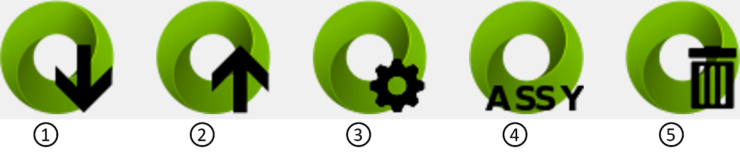

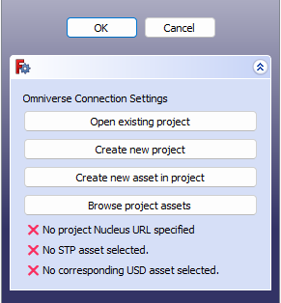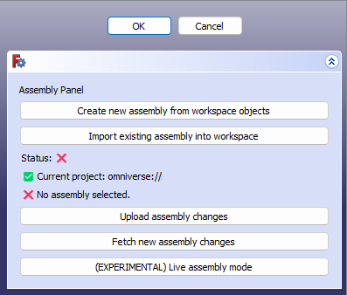

|  |  |  |
| --- | --- | --- |
| **Button name** | **Description** | **Mode of activation** |
| Pull from Nucleus | Pulls the specified asset from Nucleus into the FreeCAD workspace | Only active if a project link and asset has been specified |
| Push to Nucleus | Pushes geometry in the FreeCAD workspace onto Nucleus using the specified project link and asset | Only active if a project link and asset has been specified |
| Settings Panel | Button to open the Settings Panel | Always active |
| Assembly Panel | Button to open the Assembly Panel | Active is a project link has been specified |
| Clear current session | Deletes the stored Nucleus information from memory. | Always active |

## How-to guide

### Establishing a connection with Nucleus

Establishing a connection with a component stored on the Nucleus is done through a project-based process: the user can either open an existing project or create a new project, and then select an existing asset or create a new one. When opening an existing project, clicking the ‘Open existing project’ button will prompt the user to input the Nucleus link of their project. Clicking the ‘Create new project’ button will prompt the user to input the Nucleus hostname and the new project name. Once done, clicking the ‘Browse project assets’ button opens a pop-up menu prompting the user to select an existing asset. The user can also create a new asset using the ‘Create new asset’ button.

### Uploading and downloading assets from Nucleus

### Assembly tools

The push-pull assembly workflow provides a way for the FreeCAD user to use the various assembly functionalities of FreeCAD such as that found on the standard Part workbench, [A2plus](https://wiki.freecad.org/A2plus_Workbench), [Assembly3](https://wiki.freecad.org/Assembly3_Workbench), or [Assembly4](https://wiki.freecad.org/Assembly4_Workbench), and propagate the component placement to a USD file on the Omniverse Nucleus.

The main user interface for the assembly feature in the FreeCAD connector is the Assembly Tools panel. A screenshot of this is given in **Fig. 1**.

There are two main UI areas in this panel, which in total contains 5 different buttons. The Create New Assembly button allows the user to create a USDA file on the Nucleus server which references the USD objects in the current FreeCAD workspace. Clicking this button opens a pop-up menu that prompts the user to input an assembly name and to select items in the workspace to include in the assembly. A new USDA file will be made in $PROJECT_FOLDER/assembly/, containing only references to the USD component, that can be visualised on Omniverse in the same placement as that on FreeCAD. The Import Existing Assembly button will open a pop-up menu that prompts the user to select an existing assembly from the current project folder. Upon selection, the entire assembly and its components will be imported into the FreeCAD workspace.

|  |
| --- |
|  |
| *Fig. 1. FreeCAD Connector Assembly Tools panel with a project and assembly loaded.* |

Under these two buttons, status indicators are given, detailing the current project and assembly in use in the given session. If both current project and assembly elements are valid, the status will show the ‘Ready’ indicator, which allows users to access the Upload assembly changes, Fetch assembly changes, and Live assembly mode features.

The remaining three buttons allow the user to transfer positional information (translation and rotation) to and from the Nucleus server. The Upload assembly changes button sends the cartesian coordinates and rotation of each component in the current FreeCAD assembly to the assembly USDA file stored on the Nucleus and alters the position of each referenced single component within the assembly USDA file. Meanwhile, the Fetch new assembly changes button requests the coordinates and rotation of each element in the assembly USDA file stored in the Nucleus server and adjusts each component’s rotation and translation in the FreeCAD workspace. These two buttons allow for simple manipulation of position and angle of the components, integrated with the Omniverse environment.

An exciting addition to the Omniverse Connector for FreeCAD is the Live assembly mode. This button allows for live real-time communication between the FreeCAD workspace and Omniverse environment. Upon clicking this button, a pop-up menu will prompt the user to select an available Omniverse Live session attached to the assembly USDA file. These available sessions are also possible to view on the Omniverse USD Composer app. This is shown in Figs. 2 (a) and (b).

|  |  |
| --- | --- |
|   *(a)* |   *(b)* |
| *Fig. 2. Available Live Sessions pop-up dialog on (a) FreeCAD and (b) Omniverse USD Composer.* | |

On FreeCAD, the Live Assembly Mode button will show that it is active and toggled in blue, as shown in Fig 3(a). If the assembly USDA file is opened on Omniverse USD Composer and a user is logged into the same Live Session as the FreeCAD user, a small user icon will appear near the Live button of the USD Composer app. Also, a message will appear on the USD Composer notifying the user that another user has joined the session. These are shown in Figs. 3(b) and ©. Any changes done on the Omniverse side will now propagate in real-time on FreeCAD. Clicking the Live assembly button again on FreeCAD deactivates the Live mode, triggering the Omniverse Client to quit the Live Session and thus turning the button white in the process.

|  |  |
| --- | --- |
|   *(a)* |   *(b)* |
|   *(c)* | |
| *Fig.3. Indications that Live Session is active: (a) Toggled Live assembly button active on FreeCAD, (b) User icon next to Live button on USD Composer, and (c) User joining message on USD Composer.* | |