**部署thegraph私有节点**

因为要搞的链是thegraph托管服务不支持的链（托管服务不支持的链或私有链），所以需要部署一个thegraph私有节点去同步链的信息，给subgraph查询提供服务。  
必要信息：

* 你的链的rpc节点

**一、部署thegraph私有节点**

首先参考了[剖析DeFi借贷产品之Compound：Subgraph篇](https://mp.weixin.qq.com/s/CaKXWC4-VG08kHiaq41jRA)

*若要自己搭建私有节点，可按照 Github 上的 graph-node 项目的说明进行部署。其 Github 地址为：*[*https://github.com/graphprotocol/graph-node*](https://github.com/graphprotocol/graph-node) *部署 graph-node 也有两种方式，一是 README 上所描述的步骤，二是用 Docker 进行部署。两种方式我都尝试过，但第一种方式以失败告终，多次尝试解决问题依然无果，第二种方式很快就成功了，所以我强烈推荐用 Docker 方式进行部署。  
首先，在需要部署的服务器安装好 docker 和 docker-compose。  
其次，打开 graph-node/docker/docker-compose.yml 文件，修改其中一行：  
ethereum: 'mainnet:http://host.docker.internal:8545'  
该行指定了使用的网络和节点，比如，我部署接入 kovan 网络，节点使用 infura 的，那设置的值为：  
ethereum: 'kovan:https://kovan.infura.io/v3/<PROJECT_ID>'  
其中，<PROJECT_ID> 是在 infura 注册项目时所分配的项目ID。*

果断决定使用docker-compose 的方法进行部署。  
然后找到thegraph Github [地址](https://github.com/graphprotocol/graph-node),按着说明进行部署，因为我是mac所以决定先用mac的方式进行部署

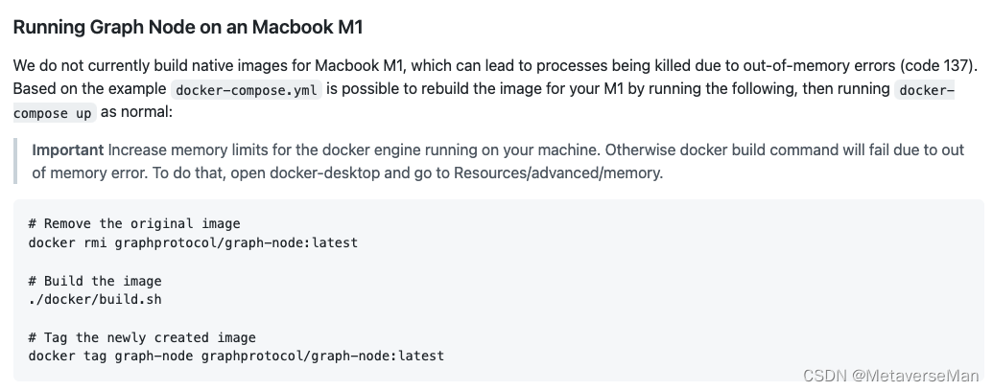

新建一个文件夹，

|  |
| --- |
| Bash git clone https://github.com/graphprotocol/graph-node |

然后进入到docker 目录，按一下步骤进行。

|  |
| --- |
| Bash # Remove the original image docker rmi graphprotocol/graph-node:latest  # Build the image ./docker/build.sh  # Tag the newly created image docker tag graph-node graphprotocol/graph-node:latest |

在进行./docker/build.sh 可能会出现错误，这个时候我是编译出来了两个镜像：没有graph-node

|  |
| --- |
| Bash hanpeng@hanpeng docker % docker images REPOSITORY TAG IMAGE ID CREATED SIZE graph-node-debug latest 21cbe2b289ad 30 minutes ago 3.06GB graph-node-build latest c90de47737e2 32 minutes ago 3.02GB |

但是多试几次，没有报错的时候是三个  
然后将graph-node tag一下（与docker-compose 文件中的services:  
graph-node:  
image: graphprotocol/graph-node  
对应）

|  |
| --- |
| Bash hanpeng@hanpeng docker % docker images REPOSITORY TAG IMAGE ID CREATED SIZE graph-node-debug latest 02367ba98882 2 days ago 3.06GB graph-node latest fcb4f4e89bf1 2 days ago 204MB graphprotocol/graph-node latest fcb4f4e89bf1 2 days ago 204MB graph-node-build latest bb5c56a1ae88 2 days ago 3.02GB |

再然后修改docker-compose文件中

|  |
| --- |
| Bash  ethereum: 'mainnet:http://host.docker.internal:8545' |

改为你要监控的链的rpc节点信息：

|  |
| --- |
| Bash ethereum: 'rangersprotocl:https://robin.rangersprotocol.com/api/jsonrpc' |

在这里是有疑惑的，因为这个配置开头是ethereum，虽然这里说可以任意repalce但是具体怎么replace，哪些是关键字，有没有校验，并没有说明。

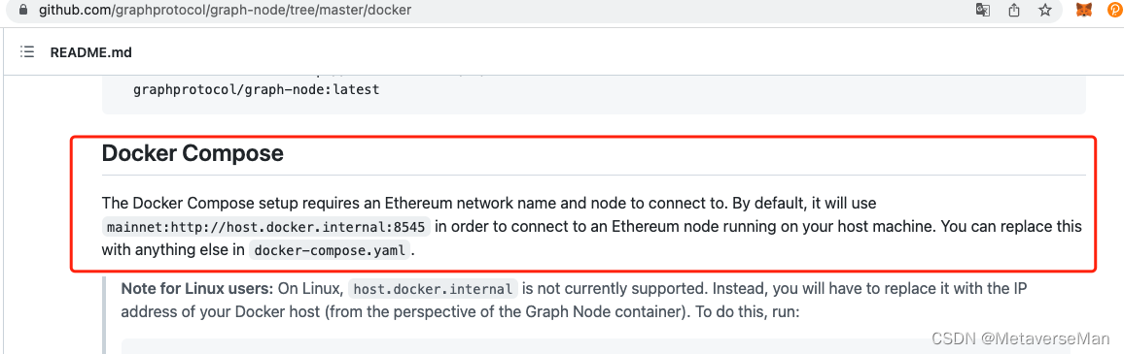

而且后边还有一个rpc节点的名称，不知道怎么填。  
***索性就还按ethereum这样填了,然后后边的rpc节点名称就用我使用的公链名填，还填错了，（我们用的是rangersprotocol，我填的是rangersprotocl,少了一个o，由此可见，这些并没有规定和校验，只是一个用作标识符的名字）***  
***但是你这里怎么填，后边子图的subgraph.yaml要对应上，不然subgraph会找不到thegraph节点***。  
修改结束后，就可以docker-compose up -d 启动了。  
docker-compose ps 看一下：

|  |
| --- |
| Bash hanpeng@hanpeng docker % docker-compose ps  Name Command State Ports  ------------------------------------------------------------------------------------------------------------------------------------------------------------------------------- docker_graph-node_1 /bin/sh -c start Up 0.0.0.0:8000->8000/tcp, 0.0.0.0:8001->8001/tcp, 0.0.0.0:8020->8020/tcp, 0.0.0.0:8030->8030/tcp,   0.0.0.0:8040->8040/tcp  docker_ipfs_1 /sbin/tini -- /usr/local/b ... Up 4001/tcp, 4001/udp, 0.0.0.0:5001->5001/tcp, 8080/tcp, 8081/tcp  docker_postgres_1 docker-entrypoint.sh postg ... Up 0.0.0.0:5432->5432/tcp |

服务都起来了。  
接下来就是将子图部署到graph私有节点了。

**二、准备合约**

* 准备一个合约，将合约编译获得ABI
* 部署合约，获得合约地址

我这里还是用的之前写的game那个合约，参考：[https://github.com/MetaverseMan/contractSample](https://blog.csdn.net/qq_37106501/article/details/126832402?spm=1001.2014.3001.5502)  
将合约部署到你的rpc节点对应的的链上，不要粗心搞错了。

**三、部署子图到私有节点**

1：准备子图  
这里要参考一篇官方文章：<https://thegraph.academy/developers/local-development/>

我们参考文章里的3和5  
graph-cli我已经安装过了，我从3.B开始。

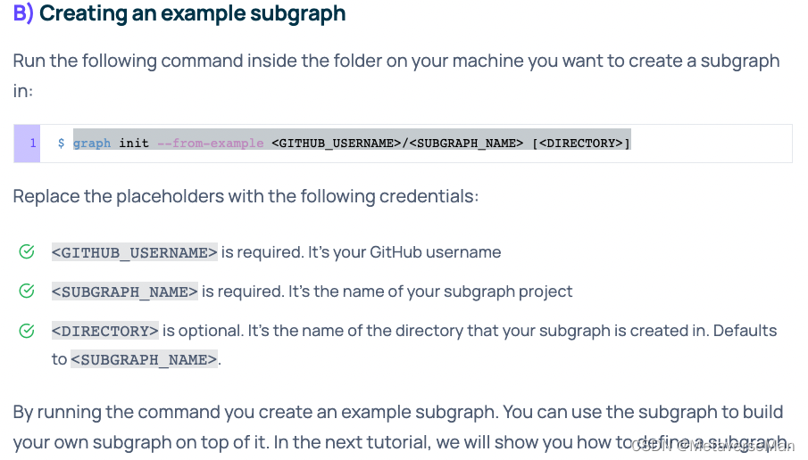

|  |
| --- |
| Bash graph init --from-example MetaverseMan/gameonrangers |

然后修改subgraph.yaml，schema.graphql，package.json这三个文件。（还需要将ABI文件和Game.ts文件复制粘贴到对应目录）  
我这里是用之前已经修改好的文件直接替换了subgraph.yaml和schema.graphql（将原来的重命名为别的），其中subgraph.yaml这里要注意：

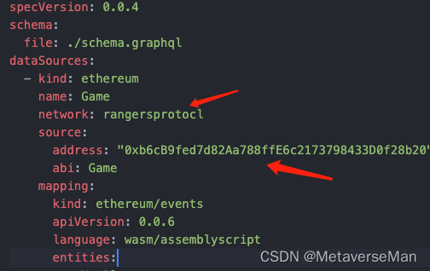

network要和你启动thegraph私有节点的docker-compose文件里网络分类一致，我这里就将错就错，填rangersprotocl。

**一定记得要看一下package.json**

我把这种

|  |
| --- |
| Bash --ipfs https://api.thegraph.com/ipfs/ --node https://api.thegraph.com/deploy/ |

都替换成了对应的

|  |
| --- |
| Bash --ipfs http://127.0.0.1:5001 --node http://127.0.0.1:8020 |

但其实init项目的时候create-local和deploy-local是配置好的，你只要检查下是否是本地的路由和端口。如果不是，修改create-local和deploy-local就行了。  
我的：

|  |
| --- |
| Bash {  "name": "gameonrangers",  "version": "0.1.0",  "scripts": {  "build-contract": "solc contracts/Gravity.sol --abi -o abis --overwrite && solc contracts/Gravity.sol --bin -o bin --overwrite",  "create": "graph create MetaverseMan/gameonrangers --node http://127.0.0.1:8020",  "create-local": "graph create MetaverseMan/gameonrangers --node http://127.0.0.1:8020",  "codegen": "graph codegen",  "build": "graph build",  "deploy": "graph deploy MetaverseMan/gameonrangers --ipfs http://127.0.0.1:5001 --node http://127.0.0.1:8020",  "deploy-local": "graph deploy MetaverseMan/gameonrangers --node http://127.0.0.1:8020 --ipfs http://127.0.0.1:5001"  },  "devDependencies": {  "@graphprotocol/graph-cli": "^0.30.2",  "@graphprotocol/graph-ts": "^0.27.0"  },  "dependencies": {  "babel-polyfill": "^6.26.0",  "babel-register": "^6.26.0",  "truffle": "^5.0.4",  "truffle-contract": "^4.0.5",  "truffle-hdwallet-provider": "^1.0.4"  } } |

修改完成后，就可以部署子图了。

2：部署子图  
在你的子图项目的根目录参考<https://thegraph.academy/developers/local-development/>的5，运行命令行。主要有以下命令

|  |
| --- |
| Bash 1：sed -i -e 's/0x2E645469f354BB4F5c8a05B3b30A929361cf77eC/0xb6cB9fed7d82Aa788ffE6c2173798433D0f28b20/g' subgraph.yaml 2: yarn codegen  3: yarn create-local 4: yarn deploy-local |

也可以在codegen之后加上yarn build

|  |
| --- |
| Bash hanpeng@hanpeng gameonrangers % sed -i -e 's/0x2E645469f354BB4F5c8a05B3b30A929361cf77eC/0xb6cB9fed7d82Aa788ffE6c2173798433D0f28b20/g' subgraph.yaml hanpeng@hanpeng gameonrangers % yarn codegen  yarn run v1.22.18 warning ../../../../package.json: No license field $ graph codegen  Skip migration: Bump mapping apiVersion from 0.0.1 to 0.0.2  Skip migration: Bump mapping apiVersion from 0.0.2 to 0.0.3  Skip migration: Bump mapping apiVersion from 0.0.3 to 0.0.4  Skip migration: Bump mapping apiVersion from 0.0.4 to 0.0.5  Skip migration: Bump mapping apiVersion from 0.0.5 to 0.0.6  Skip migration: Bump manifest specVersion from 0.0.1 to 0.0.2  Skip migration: Bump manifest specVersion from 0.0.2 to 0.0.4 ✔ Apply migrations ✔ Load subgraph from subgraph.yaml  Load contract ABI from abis/Game.json ✔ Load contract ABIs  Generate types for contract ABI: Game (abis/Game.json)  Write types to generated/Game/Game.ts ✔ Generate types for contract ABIs ✔ Generate types for data source templates ✔ Load data source template ABIs ✔ Generate types for data source template ABIs ✔ Load GraphQL schema from schema.graphql  Write types to generated/schema.ts ✔ Generate types for GraphQL schema  Types generated successfully  ✨ Done in 3.01s. hanpeng@hanpeng gameonrangers % yarn create-local yarn run v1.22.18 warning ../../../../package.json: No license field $ graph create MetaverseMan/gameonrangers --node http://127.0.0.1:8020 Created subgraph: MetaverseMan/gameonrangers ✨ Done in 1.68s. hanpeng@hanpeng gameonrangers % yarn deploy-local yarn run v1.22.18 warning ../../../../package.json: No license field $ graph deploy MetaverseMan/gameonrangers --node http://127.0.0.1:8020 --ipfs http://127.0.0.1:5001 ? Version Label (e.g. v0.0.1) › (node:98385) ExperimentalWarning: The Fetch API is an experimental feature. This feature could change at any time (Use `node --trace-warnings ...` to show where the warning was created) ✔ Version Label (e.g. v0.0.1) ·   Skip migration: Bump mapping apiVersion from 0.0.1 to 0.0.2  Skip migration: Bump mapping apiVersion from 0.0.2 to 0.0.3  Skip migration: Bump mapping apiVersion from 0.0.3 to 0.0.4  Skip migration: Bump mapping apiVersion from 0.0.4 to 0.0.5  Skip migration: Bump mapping apiVersion from 0.0.5 to 0.0.6  Skip migration: Bump manifest specVersion from 0.0.1 to 0.0.2  Skip migration: Bump manifest specVersion from 0.0.2 to 0.0.4 ✔ Apply migrations ✔ Load subgraph from subgraph.yaml  Compile data source: Game => build/Game/Game.wasm ✔ Compile subgraph  Copy schema file build/schema.graphql  Write subgraph file build/Game/abis/Game.json  Write subgraph manifest build/subgraph.yaml ✔ Write compiled subgraph to build/  Add file to IPFS build/schema.graphql  .. Qmc8mBqzRArjzreqnyBF4PEargATRKuaLesmGm7vbXALQ8  Add file to IPFS build/Game/abis/Game.json  .. QmapPy7RyHEGVX7Fpp8ZgjdeeDXGN3JA2xnvJzbV78R2rP  Add file to IPFS build/Game/Game.wasm  .. QmdW8vg7vvPJBXnPxx3dQURBdi3Peq3yiKCJSdbYsjdddG ✔ Upload subgraph to IPFS  Build completed: QmQpLfGm4PB1UUDS4f5YB5R8RqCJszR9oiSLBJGgMN2263  Deployed to http://127.0.0.1:8000/subgraphs/name/MetaverseMan/gameonrangers/graphql  Subgraph endpoints: Queries (HTTP): http://127.0.0.1:8000/subgraphs/name/MetaverseMan/gameonrangers  ✨ Done in 121.49s. |

这里有一个小坑：

***在执行yarn deploy-local后，是一个问号开头的log这里需要按一下enter键！！！***

丫的，我以为跟上边一样呢，直接打印执行结果，或者就进入了一个进程，占用了一个窗口。但其实是需要按enter键确认，我每次都是等结果，没反应，然后就ctrl+c结束掉了。  
另外 两个网络的名字一定要一致不然是会有以下错误：

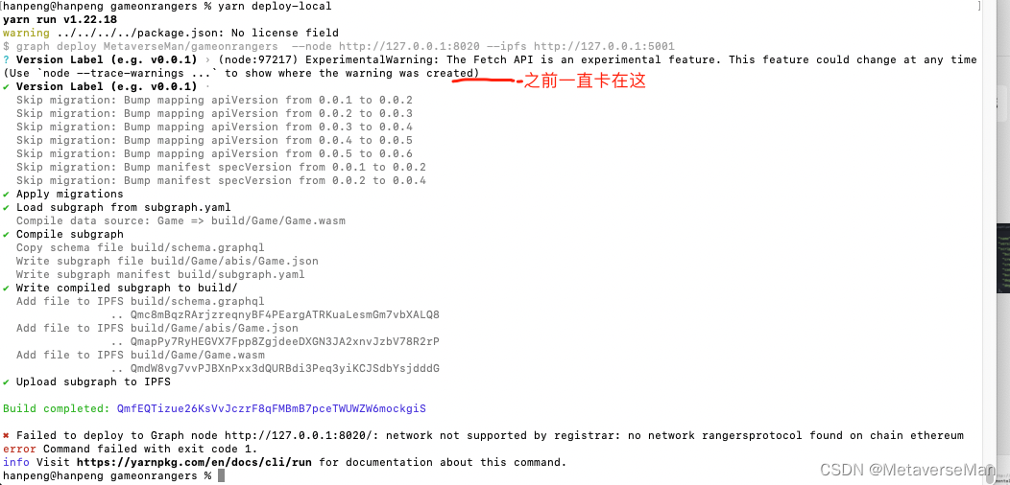

最后终于成功！

|  |
| --- |
| Bash hanpeng@hanpeng gameonrangers % yarn deploy-local yarn run v1.22.18 warning ../../../../package.json: No license field $ graph deploy MetaverseMan/gameonrangers --node http://127.0.0.1:8020 --ipfs http://127.0.0.1:5001 ? Version Label (e.g. v0.0.1) › (node:98385) ExperimentalWarning: The Fetch API is an experimental feature. This feature could change at any time (Use `node --trace-warnings ...` to show where the warning was created) ✔ Version Label (e.g. v0.0.1) ·   Skip migration: Bump mapping apiVersion from 0.0.1 to 0.0.2  Skip migration: Bump mapping apiVersion from 0.0.2 to 0.0.3  Skip migration: Bump mapping apiVersion from 0.0.3 to 0.0.4  Skip migration: Bump mapping apiVersion from 0.0.4 to 0.0.5  Skip migration: Bump mapping apiVersion from 0.0.5 to 0.0.6  Skip migration: Bump manifest specVersion from 0.0.1 to 0.0.2  Skip migration: Bump manifest specVersion from 0.0.2 to 0.0.4 ✔ Apply migrations ✔ Load subgraph from subgraph.yaml  Compile data source: Game => build/Game/Game.wasm ✔ Compile subgraph  Copy schema file build/schema.graphql  Write subgraph file build/Game/abis/Game.json  Write subgraph manifest build/subgraph.yaml ✔ Write compiled subgraph to build/  Add file to IPFS build/schema.graphql  .. Qmc8mBqzRArjzreqnyBF4PEargATRKuaLesmGm7vbXALQ8  Add file to IPFS build/Game/abis/Game.json  .. QmapPy7RyHEGVX7Fpp8ZgjdeeDXGN3JA2xnvJzbV78R2rP  Add file to IPFS build/Game/Game.wasm  .. QmdW8vg7vvPJBXnPxx3dQURBdi3Peq3yiKCJSdbYsjdddG ✔ Upload subgraph to IPFS  Build completed: QmQpLfGm4PB1UUDS4f5YB5R8RqCJszR9oiSLBJGgMN2263  Deployed to http://127.0.0.1:8000/subgraphs/name/MetaverseMan/gameonrangers/graphql  Subgraph endpoints: Queries (HTTP): http://127.0.0.1:8000/subgraphs/name/MetaverseMan/gameonrangers  ✨ Done in 121.49s. |

docker-compose logs -f 日志如下：

|  |
| --- |
| Bash graph-node_1 | Sep 21 08:13:10.888 INFO Syncing 2 blocks from Ethereum, code: BlockIngestionStatus, blocks_needed: 2, blocks_behind: 2, latest_block_head: 23801503, current_block_head: 23801501, provider: rangersprotocl-rpc-0, component: BlockIngestor graph-node_1 | Sep 21 08:13:12.879 INFO Syncing 2 blocks from Ethereum, code: BlockIngestionStatus, blocks_needed: 2, blocks_behind: 2, latest_block_head: 23801505, current_block_head: 23801503, provider: rangersprotocl-rpc-0, component: BlockIngestor graph-node_1 | Sep 21 08:13:14.007 INFO Resolve schema, link: /ipfs/Qmc8mBqzRArjzreqnyBF4PEargATRKuaLesmGm7vbXALQ8, sgd: 0, subgraph_id: QmQpLfGm4PB1UUDS4f5YB5R8RqCJszR9oiSLBJGgMN2263, component: SubgraphRegistrar graph-node_1 | Sep 21 08:13:14.008 INFO Resolve data source, source_start_block: 0, source_address: Some(0xb6cb9fed7d82aa788ffe6c2173798433d0f28b20), name: Game, sgd: 0, subgraph_id: QmQpLfGm4PB1UUDS4f5YB5R8RqCJszR9oiSLBJGgMN2263, component: SubgraphRegistrar graph-node_1 | Sep 21 08:13:14.008 INFO Resolve mapping, link: /ipfs/QmdW8vg7vvPJBXnPxx3dQURBdi3Peq3yiKCJSdbYsjdddG, sgd: 0, subgraph_id: QmQpLfGm4PB1UUDS4f5YB5R8RqCJszR9oiSLBJGgMN2263, component: SubgraphRegistrar graph-node_1 | Sep 21 08:13:14.008 INFO Resolve ABI, link: /ipfs/QmapPy7RyHEGVX7Fpp8ZgjdeeDXGN3JA2xnvJzbV78R2rP, name: Game, sgd: 0, subgraph_id: QmQpLfGm4PB1UUDS4f5YB5R8RqCJszR9oiSLBJGgMN2263, component: SubgraphRegistrar graph-node_1 | Sep 21 08:13:14.013 INFO Set subgraph start block, block: None, sgd: 0, subgraph_id: QmQpLfGm4PB1UUDS4f5YB5R8RqCJszR9oiSLBJGgMN2263, component: SubgraphRegistrar graph-node_1 | Sep 21 08:13:14.013 INFO Graft base, block: None, base: None, sgd: 0, subgraph_id: QmQpLfGm4PB1UUDS4f5YB5R8RqCJszR9oiSLBJGgMN2263, component: SubgraphRegistrar graph-node_1 | Sep 21 08:13:14.714 INFO Starting subgraph writer, queue_size: 5, sgd: 1, subgraph_id: QmQpLfGm4PB1UUDS4f5YB5R8RqCJszR9oiSLBJGgMN2263, component: SubgraphInstanceManager graph-node_1 | Sep 21 08:13:14.732 INFO Resolve subgraph files using IPFS, sgd: 1, subgraph_id: QmQpLfGm4PB1UUDS4f5YB5R8RqCJszR9oiSLBJGgMN2263, component: SubgraphInstanceManager graph-node_1 | Sep 21 08:13:14.732 INFO Resolve schema, link: /ipfs/Qmc8mBqzRArjzreqnyBF4PEargATRKuaLesmGm7vbXALQ8, sgd: 1, subgraph_id: QmQpLfGm4PB1UUDS4f5YB5R8RqCJszR9oiSLBJGgMN2263, component: SubgraphInstanceManager graph-node_1 | Sep 21 08:13:14.733 INFO Resolve data source, source_start_block: 0, source_address: Some(0xb6cb9fed7d82aa788ffe6c2173798433d0f28b20), name: Game, sgd: 1, subgraph_id: QmQpLfGm4PB1UUDS4f5YB5R8RqCJszR9oiSLBJGgMN2263, component: SubgraphInstanceManager graph-node_1 | Sep 21 08:13:14.733 INFO Resolve mapping, link: /ipfs/QmdW8vg7vvPJBXnPxx3dQURBdi3Peq3yiKCJSdbYsjdddG, sgd: 1, subgraph_id: QmQpLfGm4PB1UUDS4f5YB5R8RqCJszR9oiSLBJGgMN2263, component: SubgraphInstanceManager graph-node_1 | Sep 21 08:13:14.733 INFO Resolve ABI, link: /ipfs/QmapPy7RyHEGVX7Fpp8ZgjdeeDXGN3JA2xnvJzbV78R2rP, name: Game, sgd: 1, subgraph_id: QmQpLfGm4PB1UUDS4f5YB5R8RqCJszR9oiSLBJGgMN2263, component: SubgraphInstanceManager graph-node_1 | Sep 21 08:13:14.734 INFO Successfully resolved subgraph files using IPFS, sgd: 1, subgraph_id: QmQpLfGm4PB1UUDS4f5YB5R8RqCJszR9oiSLBJGgMN2263, component: SubgraphInstanceManager graph-node_1 | Sep 21 08:13:14.734 INFO Data source count at start: 1, sgd: 1, subgraph_id: QmQpLfGm4PB1UUDS4f5YB5R8RqCJszR9oiSLBJGgMN2263, component: SubgraphInstanceManager graph-node_1 | Sep 21 08:13:14.870 INFO Syncing 2 blocks from Ethereum, code: BlockIngestionStatus, blocks_needed: 2, blocks_behind: 2, latest_block_head: 23801507, current_block_head: 23801505, provider: rangersprotocl-rpc-0, component: BlockIngestor graph-node_1 | Sep 21 08:13:15.857 INFO Scanning blocks [0, 0], range_size: 1, sgd: 1, subgraph_id: QmQpLfGm4PB1UUDS4f5YB5R8RqCJszR9oiSLBJGgMN2263, component: BlockStream graph-node_1 | Sep 21 08:13:17.478 INFO Syncing 2 blocks from Ethereum, code: BlockIngestionStatus, blocks_needed: 2, blocks_behind: 2, latest_block_head: 23801509, current_block_head: 23801507, provider: rangersprotocl-rpc-0, component: BlockIngestor |

在这Queries (HTTP): http://127.0.0.1:8000/subgraphs/name/MetaverseMan/gameonrangers  
去查显示还未同步

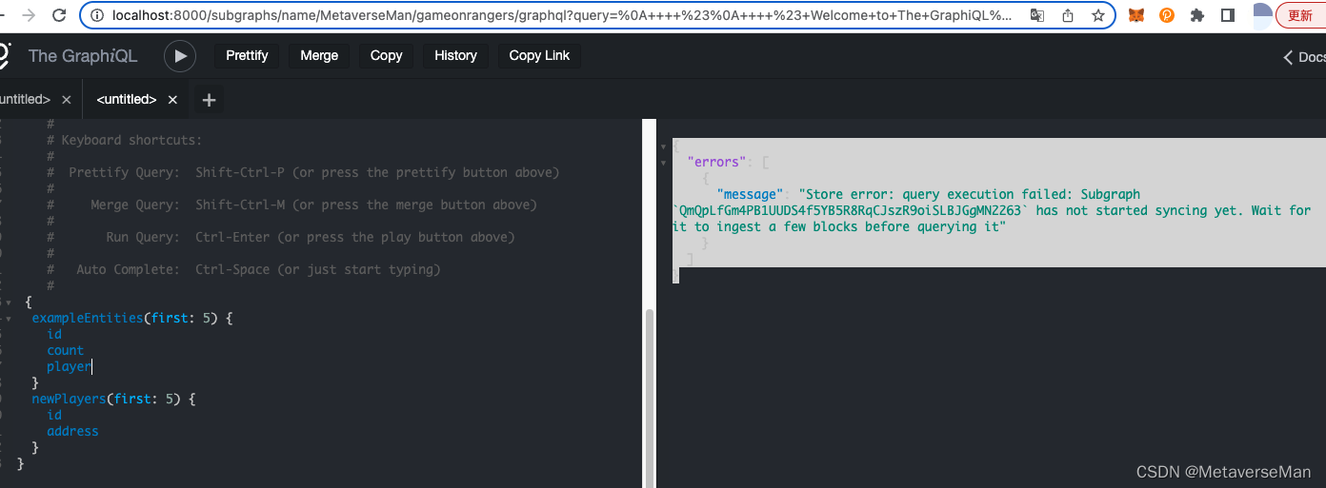

等了两个小时还是未同步，看来还是有毛病。。。  
另外：你的合约部署的块的高度一定要大于你私有节点同步的起始高度。也就是必须要先部署私有节点然后再部署合约，因为私有节点不会同步你部署之前的区块，可以看这个github issue:[subgraph can't fetch history block #3793](https://github.com/graphprotocol/graph-node/issues/3793)  
其实可以通过docker-compose logs 很容易看到私有节点同步的起始节点和正在同步的进度。

日志里已经开始块同步了 但是查不到



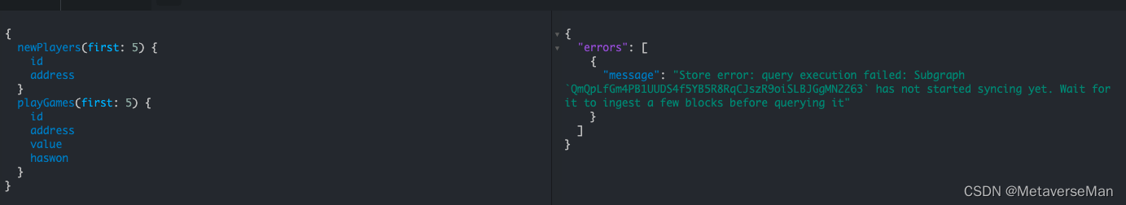

本来感觉[0,0]不对  
但是找到了这个说是对的 <https://docs.skale.network/develop/using-graph>

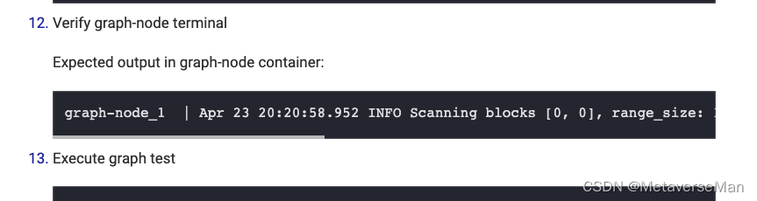

docker-compose logs -f | grep Scanning  
查看一下同步的日志

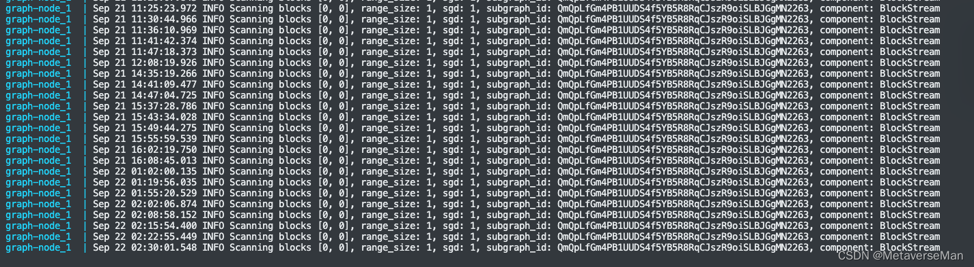

明明有同步，却还是查不到数据

------------------------分割线-------------------------------------------------

成功了, 事实证明不是部署上的错误，是链的RPC节点可能有点问题！而且[0,0]是不对的！应该是增长的。  
经过几次略微调整我认为可能不对的点，重新部署之前的rangers链后，还是不对 !  
于是我决定换条链试试，我把合约部署在了 rinkeby测试网，节点选用infura的，

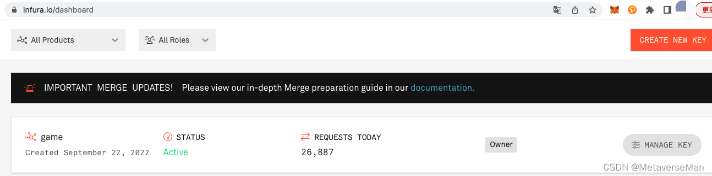

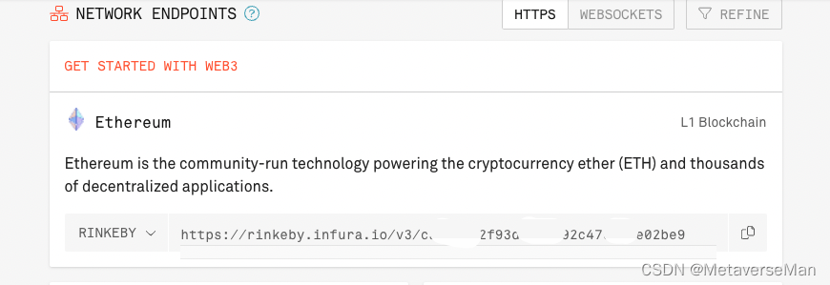

|  |
| --- |
| Bash https://rinkeby.infura.io/v3/<your infura api key> |

然后还是按着以上步骤进行了部署，但是thegraph节点，不用重新部署了，直接

|  |
| --- |
| Bash docker-compose down vim docker-compose.yml (修改这行：ethereum: 'rinkeby:https://rinkeby.infura.io/v3/<your infura api key>') docker-compose up -d |

然后参考以上将子图部署到私有节点上。

|  |
| --- |
| Bash graph-node_1 | Sep 22 08:19:00.563 INFO Received subgraph_deploy request, params: SubgraphDeployParams { name: SubgraphName("MetaverseMan/Game"), ipfs_hash: DeploymentHash("QmaKiVgqUe29bhNm8ZJ5EpbosyjaTNQBaKH9hMmrXjeV5F"), node_id: None, debug_fork: None }, component: JsonRpcServer graph-node_1 | Sep 22 08:19:05.581 INFO Resolve schema, link: /ipfs/QmdKLtNAeVDpuKL1yYEQHn7Bdh7iqjbVHtsgwHL9GTobBu, sgd: 0, subgraph_id: QmaKiVgqUe29bhNm8ZJ5EpbosyjaTNQBaKH9hMmrXjeV5F, component: SubgraphRegistrar graph-node_1 | Sep 22 08:19:05.582 INFO Resolve data source, source_start_block: 0, source_address: Some(0xc716e9df2bb6b6b5b3660f4d210d222e952abfce), name: Game, sgd: 0, subgraph_id: QmaKiVgqUe29bhNm8ZJ5EpbosyjaTNQBaKH9hMmrXjeV5F, component: SubgraphRegistrar graph-node_1 | Sep 22 08:19:05.583 INFO Resolve mapping, link: /ipfs/QmcmqtAfWdyR2ZdtmpEKtRQDwzrCPw7U2c8woJyZad7b3P, sgd: 0, subgraph_id: QmaKiVgqUe29bhNm8ZJ5EpbosyjaTNQBaKH9hMmrXjeV5F, component: SubgraphRegistrar graph-node_1 | Sep 22 08:19:05.583 INFO Resolve ABI, link: /ipfs/QmapPy7RyHEGVX7Fpp8ZgjdeeDXGN3JA2xnvJzbV78R2rP, name: Game, sgd: 0, subgraph_id: QmaKiVgqUe29bhNm8ZJ5EpbosyjaTNQBaKH9hMmrXjeV5F, component: SubgraphRegistrar graph-node_1 | Sep 22 08:19:05.594 INFO Set subgraph start block, block: None, sgd: 0, subgraph_id: QmaKiVgqUe29bhNm8ZJ5EpbosyjaTNQBaKH9hMmrXjeV5F, component: SubgraphRegistrar graph-node_1 | Sep 22 08:19:05.594 INFO Graft base, block: None, base: None, sgd: 0, subgraph_id: QmaKiVgqUe29bhNm8ZJ5EpbosyjaTNQBaKH9hMmrXjeV5F, component: SubgraphRegistrar graph-node_1 | Sep 22 08:19:06.255 INFO Starting subgraph writer, queue_size: 5, sgd: 1, subgraph_id: QmaKiVgqUe29bhNm8ZJ5EpbosyjaTNQBaKH9hMmrXjeV5F, component: SubgraphInstanceManager graph-node_1 | Sep 22 08:19:06.266 INFO Resolve subgraph files using IPFS, sgd: 1, subgraph_id: QmaKiVgqUe29bhNm8ZJ5EpbosyjaTNQBaKH9hMmrXjeV5F, component: SubgraphInstanceManager graph-node_1 | Sep 22 08:19:06.266 INFO Resolve schema, link: /ipfs/QmdKLtNAeVDpuKL1yYEQHn7Bdh7iqjbVHtsgwHL9GTobBu, sgd: 1, subgraph_id: QmaKiVgqUe29bhNm8ZJ5EpbosyjaTNQBaKH9hMmrXjeV5F, component: SubgraphInstanceManager graph-node_1 | Sep 22 08:19:06.266 INFO Resolve data source, source_start_block: 0, source_address: Some(0xc716e9df2bb6b6b5b3660f4d210d222e952abfce), name: Game, sgd: 1, subgraph_id: QmaKiVgqUe29bhNm8ZJ5EpbosyjaTNQBaKH9hMmrXjeV5F, component: SubgraphInstanceManager graph-node_1 | Sep 22 08:19:06.267 INFO Resolve mapping, link: /ipfs/QmcmqtAfWdyR2ZdtmpEKtRQDwzrCPw7U2c8woJyZad7b3P, sgd: 1, subgraph_id: QmaKiVgqUe29bhNm8ZJ5EpbosyjaTNQBaKH9hMmrXjeV5F, component: SubgraphInstanceManager graph-node_1 | Sep 22 08:19:06.267 INFO Resolve ABI, link: /ipfs/QmapPy7RyHEGVX7Fpp8ZgjdeeDXGN3JA2xnvJzbV78R2rP, name: Game, sgd: 1, subgraph_id: QmaKiVgqUe29bhNm8ZJ5EpbosyjaTNQBaKH9hMmrXjeV5F, component: SubgraphInstanceManager graph-node_1 | Sep 22 08:19:06.268 INFO Successfully resolved subgraph files using IPFS, sgd: 1, subgraph_id: QmaKiVgqUe29bhNm8ZJ5EpbosyjaTNQBaKH9hMmrXjeV5F, component: SubgraphInstanceManager graph-node_1 | Sep 22 08:19:06.268 INFO Data source count at start: 1, sgd: 1, subgraph_id: QmaKiVgqUe29bhNm8ZJ5EpbosyjaTNQBaKH9hMmrXjeV5F, component: SubgraphInstanceManager graph-node_1 | Sep 22 08:19:06.520 INFO Scanning blocks [0, 0], range_size: 1, sgd: 1, subgraph_id: QmaKiVgqUe29bhNm8ZJ5EpbosyjaTNQBaKH9hMmrXjeV5F, component: BlockStream graph-node_1 | Sep 22 08:19:07.216 INFO Scanning blocks [1, 10], range_size: 10, sgd: 1, subgraph_id: QmaKiVgqUe29bhNm8ZJ5EpbosyjaTNQBaKH9hMmrXjeV5F, component: BlockStream graph-node_1 | Sep 22 08:19:07.915 INFO Scanning blocks [11, 110], range_size: 100, sgd: 1, subgraph_id: QmaKiVgqUe29bhNm8ZJ5EpbosyjaTNQBaKH9hMmrXjeV5F, component: BlockStream graph-node_1 | Sep 22 08:19:08.605 INFO Scanning blocks [111, 1110], range_size: 1000, sgd: 1, subgraph_id: QmaKiVgqUe29bhNm8ZJ5EpbosyjaTNQBaKH9hMmrXjeV5F, component: BlockStream graph-node_1 | Sep 22 08:19:09.310 INFO Scanning blocks [1111, 3110], range_size: 2000, sgd: 1, subgraph_id: QmaKiVgqUe29bhNm8ZJ5EpbosyjaTNQBaKH9hMmrXjeV5F, component: BlockStream graph-node_1 | Sep 22 08:19:10.000 INFO Scanning blocks [3111, 5110], range_size: 2000, sgd: 1, subgraph_id: QmaKiVgqUe29bhNm8ZJ5EpbosyjaTNQBaKH9hMmrXjeV5F, component: BlockStream graph-node_1 | Sep 22 08:19:10.763 INFO Scanning blocks [5111, 7110], range_size: 2000, sgd: 1, subgraph_id: QmaKiVgqUe29bhNm8ZJ5EpbosyjaTNQBaKH9hMmrXjeV5F, component: BlockStream graph-node_1 | Sep 22 08:19:11.463 INFO Scanning blocks [7111, 9110], range_size: 2000, sgd: 1, subgraph_id: QmaKiVgqUe29bhNm8ZJ5EpbosyjaTNQBaKH9hMmrXjeV5F, component: BlockStream graph-node_1 | Sep 22 08:19:12.190 INFO Scanning blocks [9111, 11110], range_size: 2000, sgd: 1, subgraph_id: QmaKiVgqUe29bhNm8ZJ5EpbosyjaTNQBaKH9hMmrXjeV5F, component: BlockStream graph-node_1 | Sep 22 08:19:12.900 INFO Scanning blocks [11111, 13110], range_size: 2000, sgd: 1, subgraph_id: QmaKiVgqUe29bhNm8ZJ5EpbosyjaTNQBaKH9hMmrXjeV5F, component: BlockStream graph-node_1 | Sep 22 08:19:13.603 INFO Scanning blocks [13111, 15110], range_size: 2000, sgd: 1, subgraph_id: QmaKiVgqUe29bhNm8ZJ5EpbosyjaTNQBaKH9hMmrXjeV5F, component: BlockStream graph-node_1 | Sep 22 08:19:14.296 INFO Scanning blocks [15111, 17110], range_size: 2000, sgd: 1, subgraph_id: QmaKiVgqUe29bhNm8ZJ5EpbosyjaTNQBaKH9hMmrXjeV5F, component: BlockStream |

看到扫块的个数是增长的，不是[0,0].......这里也被那篇文章误导了，以为[0,0]是正常状态，其实想想也应该是有增长的。  
这个时候再去面板查询就已经不是query execution failed: Subgraph has not started syncing yet 了，而是正常的展示，没报错。  
现在还没同步完，我的合约在11423609块上，目前看还得同步个个把小时。一会好了查查看。对了，这个scanning是从0块开始扫的，syncing是从你部署的时候的高度开始同步的。

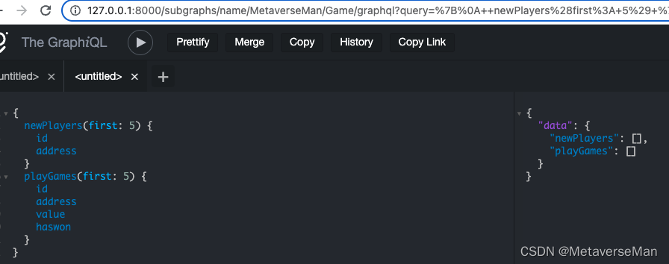

----------------------------------分割线---------------------------

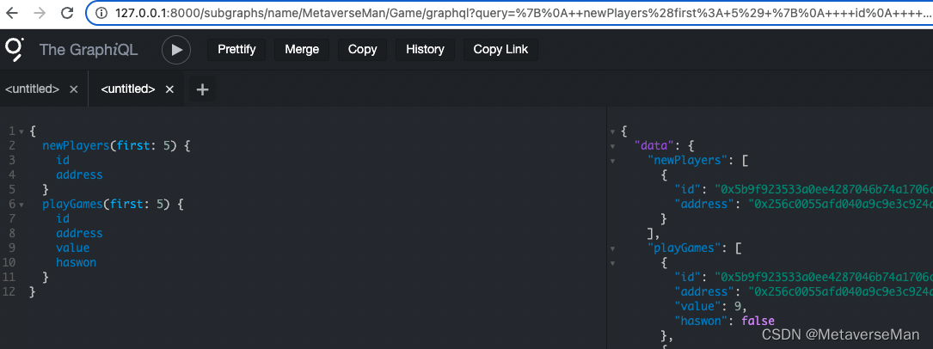

同步完了。查询功能正常使用。