Tried the trade network form 1915 to 2014. Consider q=2 or q=3 clusters, the likelihood versus the year is shown below:

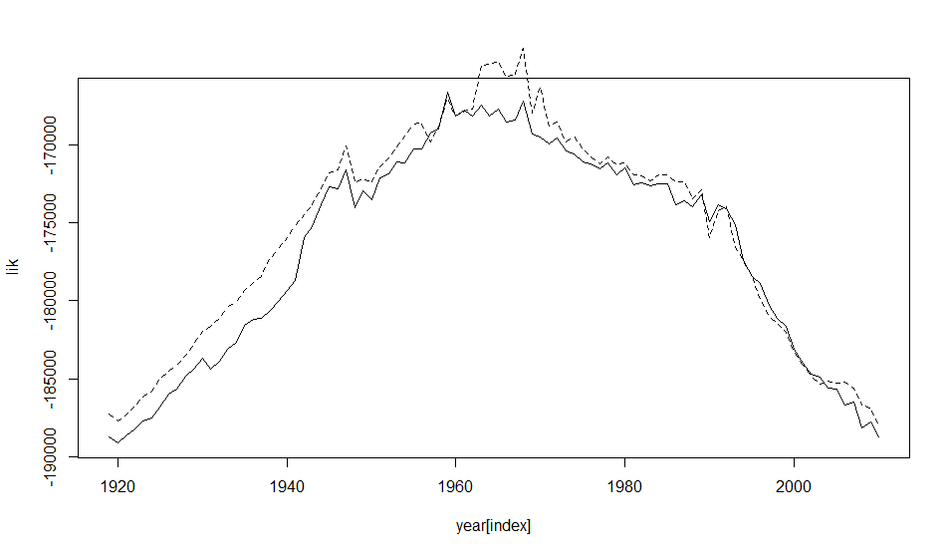

For q=2 (solid line), the change point which maximizes the likelihood is 1959;

For q=3 (dashed line), the change point is 1968.

For q=2, before and after change point, we observe the following membership switch:

From rich country cluster to poor country cluster:

[1] "Cuba" "Haiti" "Dominican Republic" "Mexico" "Guatemala" "Honduras" "El Salvador"

[8] "Nicaragua" "Costa Rica" "Panama" "Venezuela" "Ecuador" "Bolivia" "Paraguay"

[15] "Chile" "Uruguay" "Germany" "Czechoslovakia" "Albania" "Bulgaria" "Estonia"

[22] "Latvia" "Lithuania" "Ethiopia" "Iran"

From poor country cluster to rich country cluster:

[1] "Luxembourg" "Czech Republic" "Slovakia" "Croatia" "Slovenia" "Cyprus" "Ukraine" "Ghana"

[9] "Morocco" "Lebanon" "Israel" "Saudi Arabia" "India" "Pakistan" "Bangladesh" "Sri Lanka"

[17] "Philippines" "Indonesia"

For rich country maintain unchanged:

[1] "United States of America" "Canada" "Colombia" "Peru" "Brazil"

[6] "Argentina" "United Kingdom" "Ireland" "Netherlands" "Belgium"

[11] "France" "Switzerland" "Spain" "Portugal" "Poland"

[16] "Austria" "Hungary" "Italy" "Yugoslavia" "Greece"

[21] "Romania" "Russia" "Finland" "Sweden" "Norway"

[26] "Denmark" "South Africa" "Turkey" "Egypt" "China"

[31] "Japan" "Thailand" "Australia" "New Zealand"

Poor country cluster is very large and I didn’t report here. Among them include N and S Korea, Malaysia and Singapore. I guess mainly because these countries just gained independence and a lot of complications are there.

|  |  |
| --- | --- |
| Before change | [,1] [,2] [,3] [,4] [,5] [,6] [,7] [,8]  [1,] 0.0004827925 0.003572175 3.18783e-05 0.0000974632 0.1235154 0.1006150 0.006953954 0.002573598  [2,] 0.0000000000 0.074455291 0.00000e+00 0.0012391854 0.0000000 0.1037913 0.000000000 0.001699515  > |
| After change | [,1] [,2] [,3] [,4] [,5] [,6] [,7] [,8]  [1,] 0.06295356 0.08135524 0.002662638 0.0006068453 0.00799453 0.07018049 0.0003497969 0.0005267163  [2,] 0.00000000 0.03438848 0.000000000 0.0002539770 0.00000000 0.14138801 0.0000000000 0.0009835904 |

These are estimated theta (SE) and eta (SE).

For q=3:

1. Rich country cluster: (the same before and after change point)

[1] "United States of America" "Canada" "United Kingdom"

[4] "Netherlands" "Belgium" "France"

[7] "Switzerland" "Spain" "Austria"

[10] "Italy" "Greece" "Sweden"

[13] "Norway" "Denmark" "Japan"

2. Poor country cluster (cluster size 110)

3. intermediate coutry: (the same before and after change point)

[1] "Dominican Republic" "Mexico" "Guatemala" "Honduras"

[5] "El Salvador" "Nicaragua" "Costa Rica" "Panama"

[9] "Colombia" "Venezuela" "Ecuador" "Brazil"

[13] "Bolivia" "Paraguay" "Chile" "Uruguay"

[17] "Hungary" "Bulgaria" "Romania" "Russia"

[21] "Latvia" "Ethiopia" "South Africa" "Turkey"

[25] "China" "Thailand" "New Zealand"

Then member switch after change point for the following countries:

From 1 to 2:

[1] "Germany" "Yugoslavia"

From 1 to 3:

[1] "Cuba" "Peru" "Argentina" "Poland" "Czechoslovakia"

From 2 to 1:

[1] "Luxembourg" "India" "Pakistan" "Singapore" "Australia"

From 2 to 3:

[1] "Jamaica" "Trinidad and Tobago" "Guyana"

[4] "German Democratic Republic" "Malta" "Cyprus"

[7] "Iceland" "Senegal" "Ivory Coast"

[10] "Ghana" "Cameroon" "Nigeria"

[13] "Congo" "Kenya" "Tanzania"

[16] "Zambia" "Malawi" "Madagascar"

[19] "Mauritius" "Morocco" "Algeria"

[22] "Tunisia" "Sudan" "Iran"

[25] "Egypt" "Lebanon" "Israel"

[28] "Saudi Arabia" "Taiwan" "South Korea"

[31] "Sri Lanka" "Malaysia" "Philippines"

[34] "Indonesia"

From 3 to 1:

[1] "Ireland" "Portugal" "Finland"

From 3 to 2:

[1] "Haiti" "Albania" "Lithuania" "Afghanistan"

|  |  |
| --- | --- |
| Before change | [,1] [,2] [,3] [,4] [,5] [,6] [,7] [,8]  [1,] 0.04013204 0.005768328 0.10912118 0.001252442 0.0001475088 0.0023772596 0.1712806 0.1494433  [2,] 0.00000000 0.002494125 0.01164676 0.000000000 0.0000651705 0.0002801179 0.0000000 0.1455586  [3,] 0.00000000 0.000000000 0.12723164 0.000000000 0.0000000000 0.0059280333 0.0000000 0.0000000  [,9] [,10] [,11] [,12]  [1,] 0.08076884 0.004962026 0.003505624 0.001787657  [2,] 0.05578658 0.000000000 0.003452764 0.001307004  [3,] 0.04303059 0.000000000 0.000000000 0.002100999 |
| After change | [,1] [,2] [,3] [,4] [,5] [,6] [,7] [,8]  [1,] 0.02409616 0.06306614 0.068724655 0.0002984915 0.000514352 0.001405648 0.1475694 0.10906543  [2,] 0.00000000 0.17331586 0.117520443 0.0000000000 0.002308626 0.007065323 0.0000000 0.06476495  [3,] 0.00000000 0.00000000 0.007285974 0.0000000000 0.000000000 0.004097982 0.0000000 0.00000000  [,9] [,10] [,11] [,12]  [1,] 0.0245069148 0.00170551 0.0008671110 0.0005136817  [2,] 0.0035006895 0.00000000 0.0009180274 0.0002267199  [3,] 0.0001761571 0.00000000 0.0000000000 0.0001236517 |

**New results on Aug 28:**

The following plot shows the edge time series:

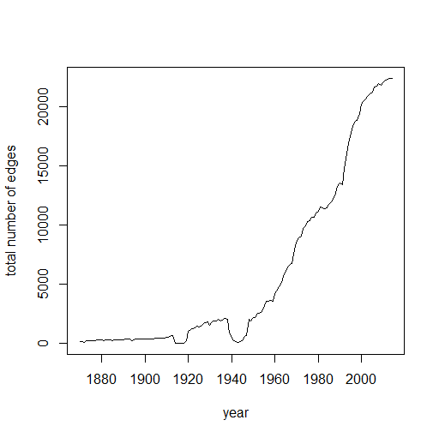

So it may only be of interest to consider trading after 1960s.

Now we consider from 1950 to 2014. The following is likelihood function corresponding to different years as change points.

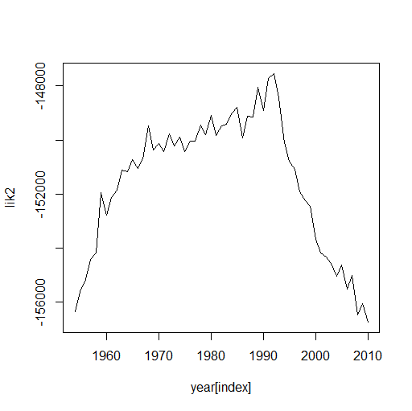

The best change point is 1992.

The two clusters have notable membership switch after 1992.

For cluster 1 with rich countries, the following remain in the same cluster:

[1] "United States of America" "Canada"

[3] "United Kingdom" "Ireland"

[5] "Netherlands" "Belgium"

[7] "Luxembourg" "France"

[9] "Switzerland" "Spain"

[11] "Portugal" "Italy"

[13] "Greece" "Finland"

[15] "Sweden" "Norway"

[17] "Denmark" "Turkey"

[19] "Egypt" "India"

[21] "Bangladesh" "Thailand"

[23] "Malaysia" "Philippines"

[25] "Australia"

After 1992, the following 47 countries join the first cluster, including Asian and East European countries.

[1] "Costa Rica" "Colombia" "Ecuador"

[4] "Peru" "Brazil" "Bolivia"

[7] "Chile" "Argentina" "Uruguay"

[10] "Germany" "Poland" "Austria"

[13] "Hungary" "Czech Republic" "Slovakia"

[16] "Malta" "Slovenia" "Cyprus"

[19] "Bulgaria" "Romania" "Russia"

[22] "Ukraine" "Iceland" "Ivory Coast"

[25] "Kenya" "Zimbabwe" "South Africa"

[28] "Madagascar" "Morocco" "Algeria"

[31] "Tunisia" "Lebanon" "Jordan"

[34] "Israel" "Saudi Arabia" "Bahrain"

[37] "United Arab Emirates" "Oman" "China"

[40] "Taiwan" "South Korea" "Japan"

[43] "Pakistan" "Sri Lanka" "Singapore"

[46] "Indonesia" "New Zealand"

One country move from cluster 1 to 2:

[1] "Yugoslavia"

The other 132 poor countries remain in cluster 2.

This change point may mark the beginning of globalization process:

Some interpretation for Globalization in the 1990s

With the collapse of the Soviet Union in 1989 and the end of the [Cold War](https://www.khanacademy.org/humanities/ap-us-history/period-8/apush-postwar-era/v/origins-of-the-cold-war) in 1991, the world became more interconnected. This is because the communist bloc countries, which had previously been intentionally isolated from the capitalist West, began to integrate into the global market economy. Trade and investment increased, while barriers to migration and to cultural exchange were lowered.

Network at 2014: (after change)

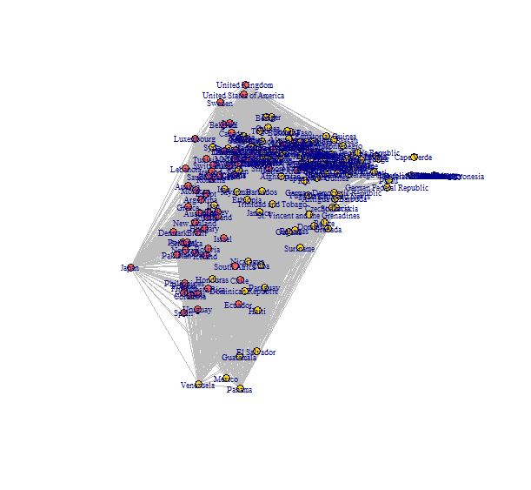

Network at 1980: (before change)

