The following plot shows the edge time series:

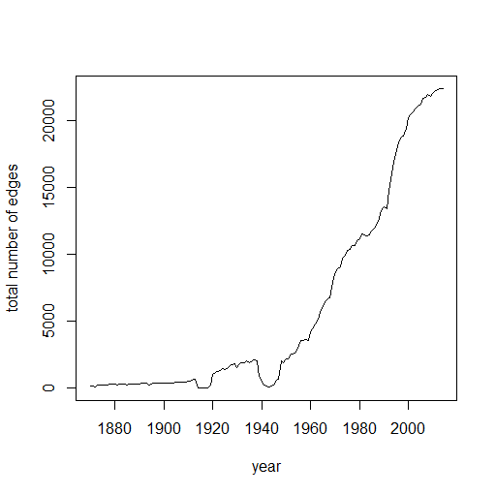

So it may only be of interest to consider trading after 1960s.

Now we consider from 1950 to 2014. The following is likelihood function corresponding to different years as change points.

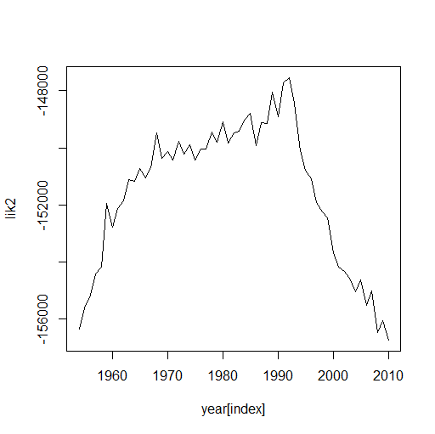

The best change point is 1992.

The two clusters have notable membership switch after 1992.

For cluster 1 with rich countries, the following remain in the same cluster:

[1] "United States of America" "Canada"

[3] "United Kingdom" "Ireland"

[5] "Netherlands" "Belgium"

[7] "Luxembourg" "France"

[9] "Switzerland" "Spain"

[11] "Portugal" "Italy"

[13] "Greece" "Finland"

[15] "Sweden" "Norway"

[17] "Denmark" "Turkey"

[19] "Egypt" "India"

[21] "Bangladesh" "Thailand"

[23] "Malaysia" "Philippines"

[25] "Australia"

After 1992, the following 47 countries join the first cluster, including Asian and East European countries.

[1] "Costa Rica" "Colombia" "Ecuador"

[4] "Peru" "Brazil" "Bolivia"

[7] "Chile" "Argentina" "Uruguay"

[10] "Germany" "Poland" "Austria"

[13] "Hungary" "Czech Republic" "Slovakia"

[16] "Malta" "Slovenia" "Cyprus"

[19] "Bulgaria" "Romania" "Russia"

[22] "Ukraine" "Iceland" "Ivory Coast"

[25] "Kenya" "Zimbabwe" "South Africa"

[28] "Madagascar" "Morocco" "Algeria"

[31] "Tunisia" "Lebanon" "Jordan"

[34] "Israel" "Saudi Arabia" "Bahrain"

[37] "United Arab Emirates" "Oman" "China"

[40] "Taiwan" "South Korea" "Japan"

[43] "Pakistan" "Sri Lanka" "Singapore"

[46] "Indonesia" "New Zealand"

One country move from cluster 1 to 2:

[1] "Yugoslavia"

The other 132 poor countries remain in cluster 2.

This change point may mark the beginning of globalization process:

Some interpretation for Globalization in the 1990s

With the collapse of the Soviet Union in 1989 and the end of the [Cold War](https://www.khanacademy.org/humanities/ap-us-history/period-8/apush-postwar-era/v/origins-of-the-cold-war) in 1991, the world became more interconnected. This is because the communist bloc countries, which had previously been intentionally isolated from the capitalist West, began to integrate into the global market economy. Trade and investment increased, while barriers to migration and to cultural exchange were lowered.

Network at 2014: (after change)

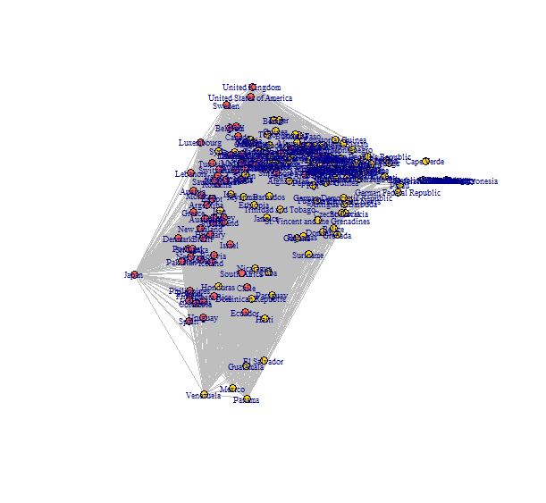

Network at 1980: (before change)

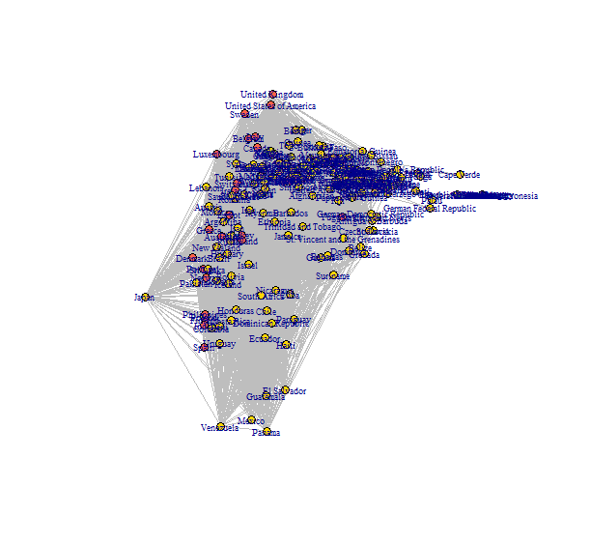

Additional layout:

layout_with_kk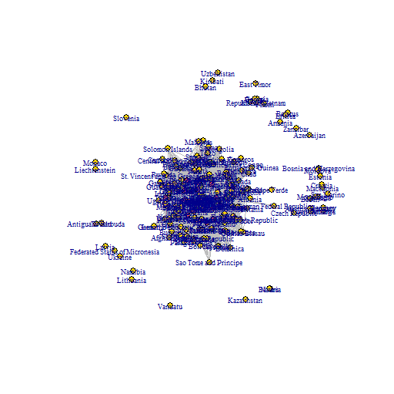

layout=layout_with_mds

