**Mete Uz**

**60353**

**Engr421**

**Homework 1**

**Data Generation:** I generated points with similar implementation used in lab sessions. Then I put all points into a data matrix and generated a vector of corresponding labels.

**Estimations:** I calculated the mean of each feature of each observation of each class separately using numpy.mean. Which gave me 2 vectors of means for the features of each class. Vertically stacking the mean vectors gave me an output similar expected output. For covariances i used the numpy.cov function and put each resulting matrix into a 3 dimensional array. Prior probabilities were estimated by dividing number of elements of a class with total number of elements.

**Scoring:** I implemented the quadratic discriminant function described in the book in the logarithmic form:

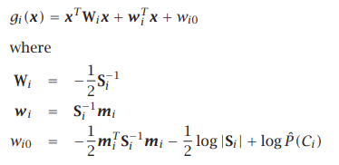

Where S is the sample covariance matrix, **m** is the sample mean vector and P is the prior probability of each class. I calculated the W, w and w0 values for each class separately and calculated the scores for each observation for all classes. I put all scores into an array.

**Confusion Matrix:** I predicted the class of each observation by taking the highest class score from the score array. Created the confusion matrix comparing the prediction with truth using pandas.crosstab.

**Plotting:** First I plotted the data points using different colors for different classes. Then I marked the points where the predicted classes did not agree with true classes. To plot boundaries I got the score for each coordinate on the plot and plotted a line when the predicted class of each data point changed.