**Mete Uz**

**60353**

**Engr421**

**Homework 2**

**Reading Data:** I read the files with similar implementation as labs. For the labels i read the data as a pandas array, converted each label to one of K encoding using pandas.get_dummies function then converted it into a numpy array. I divided the data into test and training sets using for loops to put each element into their respective arrays.

**Learning parameters:** I defined the sigmoid function as:

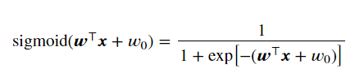

I used logistic regression. I generated random W and w0 values with martix sizes to work with the training set.

The gradient descent for W and w0 for each class:

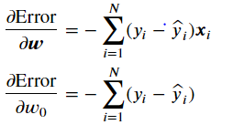

Error Function(Logistic Regression):

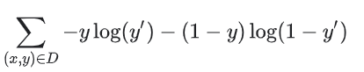

My learning parameters are same as the pdf. I only learned parameters for the training set to use those parameters in the test set.

**Scoring:** I used the sigmoid function to score my data sets.

**Confusion Matrix:** I predicted the class of each observation by taking the highest class score from the score array. Created the confusion matrix comparing the prediction with truth using pandas.crosstab. For the test set I used my learned W and w0 parameters to score the data.