**Mete Uz**

**60353**

**Engr421**

**Homework 4**

**Regressogram:** I used a similar implementation as lab 6 for bin boundaries and see if x is in the bin. I used the following function to calculate p hats.

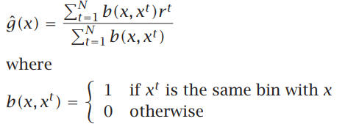

When calculating RMSE I divided the x value of the test data by 3 the integer solution of which gave me the position of the estimated y value in the p hat array.

**Running Mean Smoother:** I used the following function where h is equal to half of bin width.

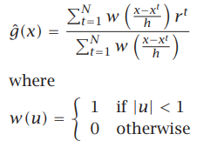

For RMSE I multiplied the x value of the test data by 100 the integer solution of which gave me the position of the estimated y value in the p hat array. I also used this for Kernel smoothing. There also was a warning in this equation however I chose to ignore it as it did not change the output in any meaningful way.

**Kernel Smoother:** I used the following function where K is the Gaussian Kernel function.

