**Mete Uz**

**60353**

**Engr421**

**Homework 6**

**Data Generation:** I used the same approach I used in homework 1.

**Centroids:** I used the code from lab 11 and ran 2 iterations to get initial centroid values.

**EM Algorithm:** I used the centroid values to find prior probablities, covariances and cluster distrubition. I used the following formulas from the lectures for the EM algorithm.

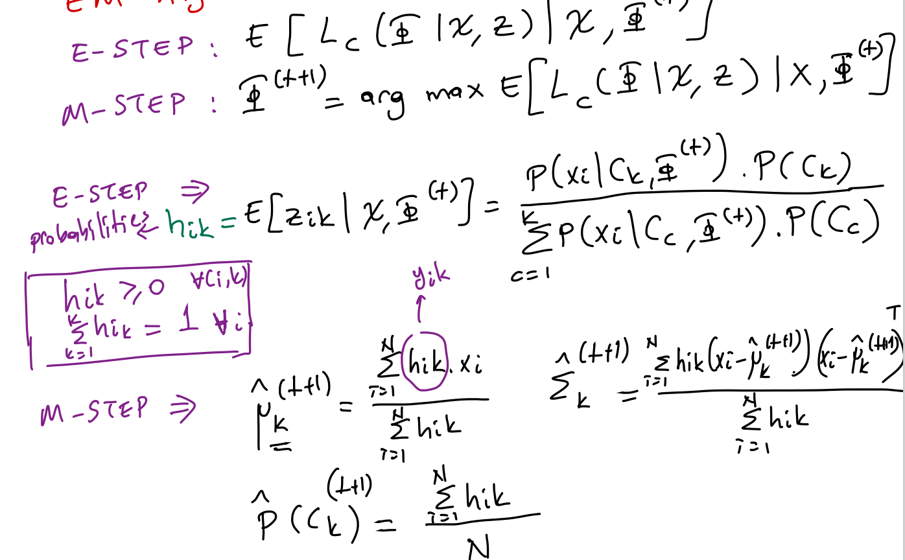

**Plotting:** Same as lab 11.