In WinInventoryAdjustment around the line 391,

productAmount = Convert.ToInt32(Convert.ToDecimal(txtProductAmount.Text)); is correct but what if the amount in stock is minus??

Refactor the entrance buttons' on click methods for WinPOS and WInPOP. You do not have to block the btnEntranceEnter and Clear in amount key up methods. You need to first push the user to enter correct value and if there is no any values, then check it in the entranceEnter methods.

LoadUserInformations method is available in WinDeposit, WinPOS, and WinPOP. Try to make them global!

WinPointOfPurchase: Around 324, do you really need to call GetLastInvoiceRecord in order to assign currentInvoiceId in the if block later?

You do NOT have to store the total amount, cost, and grand price since you can reach this infos by summing the values from the pop_detailed table!.

Try to make point of sale ids as auto incremental!

LblAssetSupplierId => lblIdAssetSupplier

**03/19/2022**

Create a new column named “id” for tbl pointOfSaleDetail and change the previous id column name with id_pos. Assign id_pos as foreign key of id in tbl pos.

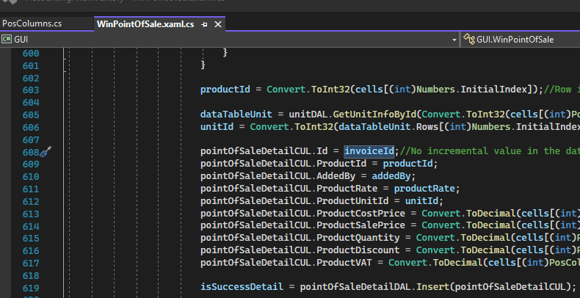

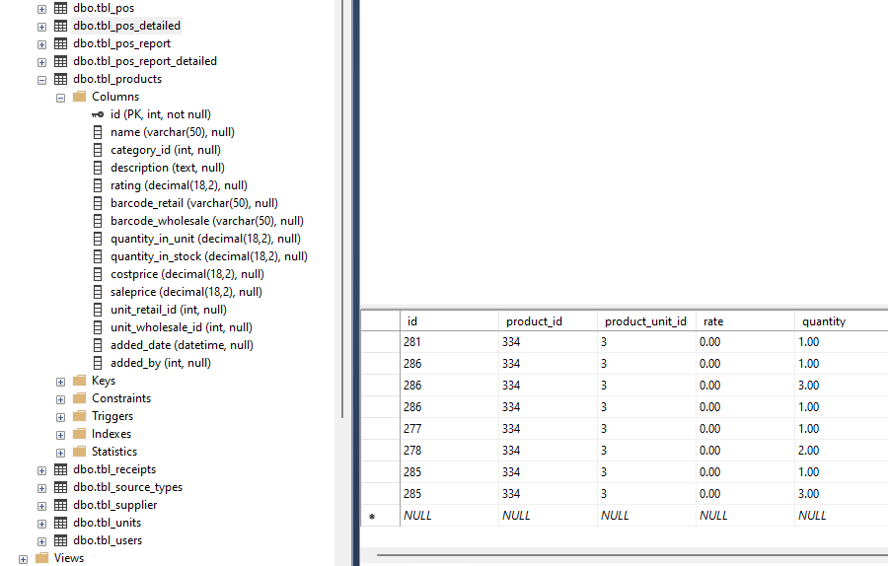

03/23/2022 Try to use “continue” in loops.