Any changes and anything that you do in the API tier, you need to regenerate swagger.json file!
To do this,
Set API tier as startup project. Simply you can right click on “HR.LeaveManagement.Api> Debug> Start Without Debugging” and this will run API project at startup temporarily.
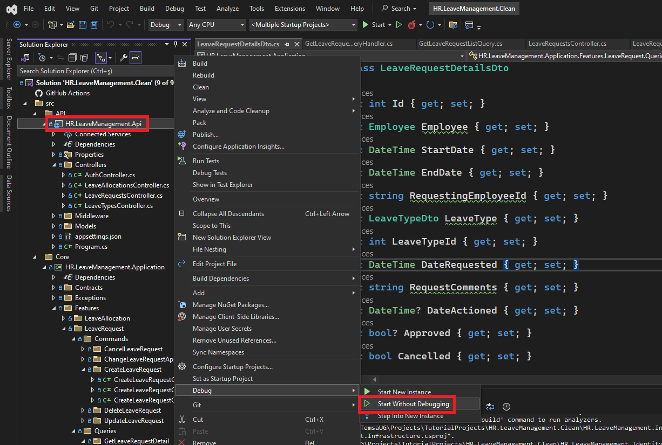
Open NSwag Studio. Click on “Create local Copy”. This will redownload the json associated with the API documentation. Then, click on “Generate Files”. This will update all of the DTO references in the client app.
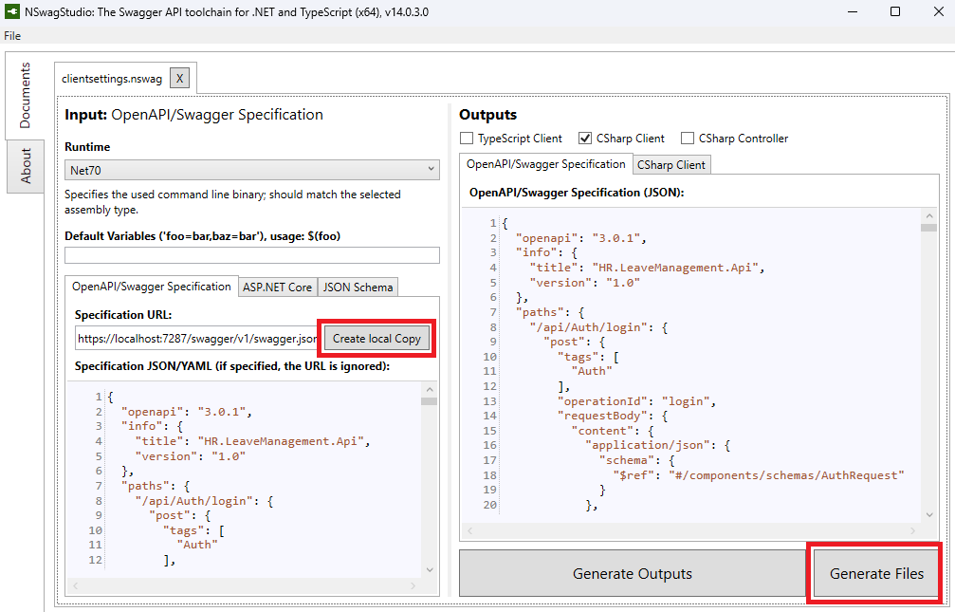
1) DBContext was setup in the Persistence layer.
To create the db, you should scaffhold the database with the following commands. Bold parts are mandatory if you have more than one dbcontext.
- add-migration InitialMigration -Context HrDatabaseContext
- update-database -Context HrDatabaseContext
Or if you add anything that may affect the database, for example you added something to the Domain part, you should update your database. To do that, apply the same commands above. I have added new properties to the following file:
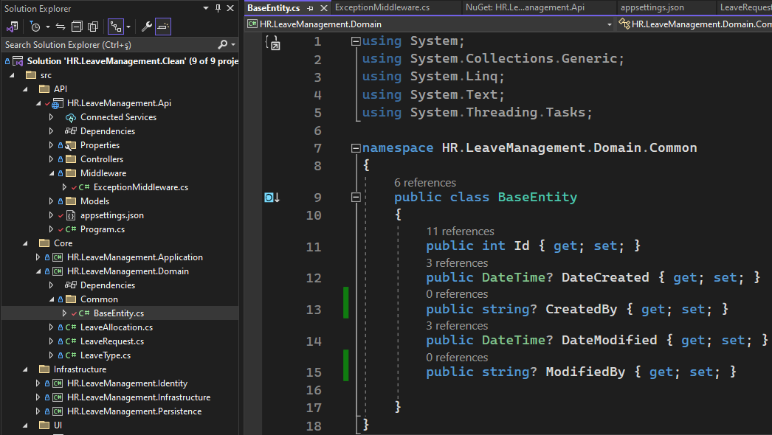
So go to “Package Manager Console” on the bottom of the page and run these commands. Note that the default project should be the project where our db context is located. In the Picture below, we added “-Context dbContextName” since we have more than one db context. Otherwise, you can omit it.
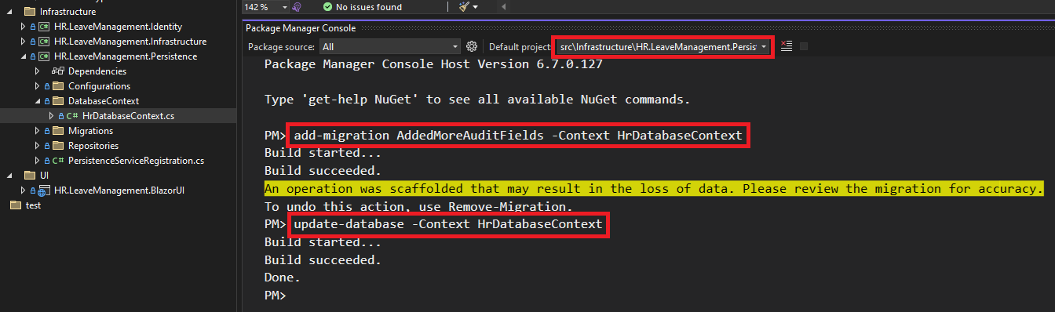
2) In case we make a change in the Identity layer, we need to scaffold our database to support our new authentication features. Note that the db context name is different than the previous one. It is “HrLeaveManagementIdentityDbContext”.
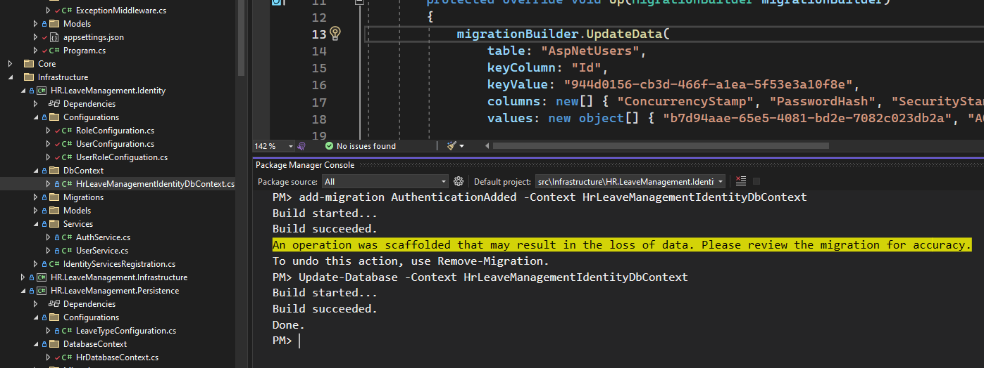
In addition to that, your startup project top of the page should be the Api Project.
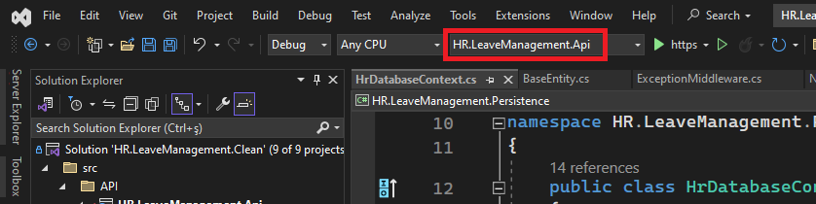

In case you get the error 401, correct Now->UTCNow

There is a problem with a normal user. Hen the user logs in, it is possible to reach the admin page to approve the request. Users can approve the request by themself.
