Try writing red code block like the blue one below:



You will get this:



When you finish the basic structure of the project, remember reviewing the project document indicated by the teacher!

Check the naming of the folders!

İndex-admin.php Template Resource: <https://www.w3schools.com/bootstrap/bootstrap_templates.asp>

Develop a secure login. Remember that you can access to the admin page by pasting the admin link! Fix it!

Availability->Stock, In Stock, Quantity

Medium and Large prices are not visible:

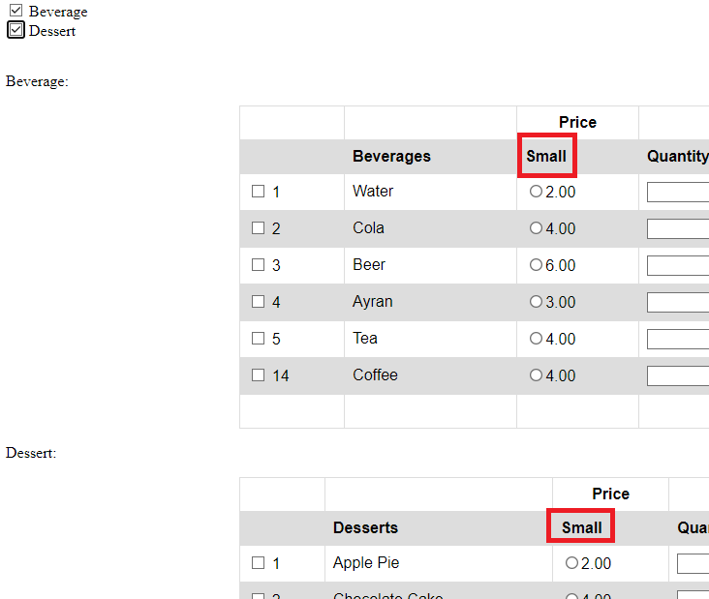

You need to automatise the quantity column to be updated without clicking the button below:

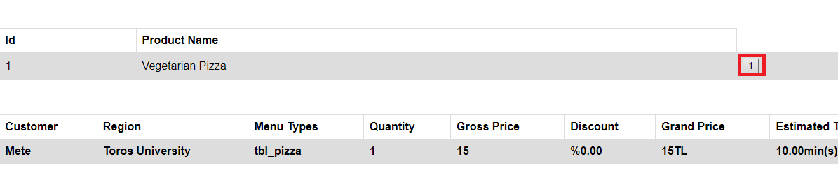

**FOR POP-UP:** <https://www.youtube.com/watch?v=mh4MVFiMZTM&t=2sp>

Get or assignusernamebyid?

