**Project Report**

**Project Definition**

The objective of this project was to color the map of the South America continent using a backtracking search algorithm. The constraints were that two neighboring countries should not have the same color and that at most 4 different colors (blue, green, red, and yellow) could be used.

The border neighborhoods of the countries in South America were presented in a table. This information was embedded into the application in the form of a dictionary structure where each country was a key, and its neighboring countries were listed as the values.

The result was a choropleth map of South America, with each country colored according to the backtracking algorithm's solution.

**Methodology**

1. Defined the countries and colors as global variables.
2. Created a dictionary to represent the graph of South American countries and their neighbors.
3. Implemented a backtracking function to color the map. The function used a recursive approach to assign colors to countries while respecting the constraint that neighboring countries should not share the same color.
4. Invoked the backtracking function and plotted the resulting map using the plot_choropleth function.

**Code Explanation**

The backtracking algorithm worked by recursively choosing a color for each country from the list of colors. If a chosen color didn't violate the constraint of neighboring countries having different colors, the algorithm proceeded to the next country. If no valid color could be found for a country, the algorithm backtracked to the previous country and tried a different color. This process continued until a valid coloring was found for all countries or all possible colorings were tried.

The plot_choropleth function was used to plot the colored map. The function took a dictionary of countries and their assigned colors as an argument. The px.choropleth function from the Plotly library was used to generate the map. The locations parameter was set to the list of countries, and the color parameter was set to the corresponding colors from the input dictionary. Only problem with this when the cursor is hovering on countries it shows the country name as country color. Since I can’t edit this function it stayed that way.

**Dependencies**

To run this project, the following Python libraries were required:

pandas 2.0.1

plotly 4.13.0

**Sample Output**

The sample output was a choropleth map of South America where each country was colored according to the solution found by the backtracking algorithm. Here are some examples: metin, harita içeren bir resim

Açıklama otomatik olarak oluşturuldu

*Example 1*

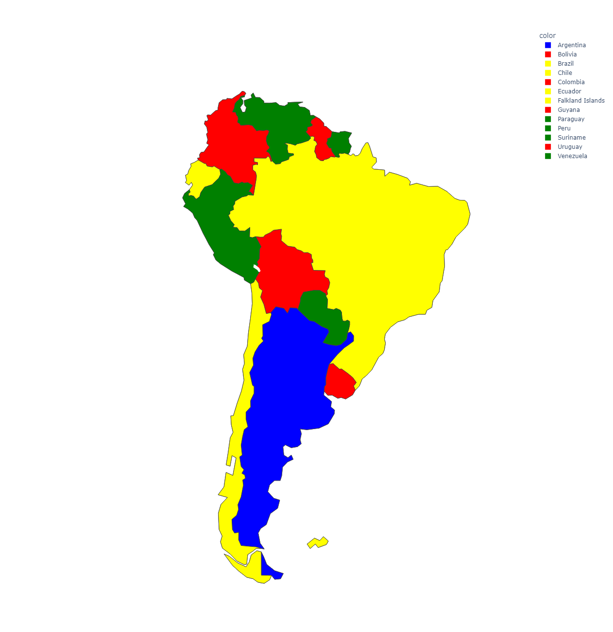

*Example 2*

**Conclusion**

This project demonstrated the use of a backtracking algorithm to solve a constraint satisfaction problem, specifically the map-coloring problem. The algorithm successfully found a solution where each country on the map of South America was colored such that no neighboring countries shared the same color. The result was visualized using a choropleth map, providing a clear representation of the solution. The project showcased the power of recursive algorithms and their applicability in solving complex problems. However this Project does not guarantee the best possible solution. Meaning that with improvements we might actually use fewer colors than 3 if possible.