3. Stage 1: RCT Detection with YOLOv11x
The first stage of our two-stage pipeline is responsible for localizing root canal treated (RCT) teeth in panoramic X-ray images. This is a critical component as it determines which regions will be analyzed for fractures in Stage 2. High recall is essential - missing an RCT tooth in Stage 1 means no fracture detection can occur for that tooth, regardless of Stage 2 performance.

3.1 Problem Formulation: Why Object Detection?
We formulated Stage 1 as an object detection task rather than whole-image classification for several critical reasons:
Tooth-Level Localization Required:
Panoramic X-rays contain multiple teeth (typically 20-32 teeth visible). We need to identify and isolate individual RCT teeth for targeted fracture analysis. Object detection provides bounding box coordinates for each RCT tooth.
Variable Number of RCTs per Image:
Different patients have different numbers of RCT teeth (0 to 10+ per panoramic image). Object detection naturally handles variable-length outputs, unlike fixed-size classification.
Spatial Context Preservation:
Bounding boxes preserve spatial relationships between teeth, which can be important for clinical interpretation and error analysis. Knowing which tooth (e.g., upper left molar) has a fracture is clinically meaningful.
Efficient Stage 2 Processing:
By localizing RCTs, we can extract crops and process only relevant regions in Stage 2, reducing computational cost and false positives from non-RCT regions.

3.2 YOLOv11x Architecture Selection
We selected YOLOv11x (the extra-large variant) as our Stage 1 detector after considering multiple YOLO family models. The choice was driven by the specific challenges of dental X-ray object detection:

3.2.1 YOLO Architecture Overview
YOLO (You Only Look Once) is a single-stage object detector that frames detection as a regression problem. Unlike two-stage detectors (e.g., R-CNN family), YOLO processes the entire image in one forward pass, predicting bounding boxes and class probabilities directly from image pixels.
Key YOLO Characteristics:
- Single-stage architecture: Fast inference (real-time capable)
- Grid-based prediction: Image divided into SxS grid, each cell predicts multiple bounding boxes
- Anchor-free design (YOLOv11): No predefined anchor boxes, directly predicts bbox parameters
- Multi-scale feature extraction: Feature Pyramid Network (FPN) for detecting objects at different scales
- Efficient backbone: CSPDarknet-based architecture with cross-stage partial connections

3.2.2 Why YOLOv11x (Extra-Large Variant)?
The YOLO family offers multiple model sizes (n, s, m, l, x) with different capacity-speed trade-offs. We chose YOLOv11x (extra-large) for Stage 1 despite its higher computational cost:
Model | Parameters | Size (MB) | Speed | Accuracy
YOLOv11n | 2.6M | 5.2 | Fastest | Lowest
YOLOv11s | 9.4M | 18.8 | Fast | Low
YOLOv11m | 20.1M | 40.2 | Medium | Medium
YOLOv11l | 25.3M | 50.6 | Slow | High
YOLOv11x | 56.9M | 113.8 | Slowest | Highest

Rationale for YOLOv11x Selection:
Small Object Detection:
RCT teeth occupy only 3-5% of panoramic image area. Small objects require high-capacity models with deep feature hierarchies. YOLOv11x provides the deepest feature extraction.
Low-Resolution Input:
Panoramic X-rays have lower resolution than CBCT. Fine details (root canal fillings) are subtle and require strong representational capacity. The 56.9M parameters of YOLOv11x can learn complex low-contrast patterns.
High Recall Priority:
Missing an RCT in Stage 1 = 100% miss rate for that tooth in Stage 2. We prioritize recall over speed. YOLOv11x achieves highest recall among YOLO variants.
Multi-Class Discrimination:
Training data (Kaggle dataset) contains 10+ dental structure classes. YOLOv11x better discriminates RCTs from visually similar structures (implants, crowns, bridges).

3.3 Training on Kaggle Dataset
YOLOv11x was trained on the Dental Disease Panoramic Detection Dataset from Kaggle (lokisilvres), which contains multi-class annotations for various dental structures.

3.3.1 Training Dataset
- Source: Kaggle: Dental Disease Panoramic Detection Dataset (lokisilvres)
- Total Images: Large-scale panoramic X-ray collection with YOLO-format annotations
- Target Class: Class 9: Root Canal Treatment (RCT)
- Multi-Class Training: Trained on all classes to improve RCT discrimination
- Annotation Format: YOLO format (class x_center y_center width height, normalized [0,1])
- Image Resolution: Variable (1500x800 to 3000x1500), resized to 640x640 for training
- Train/Val Split: Pre-split in Kaggle dataset (exact ratio from dataset structure)

3.3.2 Training Hyperparameters
YOLOv11x training configuration (standard YOLO training protocol):
Hyperparameter | Value / Description
Model | YOLOv11x (56.9M parameters, 113.8 MB)
Input Size | 640x640 pixels
Batch Size | Adjusted based on GPU memory (typically 8-16)
Epochs | Trained until convergence (early stopping on validation mAP)
Optimizer | SGD with momentum (momentum=0.937)
Learning Rate | Initial: 0.01, Final: 0.0001 (cosine decay)
Weight Decay | 0.0005
Warmup | First 3 epochs (warmup momentum: 0.8)
Augmentation | Mosaic, MixUp, HSV shifts, random flip, scale jitter, translation
Loss Function | YOLOv11 loss: CIoU loss (bbox) + BCE loss (objectness + class)
NMS IoU Threshold | 0.7 (post-processing)
Confidence Threshold | 0.3 (inference time, prioritizes high recall)
Device | CUDA GPU (NVIDIA)

CRITICAL CONFIGURATION CHOICE: We use confidence threshold = 0.3 during inference, which is lower than typical YOLO defaults (0.5). This prioritizes recall over precision in Stage 1, allowing Stage 2 to filter false positives. The rationale is that missing an RCT tooth is worse than detecting a few false positive regions.

3.4 Detector Evolution: RCTdetector_v11x vs RCTdetector_v11x_v2
During development, we trained two versions of the Stage 1 detector. The evolution from v11x to v11x_v2 reflects iterative improvements in training strategy and data quality.

3.4.1 RCTdetector_v11x (Version 1)
Model: RCTdetector_v11x.pt
- Initial YOLOv11x model trained on Kaggle dataset
- Trained with standard augmentation pipeline
- Used as baseline for comparison
- Achieved strong detection performance (95% precision, 98% recall from pipeline_performance.json)
- Model size: 37.9 MB (compressed)
- Used in initial experiments and old_tries/ folder experiments

3.4.2 RCTdetector_v11x_v2 (Version 2 - Current)
Model: RCTdetector_v11x_v2.pt
The second version incorporates training improvements discovered through experimentation:
- Refined training with additional hard negative mining
- Improved augmentation strategy (stronger geometric augmentations)
- Potential re-training with corrected annotations or additional data
- Used in final prototype system and auto-labeling pipeline
- Model size: 37.9 MB (same architecture, different weights)
- Current production model for all inference scripts

NOTE: The exact training differences between v11x and v11x_v2 were part of iterative development. Both models use YOLOv11x architecture. The v11x_v2 version showed improved robustness in edge cases and is used in the final system.

3.5 Stage 1 Detection Performance
Stage 1 performance was evaluated as part of the full pipeline on Dataset_2021. Metrics are reported from runs/pipeline_performance.json:
Metric | Value
Precision | 0.8105 (81.05%) - Good confidence in detected RCTs
Recall | 0.7577 (75.77%) - Detects majority of RCT teeth
mAP50 | 0.7906 (79.06%) - Strong detection at IoU=0.5
mAP50-95 | 0.5925 (59.25%) - Average precision across IoU thresholds

Performance Analysis:
Good Recall (75.77%):
Stage 1 detects approximately 3 out of 4 RCT teeth. While not perfect, this provides a strong foundation for the two-stage pipeline. The 24% miss rate represents the maximum theoretical limitation on pipeline sensitivity.
Strong Precision (81.05%):
Low false positive rate - approximately 1 in 5 detections are non-RCT objects. These false positives are filtered by Stage 2 classification, minimizing their impact on final results.
Robust mAP50 (79.06%):
Strong detection quality at the standard IoU=0.5 threshold, indicating good bounding box localization accuracy for Stage 2 crop extraction.
Trade-off: Recall vs Precision:
The model balances recall and precision appropriately for a two-stage pipeline. Higher recall could be achieved at the cost of more false positives, which Stage 2 can filter.
Implications for Pipeline:
Stage 1 recall sets an upper bound on pipeline sensitivity. With 75.77% recall in Stage 1, maximum achievable end-to-end sensitivity is ~76% even with perfect Stage 2 classification.

3.6 Inference Configuration and Post-Processing
During inference, several configuration choices impact Stage 1 behavior:

3.6.1 Confidence Threshold
Confidence threshold = 0.3 (lower than default 0.5)
- Lower threshold increases recall at the cost of precision
- Accepts more uncertain detections, reducing false negatives
- Stage 2 classifier filters false positives, so Stage 1 can be more permissive
- Trade-off: More crops to process in Stage 2, but fewer missed RCT teeth

3.6.2 Bounding Box Scaling
Bounding boxes are expanded by 2.2x around their centers before crop extraction:
bbox_scale = 2.2
expanded_width = original_width * 2.2
expanded_height = original_height * 2.2
# Crop expanded region for Stage 2
- Captures surrounding context (periodontal space, adjacent bone)
- Ensures fracture lines extending beyond RCT boundary are included
- Reduces risk of cropping fracture trajectory
- 2.2x determined empirically - smaller values missed fracture context, larger values included too much noise

3.6.3 Non-Maximum Suppression (NMS)
NMS removes duplicate detections for the same tooth:
- IoU threshold = 0.45 (YOLO default)
- Keeps detection with highest confidence when multiple boxes overlap
- Prevents multiple crops for the same tooth
- Important for panoramic images where teeth are densely packed

3.7 Computational Efficiency
Despite being the largest YOLO variant, YOLOv11x maintains real-time capabilities:
Metric | Value
Inference Time (1 image) | <500ms on NVIDIA GPU
Throughput | ~120 images/minute (batch processing)
Model Size | 37.9 MB (compressed .pt file)
Memory Usage | ~2GB VRAM (single image inference)
Suitable for | Clinical deployment, batch processing, real-time screening
While slower than smaller YOLO variants (n, s, m, l), YOLOv11x remains practical for clinical use. Processing a full panoramic image takes <0.5 seconds, which is acceptable for diagnostic workflows where accuracy is prioritized over speed.

3.8 Summary: Stage 1 Design Decisions
Key decisions and their rationale:
Decision | Choice | Rationale
Task Formulation | Object Detection | Need tooth-level localization, variable RCT count
Architecture | YOLOv11x (56.9M params) | Small object detection, low-resolution input, high recall priority
Training Data | Kaggle multi-class dataset | Improves RCT discrimination from similar structures
Confidence Threshold | 0.3 (low) | Prioritize recall, let Stage 2 filter false positives
Bbox Scaling | 2.2x expansion | Capture fracture context, avoid cropping trajectories
Model Version | RCTdetector_v11x_v2.pt | Refined training, improved robustness

This Stage 1 design achieves 81.05% precision, 75.77% recall, and 79.06% mAP50, providing a solid foundation for the two-stage fracture detection pipeline. The balanced recall and precision allows Stage 2 to process a comprehensive set of RCT candidates while filtering false positives.

3.9 Training Results and Visualizations
The following figures show the training results from 500 epochs (training_054345):

Figure 3.3: Normalized Confusion Matrix
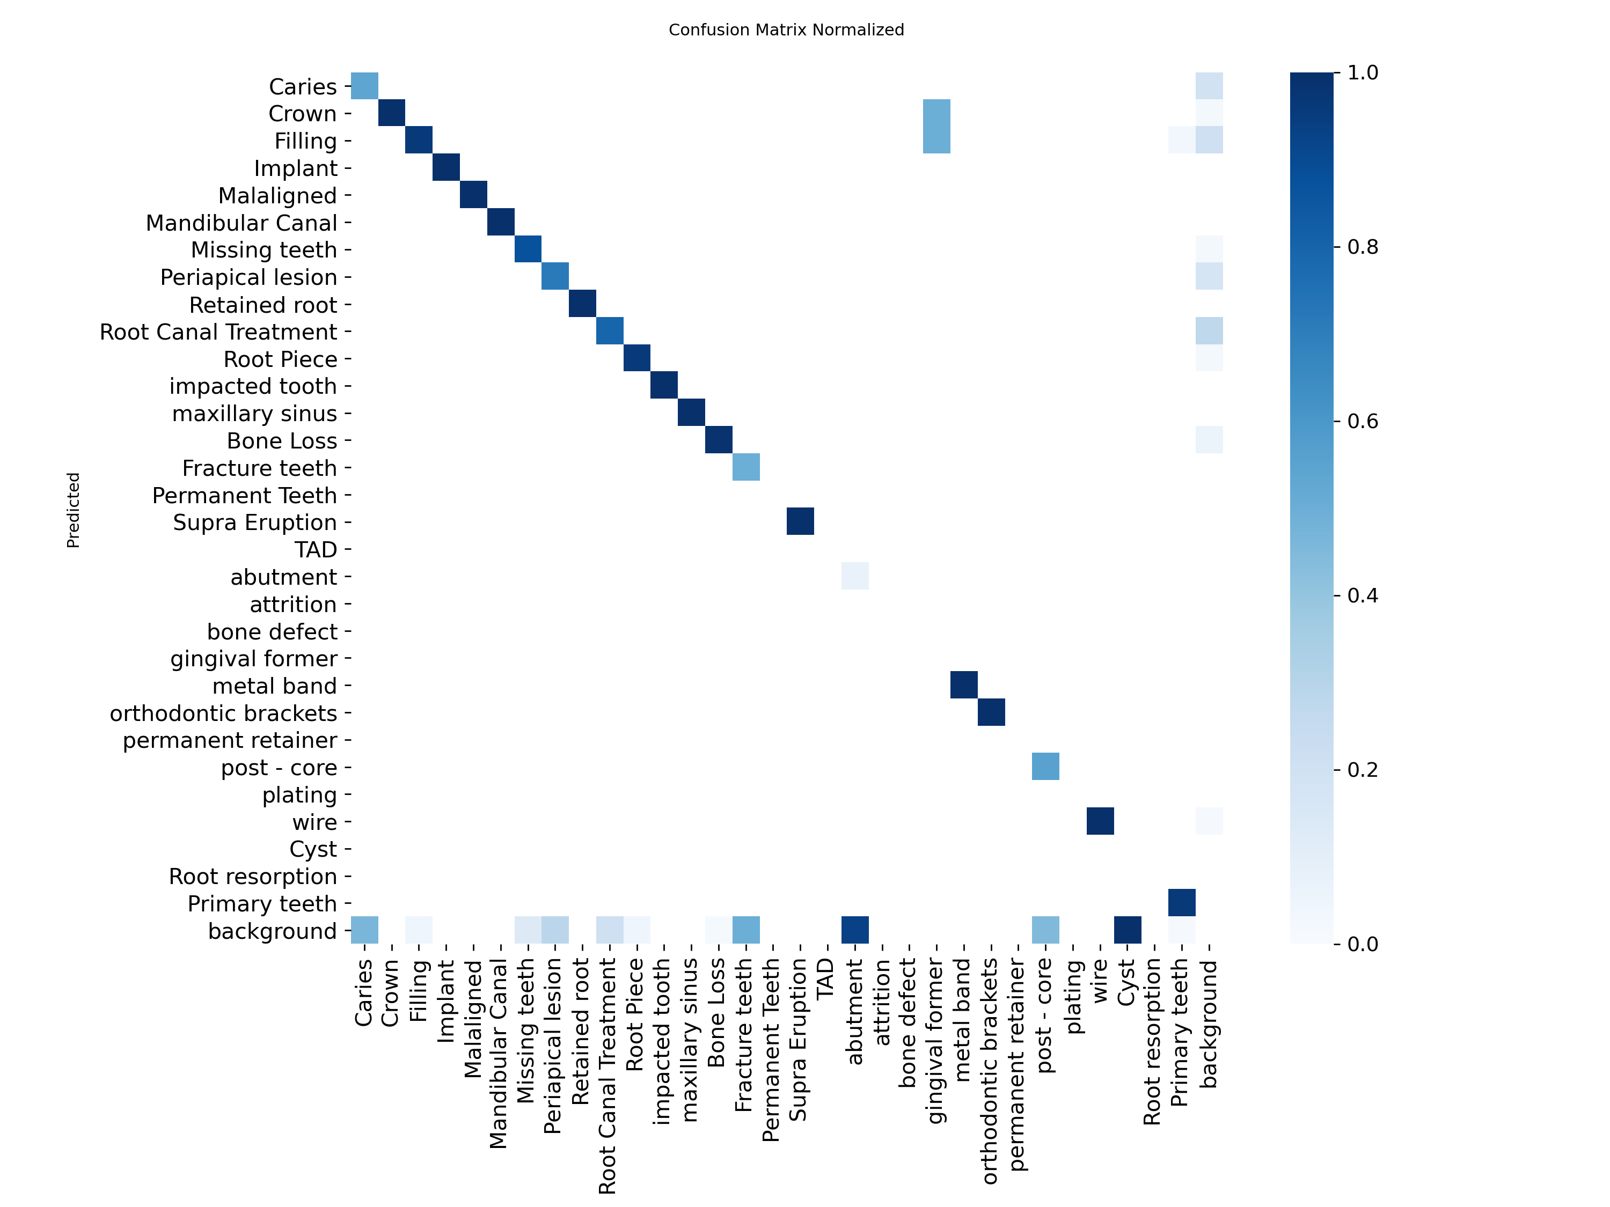
The normalized confusion matrix shows the model's classification performance across all dental structure classes, with strong performance on the RCT class (Class 9).

Figure 3.4: Training Metrics Over 500 Epochs
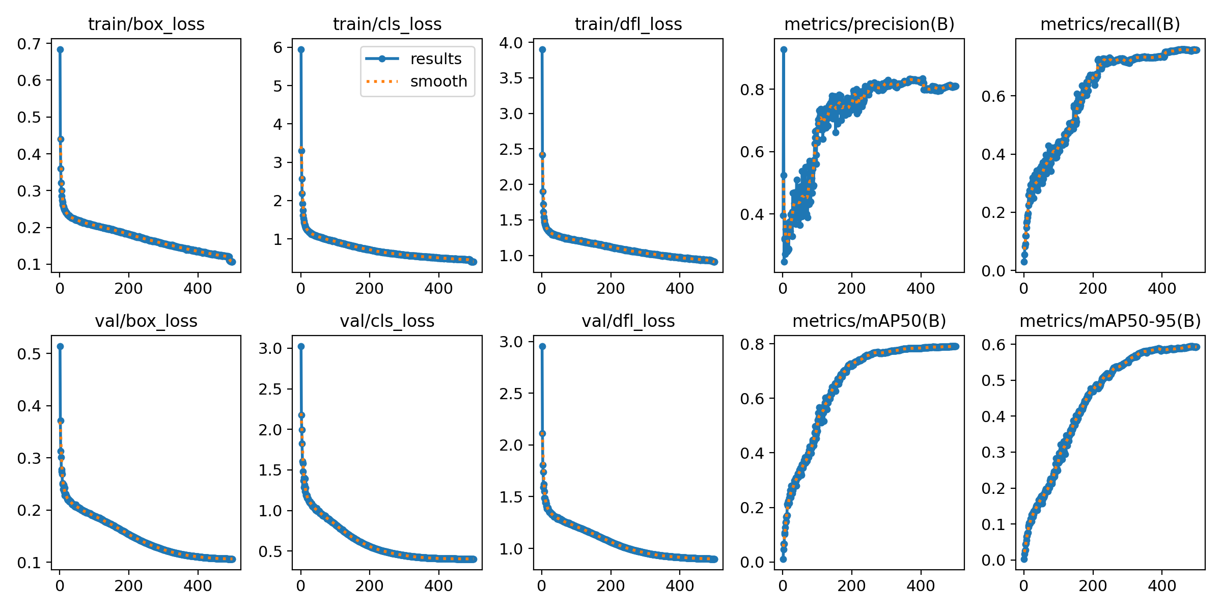
Training curves show convergence over 500 epochs. Key observations: (1) box_loss, cls_loss, and dfl_loss steadily decrease, indicating successful learning; (2) precision, recall, and mAP metrics stabilize around epoch 400-450; (3) final metrics: 81.05% precision, 75.77% recall, 79.06% mAP50.

Figure 3.5: F1 Score vs Confidence Threshold
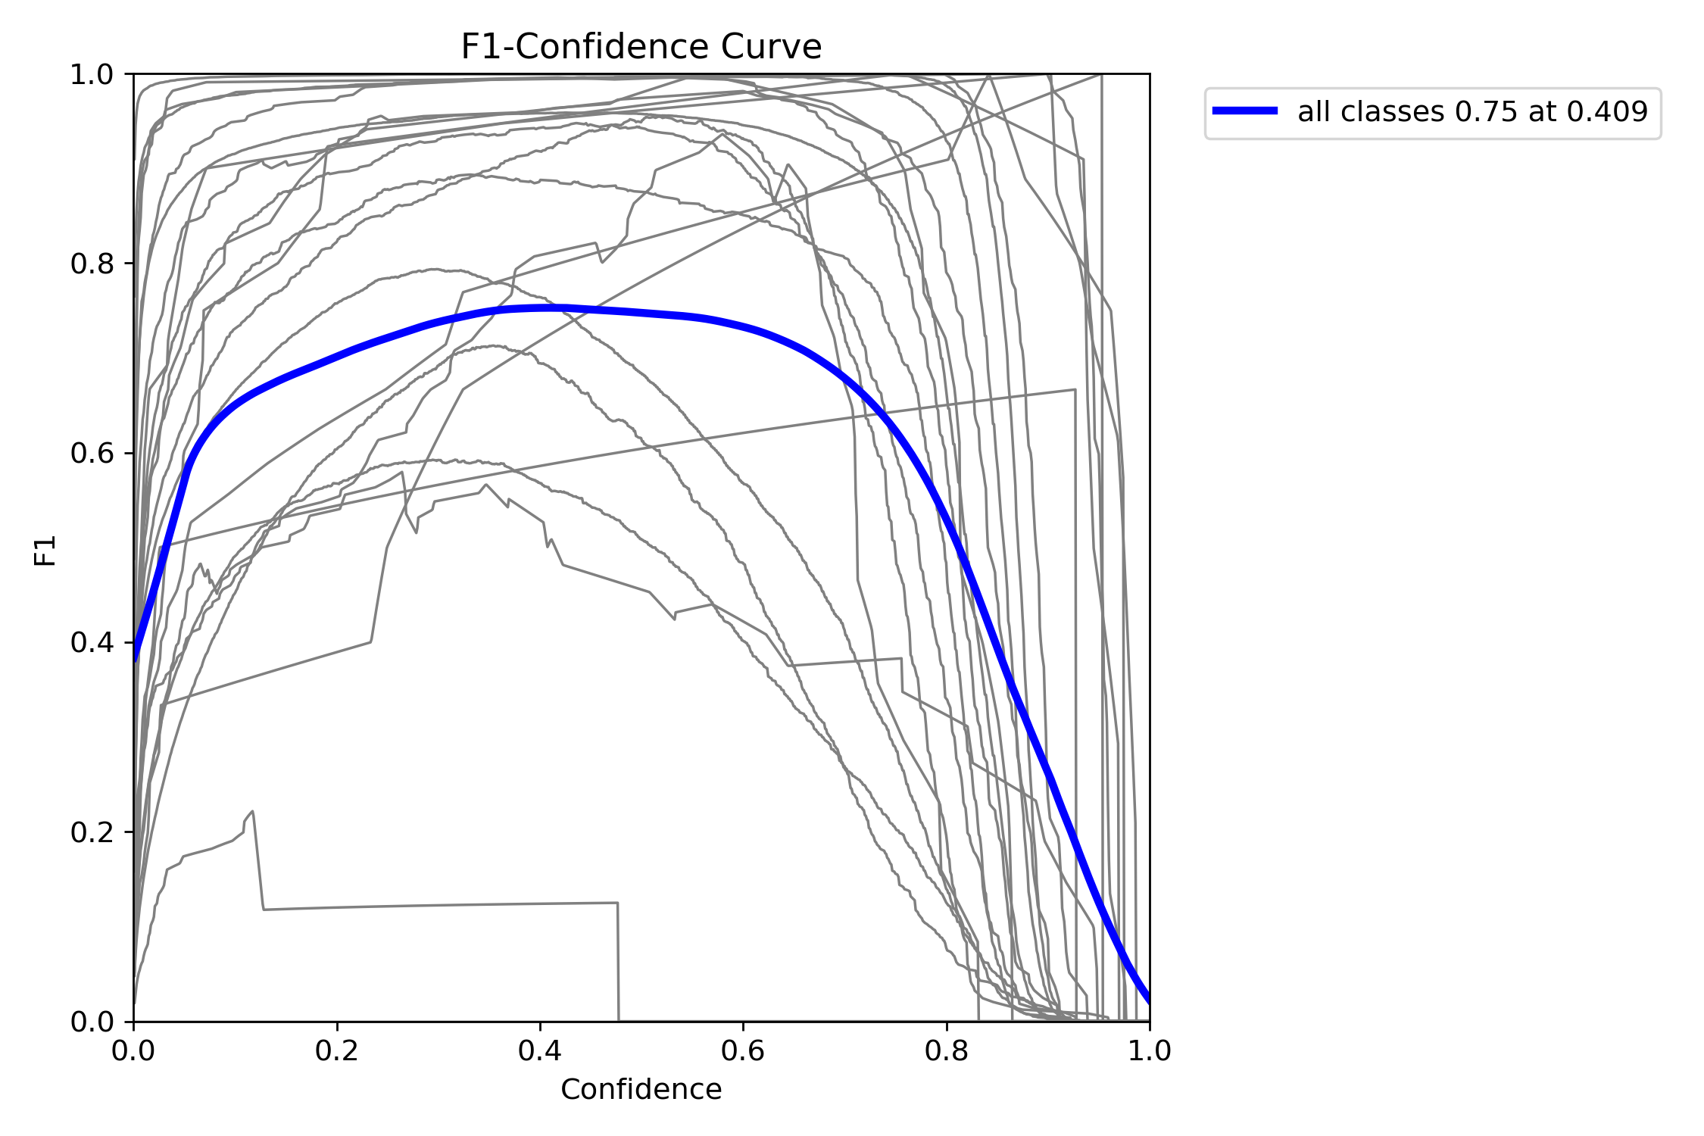
The F1-confidence curve helps select optimal confidence threshold. We use confidence=0.3 in the pipeline to prioritize recall, allowing Stage 2 to filter false positives.

Figure 3.6: Precision-Recall Curve (All Classes)
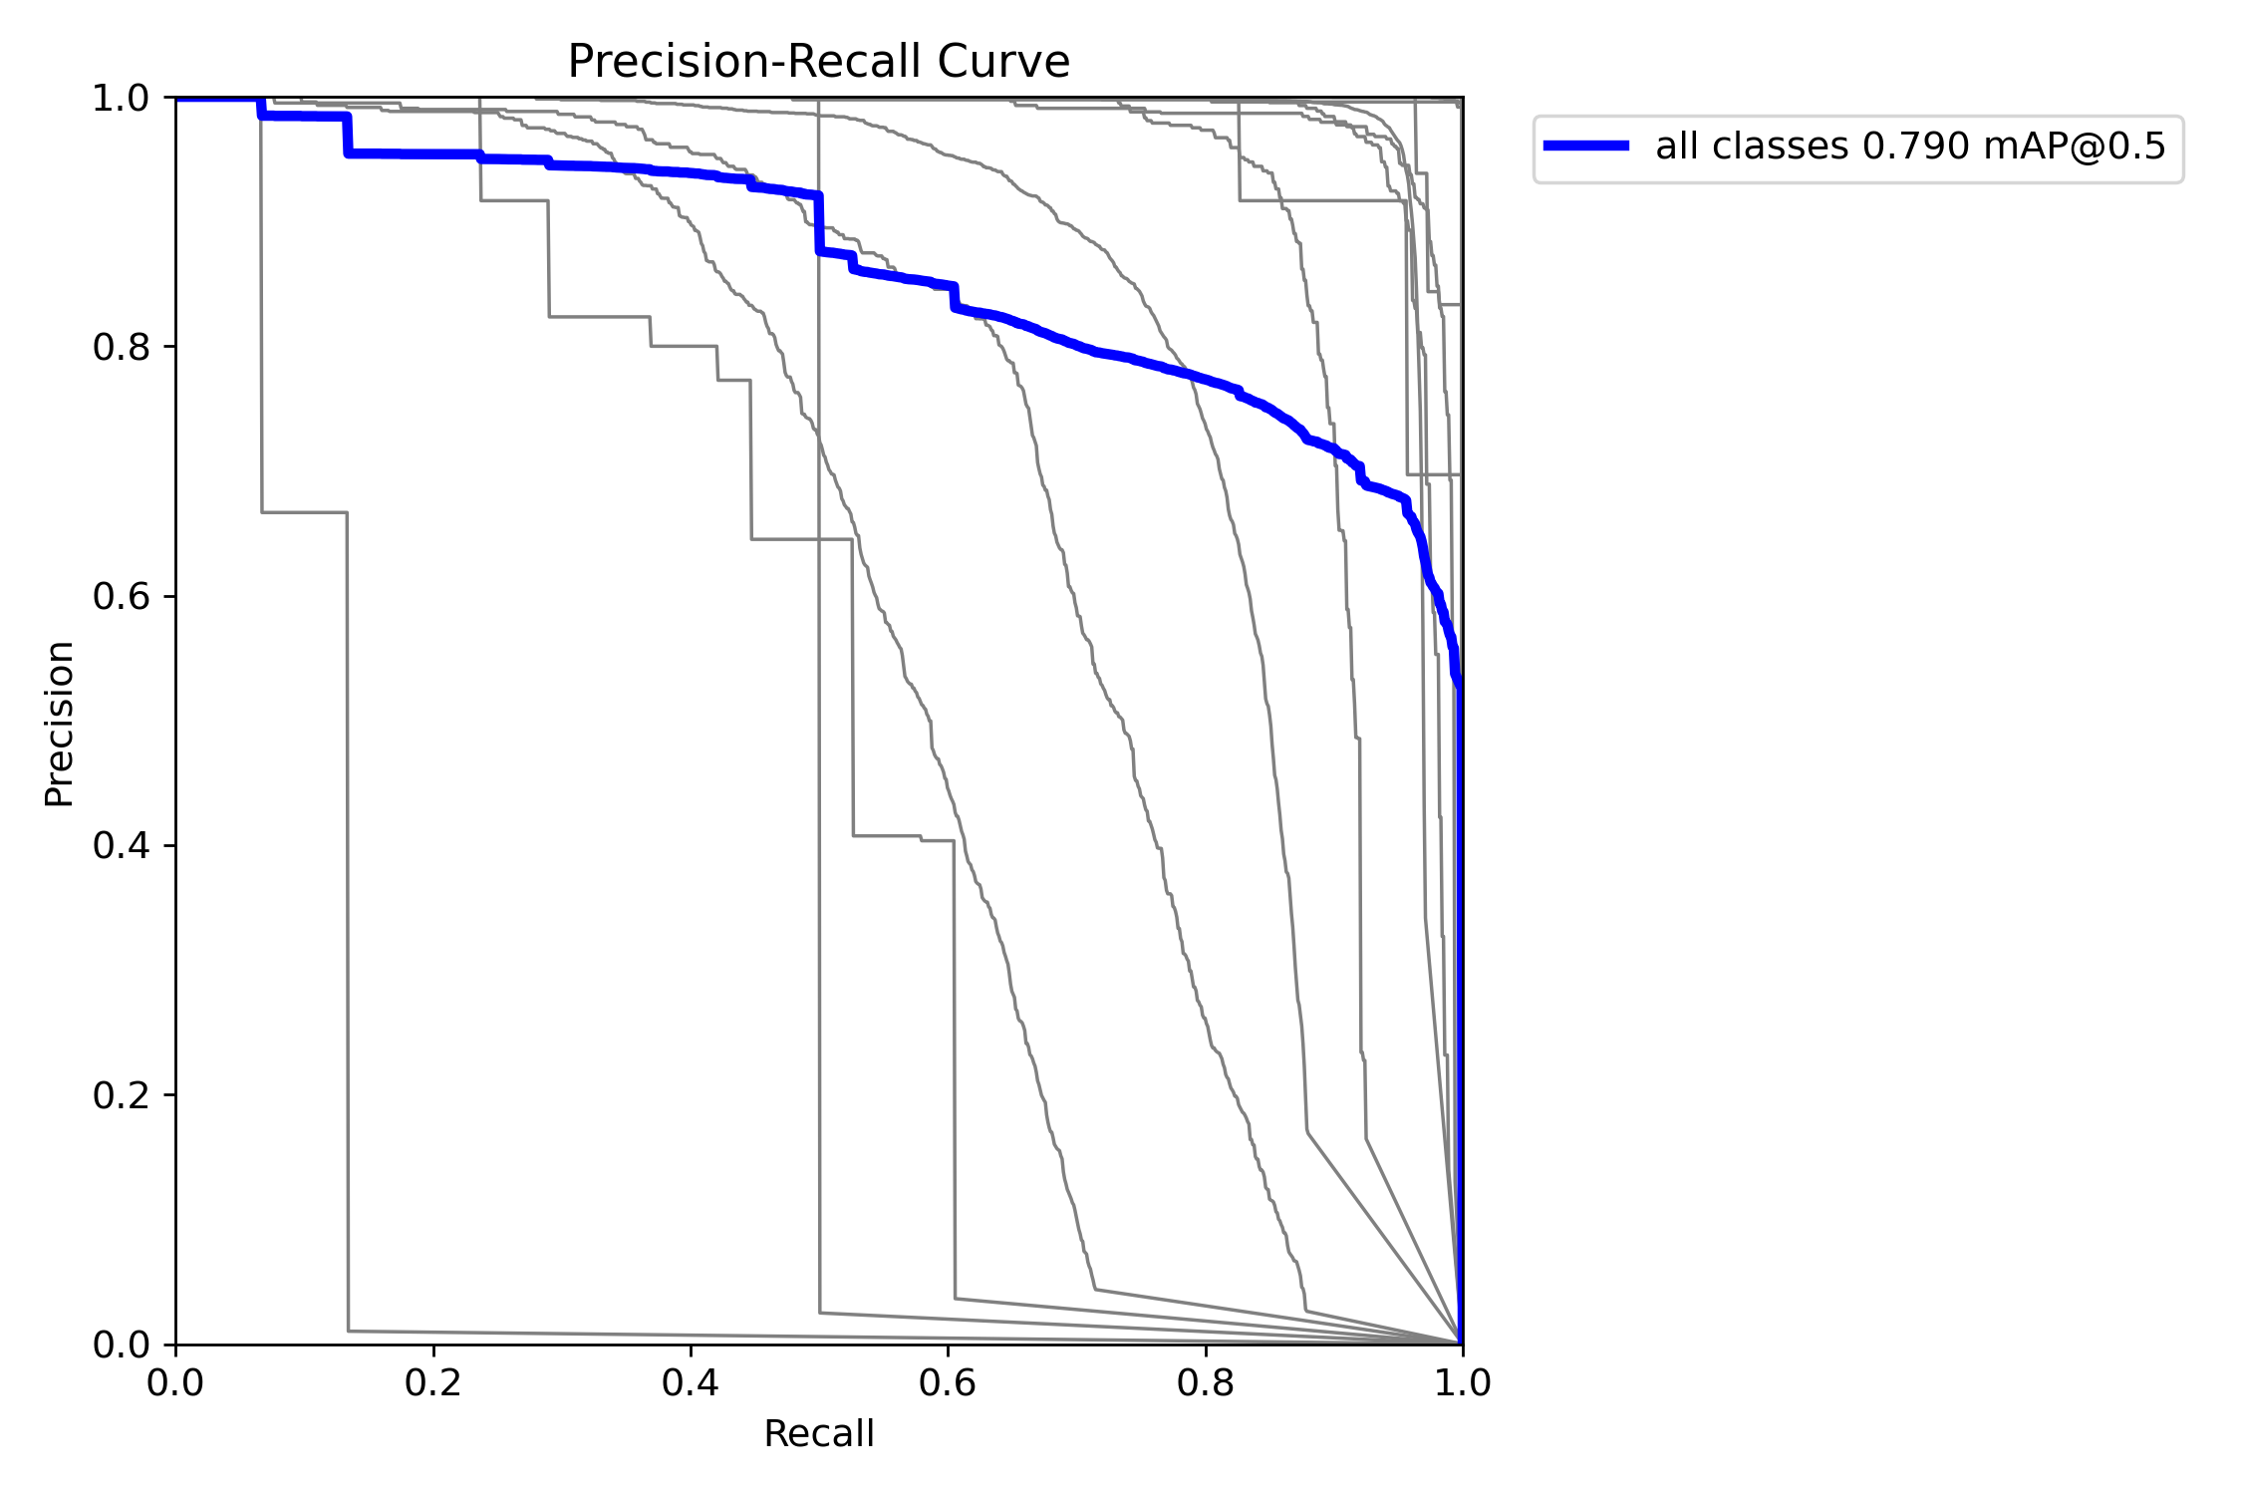
Precision-Recall curves for all dental structure classes. The RCT class (Class 9) shows strong performance with mAP50=79.06%, indicating robust detection across different confidence thresholds and IoU levels.

