**Colab: How to connect local runtime**

**Step 1 : open cmd command and run 3 commands below**

pip install jupyter_http_over_ws

jupyter serverextension enable — py jupyter_http_over_ws

jupyter notebook -NotebookApp.allow_origin='https://colab.research.google.com' --port=8888 --NotebookApp.port_retries=0

**Step 2 : Copy highlighted URL in the command line as in the picture below**

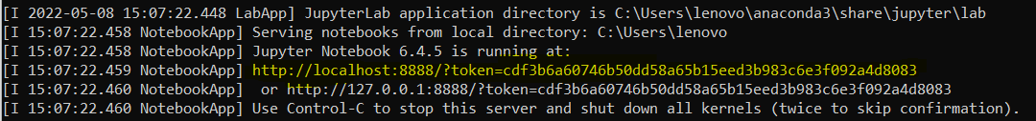

**Step 3 : go to Colab click connect  and select “Connect to a local runtime”**

**Step 4 paste URL in the backend URL text box**

**Final: Now you are connected**

