**SOFT521- User Guide**

1. Login

1.1

2

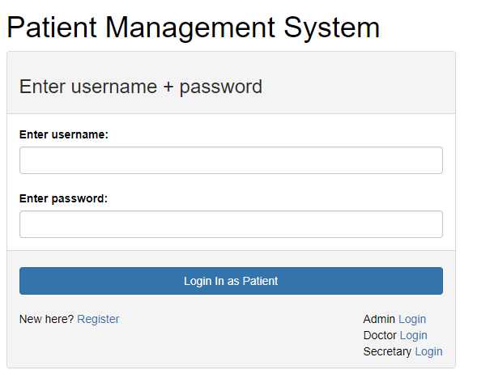

* 1. Register for new user – Here you can register for an account, but the account must first be verified by a secretary.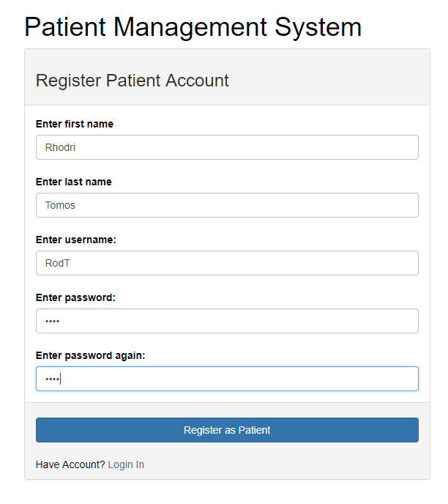

1. Here you can choose between the different login forms .

Patient Form

As an example we will login with the username of ‘ericpat’ and the password of ‘ericpat’. 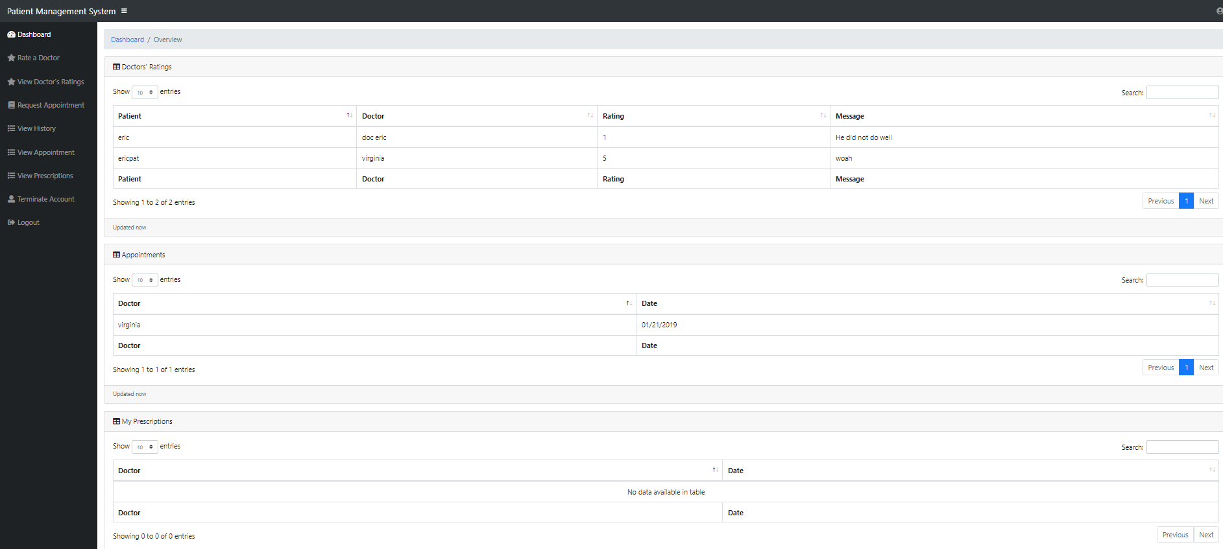

This first thing you are greeted with is the Patient dashboard, most of the important data for the patient is located here such as appointments and prescriptions. On the left side there are links that will take the patient to the respective page.

Rate a doctor

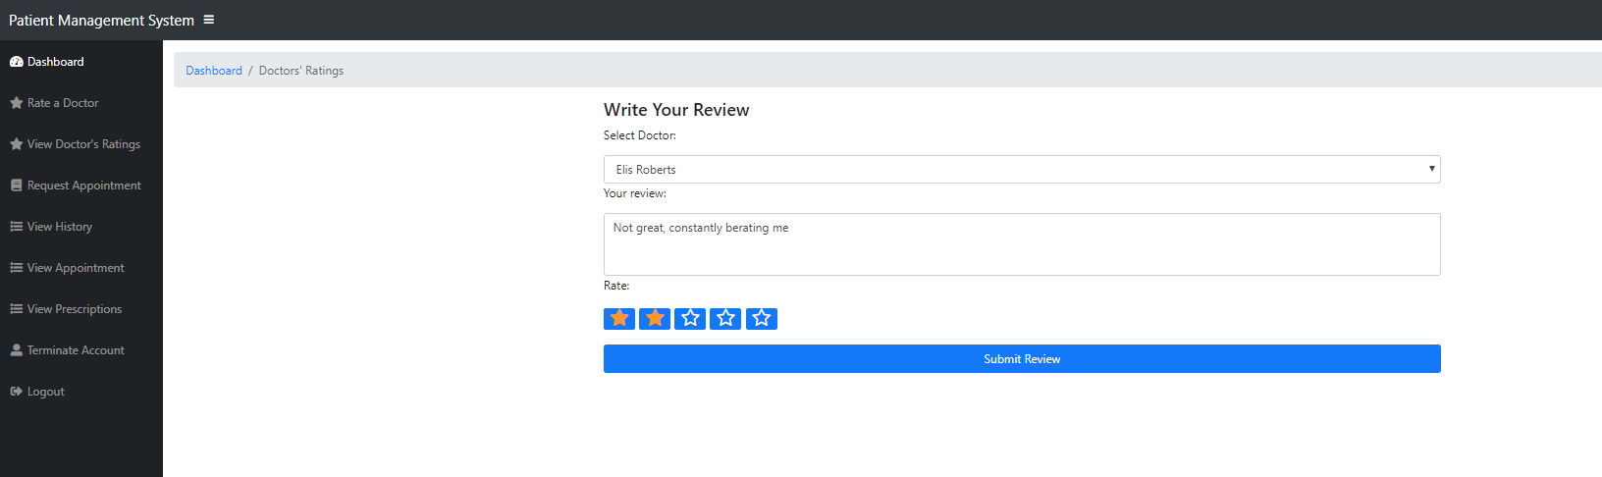

Here the patient can rate doctors, they can choose the doctors by the dropdown list, write a comment about them and give them a start out of 5

View Doctors Ratings

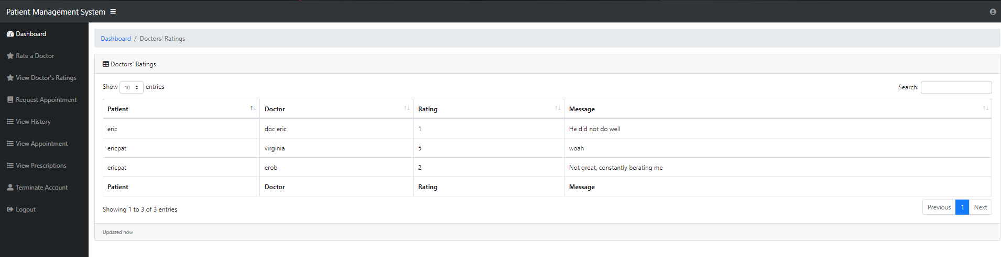

Here the patient can see the ratings of all the doctors.

Request Appointment

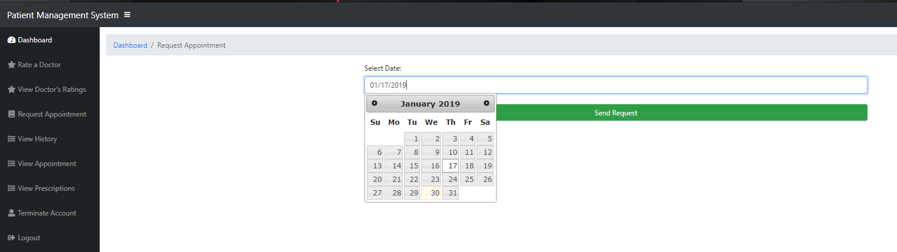

Here the patient can request an appointment through the use of a calendar, the appointment must then be approved by a secretary.

View History

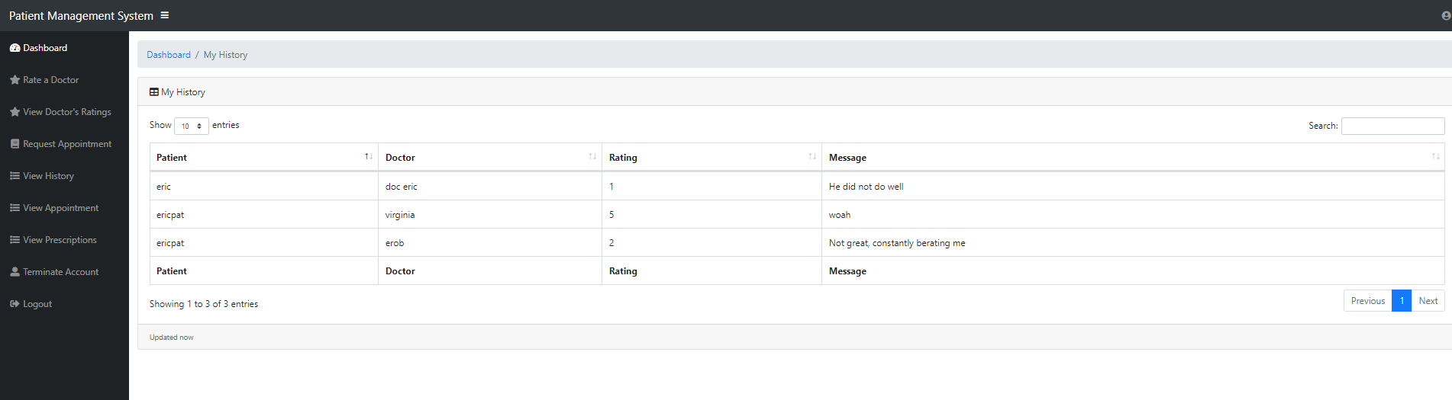

This shows the patients the history of appointments

View Appointments

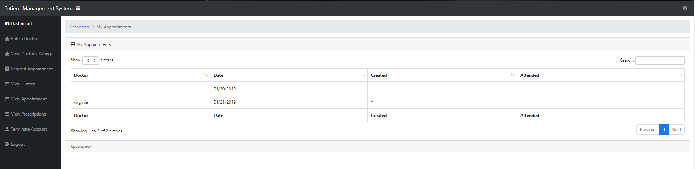

This shows the patient their personal appointments (please note that the reason why the fields are empty is because the secretary has not yet approved it).

View Prescriptions

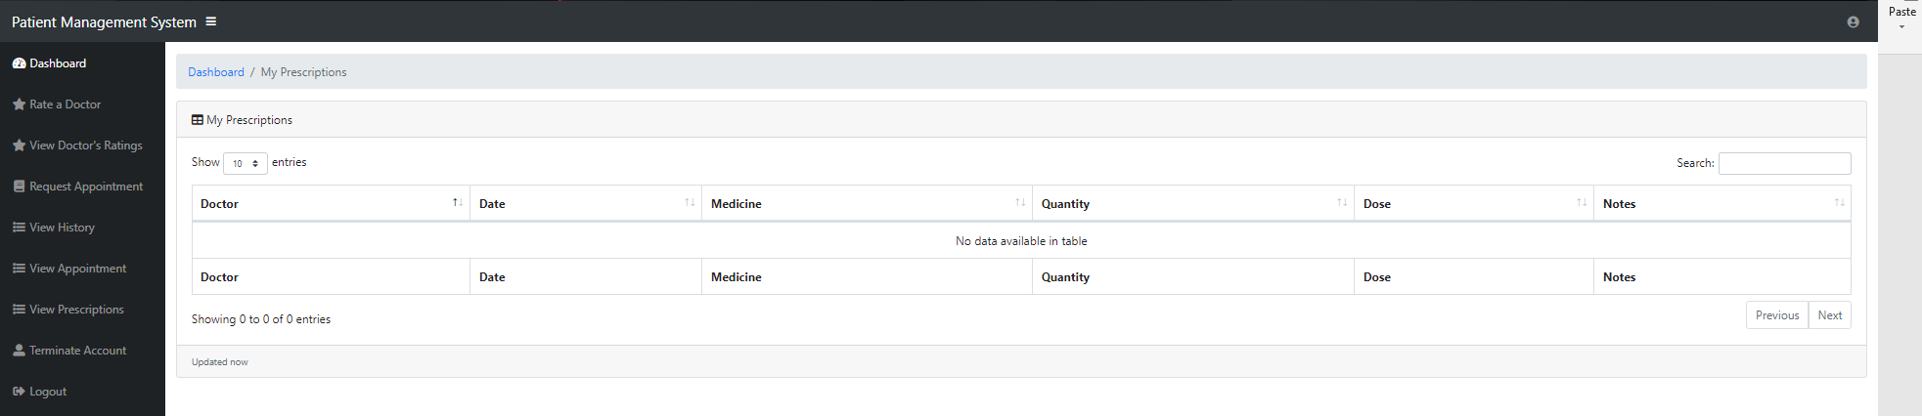

This shows the patients prescription (current patient has none)

Terminate Account

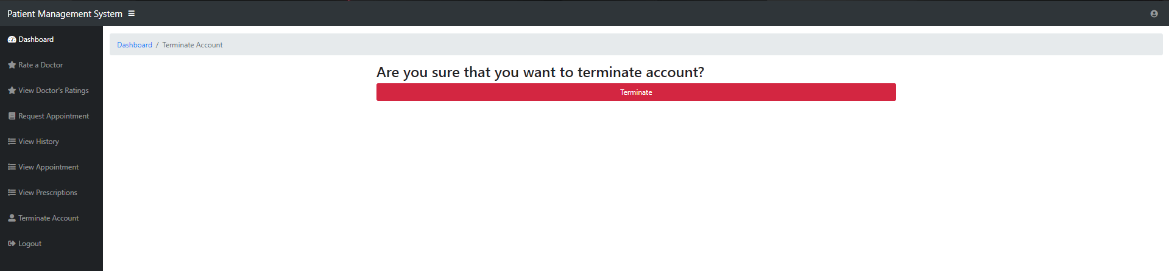

If the user wishes to leave the clinic they can delete their account.

Admin Form

As an example we will login with the username of ‘eric’ and the password of ‘eric’.

Admin Overview

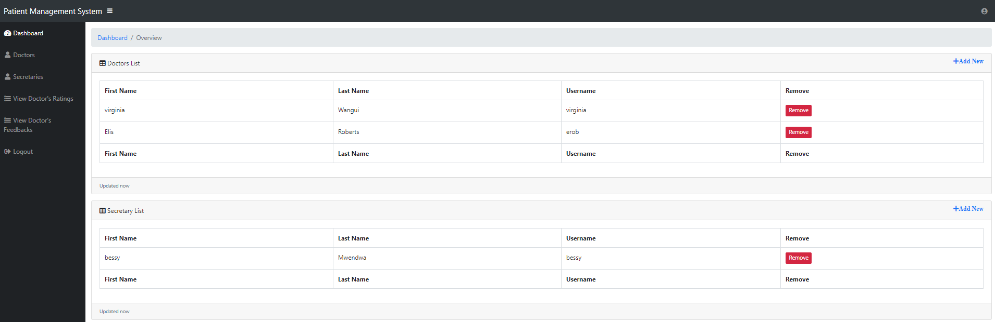

Here the admin can delete or add more doctors or secretary though the red remove button or the blue text add new found on the top right corner of each respective box.

Add doctor or secretary

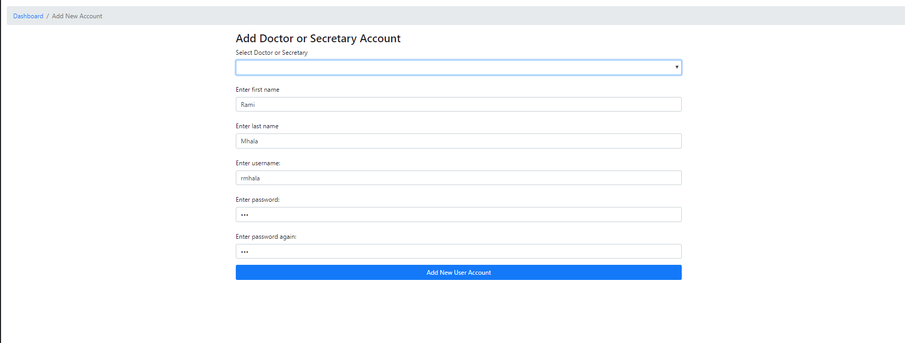

Here the admin can create a secretary or doctor, the account type is decided from a dropdown list.

View Doctors Rating

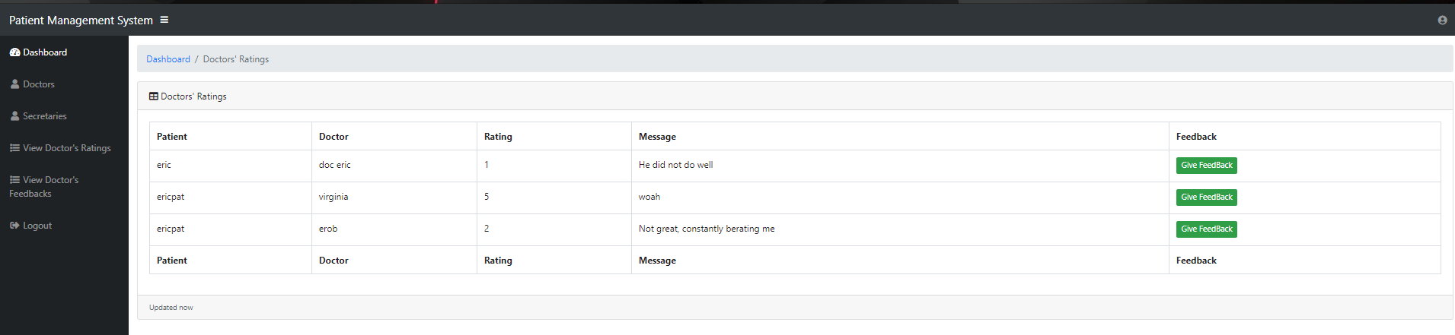

Here the admin can see the doctors ratings given by patients, the admin can also send feedback to the doctors based on there.

Give Doctors feedback

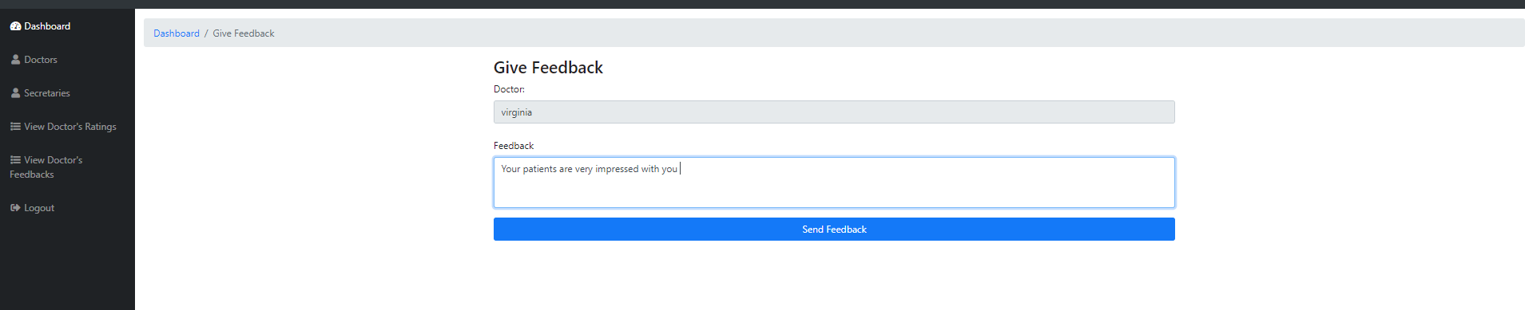

Here the admin can give feedback to the doctors based on their reviews.

Doctors admin feedback

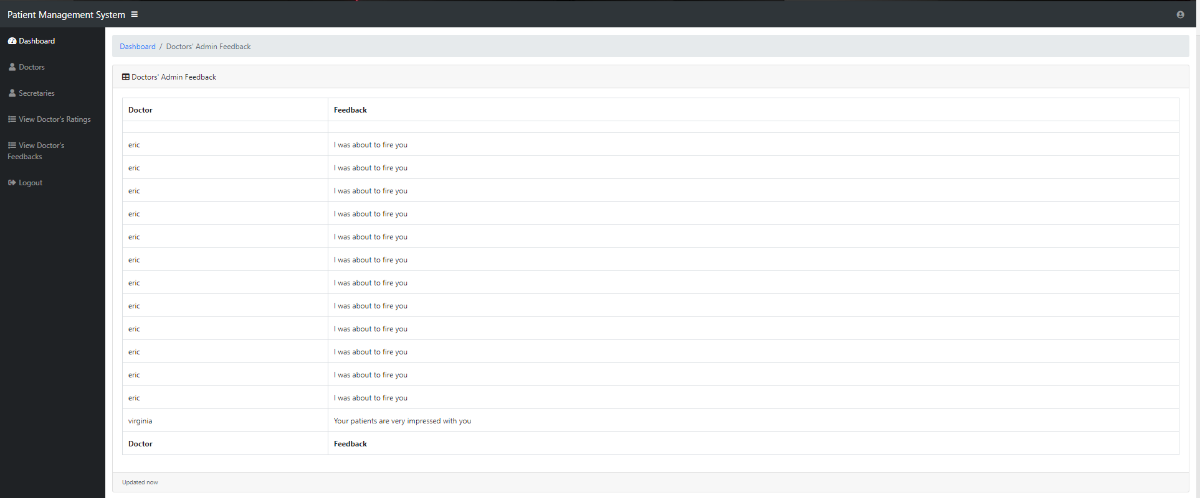

This is where the admin can see what feedback they gave and to what doctor

Secretary Form

As an example we will login with the username of ‘bessy’ and the password of ‘bessy’.

Secretary Dashboard

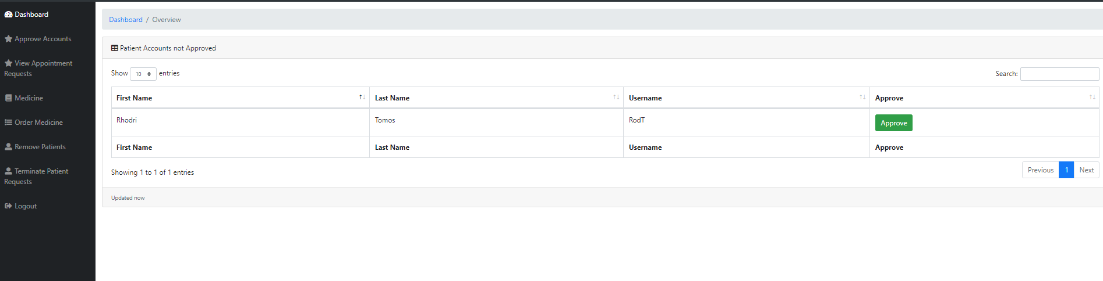

Here the secretary can approve of patient’s accounts being created.

View appointments

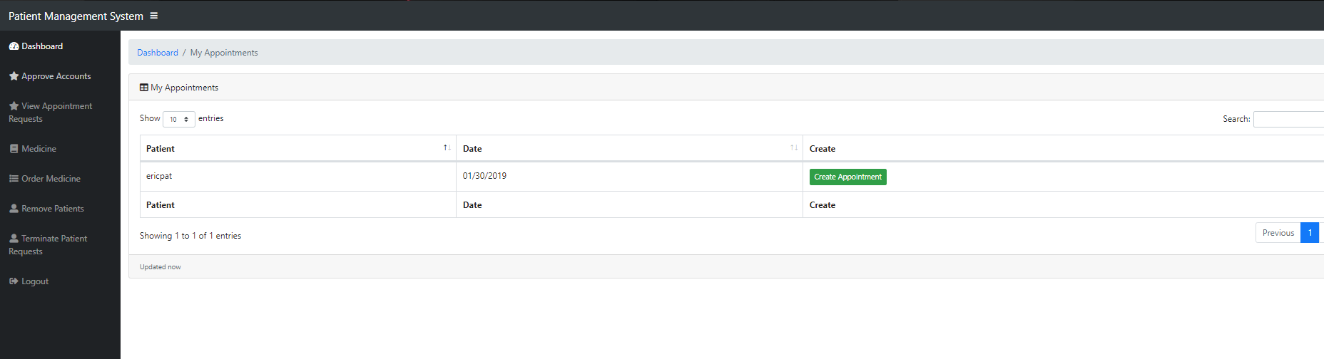

Here the secretary can create appointment off appointment requests of patients

Create Appointment

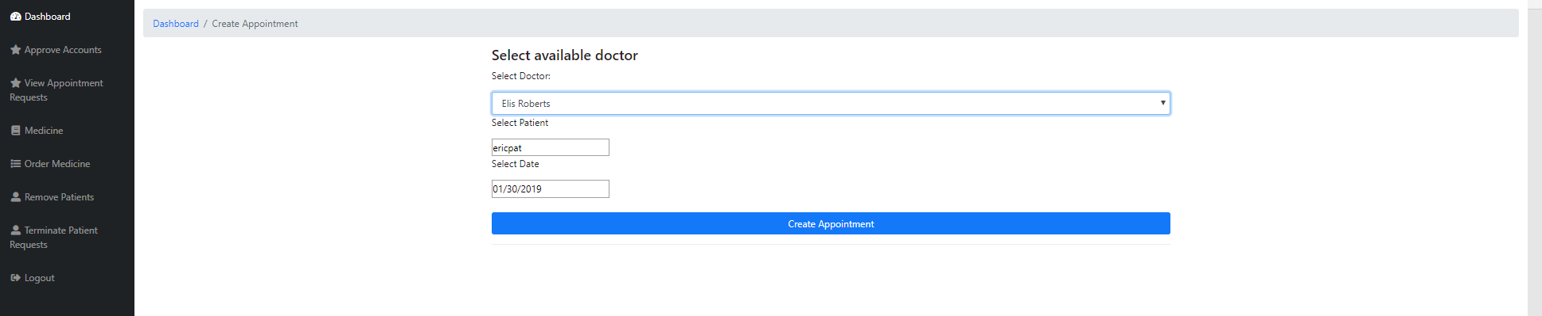

Here the secretary can create appointments by choosing what doctor the patient gets too see, they can also change the date from what the patient requested.

View Medicines

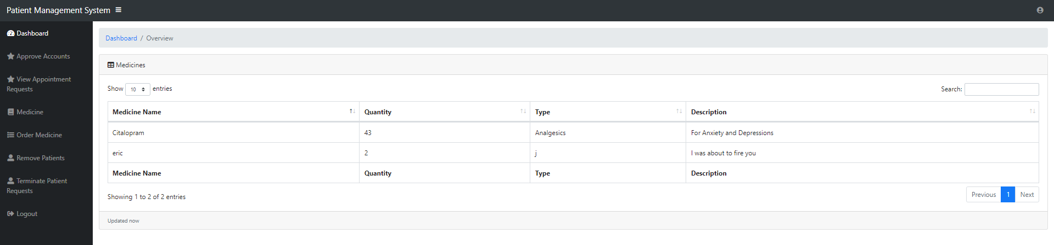

Here the secretary can see the current medicines created

Medicine Stock

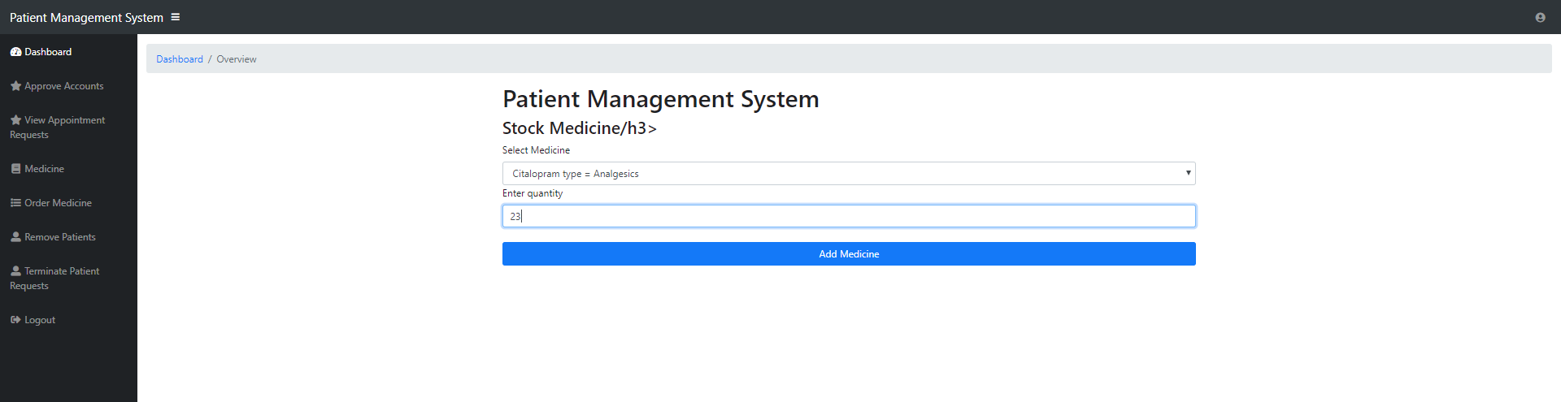

Here the secretary can order more medicine from a dropdown list.

Remove patients

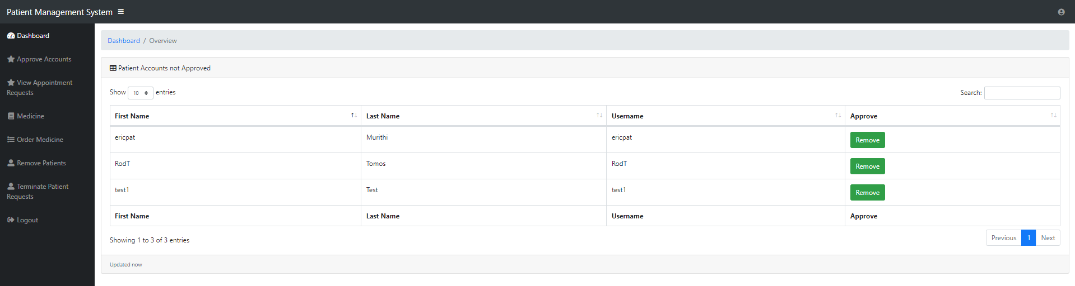

Here the secretary can remove patients

Accept termination requests

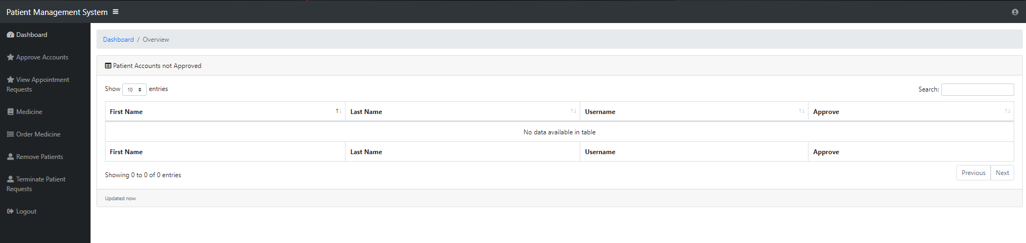

Here the secretary can accept a user’s request to terminate their account.

Doctors form

As an example we will login with the username of ‘erob’ and the password of ‘erob’.

Doctors Dashboard

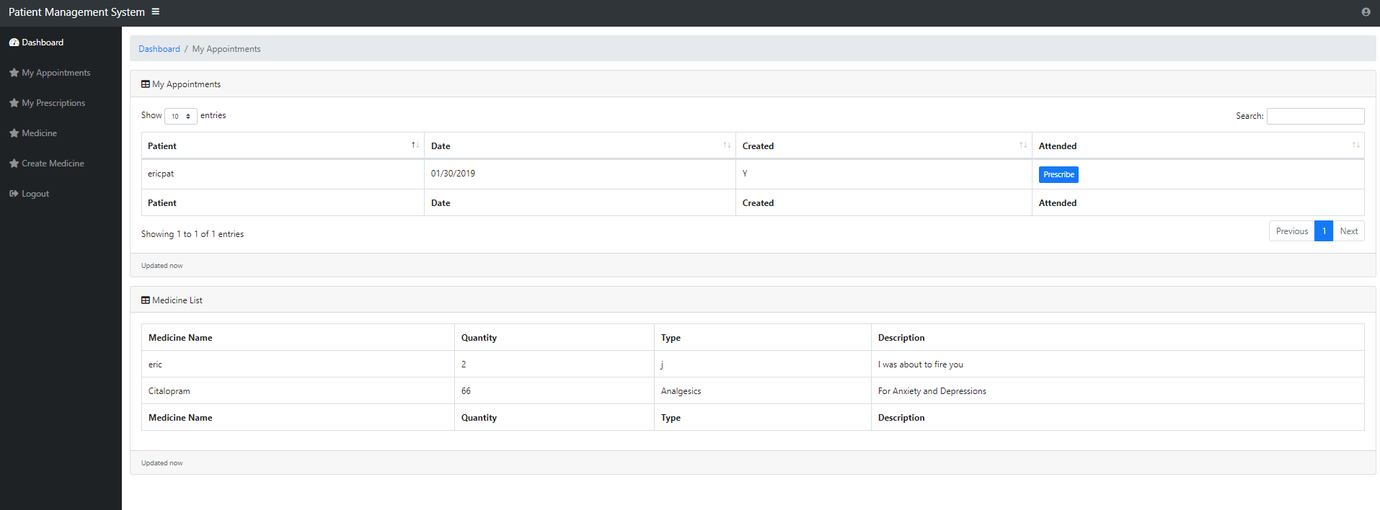

Here the doctor can see his upcoming appointments, prescribe patients and medicine list.

Doctors’ appointments

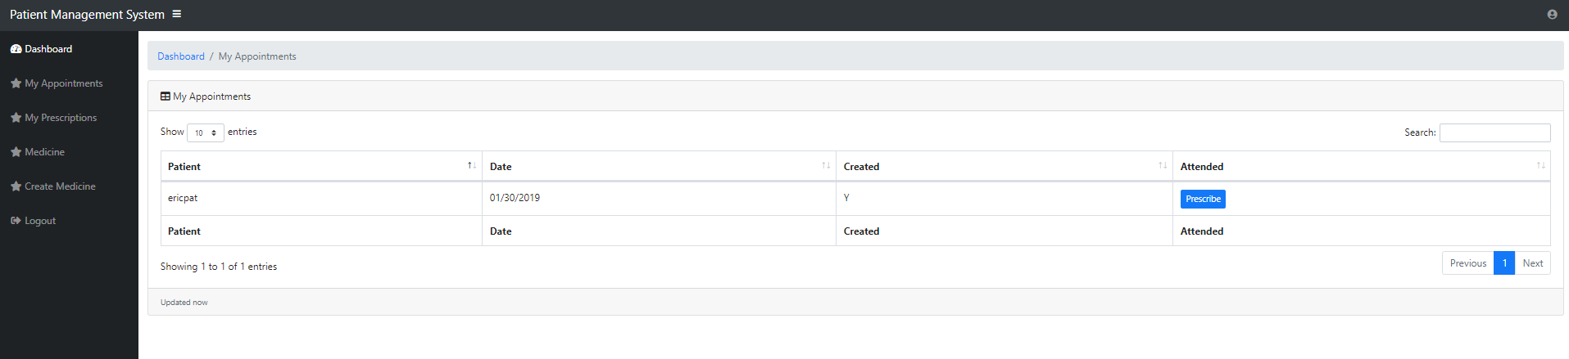

Here the doctor can see his appointments, by clicking the blue prescribe button the doctor gets taken to the prescription screen.

Assign Prescription

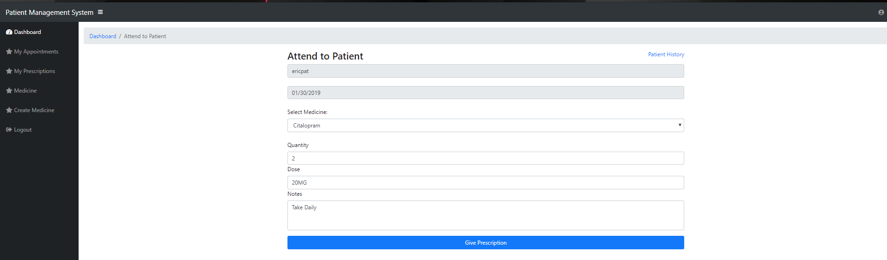

Here the patient that was selected in the previous form can be assigned a prescriptions.

Admin Prescriptions

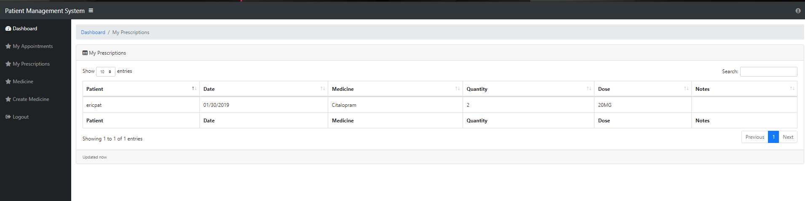

Here the admin can see the prescriptions he had made.

Admin Medicine

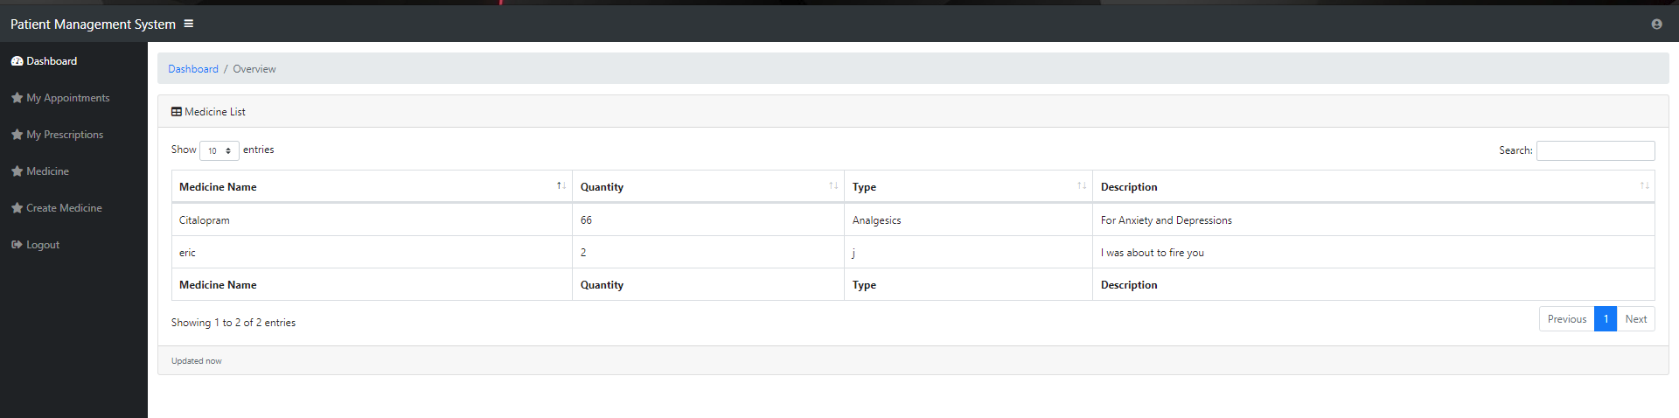

Here the admin can see the current stock of medicine

Create Medicine

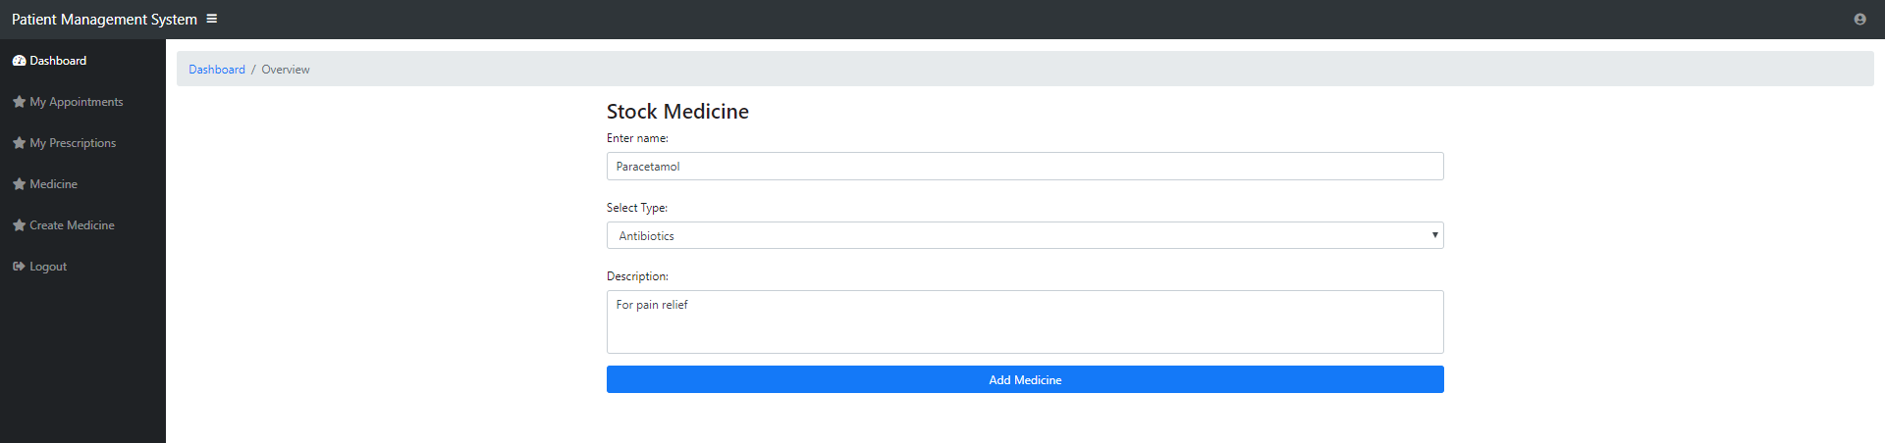

Here the doctor can add more medicine to the database, the stock must then be ordered by a secretary.