Molecular-window methods — multi-site comparison (Payerne, Amsterdam, EDT)
*Regenerated 2026-06-21 with the current method set (calibration/rayleigh/molecular_methods.py):
E-PROF v1.1 / v1.2 / v0.25 (MATLAB) / v2 (optimized C8), EARLINET/SCC, Bellini/ALICENET — the
calipso method has been retired (CALIOP's "highest clean layer" needs a stratosphere a ground-up ALC
lacks). Coefficients follow the Wiegner lidar constant C_L = RCS/β_att
([calibration_coefficient_convention.md](calibration_coefficient_convention.md)). L2 monthly data;
independent of the L1 grid fix.*
Sampled 35 nights (every 2nd day, Feb+Mar 2026) per instrument. n_cal = nights that calibrate through
the full pipeline (rel_error ≤ 15 %). CL_CV = night-to-night lidar-constant scatter (lower = more stable).
Small-sample caveat. Only 35 nights are sampled and most are cloudy, so n_cal is small (0–8 per
instrument) and CL_CV is noisy (e.g. v1.1's 71.8 % mean is driven by a couple of EDT/Payerne outliers).
Treat this as an illustrative cross-site spot-check; the statistically robust method evidence is the
full-network comparison ([network_v2_vs_v11_report.md](network_v2_vs_v11_report.md), 164 streams) and the
long-run ranking ([molecular_methods_longrun_report.md](molecular_methods_longrun_report.md)), both of
which favour v2 (C8) for precision and yield.
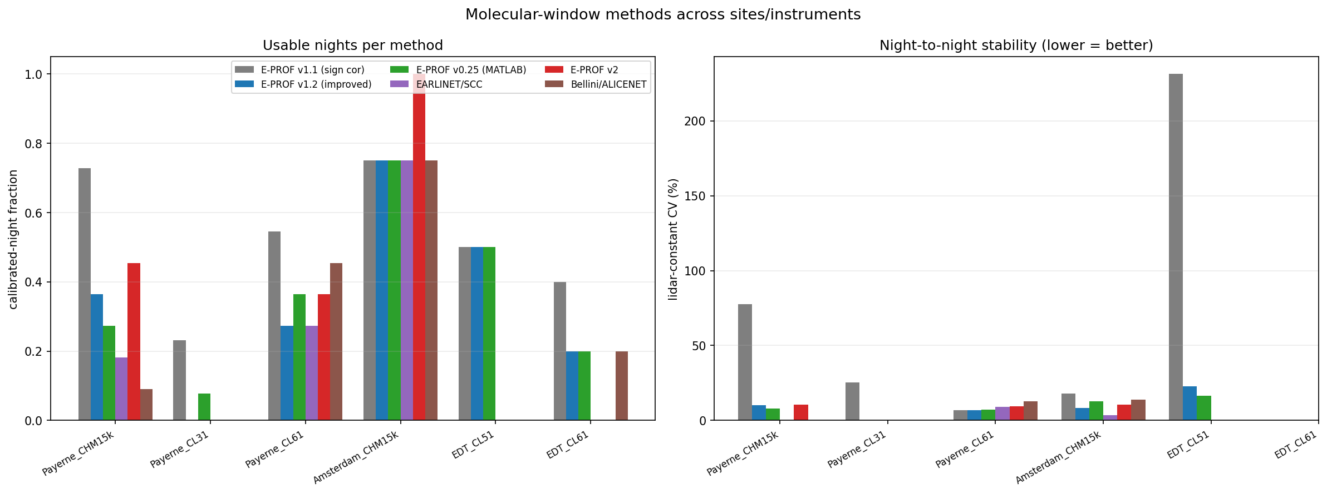
Usable-night fraction (left) and night-to-night lidar-constant CV (right) per method across the key stations.
inst | type | method | nights | n_cal | CL_CV% | med_R2 | med_tcv | med_rel%
Payerne_CHM15k | CHM15k | eprof_v1.1 | 11 | 8 | 77.6 | 0.654 | 1.14 | 3.5
Payerne_CHM15k | CHM15k | eprof_v1.2 | 11 | 4 | 10.1 | 0.963 | 0.54 | 11.0
Payerne_CHM15k | CHM15k | eprof_v0.25 | 11 | 3 | 8.1 | 0.894 | 0.80 | 3.1
Payerne_CHM15k | CHM15k | earlinet | 11 | 2 | - | 0.904 | 0.33 | 11.3
Payerne_CHM15k | CHM15k | eprof_v2 | 11 | 5 | 10.4 | 0.957 | 0.33 | 10.9
Payerne_CHM15k | CHM15k | bellini | 11 | 1 | - | 0.784 | 0.68 | 2.1
Payerne_CL31 | CL31 | eprof_v1.1 | 13 | 3 | 25.5 | 0.391 | 0.90 | 7.5
Payerne_CL31 | CL31 | eprof_v1.2 | 13 | 0 | - | - | - | -
Payerne_CL31 | CL31 | eprof_v0.25 | 13 | 1 | - | 0.545 | 7.99 | 10.3
Payerne_CL31 | CL31 | earlinet | 13 | 0 | - | - | - | -
Payerne_CL31 | CL31 | eprof_v2 | 13 | 0 | - | - | - | -
Payerne_CL31 | CL31 | bellini | 13 | 0 | - | - | - | -
Payerne_CL61 | CL61 | eprof_v1.1 | 11 | 6 | 6.8 | 0.981 | 0.24 | 8.2
Payerne_CL61 | CL61 | eprof_v1.2 | 11 | 3 | 6.7 | 0.991 | 0.21 | 4.1
Payerne_CL61 | CL61 | eprof_v0.25 | 11 | 4 | 7.2 | 0.981 | 0.29 | 8.3
Payerne_CL61 | CL61 | earlinet | 11 | 3 | 9.0 | 0.691 | 0.23 | 5.6
Payerne_CL61 | CL61 | eprof_v2 | 11 | 4 | 9.3 | 0.956 | 0.30 | 8.9
Payerne_CL61 | CL61 | bellini | 11 | 5 | 12.9 | 0.756 | 0.42 | 9.3
Amsterdam_CHM15k | CHM15k | eprof_v1.1 | 4 | 3 | 18.0 | 0.932 | 0.31 | 4.8
Amsterdam_CHM15k | CHM15k | eprof_v1.2 | 4 | 3 | 8.2 | 0.987 | 0.08 | 4.5
Amsterdam_CHM15k | CHM15k | eprof_v0.25 | 4 | 3 | 12.9 | 0.963 | 0.28 | 5.2
Amsterdam_CHM15k | CHM15k | earlinet | 4 | 3 | 3.5 | 0.962 | 0.08 | 3.6
Amsterdam_CHM15k | CHM15k | eprof_v2 | 4 | 4 | 10.7 | 0.978 | 0.14 | 7.2
Amsterdam_CHM15k | CHM15k | bellini | 4 | 3 | 13.7 | 0.949 | 0.23 | 3.4
EDT_CL51 | CL51 | eprof_v1.1 | 6 | 3 | 231.3 | 0.983 | 0.79 | 5.5
EDT_CL51 | CL51 | eprof_v1.2 | 6 | 3 | 22.9 | 0.899 | 0.17 | 12.8
EDT_CL51 | CL51 | eprof_v0.25 | 6 | 3 | 16.5 | 0.979 | 0.33 | 1.6
EDT_CL51 | CL51 | earlinet | 6 | 0 | - | - | - | -
EDT_CL51 | CL51 | eprof_v2 | 6 | 0 | - | - | - | -
EDT_CL51 | CL51 | bellini | 6 | 0 | - | - | - | -
EDT_CL61 | CL61 | eprof_v1.1 | 5 | 2 | - | 0.888 | 0.76 | 5.8
EDT_CL61 | CL61 | eprof_v1.2 | 5 | 1 | - | 0.985 | 0.08 | 10.6
EDT_CL61 | CL61 | eprof_v0.25 | 5 | 1 | - | 0.938 | 0.53 | 0.2
EDT_CL61 | CL61 | earlinet | 5 | 0 | - | - | - | -
EDT_CL61 | CL61 | eprof_v2 | 5 | 0 | - | - | - | -
EDT_CL61 | CL61 | bellini | 5 | 1 | - | 0.842 | 0.76 | 14.8
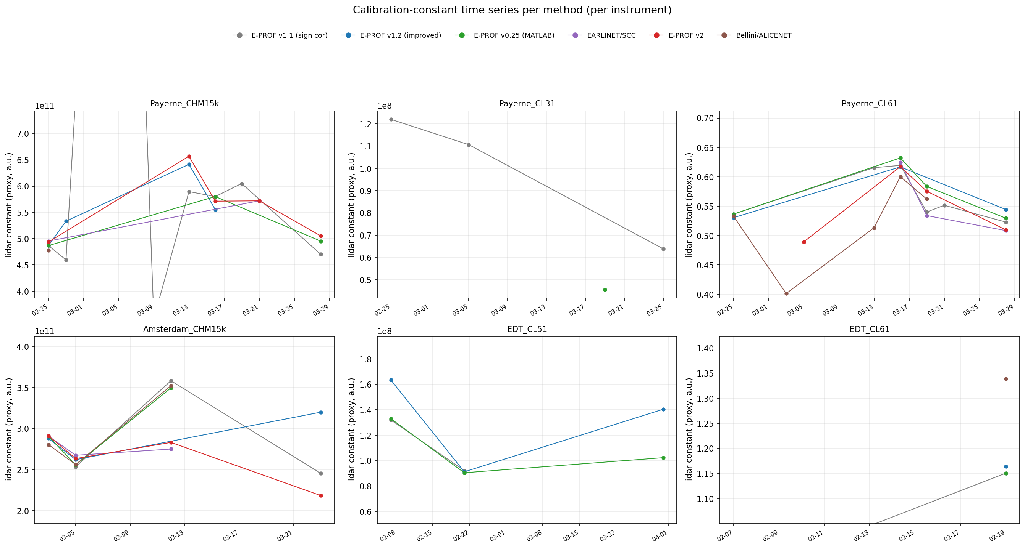
Per-method nightly lidar-constant time series across the sampled nights (one panel per instrument).

Ranking (mean over instruments)
method | calibrated-fraction | mean CL_CV% | mean temporal_cv | score
eprof_v1.2 | 0.35 | 12.0 | 0.22 | 0.286
eprof_v2 | 0.30 | 10.1 | 0.26 | 0.241
earlinet | 0.20 | 6.2 | 0.21 | 0.165
bellini | 0.25 | 13.3 | 0.52 | 0.164
eprof_v0.25 | 0.36 | 11.2 | 1.70 | 0.133
eprof_v1.1 | 0.53 | 71.8 | 0.69 | 0.087
Best overall on this small multi-site sample: eprof_v1.2 (highest usable-night fraction at
competitive stability); eprof_v2 (C8) is a close second (0.241 vs 0.286) and wins on the much larger
network and long-run samples. earlinet is the most *stable* where it calibrates (mean CL_CV 6.2 %) but
the lowest-yield (calibrated-fraction 0.20). v1.1's apparent high yield comes with a runaway CL_CV (71.8 %)
from a few unstable nights — the precision penalty the gated v2/v1.2 methods were designed to remove.

Detail figures (representative instruments)
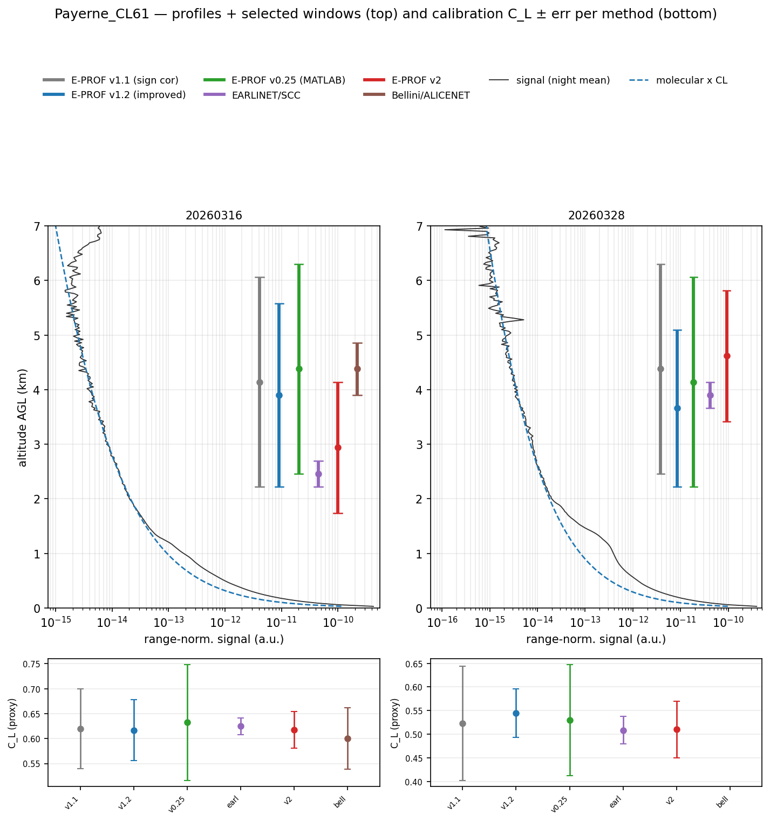
Payerne CL61 — per-method molecular windows on representative nights, and the signal/molecular time-height with selected centres.
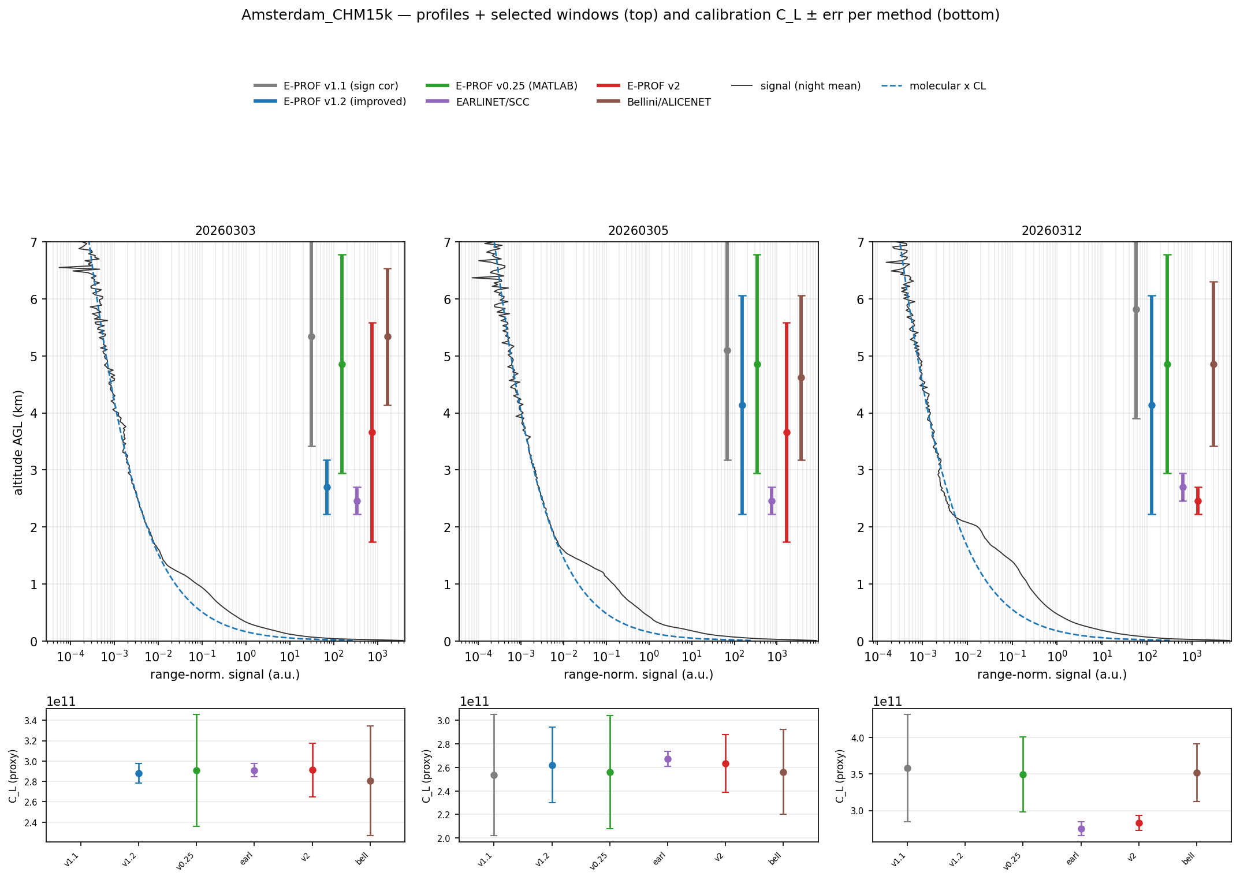
Amsterdam CHM15k — per-method molecular windows.
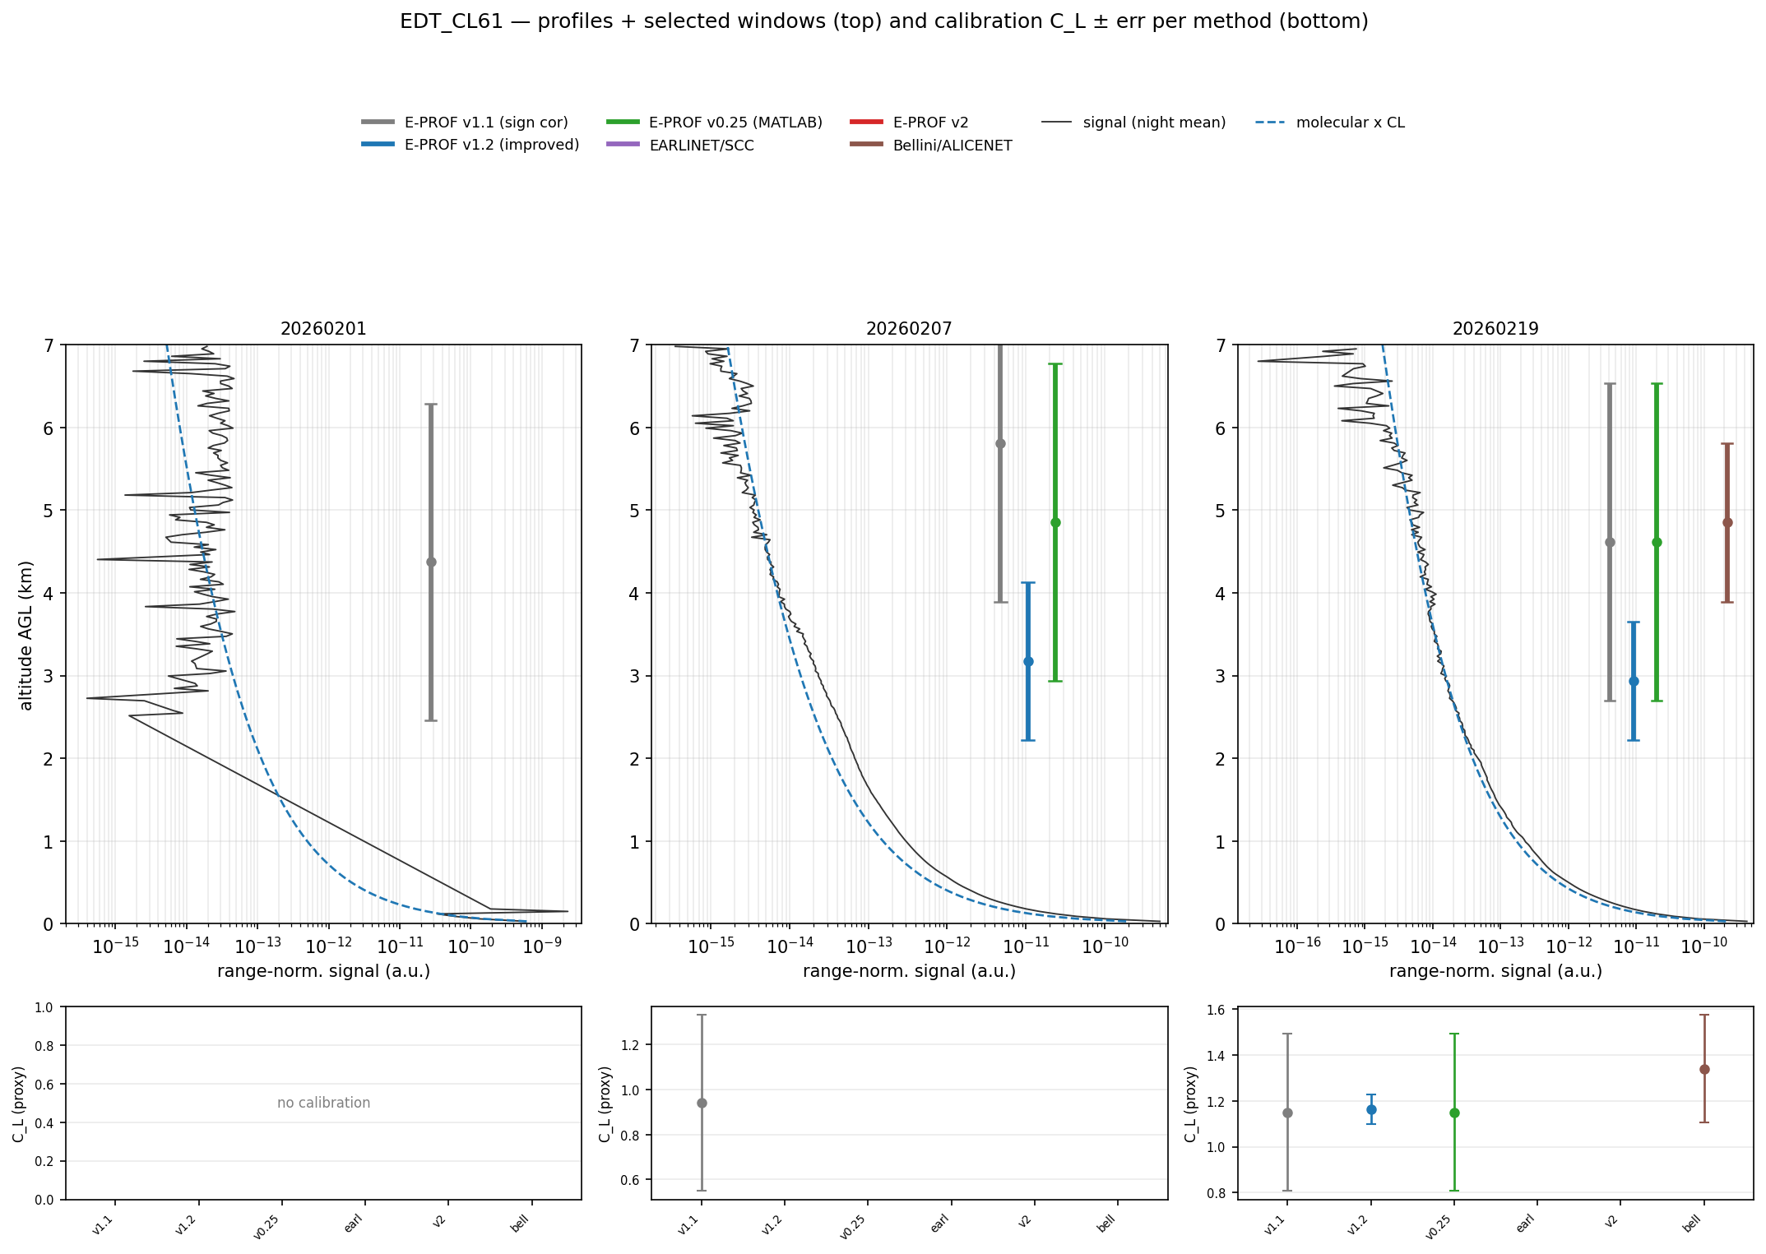
EDT CL61 — per-method molecular windows.

Reproduce
python -m validation.compare_molecular_methods # -> figs_paper_validation/molecular_methods/
python validation/embed_report.py doc/reports/method_comparison_multisite.md
python -m validation.md_to_docx doc/reports/method_comparison_multisite.md

