**xxx. Operation modes:**

**In the current version of the telescope control software (Python script) sunpos_AZI_ELE.py, there are several modes implemented as briefly described below, together with examples of light-curves. For testing, experimenting we suggest to use sunpos_AZI_ELE.py in Anaconda Python3 Spyder which allows to dump variables and checking constants as well as results. Once the system is aligned and ready for regular observation it is suggested to use the System Scheduler ssfree.exe from** *Splinterware Software Solutions*. Edit function call to the batch file tracksun.bat which then calls the Python script. Select hours of observation and every minute. Screenshot examples of ssfree.exe at the bottom of this document. So there is no loop inside the Python script, the script is executed once every minute such that in case of a bug or error the script is executed again from scratch.

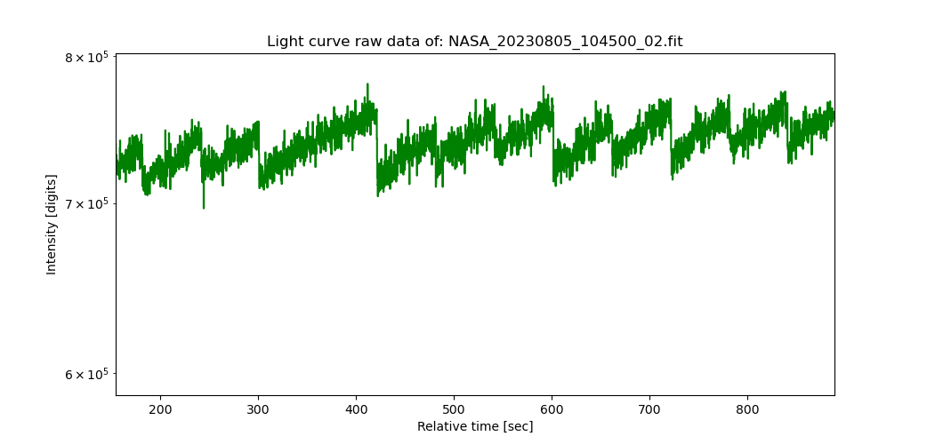

Fig. x: Simplest operating mode is just tracking source, once every minute.

This mode shown in figure x is ideal to align the telescope mechanically and by software. One adjusts both references aziref and eleref in steps of +/-0.5° … +/-1° until light curve shows maximum. After each change of references the script must be run within Spyder. The noisy zig-zag in the above light-curve is given by the fact the within one minute the sun already moves slightly in or out of the antenna beam. But it demonstrates that the tracking system is working. For this mode set parameter to:  
CaliProc = False # No calibration process during alignment!  
scanning = False # No scanning of the sun during alignment!

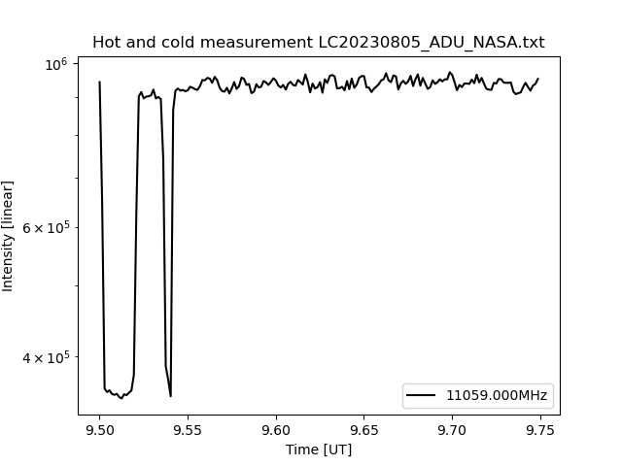

Fig. x: Operation mode = tracking source plus calibration on cold sky and hot ground.

This mode shown in figure x is useful, once the telescope is aligned with best known values for aziref and eleref. This mode might be best for eclipse observations as the calibration is ‘disturbing’ the observation only once in 15 minutes. But it allows to calibrate the signal in terms of antenna temperature and finally to estimate solar radio flux in X-band. First drop at the beginning every modulo 15 minutes is cold sky about 10° below or above the current sun position. After one minute the telescope moves down to ground to measure hot source of about 300 kelvin. Then the antenna moves back to the sun and shortly ‘sees’ cold sky again, often interfered by commercial and military satellites which produce very hot interfering signals. After a third minute the usual tacking mode continuous automatically.  
For this mode set parameter to:  
CaliProc = True # Calibration process during required during observation  
scanning = False # No scanning of the sun during calibrated observations

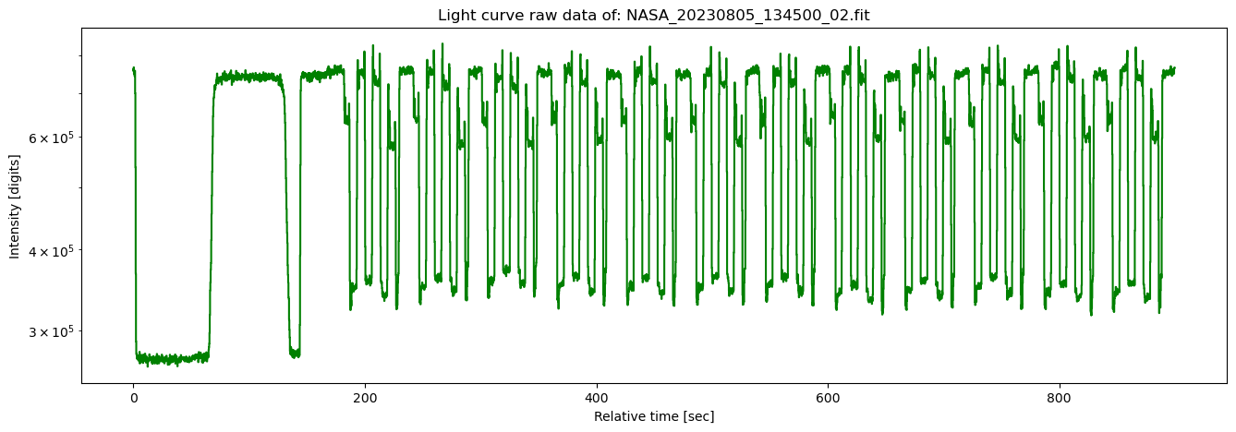

Fig. x: Operation mode = tracking source plus calibration on cold sky and hot ground plus scanning while tracking.

This mode shown in figure x is useful, when flux measurements are planned. Scanning of an area around the calculated position of the sun by ~1.8° x 1.8° in both directions, elevation and azimuth allows to find peak value of solar flux. On the left we again see first cold sky, then hot ground and briefly again cold sky while the telescope moves upwards to the sun. Then the scanning starts over 15 positions which fit in one minute of time, then starts again. Software then averages the peak values of each scan and calculates solar radio flux. This mode is not suggested for solar eclipse observations as there are too many movements of the antenna and one might hardly see the drop during totality. For this mode set parameter to:  
CaliProc = True # Calibration process during required during observation  
scanning = True # No scanning of the sun during calibrated observations

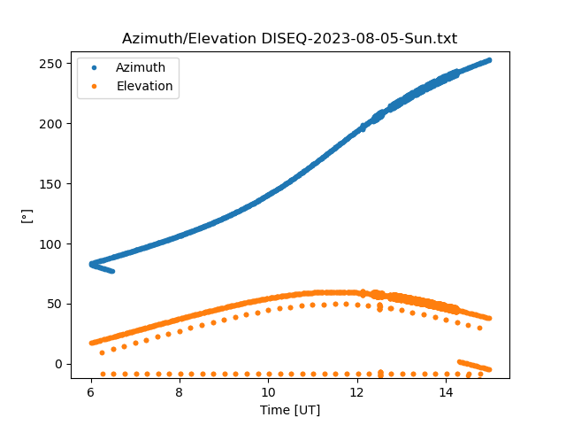

Fig. x: Plot of azimuth and elevation during one day of observation. Solid line shows the tacking path while the dots show calibration positions. Thick solid line shows scanning mode in azimuth and elevation. Non-smooth line at the beginning is given when the telescope moves from parking position to the actual position of the sun. Similarly, at the end of observation the telescope moves back into parking position

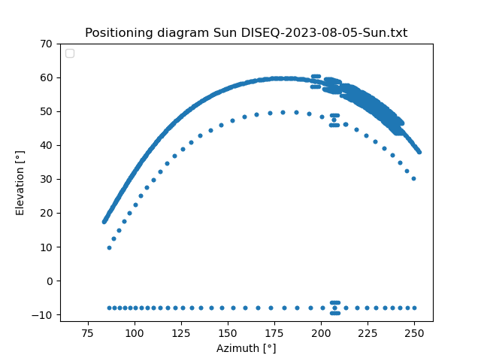

Fig. x: Same data as in figure above but now elevation as function azimuth for Saturday, August 5th 2023. Again, solid line denotes to tracking while dots indicate calibration. Wide solid line denotes to scanning mode in azimuth and elevation.

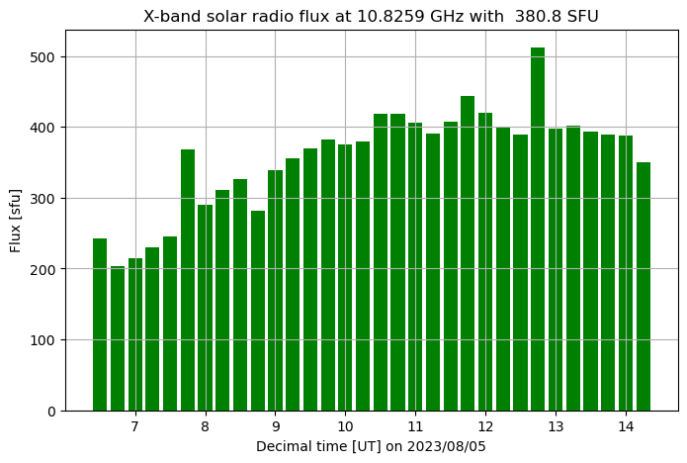

Fig. x: Calculated radio flux of the sun. Till about 12:30 UT the telescope was just tracking combined with calibration sequences but, the telescope was not perfectly aligned. After about 12:30 UT scanning mode was activated which allows to get peak flux over hours. Once the telescope is perfectly aligned, tracking, calibrating and scanning, the average value (during scanning mode) is about 400 SFU. The frequency interpolated flux from OwenDuffy.net was given to 400.9 SFU.

Configuration of System Scheduler ssfree.exe to execute Python script once every minute. For testing, experimenting and software updates the application should be disabled. Otherwise the script might be executed as an instance which ends up in a conflict because COM-port are not re-entrant.

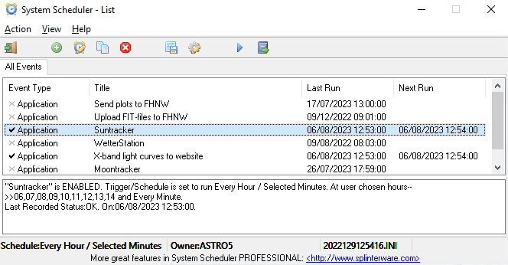

Fig. x: System Scheduler with different periodic calls. In our case relevant are Suntracker and as an option X-band light curve to website.

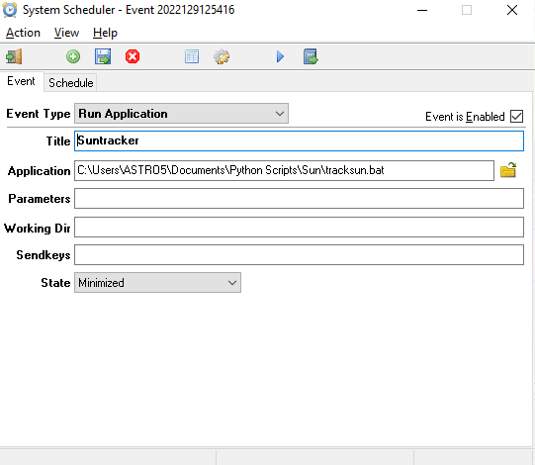

Fig. x: Window to edit function call, here batch file tracksun.bat.

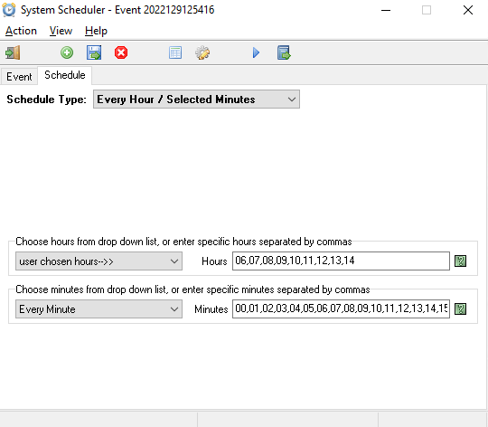

Fig. x: Window to edit time of operation. Here it was chosen 06 UT … 14 UT, the average time when the sun is above the horizon in Europe. Call will be triggered every minute 00, 01, ….59.