**Homework 8**

Noise Removal

R09921119 許凱荃

* Write a program which does:
  + (a) Generate noisy images with gaussian noise (amplitude of 10 and 30)
  + (b) Generate noisy images with salt-and-pepper noise (probability 0.1 and 0.05)
  + (c) Use the 3x3, 5x5 box filter on images generated by (a)(b)
  + (d) Use 3x3, 5x5 median filter on images generated by (a)(b)
  + (e) Use both opening-then-closing and closing-then opening filter (using the octogonal 3-5-5-5-3 kernel, value = 0) on images generated by (a)(b)
  + You must calculate the signal-to-ratio (SNR) for each instance(4 noisy images and 24 processed images)

**Outline** :

* Method
* Result
* SNR Table

**Method**

* Gaussian Noise : 每個 pixel 加上高斯函數所產生之變量。

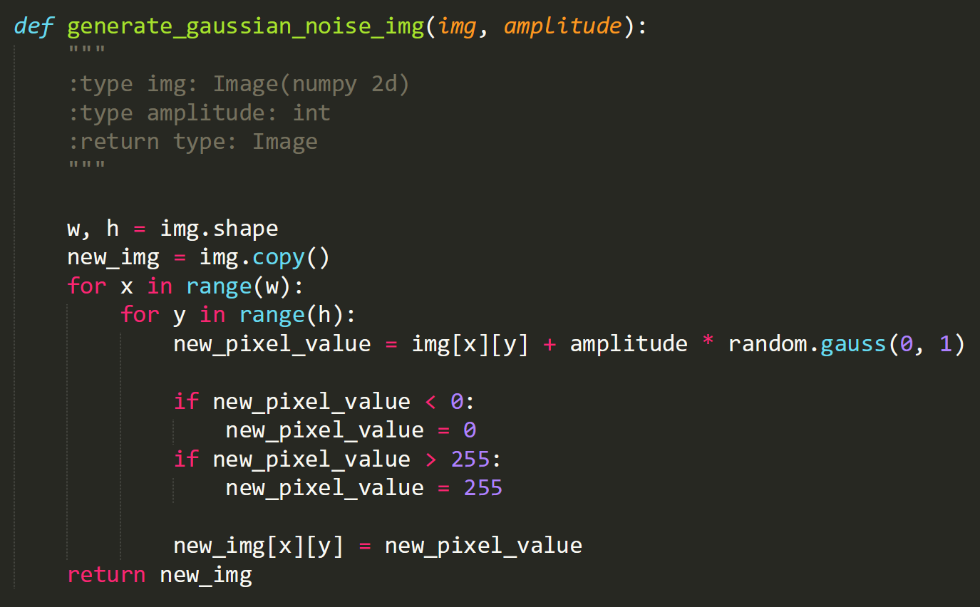

* Salt-and-Pepper Noise : 每個 pixel 隨機設定成Salt or Pepper。

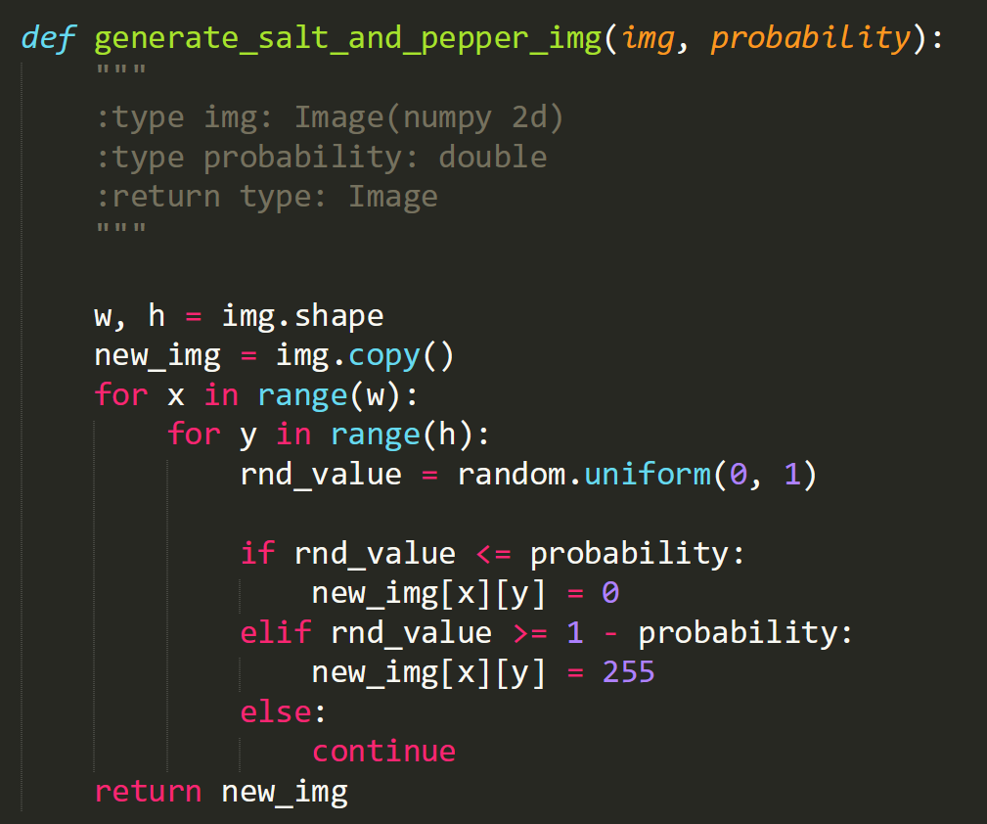

* Box Filter : 正方形內的 pixel 做平均取其值。  
  數值若有差異，可能與邊界有關。

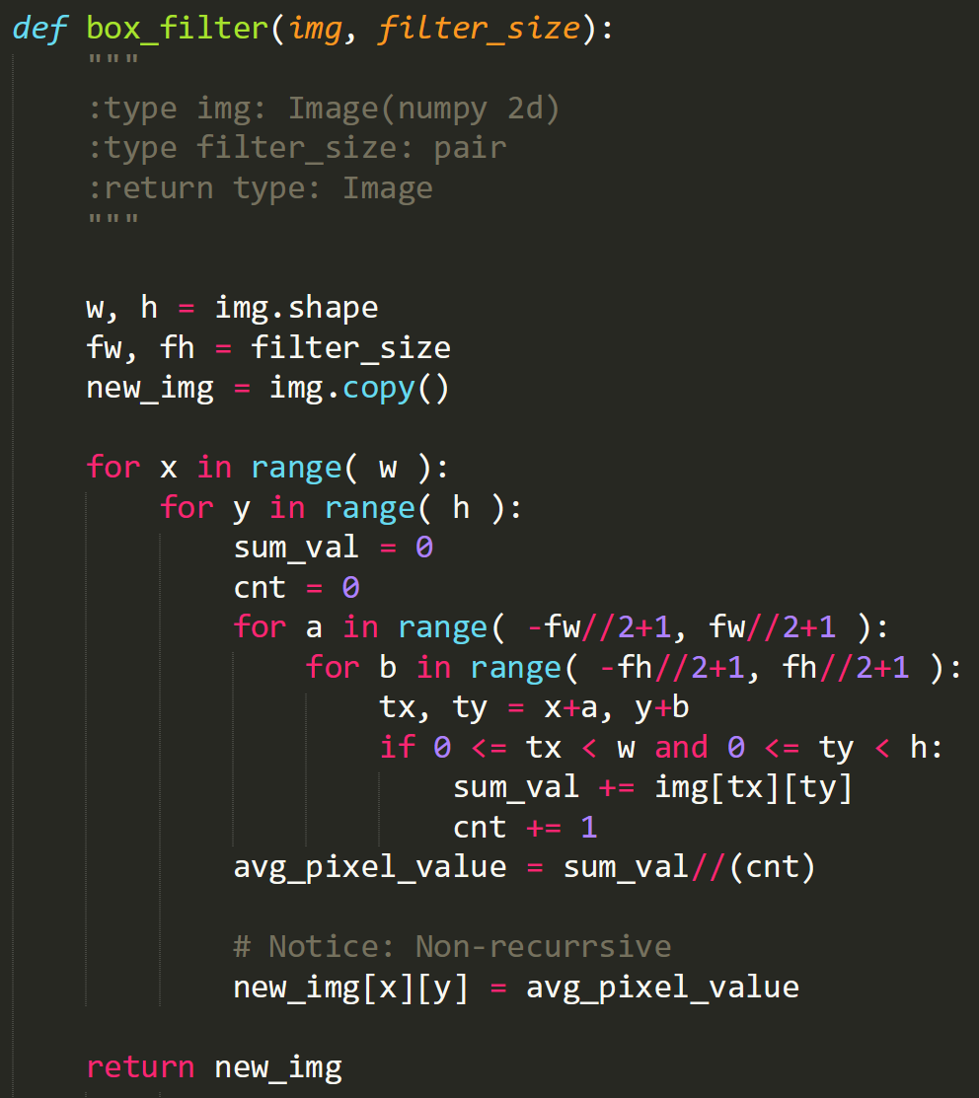

* Median Filter : 正方形內的 pixel 找其中位數取其值。

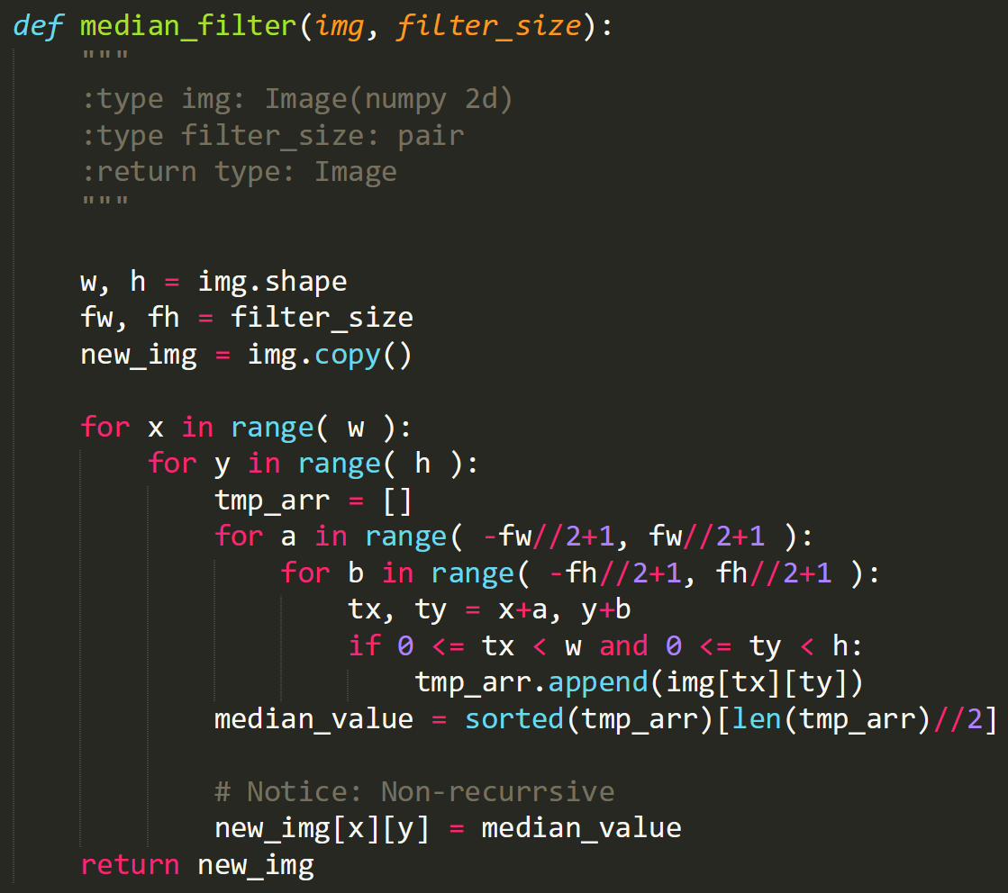

* Calculate SNR :   
  註 : 假設 Noise image 和 Source Image 同個 Size。

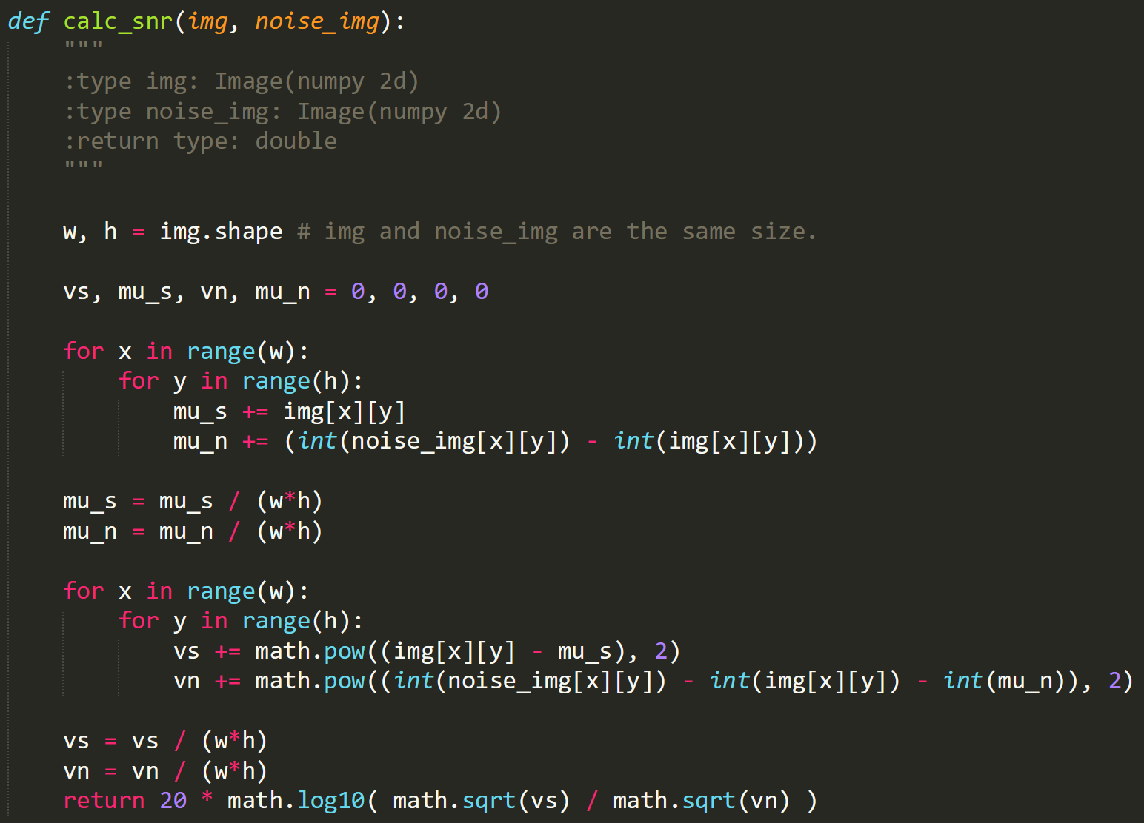

**Image Result**

* **Gaussian noise, amplitude of 10**

|  |  |
| --- | --- |
|  | |
| Gaussian noise, amplitude=10, SNR = 13.581 | |
|  |  |
| Box_3x3, SNR = 17.630 | Box_5x5, SNR = 14.812 |
|  |  |
| Median_3x3, SNR = 17.604 | Median_5x5, SNR = 15.950 |
|  |  |
| Opening-then-closing, SNR = 13.235 | Closing-then-opening, SNR = 13.605 |

* **Gaussian noise, amplitude of 30**

|  |  |
| --- | --- |
|  | |
| Gaussian noise, amplitude=30, SNR = 4.168 | |
|  |  |
| Box_3x3, SNR = 12.566 | Box_5x5, SNR = 13.256 |
|  |  |
| Median_3x3, SNR = 11.070 | Median_5x5, SNR = 12.874 |
|  |  |
| Opening-then-closing, SNR = 11.155 | Closing-then-opening, SNR = 11.234 |

* **Salt-and-pepper noise, probability=0.1**

|  |  |
| --- | --- |
|  | |
| Salt-and-pepper noise, probability=0.1, SNR = -2.109 | |
|  |  |
| Box_3x3, SNR = 6.337 | Box_5x5, SNR = 8.515 |
|  |  |
| Median_3x3, SNR = 15.278 | Median_5x5, SNR = 15.684 |
|  |  |
| Opening-then-closing, SNR = -2.057 | Closing-then-opening, SNR = -2.569 |

* **Salt-and-pepper noise, probability=0.05**

|  |  |
| --- | --- |
|  | |
| Salt-and-pepper noise, probability=0.05, SNR = 0.906 | |
|  |  |
| Box_3x3, SNR = 9.430 | Box_5x5, SNR = 11.149 |
|  |  |
| Median_3x3, SNR = 18.947 | Median_5x5, SNR = 16.359 |
|  |  |
| Opening-then-closing, SNR = 5.242 | Closing-then-opening, SNR = 5.270 |

**SNR Table**

|  |  |  |  |
| --- | --- | --- | --- |
| Filter | | **Gaussian noise** | |
| Amplitude = 10 | amplitude = 30 |
| No Filter | | 13.581 | 4.168 |
| Box | 3x3 | 17.630 | 12.566 |
| 5x5 | 14.812 | 13.256 |
| Median | 3x3 | 17.604 | 11.070 |
| 5x5 | 15.950 | 12.874 |
| Opening-then-closing | | 13.235 | 11.155 |
| Closing-then-opening | | 13.605 | 11.234 |

|  |  |  |  |
| --- | --- | --- | --- |
| Filter | | **Salt-and-pepper noise** | |
| Probability = 0.1 | Probability = 0.05 |
| No Filter | | -2.109 | 0.906 |
| Box | 3x3 | 6.337 | 9.430 |
| 5x5 | 8.515 | 11.149 |
| Median | 3x3 | 15.278 | 18.947 |
| 5x5 | 15.684 | 16.359 |
| Opening-then-closing | | -2.057 | 5.242 |
| Closing-then-opening | | -2.569 | 5.270 |

助教辛苦了 : )