Homework 1 for **Kun**

Introduce to image process

All codes are attached on the last page.

Q1a:

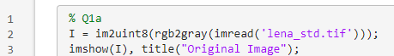

Res:

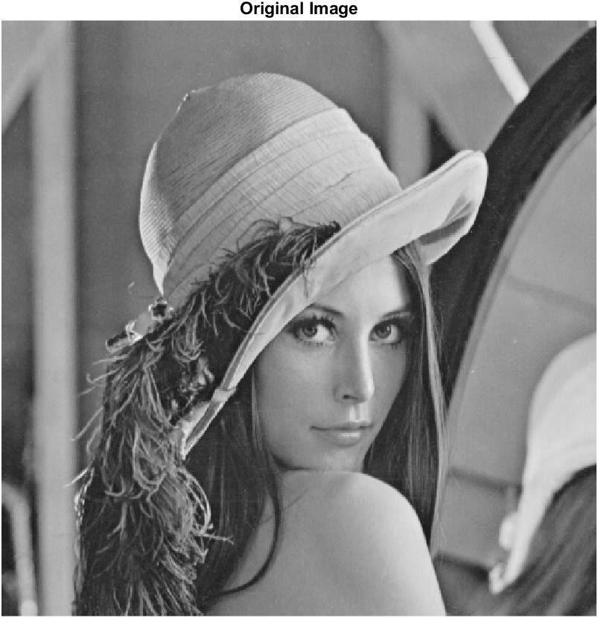

Q1b & Q1c & Q1d:

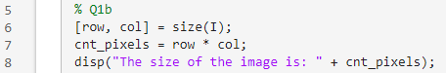

Res:

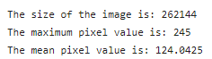

­Q1e:

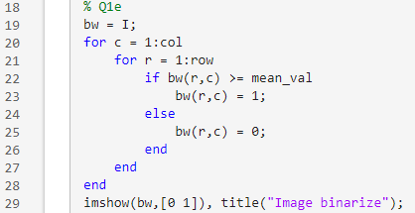

Res:

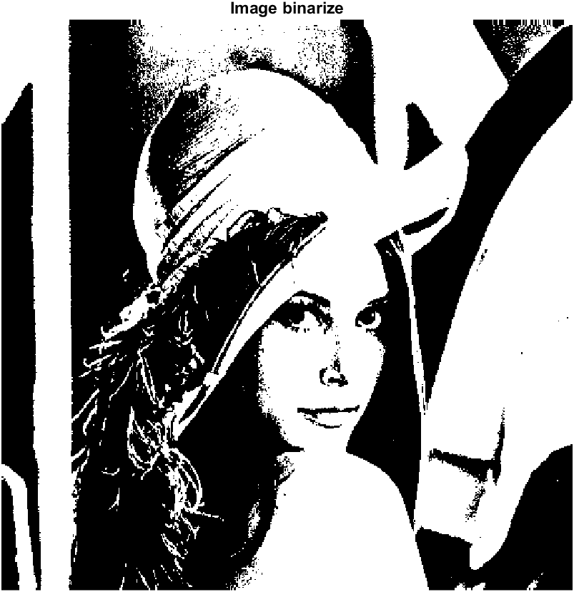

It is image binarize.

Q2:

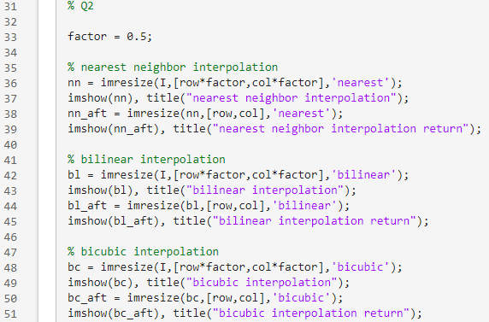

Res:

Nearest neighbor interpolation:

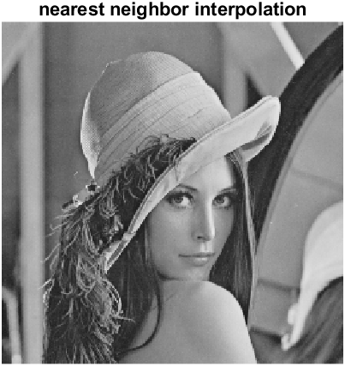

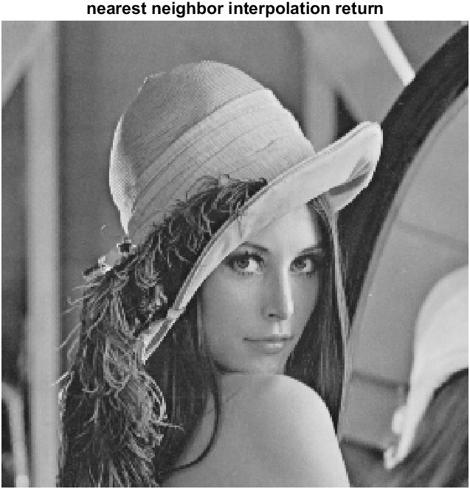

Bilinear interpolation:

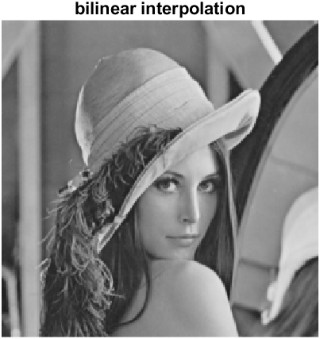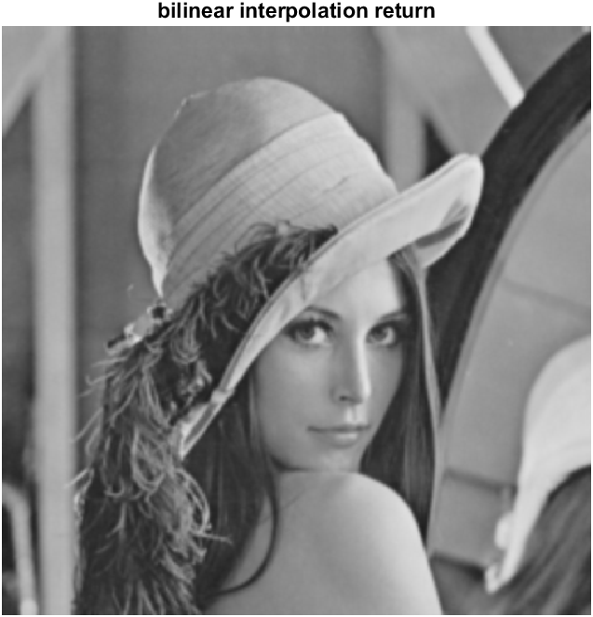

Bicubic interpolation:

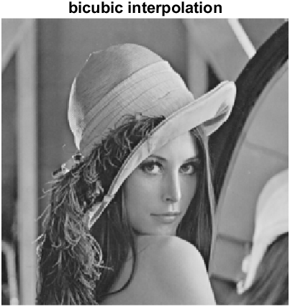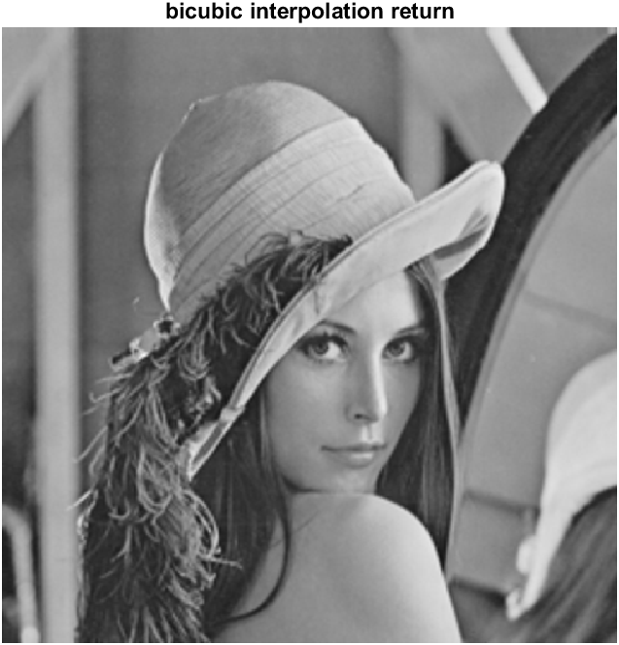

Customized factor:

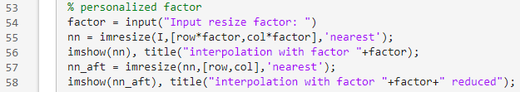

Res:



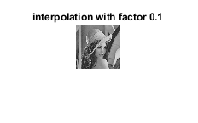

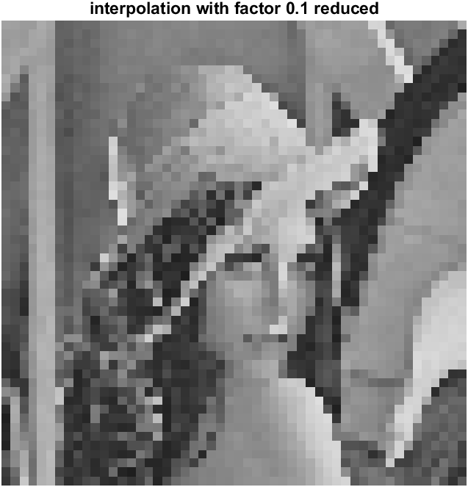

Q3:

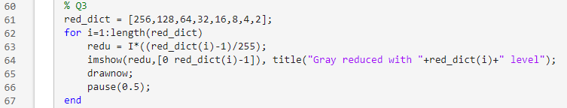

Res:

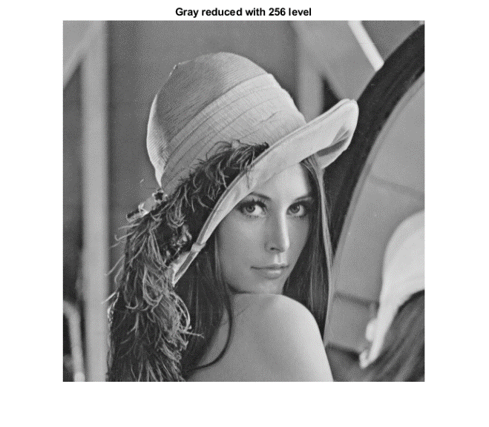

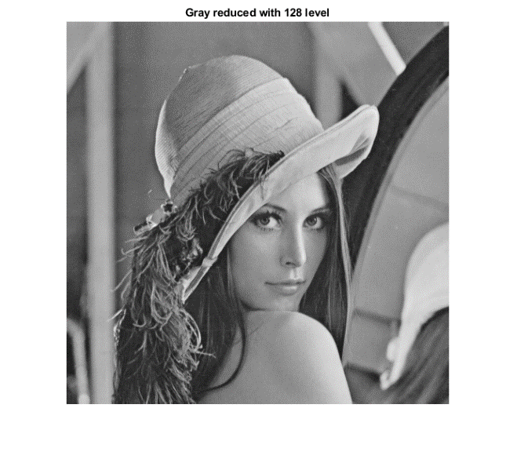

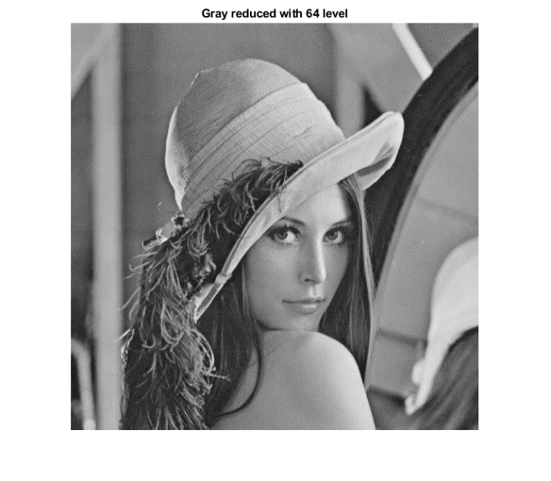

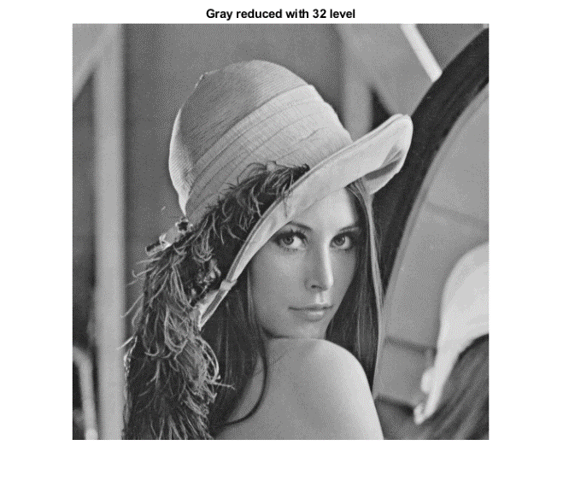

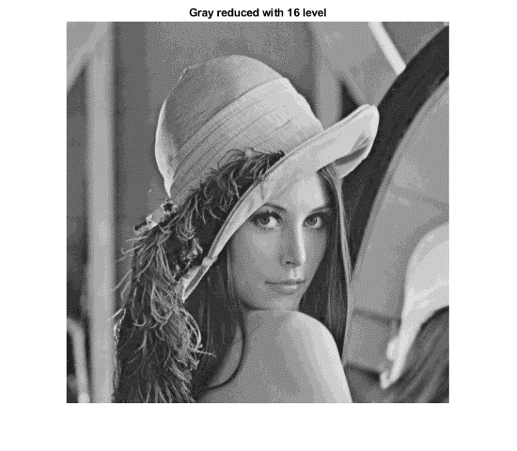

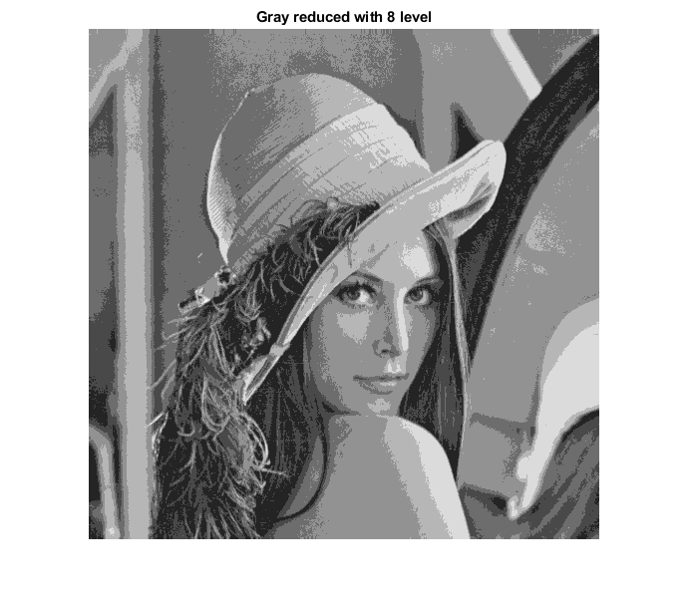

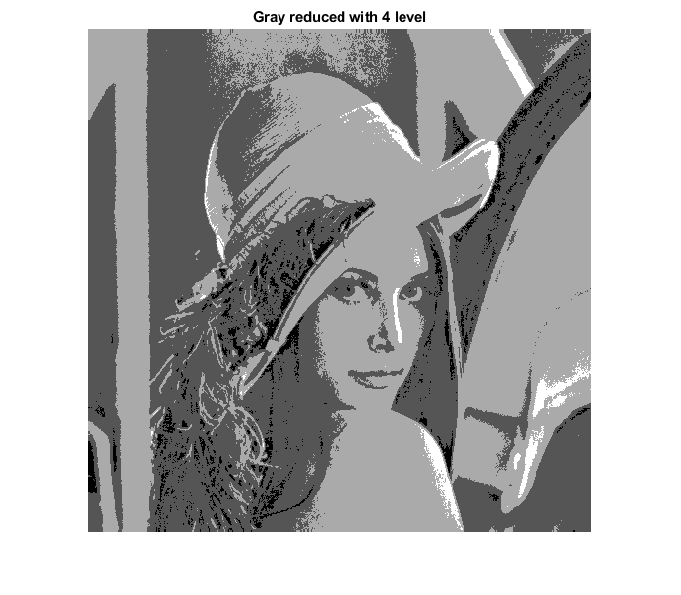

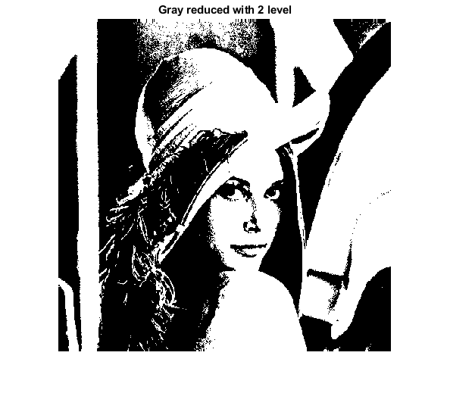

Customized Gray reduce factor:



Res:

 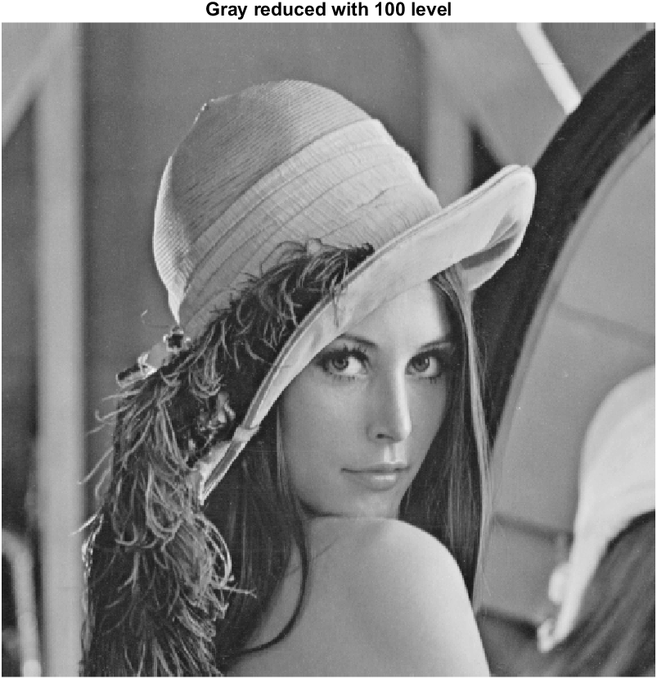

% Q1a

I = im2uint8(rgb2gray(imread('lena_std.tif')));

imshow(I), title("Original Image");

% Q1b

[row, col] = size(I);

cnt_pixels = row * col;

disp("The size of the image is: " + cnt_pixels);

% Q1c

max_val = max(I(:));

disp("The maximum pixel value is: " + max_val);

% Q1d

mean_val = mean(I(:));

disp("The mean pixel value is: " + mean_val);

% Q1e

bw = I;

for c = 1:col

for r = 1:row

if bw(r,c) >= mean_val

bw(r,c) = 1;

else

bw(r,c) = 0;

end

end

end

imshow(bw,[0 1]), title("Image binarize");

% Q2

factor = 0.5;

% nearest neighbor interpolation

nn = imresize(I,[row*factor,col*factor],'nearest');

imshow(nn), title("nearest neighbor interpolation");

nn_aft = imresize(nn,[row,col],'nearest');

imshow(nn_aft), title("nearest neighbor interpolation return");

% bilinear interpolation

bl = imresize(I,[row*factor,col*factor],'bilinear');

imshow(bl), title("bilinear interpolation");

bl_aft = imresize(bl,[row,col],'bilinear');

imshow(bl_aft), title("bilinear interpolation return");

% bicubic interpolation

bc = imresize(I,[row*factor,col*factor],'bicubic');

imshow(bc), title("bicubic interpolation");

bc_aft = imresize(bc,[row,col],'bicubic');

imshow(bc_aft), title("bicubic interpolation return");

% personalized factor

factor = input("Input resize factor: ");

nn = imresize(I,[row*factor,col*factor],'nearest');

imshow(nn), title("interpolation with factor "+factor);

nn_aft = imresize(nn,[row,col],'nearest');

imshow(nn_aft), title("interpolation with factor "+factor+" reduced");

% Q3

red_dict = [256,128,64,32,16,8,4,2];

for i=1:length(red_dict)

redu = I*((red_dict(i)-1)/255);

imshow(redu,[0 red_dict(i)-1]), title("Gray reduced with "+red_dict(i)+" level");

drawnow;

pause(0.5);

end

ngray_lev = input("Input gray reduce factor: ");

redu = I*((ngray_lev-1)/255);

imshow(redu,[0 ngray_lev-1]), title("Gray reduced with "+ngray_lev+" level");