Homework 2 for **Kun**

Introduce to image process

All codes are attached on the last page.

Q1a:



Res:

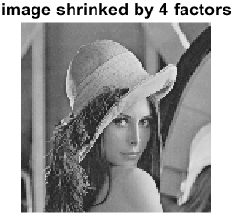

Q1b:



Res:

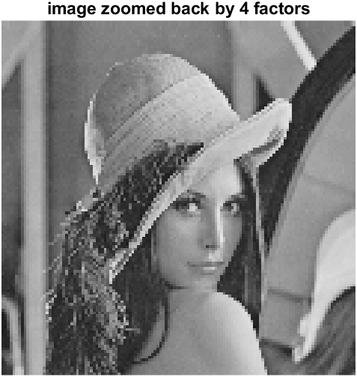

When shrinking, it lost some detail information.

Q2a: 

Res:

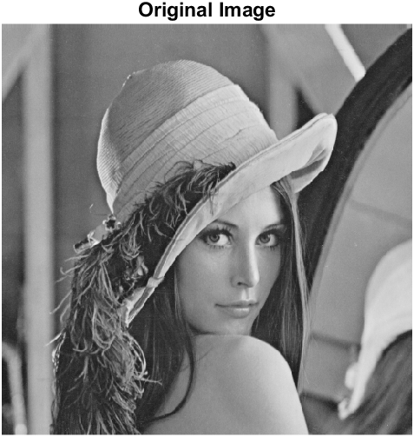

Q2b:



Res:

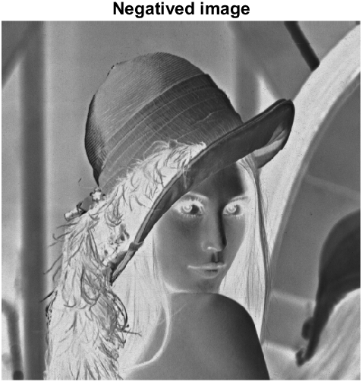

Q2c:

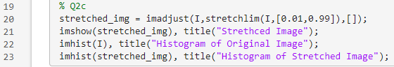

Res:

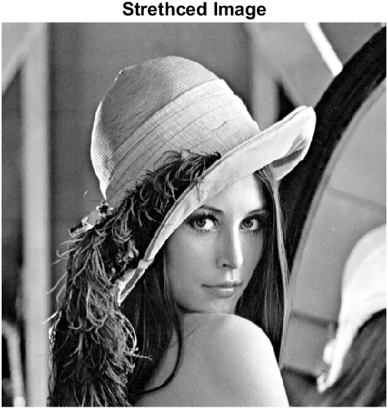 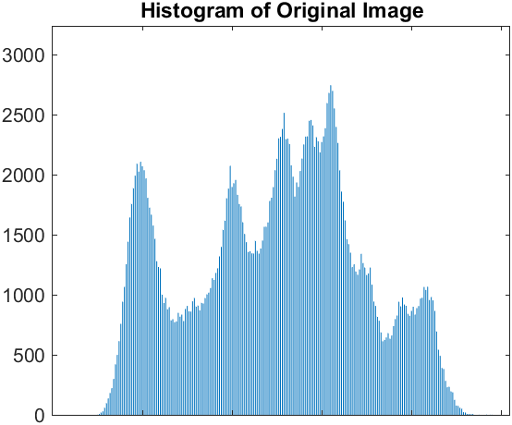

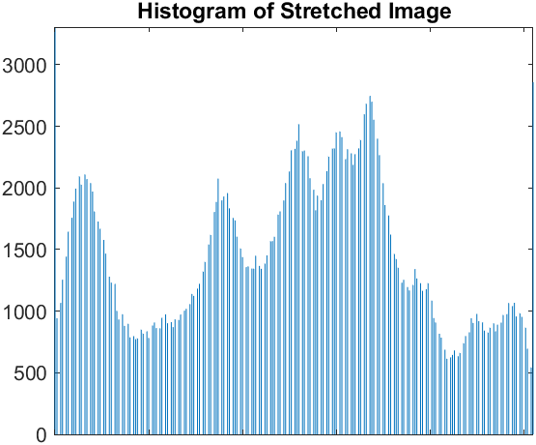

Work by hand Questions:

a)

Shortest path for N4 is not exist, because before the q pixels, which is 1, do not have {0,1} included for N4.

Shortest path for N8 is: p – 1 – 0 – 1 – 0 – 1 – q

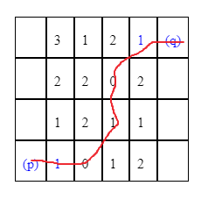

b)

D4 = 8

D8 = 3

Nope, Shortest path depends on the values of each block but D4 and D8 not.

I = im2uint8(rgb2gray(imread('lena_std.tif')));

% Q1a

shinked_res = q1(I,-4);

imshow(shinked_res), title("image shrinked by 4 factors");

% Q1b

zoomed_res = q1(shinked_res,4);

imshow(zoomed_res), title("image zoomed back by 4 factors");

% Q2a

I = im2uint8(rgb2gray(imread('lena_std.tif')));

imshow(I), title("Original Image");

% Q2b

img_neg = 255 - I;

imshow(img_neg), title("Negatived image");

% Q2c

stretched_img = imadjust(I,stretchlim(I,[0.01,0.99]),[]);

imshow(stretched_img), title("Strethced Image");

imhist(I), title("Histogram of Original Image");

imhist(stretched_img), title("Histogram of Stretched Image");

function res = q1(img, f)

f = int32(f);

[r,c] = size(img);

% image zooming

if f>0

% row pixel replication

for i = 1:r

for j = 1:c

for k = 1:f

img2(i,(j-1)*f+k) = img(i,j);

end

end

end

% col pixel replication

[r,c] = size(img2);

for i = 1:r

for j = 1:c

for k = 1:f

res((i-1)*f+k,j) = img2(i,j);

end

end

end

% image shrinking

elseif -c<f&&-r<f&&f<0

% row pixel deletion

for i=1:r/(-f)

for j = 1:c

img2(i,j) = img((i-1)*(-f)+1,j);

end

end

%col pixel deletion

[r,c] = size(img2);

for i = 1:r

for j = 1:c/(-f)

res(i,j) = img2(i,(j-1)*(-f)+1);

end

end

% image does not change if f equals 0 or less than image size

else

res = img;

end

end