Homework 3 for **Kun**

Introduce to image process

All codes are attached on the last page.

Histogram Equalization

a.

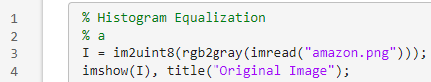

Res:

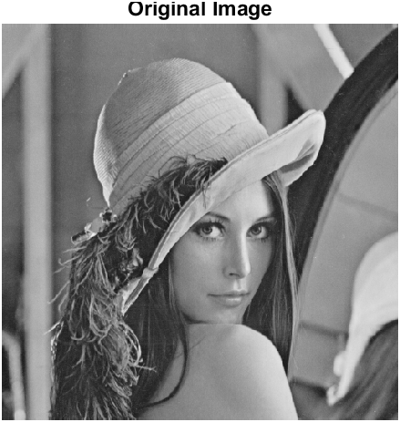

b.



Res:

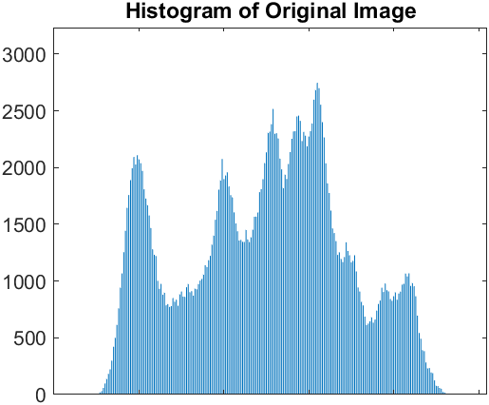



c.

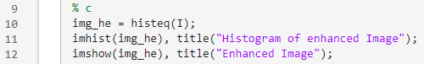

Res:

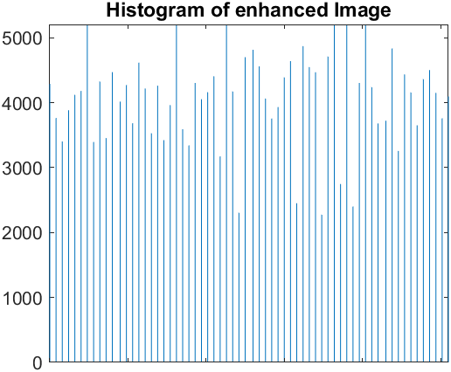



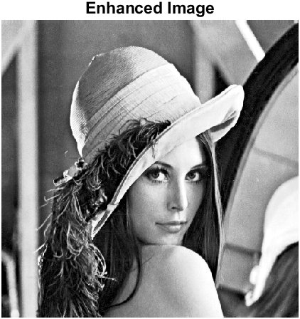

d.

The most significant target(background) has been moved to the medium position.

481 Students.

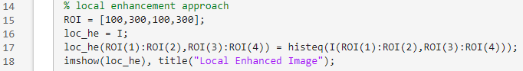

Res:

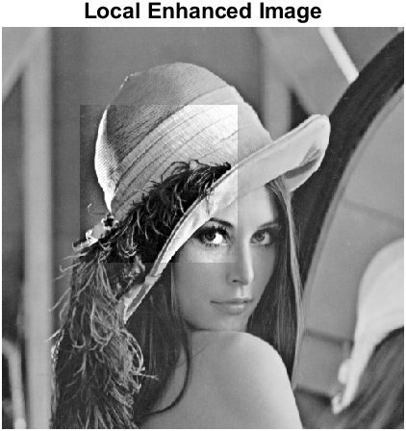

Filtering

a.

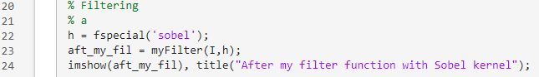

We can add zero padding to original image

Res:

b.

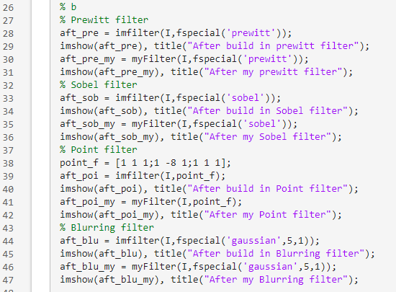

Res:

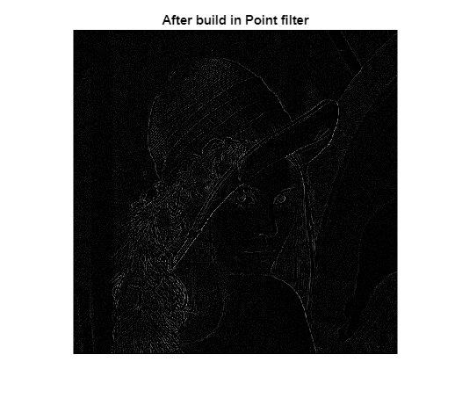

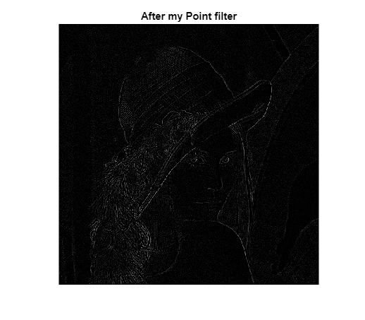

Those are almost same

Bit Plane Splicing

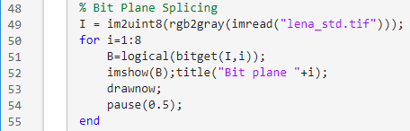

Res:

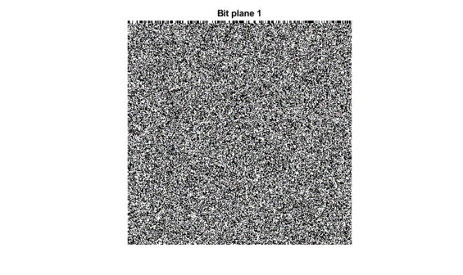

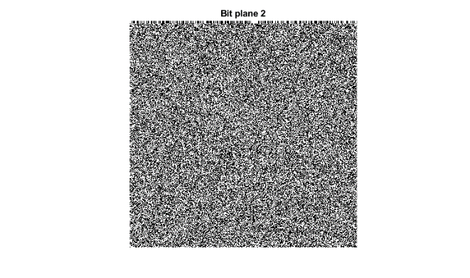

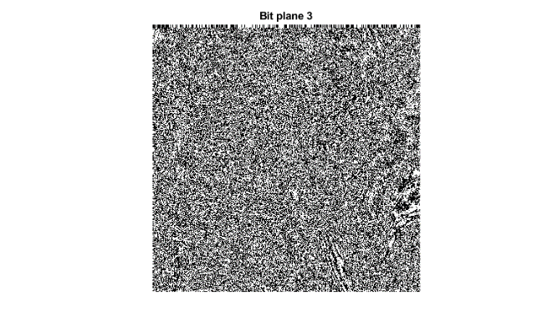

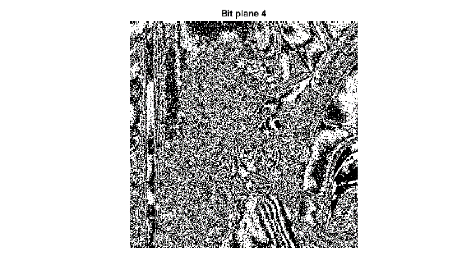

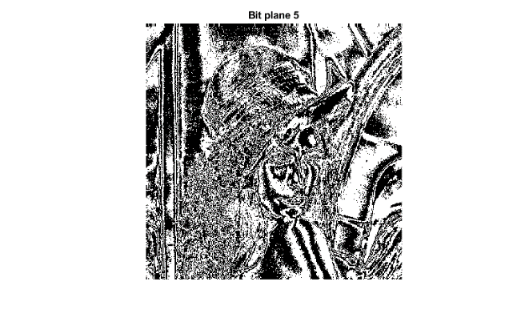

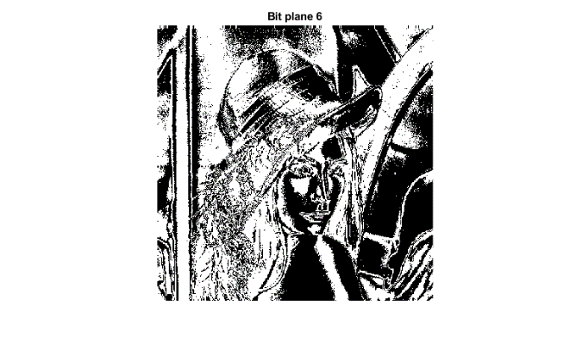

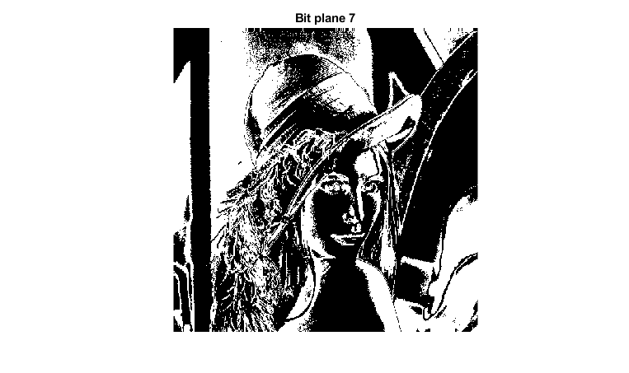

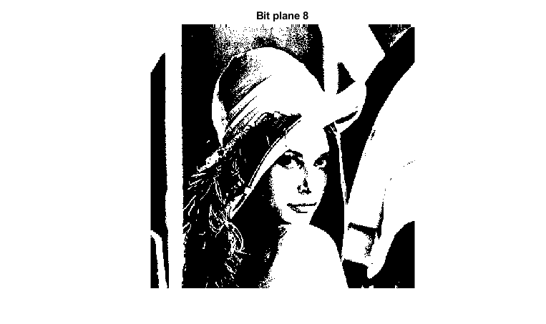

% Histogram Equalization

% a

I = im2uint8(rgb2gray(imread("lena_std.tif")));

imshow(I), title("Original Image");

% b

imhist(I), title("Histogram of Original Image");

% c

img_he = histeq(I);

imhist(img_he), title("Histogram of enhanced Image");

imshow(img_he), title("Enhanced Image");

% local enhancement approach

ROI = [100,300,100,300];

loc_he = I;

loc_he(ROI(1):ROI(2),ROI(3):ROI(4)) = histeq(I(ROI(1):ROI(2),ROI(3):ROI(4)));

imshow(loc_he), title("Local Enhanced Image");

% Filtering

% a

h = fspecial('sobel');

aft_my_fil = myFilter(I,h);

imshow(aft_my_fil), title("After my filter function with Sobel kernel");

% b

% Prewitt filter

aft_pre = imfilter(I,fspecial('prewitt'));

imshow(aft_pre), title("After build in prewitt filter");

aft_pre_my = myFilter(I,fspecial('prewitt'));

imshow(aft_pre_my), title("After my prewitt filter");

% Sobel filter

aft_sob = imfilter(I,fspecial('sobel'));

imshow(aft_sob), title("After build in Sobel filter");

aft_sob_my = myFilter(I,fspecial('sobel'));

imshow(aft_sob_my), title("After my Sobel filter");

% Point filter

point_f = [1 1 1;1 -8 1;1 1 1];

aft_poi = imfilter(I,point_f);

imshow(aft_poi), title("After build in Point filter");

aft_poi_my = myFilter(I,point_f);

imshow(aft_poi_my), title("After my Point filter");

% Blurring filter

aft_blu = imfilter(I,fspecial('gaussian',5,1));

imshow(aft_blu), title("After build in Blurring filter");

aft_blu_my = myFilter(I,fspecial('gaussian',5,1));

imshow(aft_blu_my), title("After my Blurring filter");

% Bit Plane Splicing

I = im2uint8(rgb2gray(imread("lena_std.tif")));

for i=1:8

B=logical(bitget(I,i));

imshow(B);title("Bit plane "+i);

drawnow;

pause(0.5);

end

function res = myFilter(I,h)

% We can add zero padding to original image

[img_h,img_w] = size(I);

hsize = size(h);

padsize = [((hsize(1)-1)/2),((hsize(2)-1)/2)];

padded_img = zeros(img_h+padsize(1)*2,img_w+padsize(2)*2);

padded_img(padsize(1)+1:img_h+padsize(1), ...

padsize(2)+1:img_w+padsize(2)) = I;

[padded_h,padded_w] = size(padded_img);

for i=1:img_h

for j=1:img_w

copy(i+padsize(1),j+padsize(2)) = sum(sum( ...

padded_img(i:i+hsize(1)-1,j:j+hsize(2)-1).*h));

end

end

res = uint8(copy(1+padsize(1):padded_h-padsize(1), ...

1+padsize(2):padded_w-padsize(2)));

end