Homework 5 for **Kun**

Introduce to image process

All codes are attached on the last page.

Q1

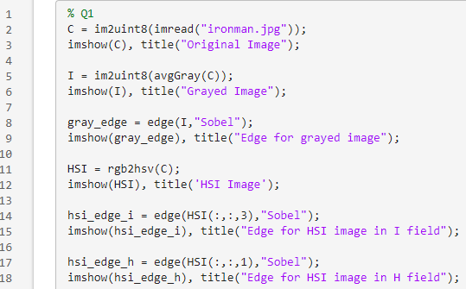

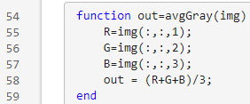

Res:

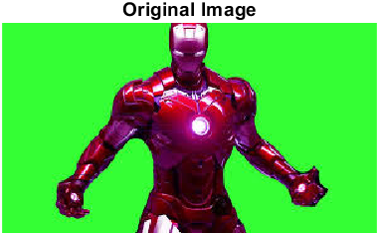

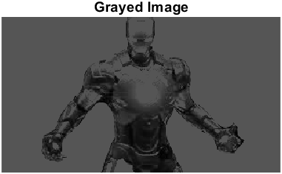

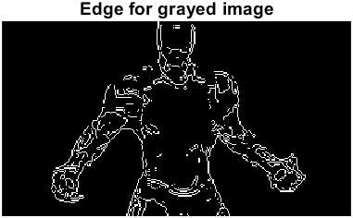

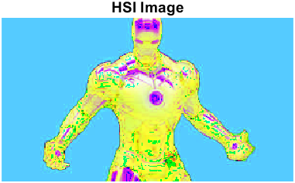

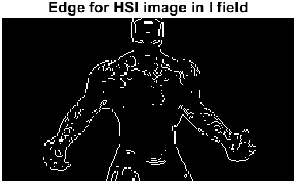

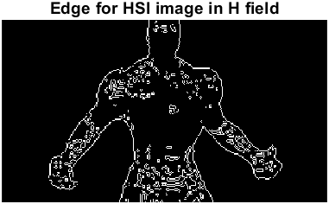

So, just average the RGB channel then get the edge is not very efficient, also work in hue field not. We can find finding edge in I field is more efficient. I guess because I field in edge can have larger gap thus Sobel can be effective.

Q2

A

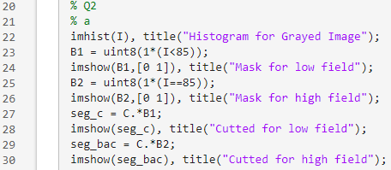

Res

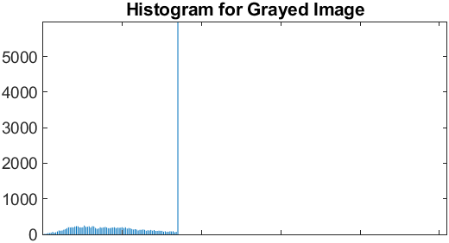

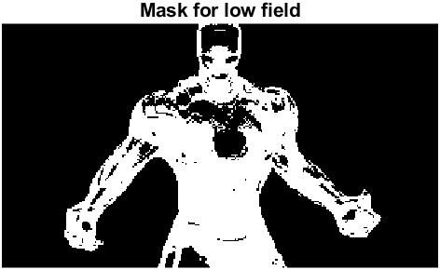

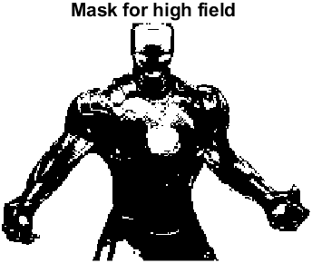

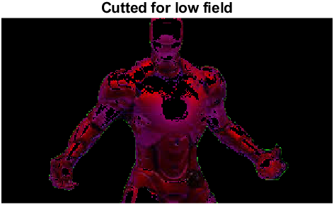 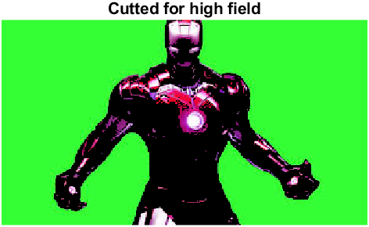

So, just calculate the threshold on the average RGB channel can not have a good segmentation. Because in average grayed image, background do have similar intensitive value with the object.

B

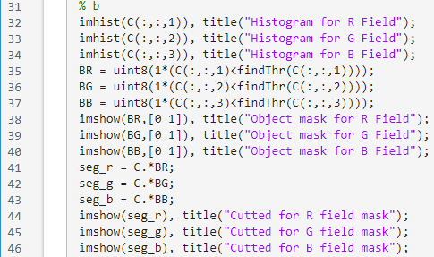



Res

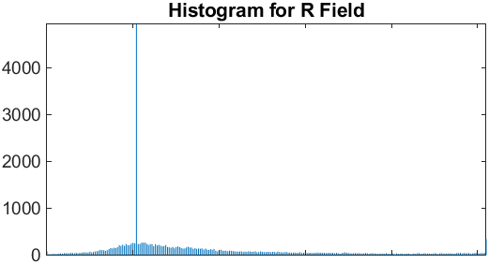

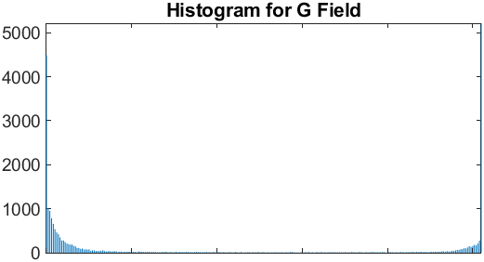

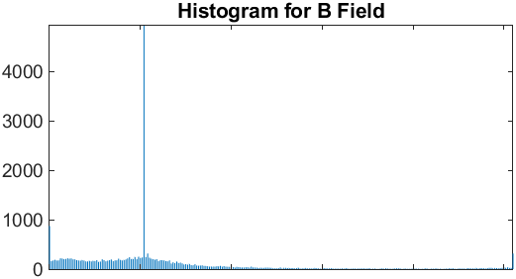

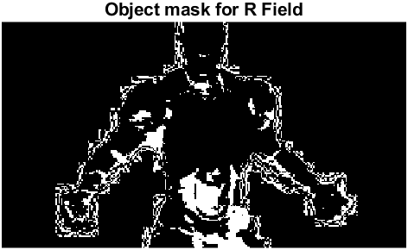

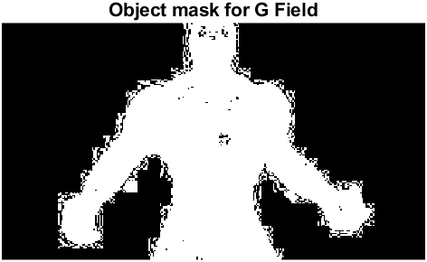

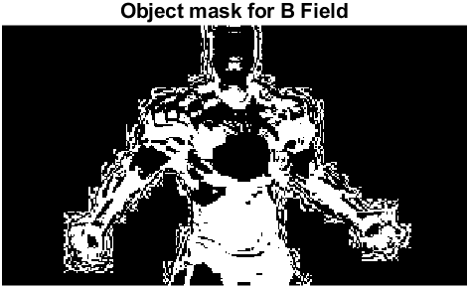

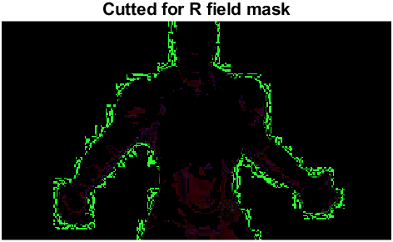

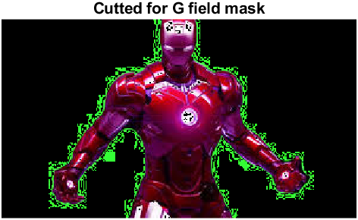

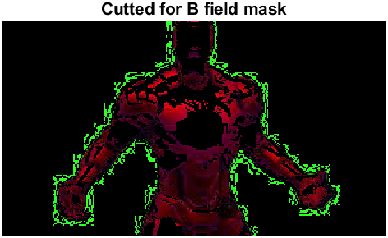

So, segment with individual RGB channel thresholds can be effective. For instance, separate with G channel can do a great segmentation!

C

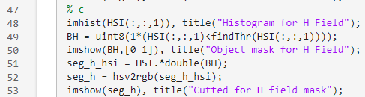

Res

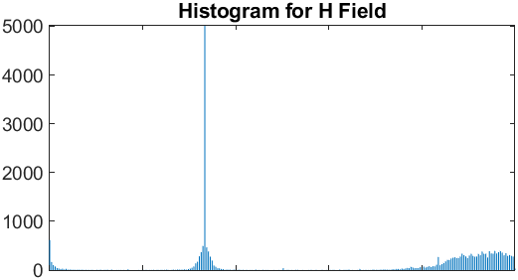

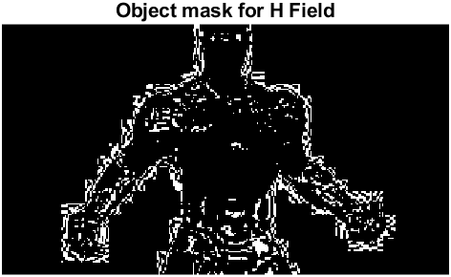

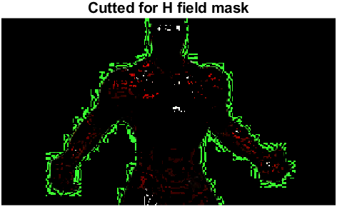

So, just separate with hue field can not have effect result, because in this picture, every place has a similar hue value. Compared to RGB cannels segmentation, it more likely segment the edge.

% Q1

C = im2uint8(imread("ironman.jpg"));

imshow(C), title("Original Image");

I = im2uint8(avgGray(C));

imshow(I), title("Grayed Image");

gray_edge = edge(I,"Sobel");

imshow(gray_edge), title("Edge for grayed image");

HSI = rgb2hsv(C);

imshow(HSI), title('HSI Image');

hsi_edge_i = edge(HSI(:,:,3),"Sobel");

imshow(hsi_edge_i), title("Edge for HSI image in I field");

hsi_edge_h = edge(HSI(:,:,1),"Sobel");

imshow(hsi_edge_h), title("Edge for HSI image in H field");

% Q2

% a

imhist(I), title("Histogram for Grayed Image");

B1 = uint8(1*(I<85));

imshow(B1,[0 1]), title("Mask for low field");

B2 = uint8(1*(I==85));

imshow(B2,[0 1]), title("Mask for high field");

seg_c = C.*B1;

imshow(seg_c), title("Cutted for low field");

seg_bac = C.*B2;

imshow(seg_bac), title("Cutted for high field");

% b

imhist(C(:,:,1)), title("Histogram for R Field");

imhist(C(:,:,2)), title("Histogram for G Field");

imhist(C(:,:,3)), title("Histogram for B Field");

BR = uint8(1*(C(:,:,1)<findThr(C(:,:,1))));

BG = uint8(1*(C(:,:,2)<findThr(C(:,:,2))));

BB = uint8(1*(C(:,:,3)<findThr(C(:,:,3))));

imshow(BR,[0 1]), title("Object mask for R Field");

imshow(BG,[0 1]), title("Object mask for G Field");

imshow(BB,[0 1]), title("Object mask for B Field");

seg_r = C.*BR;

seg_g = C.*BG;

seg_b = C.*BB;

imshow(seg_r), title("Cutted for R field mask");

imshow(seg_g), title("Cutted for G field mask");

imshow(seg_b), title("Cutted for B field mask");

% c

imhist(HSI(:,:,1)), title("Histogram for H Field");

BH = uint8(1*(HSI(:,:,1)<findThr(HSI(:,:,1))));

imshow(BH,[0 1]), title("Object mask for H Field");

seg_h_hsi = HSI.*double(BH);

seg_h = hsv2rgb(seg_h_hsi);

imshow(seg_h), title("Cutted for H field mask");

function out=avgGray(img)

R=img(:,:,1);

G=img(:,:,2);

B=img(:,:,3);

out = (R+G+B)/3;

end

function val=findThr(img)

val = mode(img,'all');

end