Homework 6 for **Kun**

Introduce to image process

All codes are attached on the last page.

Q1 Erosion and Dilation

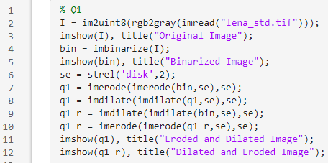

Res:

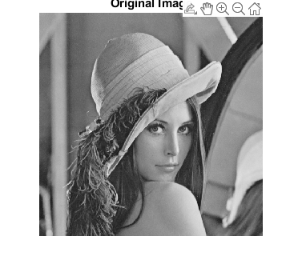

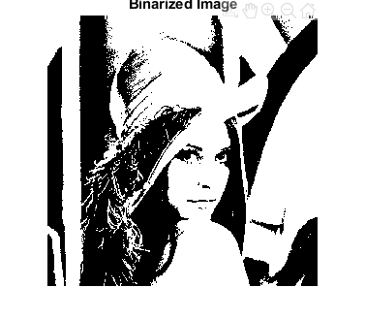

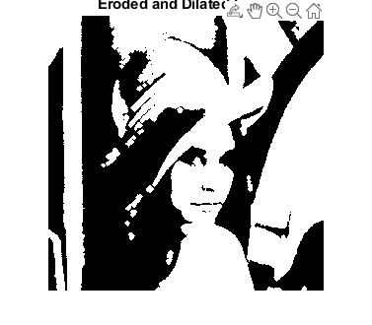

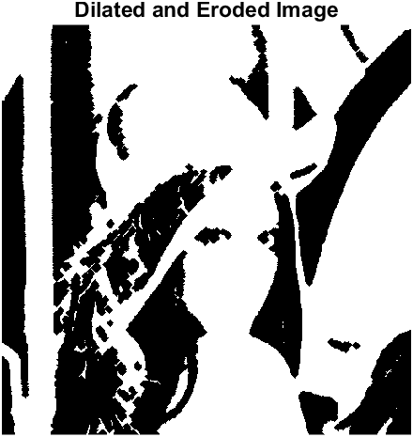

Compare to Erode first, dilated first lost more details.

Q2 Opening and Closing

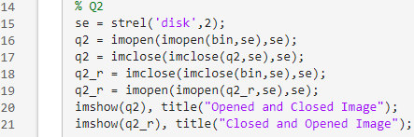

Res

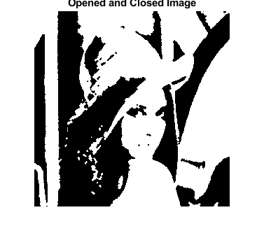

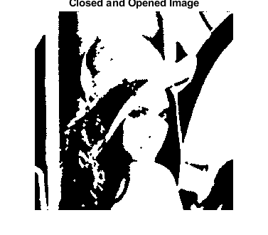

Compared to Q1, Opening and Closing operation may cause more detail losing. However, erode first keep more medium size details and kick-out more small size details than other 3 images.

Q3 Boundary Extraction

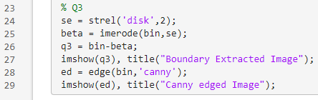Res:

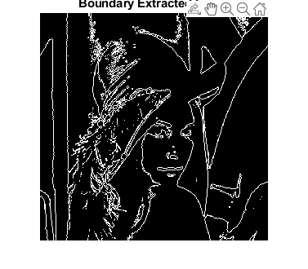

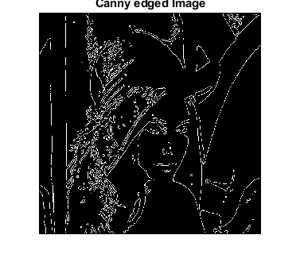

So, the boundary extraction and canny operator applied images are highly similar. Canny operator saved more details, but boundary extraction can identify edge with more accuracy.

% Q1

I = im2uint8(rgb2gray(imread("lena_std.tif")));

imshow(I), title("Original Image");

bin = imbinarize(I);

imshow(bin), title("Binarized Image");

se = strel('disk',2);

q1 = imerode(imerode(bin,se),se);

q1 = imdilate(imdilate(q1,se),se);

q1_r = imdilate(imdilate(bin,se),se);

q1_r = imerode(imerode(q1_r,se),se);

imshow(q1), title("Eroded and Dilated Image");

imshow(q1_r), title("Dilated and Eroded Image");

% Q2

se = strel('disk',2);

q2 = imopen(imopen(bin,se),se);

q2 = imclose(imclose(q2,se),se);

q2_r = imclose(imclose(bin,se),se);

q2_r = imopen(imopen(q2_r,se),se);

imshow(q2), title("Opened and Closed Image");

imshow(q2_r), title("Closed and Opened Image");

% Q3

se = strel('disk',2);

beta = imerode(bin,se);

q3 = bin-beta;

imshow(q3), title("Boundary Extracted Image");

ed = edge(bin,'canny');

imshow(ed), title("Canny edged Image");