**TalentMap**

Build resumes that win jobs!

A CV making app that manages your information in a way that creates an optimized CV with maximum potential.

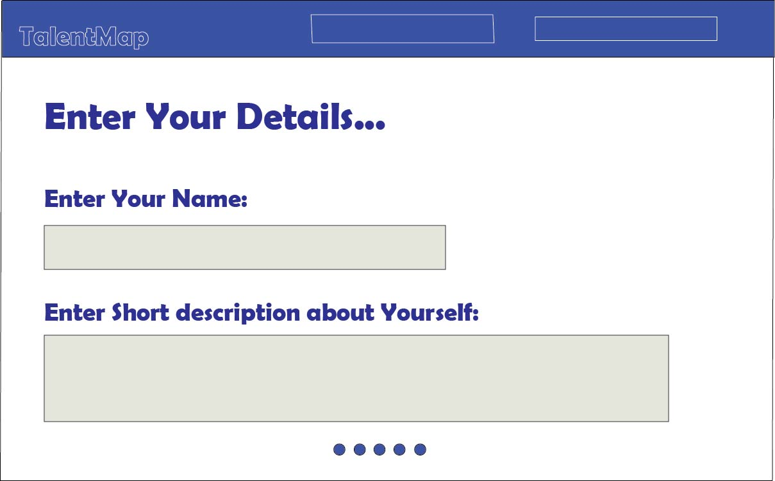

It will be a windows-based application made using Python and tkinter module with a simple and user-friendly interface.

The app allows users to select the type of CV they want to make (Academic,Corporate etc) and recommends templates and suggestions based on that. Main features of this application are:

1. Takes user’s information and stores it securely.
2. Templates and customization options,create custom templates.

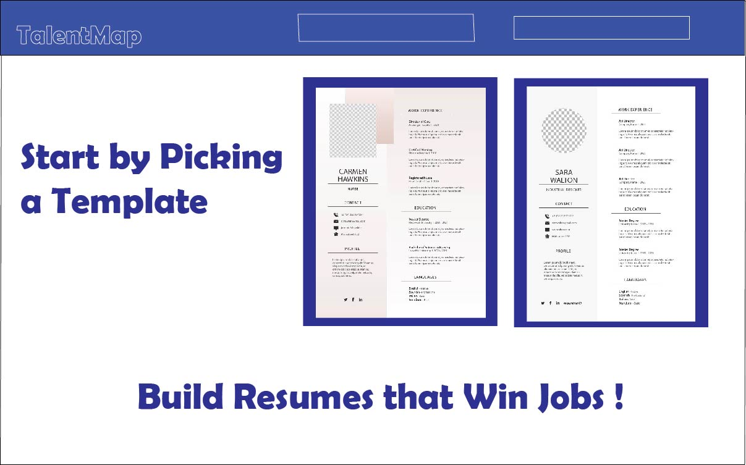

1. Validate Input and spelling correction.
2. Generate and Preview CV before saving for further customization.

5.Export CV as PDF

**Unique Features:**

1.Recommending skills to add to CV based on job description and qualification.

2.Determining which qualifications add more value to CV based on requirements.

3. In-built reminder app that notifies users before job application deadline to recheck/upgrade the CV.

4.Provides a QR code to a web-based version of CV that will keep track of the amount of times each CV has been viewed .

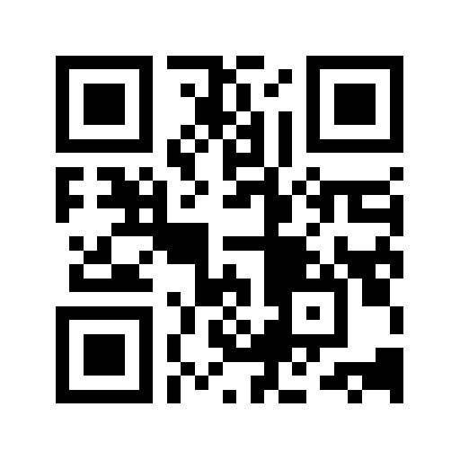

Platform:

Front end:

Database Designing:

Basic file operations

GUI Design:

PyQT/tkinter

Backend:

Python