

Sri Lanka Institute of Information Technology

**4C Knowledge Book Club**

**Software Requirement Specification**

Programming Applications & Frameworks Project 2018

Batch: **Data Science**

Submitted by:

1. IT15056658 -W.D.S De Silva
2. IT16045354 – H.M.M.T. Bandara
3. IT16070936– W.A.H.C. Weerasinghe.
4. IT16055872 – De Silva M.G.M.S

Submitted to:

Mr. Sadaru Weerasooriya

…………………………..

**30.03.2018**

# Table of Contents

**Abstract...........................................................................................................................................I** **Acknowledgement..........................................................................................................................1**

**Declaration......................................................................................................................................2** **Table of Contents ...........................................................................................................................3**

**List of Tables ..............................................................................................................................5** **List of Acronyms and Abbreviations ........................................................................................... 6**

1. **Introduction ............................................................................................................................. 7**
   1. Problem Statement ................................................................................................................ 7
   2. Product Scope........................................................................................................................ 8
   3. Project Report Structure........................................................................................................ 9
2. **Methodology .......................................................................................................................... 10**
   1. Requirements and Analysis .................................................................................................10
   2. Design ..................................................................................................................................12
   3. Implementation ....................................................................................................................46

2.4 Testing .................................................................................................................................47

1. **Evaluation .............................................................................................................................. 49**
   1. Assessment of the Project results ........................................................................................49
   2. Lessons Learned ..................................................................................................................50
   3. Future Work ........................................................................................................................51
2. **Conclusion ............................................................................................................................. 52**
3. **References .............................................................................................................................. 53**
4. **Appendix.. .............................................................................................................................. 54**



# Introduction

4C knowledge is a Online Book Club. The Book Club is available for Read Books through the

online using the System they have. In the System users also have the facility to download and share books.

Users must register to the system for view available books in book club.. There are different types of users with

various clearance levels that will be using this system. The users include Administrators(owner),

Community Administrators and Regular Users.

Previously the Book Club is handling all the processes & other functions manually. This system relies

heavily on human work which increases the possibility of introducing human errors due to the large paper

work. Therefore it becomes tedious and time consuming to retrieve records and maintain the system.

As a solution, our team will automate the whole system by implementing a Web Application using

JAVAEE to handle all aspects of the process of this Book Club. Users can check the availability of the

Books using the web based application. The system will give the user interface which will link their databases and give them ease of access to their system much more quickly and efficiently.

In the System Administrators *will be able to do all the features and functions of the system.*

*Such as* view all the user details, make admins and remove users from the system .But Community

Admin has some acquirement than Owner. He can view all the users but can’t access their all details,

Only few can access. In here Admin can do everything what Community member does. Regular Users

Can view only their details and update their user profiles.

## Problem Statement

## 

The Book Club uses a paper based documentation system to store and manage the details of the Users who has been recruited. It takes much space and effort to keep track of physical documents and also searching and upgrading the details is a tedious task to do.

Checking the availability of the books and Active Users are very hard to handle manually.

So the management level need this project (software) to overcome all the difficulties and the problems that are mentioned above, and by this software we have addressed each and every above mentioned problems and other trivial problems that are not mentioned above as well.

## Product Scope

The 4C Knowledge Book Club Application comes with a centralized database. The system gives a simple pictorial interface to the user to handle the system easily. It makes sure that the data access is reliable and efficient and also can be overcome from the existing system. It helps in managing and controlling of all the processes and operations being carried out in the hotel. It also maintains records of data of the Users and their interests in the system which can be used when required. The application helps in providing various tools which helps in effective controlling and functioning of administration department of the Book Club. Main advantage of the system is all the functions are combined together and centralized.

* User friendly GUI
* Centralized database
* Easy to handle without extra knowledge in IT
* No redundancies
* Simple calculations
* Better security

## Project Report Structure

This project report for the creation of the system for 4C Knowledge Book Club is completely designed according to the standards of IEEE, document standards. It will give the reader a friendlier environment to understand the content of it. If this project is used for further development in the future, this kind of document standard will also give a perfect approach to the development team also, to understand the system well and work of the modifications they want to achieve.

# Methodology

## Requirements and Analysis

We analyzed the functions and identified the inputs, outputs and processes required. Also we identified the nonfunctional requirements the system should consist of. Then we got a clear understanding on the functionality so that we will be able to create the document. Then we discussed the content of the document with the client.

Requirement gathering in the particular project was mainly done through conducting interviews with different kinds of people of management hierarchy of the Admins, Community Admins and general Users. Though most of the information were gathered from the administration hierarchy of the Book Club.

In this situation, they were very enthusiastic and supported us by giving relevant information. Formal system is well defined by the forms, reports, policy manuals and organization charts. Above mentioned tactic helped a lot in providing a clear view of the Book Club system.

Owner





Community Admin





MySQL





Regular User

Figure 2.1.1 High Level Architecture diagram of the proposed system

## Design

The 4C Knowledge Online Book Club System project is designed and implemented in Linux platform. Only the administrators and users can access the system and every user must keep their system password secretly. This system is designed in English language and the delivered system must be maintained by client and client pc should full fill software and hardware requirements.

We have utilized a set of UML diagrams which were conceptualized. Given below are some of these diagrams.

## User Classes and Characteristics

The Admin will be having the full access to the full system and will be able to do all the features and

functions of the system.. The Admin is responsible in keeping the system up-to-date while making sure no

issues occur with the system.Admin can view all the user details ,make admins and remove users from

the system .But Community Admin has some acquirement than Owner. He can view all the users but

can’t access their all details, only few can access. In here Admin can do everything what Community

member does. Regular Users Can view only their details and update their user profiles.

## Operating Environment

The new product that is been made to take over the existing system is a platform independent as

the whole system is a web based application. Because of this feature the system is able to operate

on Linux Platform or above without any other issues. The other software that is needed is the

Apache Tomcat 8.5 and Eclipse Oxygen. In this system used Maven as the framework.

## Design and Implementation Constraints

* MySQL Server will be used as the SQL Engine and Database for the system.
* The system will be generated using JAVAEE language through Maven framework with

using few text editors such as Apache Tomcat and Eclipse Oxygen

* HTTP will be used as the communication protocol in the system.
* Only administrators will have the permission to be able to view all users details and the

rest will have restricted access to other features.

## Project Documentation

Our project documentation is documented in standard A4 size paper. The format is simple and in a

good structured manner. The font is Times New Roman. General and all other Sub Topics will be

bold and the rest of the content will be in font size 12, with line spacing. The font color for the

Hyper Link Texts will be blue.

## User Documentation

The User Manual for the system will be with user interfaces which will help and instruct the user to

help work and operate the system. It will have the all of the needed configurations and technical

problems which a user might face when using the system and how to overcome each and

every problem specifically. Lastly the document will contain the backup procedure and contact

information of the developing team.

## Assumptions and Dependencies

**Assumptions:** All the Users must log in to the system first in order to view books.

# External Interface Requirements

## User Interfaces

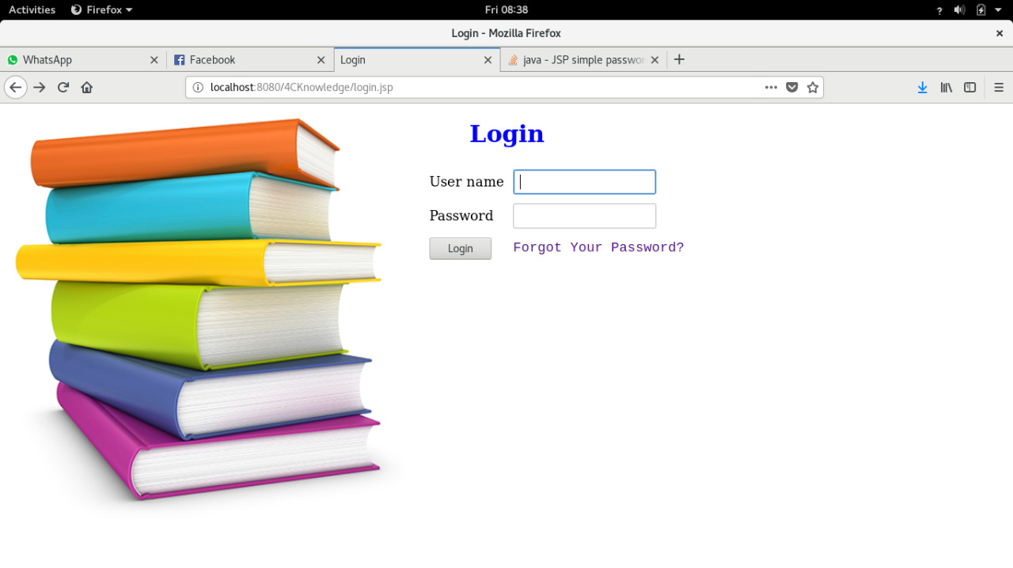

Figure 3.1: Login

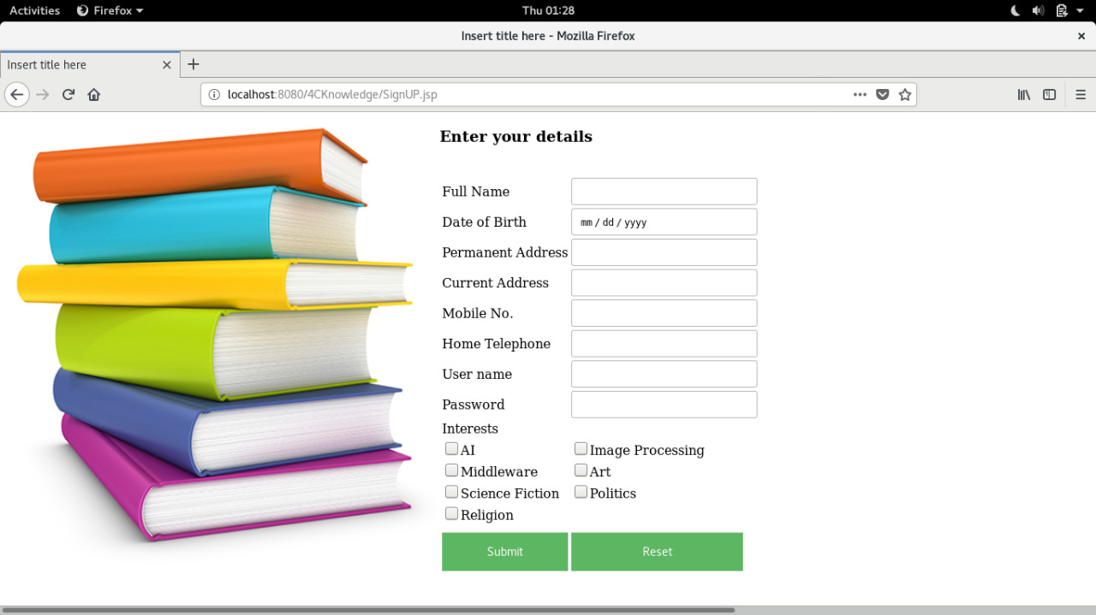

Figure 3.1: Login

## Hardware Interfaces

Computer System Hardware Requirements (Minimum):

* Operating System: Linux, Fedora14 operating System
* Processor: Intel(R) core(TM) i5-3337U CPU @ 1.80GHz
* RAM: 4.00 GB
* Ethernet port to get fast and stable network connection

## Software Interfaces

|  |  |
| --- | --- |
| **Software** | **Description** |
| Operating Systems | Fedora14 (64 bit ) |
| Web Browsers | Google Chrome, Mozilla Firefox and Safari Web Browsers |
| Databases | MySQL |
| Server | Apache Tomcat 8.5 |

## Communications Interfaces

This system is been developed to be compatible and be supported by any web browser. The system will be

using the HTTP Protocol to display and run the system. For the purpose of uploading a profile picture the

FTP protocol will be used. All of the passwords will be encrypted using the MD5 algorithm.

# System Features

## System Feature 1

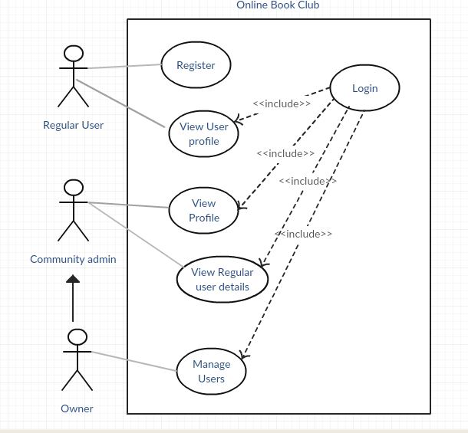

Figure 2.2.1 Use Case Diagram for 4C Knowledge Book Club System

Figure 2.2.1 Usecase Diagram for 4C Knowledge Book Club System

## Main Use Case Scenarios

|  |  |  |
| --- | --- | --- |
| Use Case Number | 01 | |
| Use Case Name | View User Profile | |
| Goal in Context | To view profile details | |
| Preconditions | All the users should Register to the system | |
| Success End Condition | User’s details are viewed | |
| Failed End Condition | User details are not displayed | |
| Primary Actor | Regular User, Community admin, Owner | |
| Trigger | Include(Login) | |
| Main Success Scenario | Step | Main Success Scenario |
| 1 | User logins to the system |
| 2 | Home page is displayed |
| 3 | User goes to view user profile |
| 4 | User details are displayed |
| Extensions | Step | Branching Action |
|  | 1a | If login fails a message is prompted. |

Figure 2.2.4 Use case Scenarios for View User Profiles

|  |  |  |
| --- | --- | --- |
| Use Case Number | 02 | |
| Use Case Name | Manage Users | |
| Goal in Context | View details of all the users and delete a user | |
| Success End Condition | User’s details are viewed and a user can be deleted | |
| Failed End Condition | User details are not displayed.  Cannot delete a user | |
| Primary Actor | Owner | |
| Trigger | Include(Login) | |
| Main Success Scenario | Step | Main Success Scenario |
| 1 | Owner logins to the system |
| 2 | Home page is displayed |
| 3 | Owner clicks on view user details |
| 4 | User details are displayed |
| 5 | Owner selects a user |
| 6 | Owner deletes a user |
|  | 7 | System prompts for confirmation |
| 8 | Owner confirms deletion |
| 9 | System is updated |
| Extensions | Step | Branching Action |
| 1a | If login fails a message is prompted. |
| 8a | If owner does not confirm, user details are displayed |

Figure 2.2.5 Use case Scenarios for Manage Users Customer

## Implementation

The database is created using MySQL which consist of the capability of producing results table efficient than the older versions. The dbconnect class is created in gathering objects from the database.

public static com.mysql.jdbc.Connection connect()

{

com.mysql.jdbc.Connection conn=null;

try

{

Class.forName("com.mysql.jdbc.Driver");

conn=(com.mysql.jdbc.Connection) DriverManager.getConnection("jdbc:mysql://localhost:3306/maintenance", "root", "");

}

catch (Exception e)

{

System.out.println("Database Connection error: "+e);

}

return conn;

}

}

The users will have to login to the system in order to prevent from unauthorized access and to maintain the access permissions such as admin, supervisor and manager logins.

Ex: Inventory login

String b = "select * from login where position='" + work + "'";

pst = con.prepareStatement(b);

rs = pst.executeQuery();

if (rs.next()) {

if (rs.getString("username").compareTo(name1) == 0) {

if ((rs.getString("password").compareTo(password) == 0)) {

if (this.a == 5) {

Inventory.InventoryMain em = new Inventory.InventoryMain(5, name1);

em.setVisible(true);

this.dispose();

}

## Testing

After implemented the individual modules by the group members, those individual modules are to be tested well before the integration. The system should be tested thoroughly using test cases and test suites before deploying or installing the system at the customer premises.

Test the system as a whole after successful integration of each unit. Deploy stress and acceptance testing of the system. Here in system testing, what happens is check whether the implemented system facilitate the requirements specified in the SRS document.

Technical documentation will be prepared describing various aspects of internal functions to make it easier to maintain the system and adapt to future changes. Because of the documentation we prepare while we developing the system will be needed and will be very useful in the maintenance phase. Creation of user documentation such as user manual, which describes how the software should be used, will be done for the ease of the users. Making tutorials and manuals to guide the users through each step of accomplishing a particular task will be very useful for the users to get familiar with the system.

# Other Nonfunctional Requirements

## Performance Requirements

In the new and improved system, the performance of the whole system including the data retrieval

and data transfer speed along with the overall system performance should be much higher than

the existing system. In order to increase the performance of the database, the tables of the database

should be normalized. By normalizing the system it will help the system in executing queries in much

more less time.

## Safety Requirements

The safety of the system should be taken into consideration as a major factor of the system.

Due to the fact that there are heaps of sensitive data in the system, All possible errors and problems

that can occur within the system should be prevented. To prevent any sort of errors happening

and in order to improve the safety of the whole system the databases and files are backed up

every week. The files will be archived and will be recovered when needed.

## Security Requirements

The system will have all records of users, which are considered as confidential

data for the organization, therefore the security should be setup in order to prevent unauthorized

access to the system and prevent any attacks from hackers. Each user will have user level

wise access and user roles according to their position. They will have passwords that should be changed

every 6 months. The passwords will also be encrypted for further security. Each login will have a

session which will be terminated after few hours of inactivity. These methods will help majorly to

increase the security of the system.

## Software Quality Attributes

**Adaptability:** The system functions will be adaptable to any browser or operating system making it

platform independent. Because of all these features there won’t be any issues for the system not

Operating correctly.

**Availability:** The system will be live and running most of the time and will be available for the users

during any hours. The server in which the system will be running will be on 99.9% of the time.

**Flexibility:** The system will have the ability to react to any possible changes made in the system whether it

was predicted or not.

**Interoperability:** The system will be using standard and simple communication protocols which will help

in been easier to exchange data and to reuse them throughout the system.

**Maintainability**: Each function is a separated feature of the system. This feature will help a lot in order

to upgrade each function individually in a very easier manner and this will increase the maintainability of

the system. The system will also be in a modular structure where each of the modules can be

maintained separately.

**Portability:** As this is a Web Based Application, the system is portable and can be used in any

environment from any location.

**Reliability:** The system processors will be made sure of working efficiently and will be ensured not to fail.

By chance if there is any failure in the system, the whole system will be backed up and the data flow will be

managed and updated accordingly. Therefore the system is way much more reliable than their existing

system.

**Reusability:** Each page and class of the system is made to be reusable. Each page can be reused for

another purpose.

**Testability:** As this system is made to be easy to maintain, finding suitable test cases and testing the system

is really efficient and easy.

**Usability:** The system is been developed to be a very user friendly environment and it can be used by any

user with any basic computer skills.

## Business Rules

* Illegal duplication or use of Reports or any other document should be strictly dealt with.

The owner should have full authority to do what is necessary.

* The owner of the system should have full access to all of the details of a user when

they register into the system, If the owner finds any discrepancy in the details he

should have the authority to terminate the registration.

# Other Requirements

* The database should hosted online in order for the system to be able to access the database at any given time.

# Evaluation

## Assessment of the Project results

One of the major and initial step for marking out the entrance for the project is formation of a group with four members that hold different aspects and achievements with knowledge in programming with specified skills and talents. With some regular discussions those aspects and talents were identified and differentiation was reduced. Several discussions with group leader and team members along with the client discussions made is easier to identify user requirements.

After conducting discussions with the client exact scope of the system’s outline for the team purposes was emended. Some of the brainstorming and mind mapping sessions among the group members aided in analysis of requirements accurately to the top most level with relevant achievement. The project was aimed to provide the efficient solutions to the external users and improve the productivity of internal users.

Our Supervisor Mr.Sadaru Weerasooriya provided us with the relevant guidelines throughout the development process.Most of the steps that we took were recorded in the documents that we have created and those reports were evaluated by our Supervisor Mr.Sadaru Weerasooriya. He advised us to do the modifications as necessary.

## Lessons Learned

There were lots of lessons that we learned throughout the time. Most importantly we learned to work according to a time schedule and how to manage the time to take the maximum benefit of the time we had. We faced lot of inconveniences while engaging with the project development and those incidents gave us the experiences of facing the problems and finding the appropriate solutions as necessary.

It is very hard to develop a first rate software without the given time period, because we were not well experienced. But at the end of this project we have learnt many things about the industry and how to face problems and how to overcome those problems easily. Since we have grouped together, we were able to overcome those difficulties.

The most difficult phases of our project were implementation of the environment to start the project.

There our team learned how to manage the workload within a given time frame and how to allocate resources efficiently.

Though our team had many issues due to lack of experience in coding, the developers could learn new techniques in coding

and database handling. Finally with the dedication of all the team members our team could come up

with a system which satisfies the requirements of our client. There our team manage to develop

the system within the proposed time period and develop the proposed functions much as we could

## Future Work

The work in the future that we have to engage should be done with lessons we learned from the project work that we have done so far. The steps that we have to be taken should be included with a higher standard than the tasks we did in the past. We should be able to reduce the errors that we have identified all through the time we spent for the project and that should be included with the experiences we gathered but with a high standard.

When the time passes, our client’s requirements can be changed. They might need more functionalities, new designs, new concepts or change existing functions that are not necessary. In such situations if they wanted us to develop and improve the current system we hope to consider their requirements and make the relevant changes as the system should be more usable and accurate for the client which fulfill their expected tasks. Apart from client requirements, if there are any changes in the system environment or inside the system, we will adapt the system to compatible with those changes as the system should be properly work according the available environments and functionalities.

Furthermore if there are any unexpected errors occur while using our system due to system failures or other reasons, we will be responsible of developing and handling those cases whenever they requested.

# Conclusion

4C Knowledge Book Club System comes with the centralized and large database. It also give a simple interface to user to handle the system easily. It make sure that the data access is reliable and efficient also overcome from the existing system. Here are solutions that proposed by our system.

When number of data increased the number of files also increased therefore no need to worry about those things our system come up with a centralized database so don’t need to worry about storage.. These are easy to find in a minute by system. It’s easy to record large amount of data in correct format without error and also can retrieve when it’s needed. Searching of a user details can be done less than a minute.

No need to worry about data duplication. With our system Simple data duplication can be done in a minute. No need to talk about data loss or data misplaced whenever a data or a set of data needed it can be retrieve

Since the existing manual system do not consists of a proper report generation, with this new system it was able to give a solution to generate realistic reports, which would help the management to get practical decisions and ideas related to the process.

Here the system would eliminate out all the unauthorized access which eventually leads to a high security.

All the data entered can be modified and viewed on a specified way that they are stored inside a centralized database. System is highly efficient hence it increases the productivity and quality along with the realistic decisions that are to be customized.

# References

* [https://creately.com/app/?tempID=h165rwt81#](https://creately.com/app/?tempID=h165rwt81)
* <https://www.youtube.com/results?search_query=hotel+management+system>
* <https://www.slideshare.net/thissagamage1/project-proposal-document-for-hotel-management-system?qid=401aa90e-bb78-4722-99af-3dd50431ce21&v=&b=&from_search=1>
* Joel Murach, Michael Urban, Murach's Beginning Java with NetBeans, 2015.
* Atul Palandurkar, Instant NetBeans IDE How-to,2013.
* Adam Myatt, Pro NetBeans IDE 5.5 Enterprise Edition,2007

**Appendix A: Design Diagram Design Diagram A:**

*ER Diagram*

