

**Faculty of Technology**

University of Sri Jayewardenepura

**Discussion Topics**

**Visual Application and Development**

**ITC 2303**

**Lecturer**

**Mrs. Nirasha**

**Name:** Dharmakeerthi MPBM

**Index No:** ICT/20/832

**Date:** 7-12-2022

01.

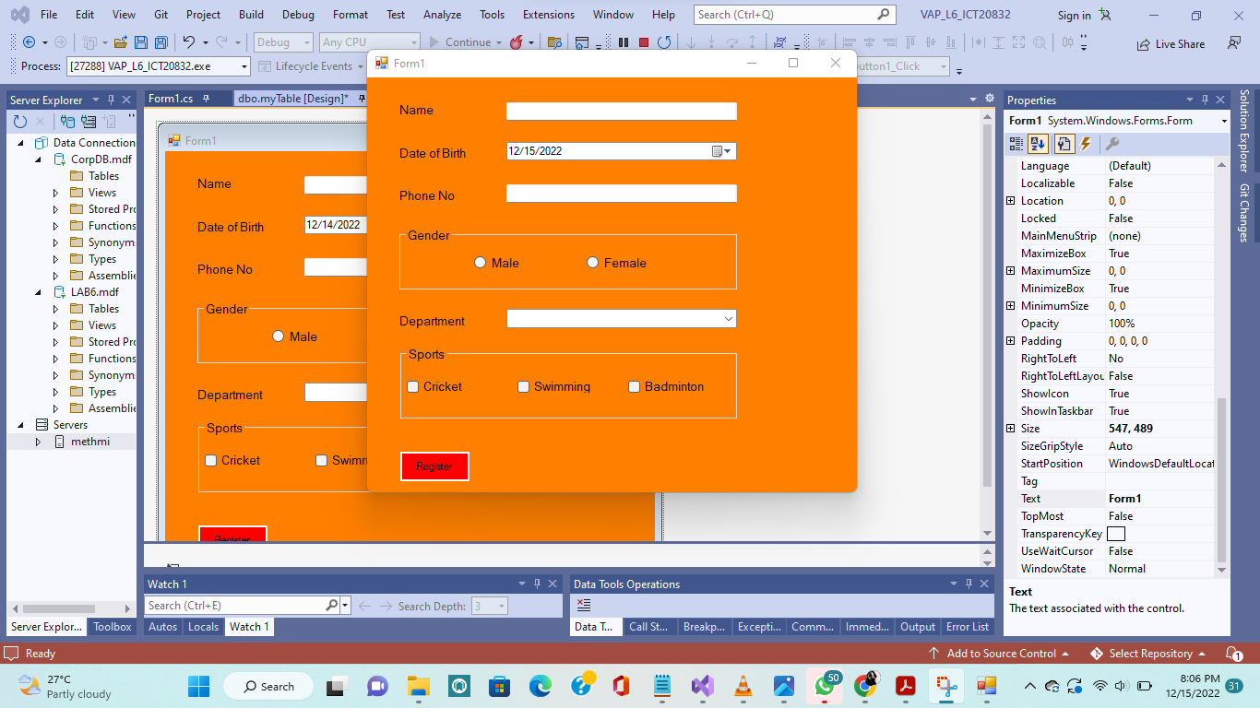

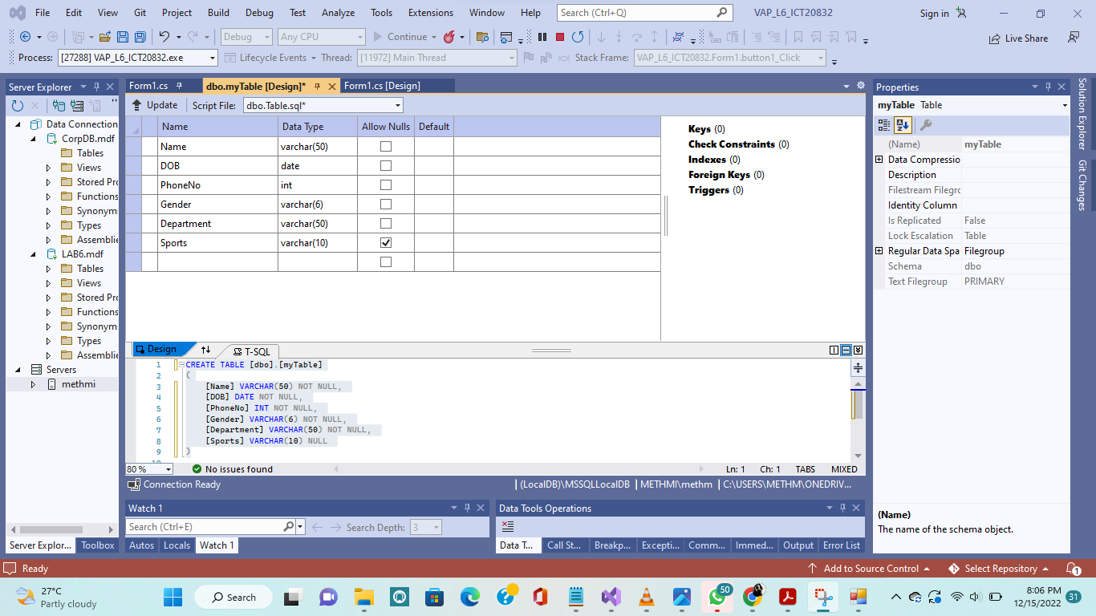

using System;

using System.Collections.Generic;

using System.ComponentModel;

using System.Data;

using System.Data.SqlClient;

using System.Drawing;

using System.Linq;

using System.Text;

using System.Threading.Tasks;

using System.Windows.Forms;

using System.Xml.Linq;

using System.Data.SqlClient;

namespace VAP_L6_ICT20832

{

public partial class Form1 : Form

{

SqlConnection myConn = new SqlConnection(@"Data Source=(LocalDB)\MSSQLLocalDB;AttachDbFilename=C:\Users\methm\OneDrive\Documents\LAB6.mdf;Integrated Security=True;Connect Timeout=30");

SqlConnection cmd;

public Form1()

{

InitializeComponent();

}

private void Form1_Load(object sender, EventArgs e)

{

}

private void label1_Click(object sender, EventArgs e)

{

}

private void groupBox1_Enter(object sender, EventArgs e)

{

}

private void groupBox2_Enter(object sender, EventArgs e)

{

}

private void dateTimePicker1_ValueChanged(object sender, EventArgs e)

{

}

private void button1_Click(object sender, EventArgs e)

{

if (txname.Text == "")

{

MessageBox.Show("Enter Your Name");

txname.Focus();

}

string gender = "";

if (Male.Checked)

{

gender = "Male";

}

else if (Female.Checked)

{

gender = "Female";

}

string Sports = "";

foreach (var checkedItem in this.checkedListBox2.CheckedItems)

{

Sports += checkedItem.ToString() + ",";

}

if (DateTime.Now.Year!=null && txname.Text!=null && PhoneNum.Text!=null && gender!="" && comboBox1 != null)

{

try

{

myConn.Open();

SqlCommand cmd = myConn.CreateCommand();

cmd.CommandType = CommandType.Text;

cmd.CommandText = "INSERT INTO [myTable](Name,DOB,PhoneNo,Gender,Department,Sports) values ('" + txname.Text + "','" + dateTimePicker1.Text + "','" + PhoneNum.Text + "','" + gender + "','" + comboBox1.Text + "','" + Sports + "')";

cmd.ExecuteNonQuery();

MessageBox.Show("Data INSERTED Successfully");

Execte_Close_Clear_TextBoxes();

}

catch

{

MessageBox.Show("Something Wrong. Please Check again");

}

}

else

{

MessageBox.Show("Something Wrong. Please Check again");

}

}

public void Execte_Close_Clear_TextBoxes()

{

myConn.Close();

txname.Clear();

PhoneNum.Clear();

comboBox1.Focus();

foreach (int i in checkedListBox2.CheckedIndices)

{

checkedListBox2.SetItemCheckState(i, CheckState.Unchecked);

}

}

private void Male_CheckedChanged(object sender, EventArgs e)

{

}

private void checkedListBox1_SelectedIndexChanged(object sender, EventArgs e)

{

}

private void checkedListBox1_SelectedIndexChanged_1(object sender, EventArgs e)

{

}

}

}

02)