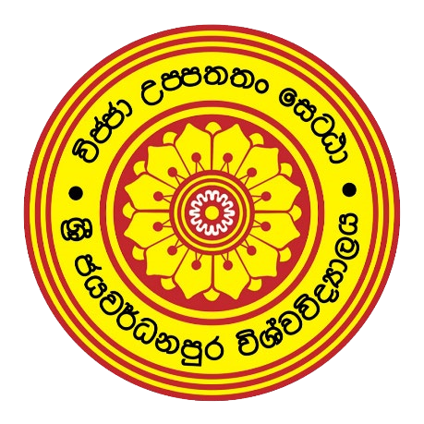

**Faculty of Technology**

University of Sri Jayewardenepura

**Discussion Topics**

**Visual Application and Development**

**ITC 2303**

**Lecturer**

**Mrs. Nirasha**

**Name:** Dharmakeerthi MPBM

**Index No:** ICT/20/832

**Date:** 16-12-2022

01.

**Employee Registration form**

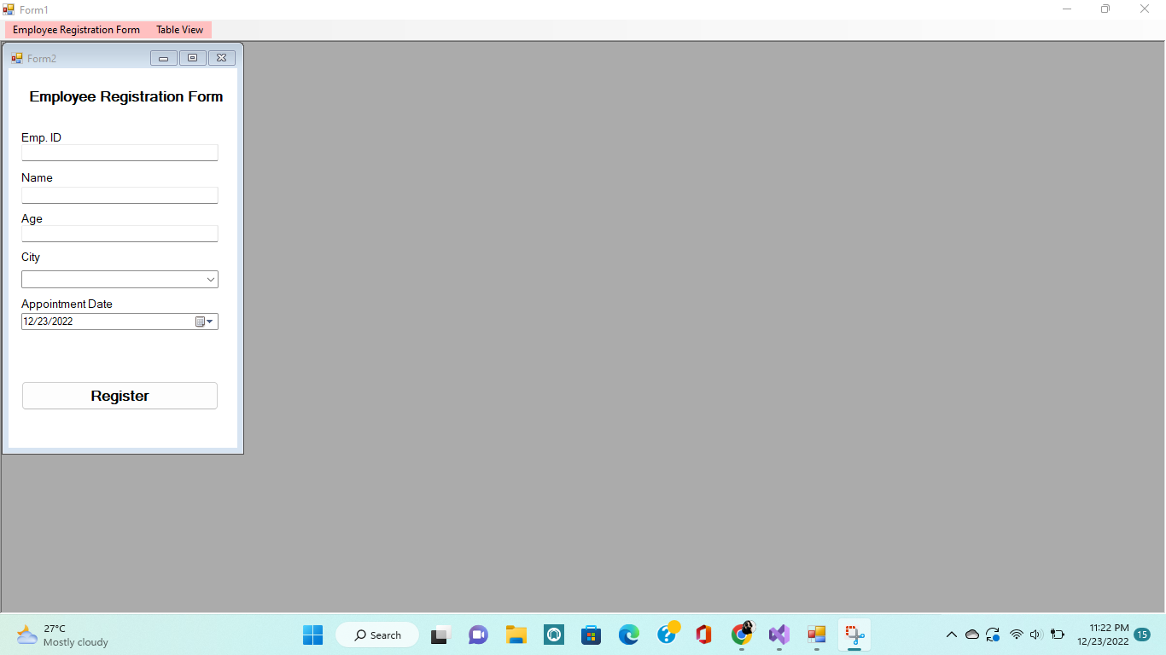

**Code**

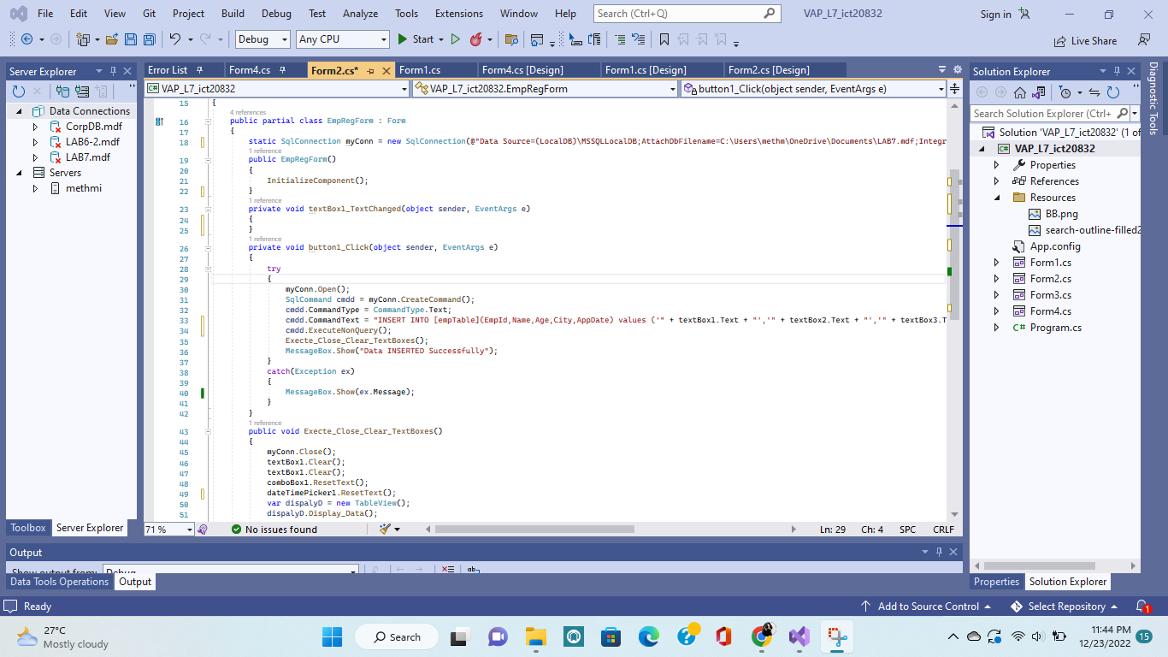

**Table View**

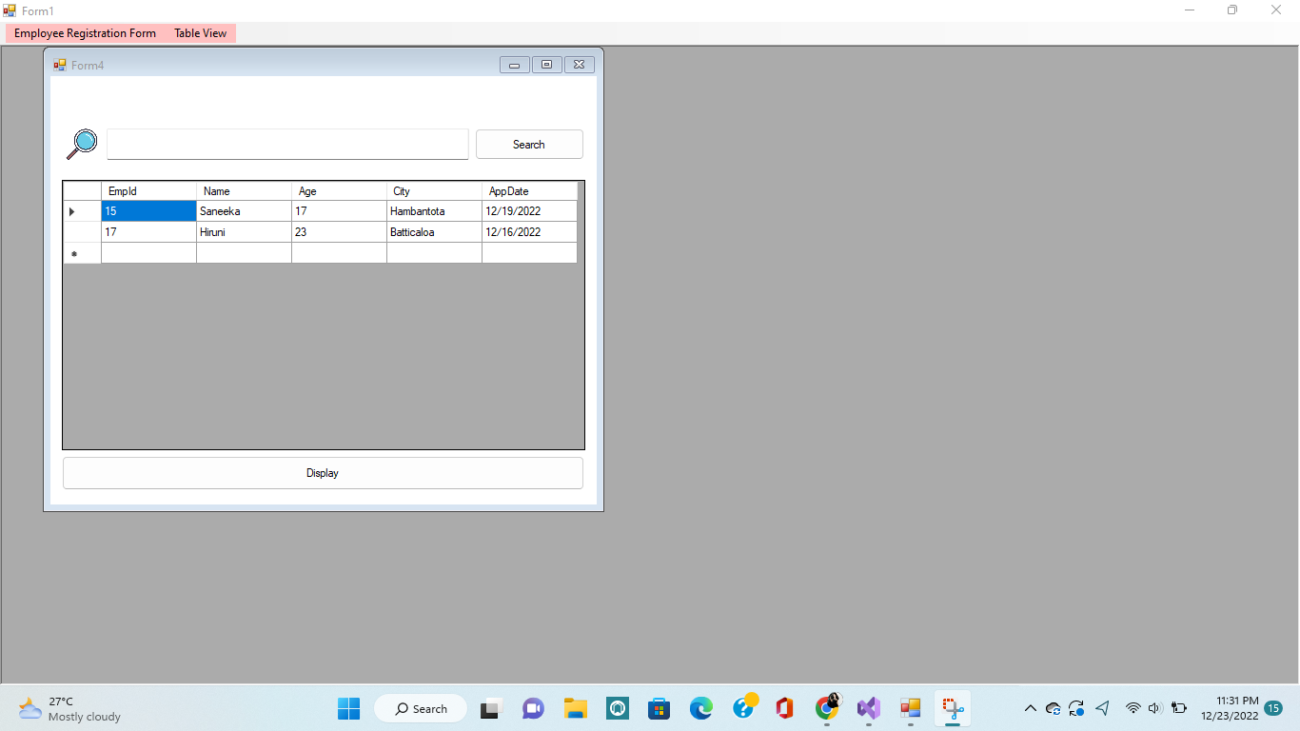

**Code**



**Parent Class Code**

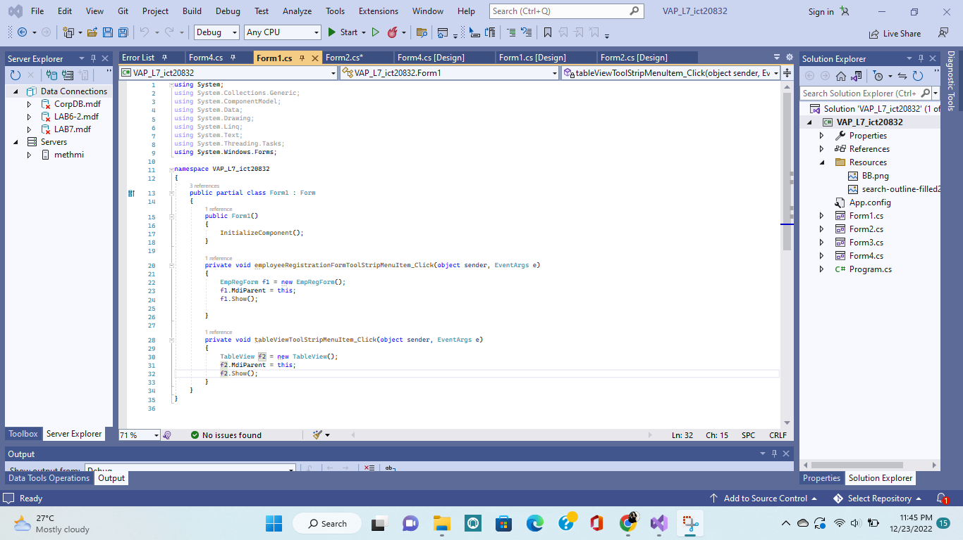

**Database**

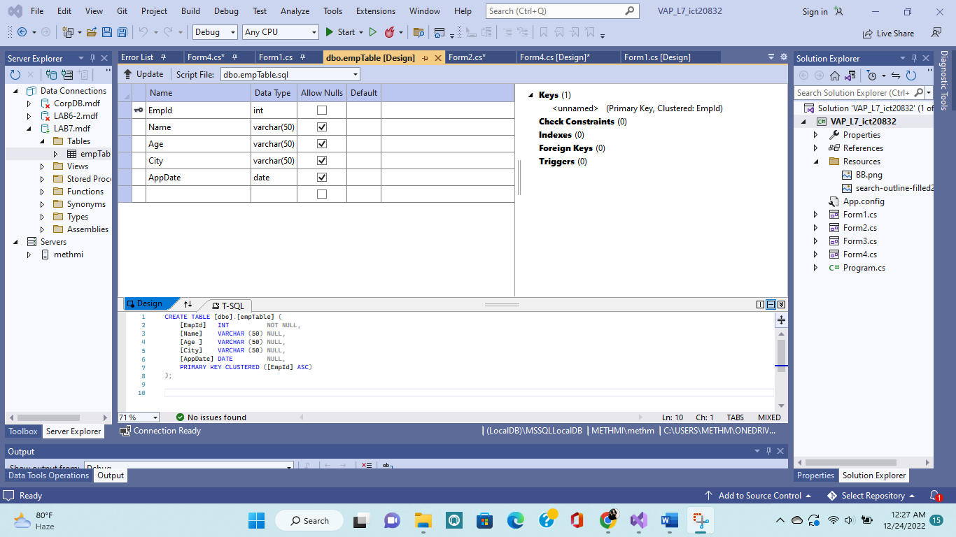

**2.**

**Visual studio 2022 do not support to cystal reports**