HNDIT4242 – Enterprise Architecture Lab sheet 02

1)

**Create Multi Thread app**

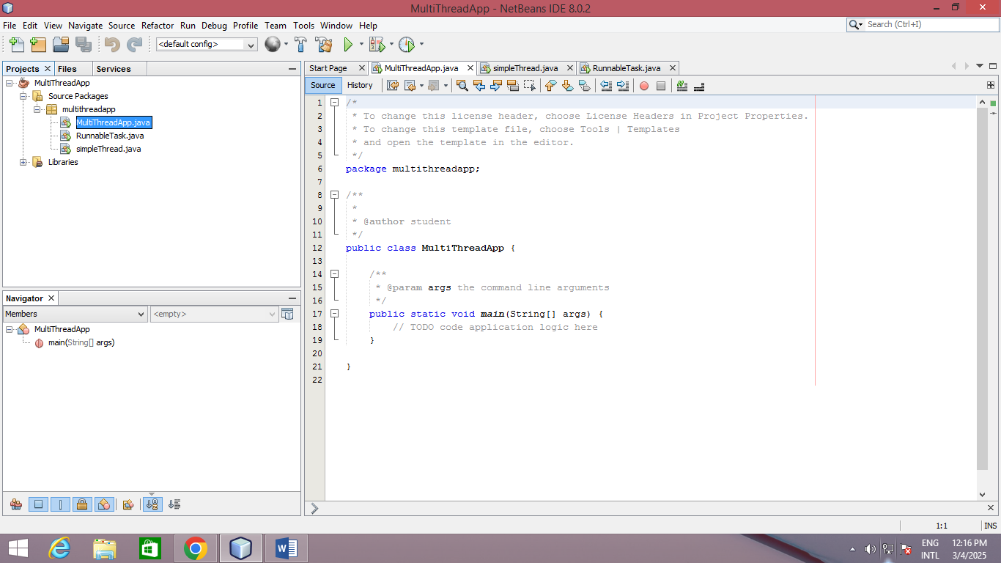

**Create a new class Simple Thread**

package multithreadapp;

public class simpleThread extends Thread{

@Override

public void run() {

System.out.println(Thread.currentThread().getId() + " is executing the thread.");

}

public static void main(String[] args) {

simpleThread thread1 = new simpleThread();

simpleThread thread2 = new simpleThread();

thread1.start(); // Starts thread1

thread2.start(); // Starts thread2

} }

**Output-**

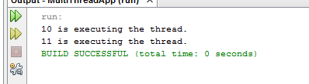

**2) Create a Runnable Class**

package multithreadapp;{

public class RunnableTask implements Runnable{

@Override

public void run() {

System.out.println(Thread.currentThread().getId() + " is executing the runnable task.");

}

public static void main(String[] args) {

RunnableTask task1 = new RunnableTask();

RunnableTask task2 = new RunnableTask();

Thread thread1 = new Thread(task1);

Thread thread2 = new Thread(task2);

thread1.start(); // Starts thread1

thread2.start(); // Starts thread2

}

}

**Output-**

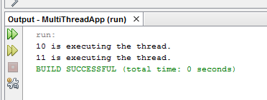

**3) Synchronizing Shared Resources**

package multithreadapp;

public class SynchronizedExample extends Thread {

private Count counter;

public SynchronizedExample(Count counter) {

this.counter = counter;

}

@Override

public void run() {

for (int i = 0; i < 1000; i++) {

counter.increment();

}

}

public static void main(String[] args) throws InterruptedException {

Count counter = new Count ();

// Create and start multiple threads

Thread thread1 = new SynchronizedExample (counter);

Thread thread2 = new SynchronizedExample (counter);

thread1.start ();

thread2.start ();

// Wait for threads to finish

thread1.join ();

thread2.join ();

System.out.println ("Final counter value: " + counter.getCount());

}

}

**Output-**

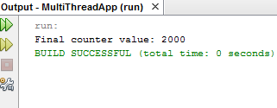

**4) Using ExecutorService for Thread Pooling**

import java.util.concurrent.ExecutorService;

import java.util.concurrent.Executors;

class Task implements Runnable {

private int taskId;

public Task(int taskId) {

this.taskId = taskId;

}

@Override

public void run() {

System.out.println("Task " + taskId + " is being processed by " +

Thread.currentThread().getName());

}

}

public class ThreadPoolExample {

public static void main(String[] args) {

// Create a thread pool with 3 threads

ExecutorService executorService = Executors.newFixedThreadPool(3);

// Submit tasks to the pool

for(int i = 1; i <= 5; i++) {

executorService.submit (new Task (i));

}

// Shutdown the thread pool

executorService.shutdown ();

}

}

**Output-**

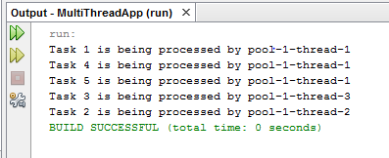

**5) Thread Lifecycle Example**

public class ThreadLifecycleExample extends Thread {

@Override

public void run() {

System.out.println(Thread.currentThread().getName() + " - State: " +

Thread.currentThread().getState());

try {

Thread.sleep(2000); // Simulate waiting state

} catch (InterruptedException e) {

e.printStackTrace();

}

System.out.println(Thread.currentThread().getName() + " - State after sleep: " + Thread.currentThread().getState());

}

public static void main(String[] args) {

ThreadLifecycleExample thread = new ThreadLifecycleExample();

System.out.println(thread.getName() + " - State before start: " +

thread.getState());

thread.start(); // Start the thread

System.out.println(thread.getName() + " - State after start: " +

thread.getState());

}

}

**Output-**

