CMPG 325-COMPUTER NETWORKS

LAMOLA MC
40624102

CLIENT REQUIREMENTS
CLIENT INFORMATION
Item | Details
Client ID | CLI-028
Organization | Ipeleng Study & Tutoring Hub
Location | Kimberley
Industry | Education
Addressing Block | 172.30.10.0/23
Networking Challenge | VLANs (switch-based segmentation)
Design Constraint | Shared risers – no civil works allowed
Change Request | CR5 – 25% user growth, no renumbering

CLIENT
Ipeleng Study & Tutoring Hub is a tutoring centre located in Kimberley that supports learners in their academic development. Its primary users include students attending tutoring sessions, staff members, and occasional visitors such as parents who come to inquire about the services offered.
CLIENT MAIN REQUIREMENTS:
- Separate networks
They want to put staff, students and visitors on different networks to prevent students from seeing staff information and have guests only have access to the internet.
- VLANs
They want VLANs to separate the traffic. VLANs are a good choice because they let me split the network logically without buying extra hardware.
- No Civil Works
They rent part of the building, so they can’t drill into the walls or install new cables. I’ll have to work with the existing risers and use the cable pathways that are already in place.
- Future growth
They’re expecting about 25% more users, so the network needs to be able to handle the extra demand without requiring any changes to the existing IP addresses or renumbering the network.
HOW TO MEET THEIR REQUIREMENTS
Requirement | My Solution
Separate networks | Use VLAN 10 (Staff), VLAN 20 (Students), VLAN 30 (Guests)
VLANs | Set up VLANs on switches and configure inter-VLAN routing on the router
No civil works | Use a star topology with all switches in one central location
25% growth | Choose subnets with spare IPs available
No renumbering | Plan addressing so there are enough extra IPs from the beginning

2. PHYSICAL TOPOLOGY
My Physical Design
I decided to use a star topology for this network. This means all switches connect back to one central switch. Here is my design:
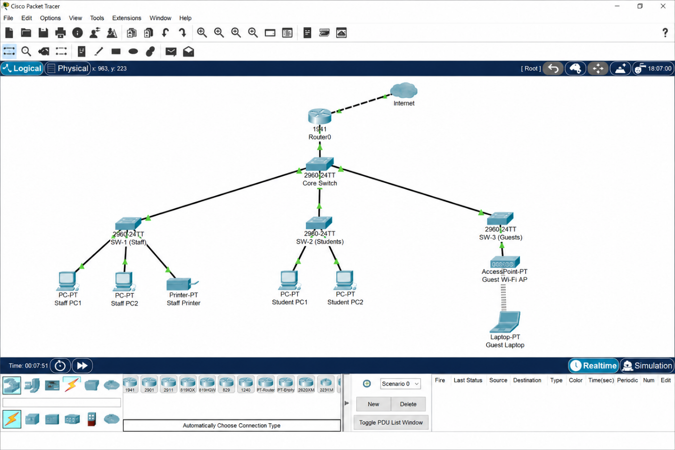

Devices I Will Use
Device | Model | Purpose
Router | Cisco 1941 | Connects to internet and does inter-VLAN routing
Core Switch | Cisco 2960 | Central switch connecting all access switches
SW-1 (Staff) | Cisco 2960 | Connects staff PCs and printer
SW-2 (Students) | Cisco 2960 | Connects student workstations
SW-3 (Guests) | Cisco 2960 | Connects guest Wi-Fi access point

Why I Chose This Design
Reason | Explanation
Star topology | Easy to manage – all switches connect to one core switch
Minimal cabling | Uses existing risers – no new cables through walls
No civil works | All equipment fits in the existing network closet
Scalable | Easy to add more switches or devices later
Central management | All traffic goes through the core switch – easy to monitor
Where Will All the Equipment Be Located?
All equipment will be located at a network closet (Telecom Room). The existing closet already has a number of cable risers that can be used to provide cabling to their respective destination areas.
Device | Location
Router | Telecom room
Core Switch | Telecom room
SW-1 (Staff) | Telecom room
SW-2 (Students) | Telecom room
SW-3 (Guests) | Telecom room
Staff PCs | Staff office (connected via existing wall ports)
Student PCs | Study area (connected via existing wall ports)
Wi-Fi AP | Guest area (connected via existing wall port)
Cabling Plan
Connection | Cable Type | Notes
Router to Core Switch | Copper (Cat6) | Short cable – same rack
Core to SW-1 | Copper (Cat6) | Uses existing riser
Core to SW-2 | Copper (Cat6) | Uses existing riser
Core to SW-3 | Copper (Cat6) | Uses existing riser
SW-1 to Staff PCs | Copper (Cat6) | Existing wall ports
SW-2 to Student PCs | Copper (Cat6) | Existing wall ports
SW-3 to Wi-Fi AP | Copper (Cat6) | Existing wall port
How This Meets the Constraints
Constraint | How I Meet It
No civil works | No drilling or wall modifications – using existing risers
Shared risers | All cables run through existing pathways
Rented building | All equipment stays in the telecom room – no changes to the building

3. Logical Topology
VLAN | Name | Subnet | What It's For
10 | Staff | 172.30.10.0/25 | Staff PCs and printer
20 | Students | 172.30.10.128/25 | Student computers
30 | Guests | 172.30.11.0/26 | Guest Wi-Fi
99 | Management | 172.30.11.64/27 | Switches and router management
WHY I SET UP LIKE THIS:
- Staff (VLAN 10): Needs access to the printer and files. This VLAN is separated from students for security reasons.
- Students (VLAN 20): Require Internet access, but they should be denied access to staff files.
- Guests (VLAN 30): Have access to a limited Internet connection. They should not have access to the organization’s network resources.
- Management (VLAN 99): For switches only. It should be isolated from other VLANs for security reasons.
LOGICAL DIAGRAM
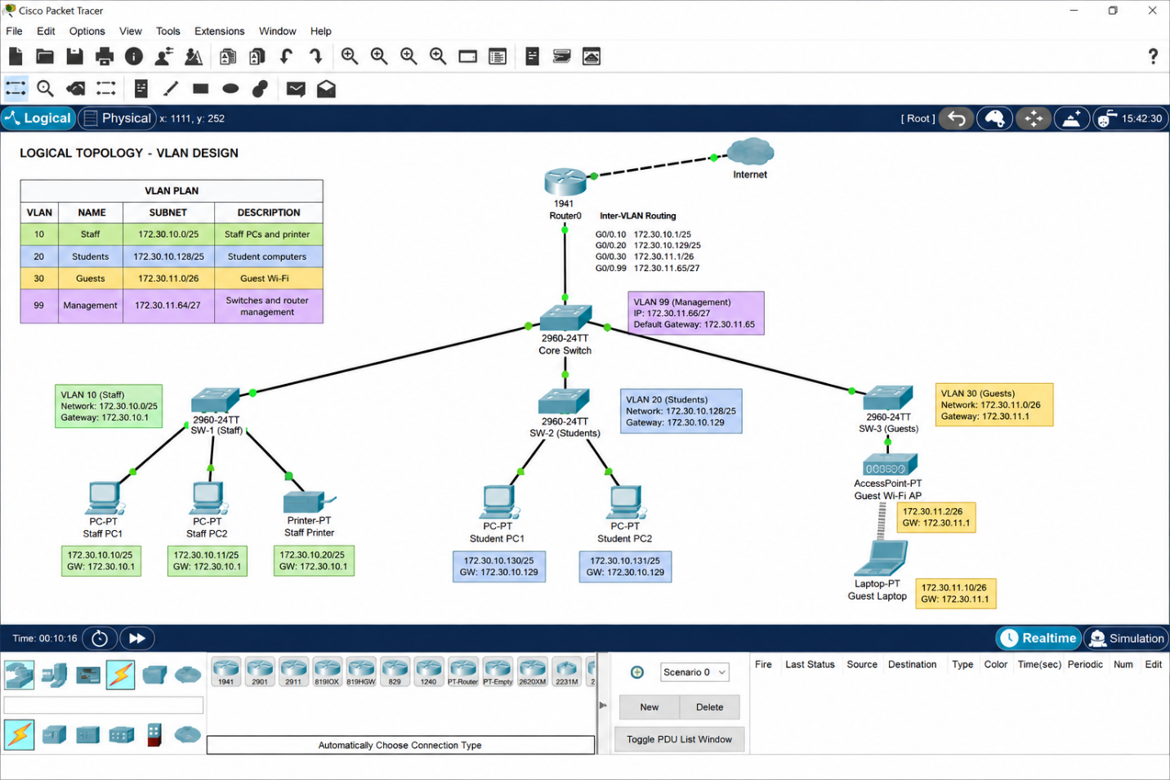
COMMUNICATION BETWEEN THE DEVICES
Traffic Type | How It Works
Within same VLAN | Devices communicate through the switch – no router needed
Between different VLANs | Traffic goes through the router (inter-VLAN routing)
To internet | Traffic goes through the router to the internet
Management | Network admins access switches via VLAN 99
Inter-VLAN Routing
- I will configure the router using the method called the Router-on-a-Stick, which consists of the following:
•Establish a trunk link from the core switch to the router
•Set up the router with several sub-interfaces, each VLAN having one sub-interface
•Assign an IP address to each of the sub-interfaces which will be the default gateway of the VLAN it is assigned to.
VLAN | Sub-interface | Gateway IP
10 | Gig0/0.10 | 172.30.10.1
20 | Gig0/0.20 | 172.30.10.129
30 | Gig0/0.30 | 172.30.11.1
99 | Gig0/0.99 | 172.30.11.65
How This Meets the Requirements
Requirement | How VLANs Meet It
Separate networks | Each user group has its own VLAN
Security | VLANs isolate traffic – no cross-VLAN access without routing
Performance | Broadcast traffic stays within each VLAN
Organisation | Easy to manage and troubleshoot

4. IP Addressing plan
IP Addressing Table
VLAN | Name | Subnet | Subnet Mask | Usable IPs | Gateway
10 | Staff | 172.30.10.0/25 | 255.255.255.128 | 126 | 172.30.10.1
20 | Students | 172.30.10.128/25 | 255.255.255.128 | 126 | 172.30.10.129
30 | Guests | 172.30.11.0/26 | 255.255.255.192 | 62 | 172.30.11.1
99 | Management | 172.30.11.64/27 | 255.255.255.224 | 30 | 172.30.11.65

Static IP Addresses
Device | IP Address | VLAN
Router (VLAN 10 gateway) | 172.30.10.1 | 10
Router (VLAN 20 gateway) | 172.30.10.129 | 20
Router (VLAN 30 gateway) | 172.30.11.1 | 30
Router (VLAN 99 gateway) | 172.30.11.65 | 99
Core Switch | 172.30.11.66 | 99
Staff Switch | 172.30.11.67 | 99
Student Switch | 172.30.11.68 | 99
Guest Switch | 172.30.11.69 | 99
Staff Printer | 172.30.10.5 | 10

DHCP Ranges
VLAN | DHCP Range
Staff (VLAN 10) | 172.30.10.10 – 172.30.10.126
Students (VLAN 20) | 172.30.10.140 – 172.30.10.254
Guests (VLAN 30) | 172.30.11.10 – 172.30.11.62
Management (VLAN 99) | No DHCP – static only

How I Handled CR5 (25% Growth)
Item | Value
Total IPs available | 512
IPs I am using | 344
Spare IPs | 168
25% growth (86 users) | 168 spare IPs is enough
Need to renumber? | No

