Rewriting the Scheduler program to use php and MySQL

# Tasks

1. **Create a MySQL database scheme and all queries needed to initialize, edit and read the database.**

The database should have 4 Entities: **Shifts, EmployeeShifts, Employees** and **EmployeeFreeTimes.** The variables *numWorkPlaces, minWorkHours* and *maxWorkHours* will be stored as session variables.

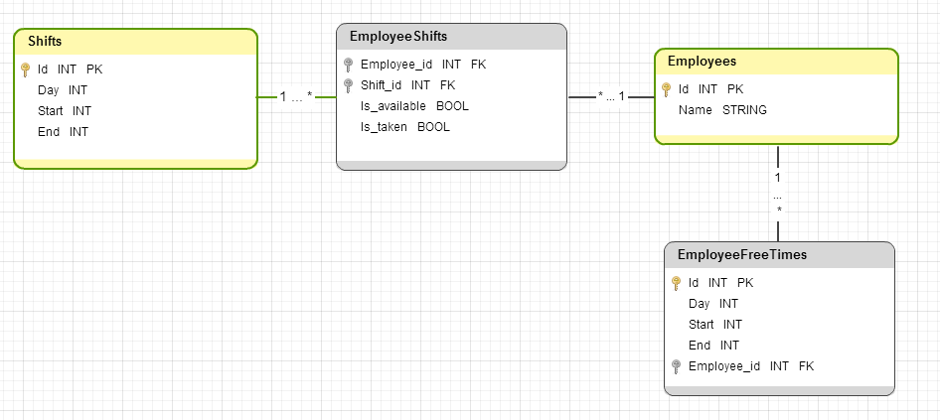

Note: The EmployeeShifts Foreign Keys both are used as Primary Key. The tool doesn’t have an option to draw that (or at least I couldn’t find such). Sorry about the inconvenience.

The queries that would be needed are:

* CREATE queries for all tables
* INSERT queries for all tables
* READ queries
* DELETE queries

1. **Welcome page.**

The welcome page should have the following elements:

* Work days
* Work places count
* Employee min and max work hours
* Shifts
* Employees
* Schedule generating button

Example:

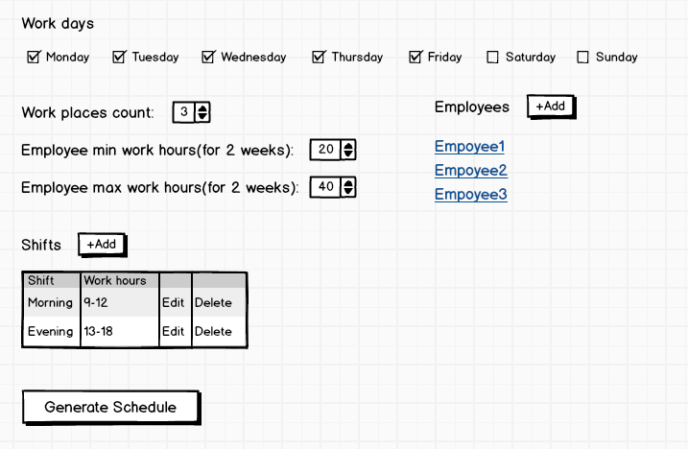

**Note**: The order and type of the elements undergo discussion and changes according to the implementer and team members

1. **Edit and Add pages.**
   1. **Employee Add page**

Each employee should have an Add page, which has:

* Employee name
* Employee free hour

Example:

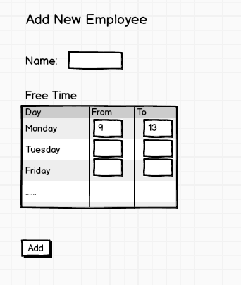

**Note**: The order and type of the elements undergo discussion and changes according to the implementer and team members

* 1. **Employee page**

Similar to the add page, but should also have a **Delete button**

* 1. **Shift Add page**

Can be implemented like Employee add page or like a prompt pop-up window. On implementer’s choice.

1. **Rewriting the existing code to php**
   1. **Reading all user input data from Web pages.**

Proper safety measures should be applied so that user enters correct data (just like in the Java get-ers and set-ers)

* 1. **Applying changes of Employees and Shifts to database.**

The same safeties should be plased in here that are in 4.1.

* 1. **Reading from database**

Functions that will use the SQL READ queries.

* 1. **Executing the schedule arrangement algorithm**

The same algorithm that is used in the Java implementation, but written in php.