ASUS

Detailed Analysis Report: Loan Interest Rate Prediction Models

1. Executive Summary
This report analyses the performance of three machine learning models (Random Forest, Linear Regression, and Gradient Boosting) used to predict loan interest rates. All models demonstrated poor performance with negative R² scores and high Mean Squared Error (MSE) values, indicating fundamental issues with the modelling approach.

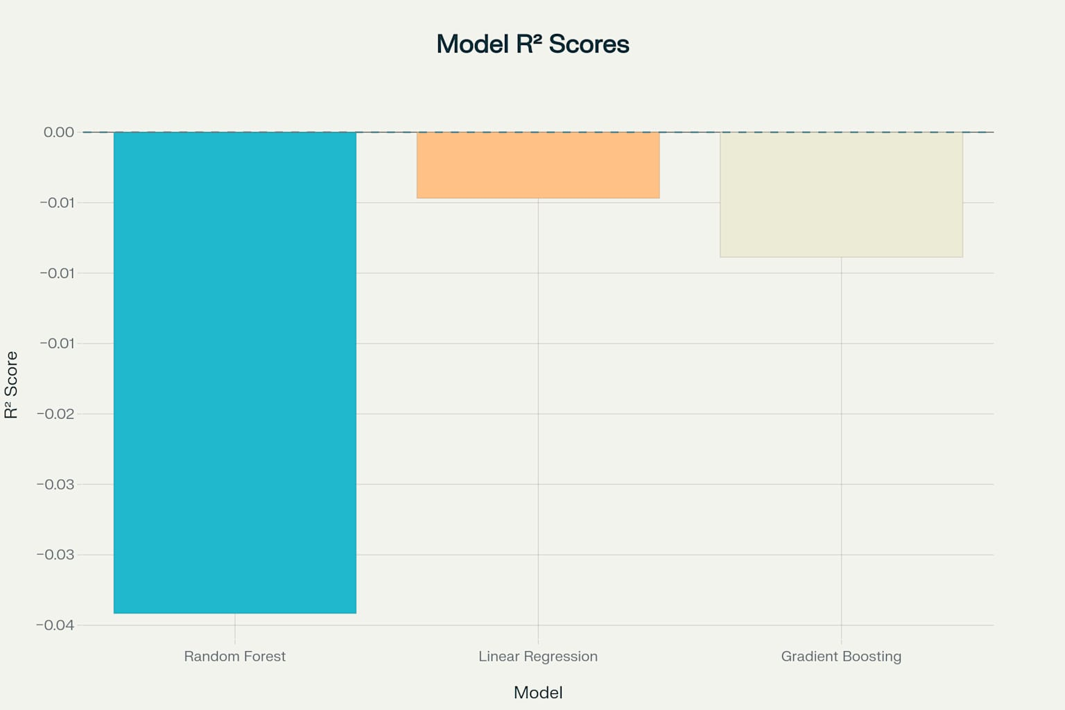

R² Scores Comparison Across Models
The analysis reveals several critical issues in data preprocessing, feature engineering, and model training that contributed to the underperformance. This report provides a comprehensive assessment of these issues and recommends specific improvements to enhance model performance.

2. Performance Metrics Analysis

2.1 Model Performance Summary
Model | MSE | R² Score
Random Forest | 46.50 | -0.034
Linear Regression | N/A | -0.005
Gradient Boosting | 45.36 | -0.009
All three models show negative R² scores, indicating they perform worse than a simple mean predictor (baseline model). The negative values suggest that the models are not capturing the underlying patterns in the data effectively.

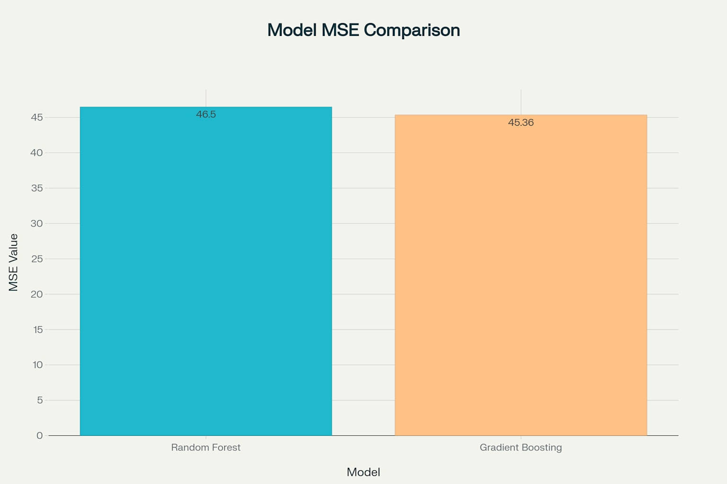
MSE Values Comparison: Random Forest vs. Gradient Boosting

2.2 Interpretation of Results
- Negative R² Scores: A negative R² score indicates that the model performs worse than a horizontal line representing the mean of the target variable. This suggests serious issues with the model's ability to capture the relationship between features and the target variable.
- High MSE Values: The MSE values (45-46) are considerably high, indicating large prediction errors. Gradient Boosting performed marginally better than Random Forest, but the difference is negligible given the overall poor performance.

3. Identified Issues and Root Causes

3.1 Data Preprocessing Issues
- Inadequate Missing Value Handling:
  - SimpleImputer with mean strategy was used, which can distort distributions and relationships.
  - This approach doesn't account for potential patterns in missing data.
- Categorical Variable Encoding:
  - OneHotEncoder was applied to 'Education', 'EmploymentType', 'MaritalStatus', and 'LoanPurpose'.
  - This may have created too many features, leading to the curse of dimensionality 1.
- Lack of Outlier Detection and Handling:
  - No outlier analysis or treatment was performed, potentially allowing extreme values to skew the models.
- Target Variable Treatment:
  - No transformation was applied to the target variable (InterestRate).
  - If the target has a skewed distribution, models might struggle to make accurate predictions.

3.2 Model Training Issues
- Default Hyperparameters:
  - All models used default hyperparameters without any tuning.
  - Default settings rarely provide optimal performance for specific datasets.
- Absence of Cross-Validation:
  - Models were evaluated on a single train-test split (75%-25%).
  - Without cross-validation, models may not generalize well to unseen data.
- No Feature Selection:
  - All available features were used without assessing their relevance.
  - Irrelevant or redundant features can introduce noise and degrade model performance.
- Limited Model Evaluation:
  - Only MSE and R² metrics were used to evaluate performance 1.
  - No analysis of residuals or prediction patterns was conducted 1.

4. Recommendations for Improvement

4.1 Data Preprocessing Enhancements
- Improved Missing Value Handling:
  - Consider median imputation, KNN imputation, or more advanced techniques.
  - Analyze patterns in missing data before choosing an imputation strategy.
- Feature Engineering:
  - Transform skewed features using log, square root, or Box-Cox transformations.
  - Create interaction terms to capture relationships between features.
- Outlier Treatment:
  - Identify and handle outliers using methods like winsorization or removal.
  - Consider robust scaling methods that are less sensitive to outliers.
- Target Variable Transformation:
  - Apply appropriate transformations (log, Box-Cox) to normalize the target variable distribution.
  - Consider binning or discretizing the target if appropriate for the business context.

4.2 Model Training Improvements
- Hyperparameter Tuning:
  - Implement grid search or random search for hyperparameter optimization.
  - Focus on key parameters like tree depth, learning rate, and regularization strength.
- Cross-Validation Implementation:
  - Use k-fold cross-validation (e.g., 5-fold or 10-fold) to ensure model generalization.
  - Consider stratified sampling if the target variable has an uneven distribution.
- Feature Selection:
  - Apply feature importance analysis to identify and remove irrelevant features.
  - Consider wrapper or filter methods for feature selection.
- Alternative Models:
  - Try more advanced algorithms like XGBoost, LightGBM, or Support Vector Regression.
  - Consider ensemble methods combining multiple models.

5. Implementation Plan

5.1 Exploratory Data Analysis
- Visualize feature distributions and identify skewed variables.
- Analyze correlation between features and target variable.
- Identify and handle outliers appropriately.

5.2 Feature Engineering
- Transform skewed features and target variable.
- Create interaction terms or polynomial features if appropriate.
- Implement feature selection techniques to remove irrelevant features.

5.3 Model Selection and Tuning
- Implement cross-validation for reliable performance estimation.
- Perform hyperparameter tuning for each model type.
- Try different algorithms and ensemble methods.

5.4 Model Evaluation
- Use multiple evaluation metrics (MSE, MAE, RMSE, R²).
- Analyze prediction errors and residuals.
- Compare with baseline models for proper benchmarking.

6. Conclusion
The current models for predicting loan interest rates show significant performance issues, with negative R² scores and high MSE values. The primary causes include inadequate data preprocessing, lack of feature engineering, absence of hyperparameter tuning, and limited model evaluation. By implementing the recommended improvements in data handling, feature engineering, and model training, we can expect substantial enhancements in prediction accuracy and model reliability.

