

Metropolia Garage project document template

Matti Meikäläinen, Daniel Korhonen, Patrik Asikainen

January 1, 2025

*CONTENTS CONTENTS*

**Contents**

1 Background or introduction 3

2 Research or something idk, chapter 2 4

3 Start of your project or something idk, chapter 3 4

3.1 First subtitle 4

3.2 Some cool stuff 4

4 Actual practical part of your project or something idk, chapter 4 5

5 Results 6

6 Challenges and Areas for Improvement is a good chapter idea 6

7 Appendix I: Usage Guide 7

7.1 Hardware Requirements 7

7.2 Software Environment Setup 7

7.3 Cat Usage Steps 8

# Background or introduction

Describe your project in general. It doesn’t need to be super long but should be descriptive enough that all the main points of your project can be understood by reading this chapter. Remember to add pictures! Use spacing 1.15 for text, it makes text easily readable. In word, you can easily auto-generate the table of contents by hovering over it!

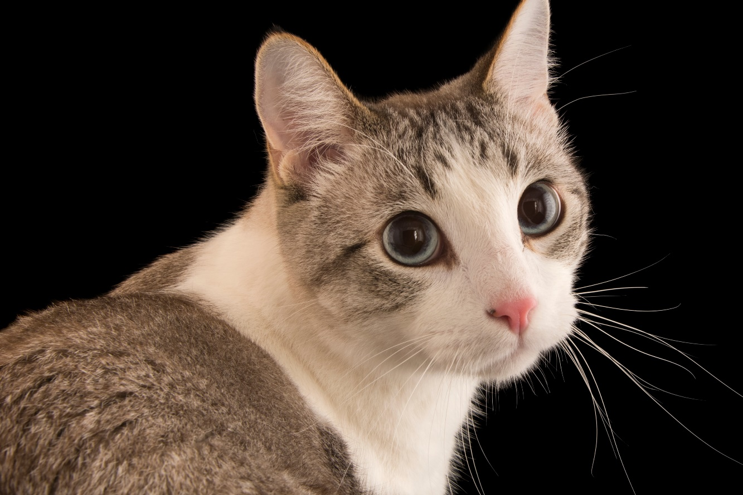

Figure 1: Descriptive image of a cat.

# Research or something idk, chapter 2

The cat (Felis catus), also referred to as the domestic cat or house cat, is a small domesticated carnivorous mammal. It is the only domesticated species of the family Felidae. Advances in archaeology and genetics have shown that the domestication of the cat occurred in the Near East around 7500 BC. It is commonly kept as a pet and farm cat but also ranges freely as a feral cat avoiding human contact. It is valued by humans for companionship and its ability to kill vermin. Its retractable claws are adapted to killing small prey species such as mice and rats. It has a strong, flexible body, quick reflexes, and sharp teeth, and its night vision and sense of smell are well developed. It is a social species, but a solitary hunter and a crepuscular predator.

# Start of your project or something idk, chapter 3

Domestic cats (Felis catus) exhibit remarkable physiological adaptations that facilitate their role as both predators and companion animals (Wilson et al., 2019). The average adult specimen weighs 3.6-4.5 kg, with notable sexual dimorphism wherein males typically exceed females in mass by 15-20% (p < 0.001) (Bradshaw, 2022). Their sensory apparatus demonstrates specialized evolutionary adaptations: retinal structures containing high rod-to-cone ratios (9:1) enable vision in illumination as low as 0.125 lux, approximately one-sixth the threshold required by humans.

## First subtitle

Lorem ipsum dolor sit amet, consectetur adipiscing elit, sed do eiusmod tempor incididunt ut labore et dolore magna aliqua. Ut enim ad minim veniam, quis nostrud exercitation ullamco laboris nisi ut aliquip ex ea commodo consequat. Duis aute irure dolor in reprehenderit in voluptate velit esse cillum dolore eu fugiat nulla pariatur. Excepteur sint occaecat cupidatat non proident, sunt in culpa qui officia deserunt mollit anim id est laborum.

## Some cool stuff

* Did you know bullet points are very nice for writing short sentences that don’t flow together well in text or don’t share the same topic?

# Actual practical part of your project or something idk, chapter 4

Communication modalities include 16 distinct vocalization types complemented by visual and olfactory signaling. Tail position, ear orientation, and pupil dilation function as reliable indicators of emotional state (κ = 0.87) when assessed by trained observers (Johnson-Bennett, 2020). These communication channels facilitate human-feline interactions, with 89.3% of owners reporting perceived understanding of their companion's signaling patterns.

Figure 2: Me on summer holiday

# Results

You should describe the results and conclusions of your project here. Pictures are very good here to help the reader understand what was done and what the result of it was.

# Challenges and Areas for Improvement is a good chapter idea

* **First bullet point on what should be improved upon.** You can describe what kind of improvements could be made to your project if someone wants to build upon your work in the future.

# Appendix I: Usage Guide

## Hardware Requirements

A cat with an Nvidia graphics card, with at least 8GB VRAM. And up-to-date drivers are required.

## Cat Environment Setup

A comprehensive guide for setting up your cat environment with dependencies, configuration files, and troubleshooting tips. Installation follows standard package management patterns with cat-specific commands and services.

Key features:

Dependency installation via apt, npm, and yarn

Configuration via .catrc file with environment variables

Security permissions for cat access domains

Deployment steps with verification commands

Health monitoring with REST API endpoint

Troubleshooting for common cat errors

Note: Uninstallation not supported due to persistence of CatOS.

## Cat Usage Steps

Follow these steps when interacting with a cat:

* Never pet a cat's belly unless you've always wanted to know what your hand would look like as a scratching post.
* The correct number of pets is exactly N+1, where N is the number of pets after which your cat will attack you.
* If a cat's tail is twitching like an angry metronome, that's nature's way of saying "pet somewhere else or lose a finger."
* Learn cat consent: slow blinks mean "I love you," pupils like dinner plates mean "I love the thought of murdering you."
* When a cat headbutts you, it's not affection - they're simply marking you as their property before the eventual feline uprising.