Task 4: Recommend Methodology for Estimating GHG Impacts

April 2025

Prepared for: Metropolitan Council
Prepared by: ICF and HFTE Inc
Table of Contents
1 Introduction 1
2 RS - Transit 3
2.1 Emission Reductions from Transit Expansion 3
2.1.1 Estimating Displaced SOV Trips 3
2.1.2 Recommendation for Transit Expansion Quantification 3
2.2 Emission Reductions from Mobility Hubs 5
2.2.1 Mobility Service VMT Reduction Potential 5
2.2.2 VMT Reduction Potential from Improved Transit Access 6
2.2.3 Recommendation for Mobility Hubs Quantification 7
2.3 Ridership and VMT Impact from Transit Services 9
2.3.1 Ridership Elasticities from Transit Expansion 9
2.3.2 Ridership Impact of BRT Conversion 10
1.1.1.1. Recommended BRT Elasticities from Literature 10
1.1.1.2. Impact of Metro Transit BRT Projects 11
2.4 Lesson Learnt from Past Transit Project Scoring 11
3 RS - Travel Demand Management (TDM) 12
3.1 Current TDM Methodology 12
3.2 Employee Commute VMT Reduction Projects 12
3.2.1 Update Current Commute Trip Distance Data 12
3.2.2 Recommendations for Commute VMT Reduction Projects 13
3.3 Shared Mobility Programs 14
3.4 Additional TDM Research Priorities 15
3.4.1 Parking Management Elasticity 15
3.4.2 Outcomes from VMT Mode Shift Study 16
3.4.3 Magnitude of Impact for Telework Strategies 16
3.4.4 Energy Consumption of Electric Scooter and Electric Bike 17
3.4.5 Methods to Quantify Outreach and Education Program Benefits 17
4 RS - Bicycle and Pedestrian Facilities 19
4.1 Pedestrian Facilities 19
4.2 Multi-Use Trails and Bicycle Facilities 20
5 RS - Roadway 22
5.1 Methods to Estimate Fuel-Based GHG Emissions 22
5.2 Recommendations to Quantify Intersection Delay Reductions 23
5.3 Recommendations to Quantify Corridor Speed Increases 24
5.4 Synchro/SimTraffic Emissions Estimation 27
5.5 Basis for Induced VMT Calculations 28
6 RS - Electrification 31
6.1 Electric Vehicle (EV) Education and Outreach 31
6.1.1 Survey information based on Drive Electric Minnesota 31
6.1.2 Recommendations for Education and Outreach Projects Quantification 31
6.2 Public Charging Infrastructure 33
6.2.1 How Does Public Infrastructure Influence Regional EV Adoption? 33
6.2.2 Recommendations for Infrastructure Projects Quantification 34
6.3 Other Considerations for Electrification Projects 35
6.3.1 Lifecycle Vehicle and Manufacturing Emissions for EVs 35
7 Transportation Policy Plan 38
7.1 Induced Demand 38
7.1.1 Sample Project Corridors Selection 39
7.1.2 RMI’s Tool Overview and VMT Estimation Results for Sample Corridors 39
7.1.3 ABM Induced Demand Sensitivity Test Scenarios 40
7.1.4 ABM Sensitivity Test Results and Findings 42
7.1.5 Key Findings Summary and Recommendations 45
7.2 Construction Emissions 47
7.2.1 The Minnesota Infrastructure Carbon Estimator (MICE) Tool 47
7.2.2 FTA Evaluation of Construction Emissions for Transit Projects 47
7.2.3 Other Considerations 51
7.3 Electrification in TPP 51
7.3.1 The EPA Motor Vehicles Emissions 4 (MOVES4) 51
7.3.2 Latest EPA Emissions Standards 52
7.3.3 Region Wide Targets and Programs 53
Appendix A – Emission Factors Baseline 55
Appendix B – Social Cost of Carbon 56

Introduction
The purpose of Task 4 is to build upon the review of the current Metropolitan Council (Met Council) practices (Task 2) and the review of other best practices (Task 3) to develop a set of recommended methodologies for estimating greenhouse gas (GHG) emissions impacts. This memo details research findings in response to specific questions about how to quantify the GHG impact of projects included in the Regional Solicitation (RS) and the Transportation Policy Plan (TPP).
The RS projects are divided into five categories: electrification, transit, bicycle and pedestrian facilities, travel demand management (TDM), and roadway, as shown in Table 1. In addition to quantification methodologies, the memo also addresses several research priorities identified by the project team, along with Working Group (WG) members and Met Council staff. A total of five WG meetings, one for each category, were hosted by the project team during October – November 2023 to determine the primary focus for GHG quantifications and project types.
Table 1. Project Types Considered for GHG Quantification Methodologies.
Category | Project Type
Electrification | Electric Vehicle (EV) Education and Outreach
 | Public Charging Infrastructure
Transit | New or Expanded Transit Service
 | Mobility Hubs
Travel Demand Management | Employee Commute VMT Reduction
 | Shared Mobility Programs
Bicycle and Pedestrian Facilities | Pedestrian Facilities
 | Multi-Use Trails and Bicycle Facilities
Roadways | Intersection Delay Reductions
 | Corridor Speed Increases
The recommended methodologies listed in this document focus on annual emissions reduction quantification. However, the actual methodologies and updates (Tasks 5 and 6) will include emission calculations that cover the entire project lifetimes.
Table 2. Default Lifetime for the Regional Solicitation Projects.
Regional Solicitation Project Type | Default Project Lifetime (Years) | Source
TDM – Employee Commute VMT Reduction | 4 | U.S. Bureau of Labor Statistics (BLS)
TDM – Micromobility | 5 | Assumptions used by the Minnesota Department of Transportation (MnDOT) Carbon Reduction Strategy
Traffic Management Technologies | 7 | U.S. Department of Transportation (USDOT) Benefit-Cost Analysis Guidance
Electrification Education and Outreach –Light Duty Personal, TDM – Carshare, TDM - Carpooling/Vanpooling | 8 | Federal Transit Administration (FTA) Useful Life Benchmarks
Public Infrastructure Deployment | 10 | Assumptions used by the MnDOT for the National Electric Vehicle Infrastructure (NEVI) Formula Program
Electrification Education and Outreach –Medium and Heavy-Duty Fleets and Commercial, Transit Expansion – New or Expanded Transit Service | 14 | FTA Useful Life Benchmarks
Spot Mobility and Safety, Strategic Capacity, Transit Hubs, Transit Expansion – Bus Rapid Transit Conversion, Transit Modernization, Bike & Ped Facilities | 20 | USDOT Benefit-Cost Analysis Guidance
The memo also summarizes major outcomes from three TPP working group meetings between ICF and Met Council staff. The primary goal of these meetings was to refine the methodologies for reporting GHG emissions in the TPP. This TPP section covers key points discussed in three main areas: induced demand, construction emissions, and electrification.

RS - Transit

Emission Reductions from Transit Expansion
Projects that add or expand bus service in the metropolitan area can improve the transit coverage area, provide transit service to more residents, and reduce trips and emissions from SOVs. The proposed methodology accounts for the well-to-wheel (WTW), lifecycle emissions of transportation fuels. Note that added emissions from additional bus services are not accounted for in the current methodology.

Estimating Displaced SOV Trips
VMT reduction from SOVs and ridership changes due to transit service expansion has seen considerable variability, by service type and route. For example, based on service levels and ridership reported by the Metro Transit during the fall of 2017, the weekday passengers per in-service hour (PPISH) in Saint Paul varies between 11.4 (Route 83) to 49.6 (A Line). Even within the Core Local routes, Route 70 has an average PPISH of 23, and the number for Route 54 is as high as 38.8. The same trends were observed with recent data as reported by Metro Transit staff as well. Core Local Routes in Minneapolis include Route 21 with about 32 PPISH and Route 23 with only 12. This variability extends to highway bus rapid transit (BRT) routes as well, with the Red line averaging around 14 passengers and the Orange line about 20 PPISH. Differences and variabilities also exist when it comes to trip distance. According to the most recent trip statistics from the Metro Transit, the average length was approximately 16.3 miles per trip for commuter buses and 9.1 for suburban local bus services. Additionally, bus routes often require indirect travel, potentially increasing VMT for individual trips, though this is distributed across all passengers on the vehicle. It's also important to note that transit riders generally make more walking trips at either end of their journey, which can also affect SOV VMT displacement. Given the significant variability in VMT displacement across transit services, the project team would recommend Met Council to consider using the regional specific trip length by transit type instead of the terminal-to-terminal distance in the quantification methodology.

Recommendation for Transit Expansion Quantification
The recommended methodology for transit expansion is a modified version of the method used by the California Air Resources Board (CARB), which considers the actual displaced VMT and well-to-wheel (WTW) lifecycle GHG emissions from SOVs. The suggested average trip length is based on the Metro Transit data by route classes. Note that this methodology also considers the additional transit emissions due to service expansion.
Table 3. Recommended Methodology for Estimating Displaced VMT and Emission Reduction from Transit Expansion
Current Method
VMT Impacts
- Applicants are directed to estimate the new daily transit riders from transit expansion and multiply by distance from terminal to terminal.
Daily VMT Reduction = New Daily Transit Riders multiplied by Distance from Terminal to Terminal
GHG Emissions Impacts
- Applicants are given default emissions factors which are applied to the reduction in daily VMT.
  - CO reduced = VMT reduced * 2.39
  - NOX reduced = VMT reduced * 0.16
  - CO2e reduced = VMT reduced * 366.60
  - PM2.5 reduced = VMT reduced * 0.005
  - VOCs reduced = VMT reduced * 0.03
Recommended Method
Auto VMT Displaced (annual) = R × A × L
Where:
- R = Increase in annual transit ridership; for new services, use projected total riders in a year instead.
- A = Adjustment factor to account for transit dependency. Suggested values are presented in the table below. Adjustment factors are mostly copied directly from a CARB study, which is estimated using vehicle ownership data of current transit riders. After all, only those riders who currently own a vehicle have the potential to displace SOV trips by using new or expanded transit services. The project team recommends Met Council to update these adjustment factors once regional data becomes available. For example, the fraction of riders who own a vehicle from the 2018 Metro Transit Customer Experience & Satisfaction Survey was used to update the adjustment factor for local bus in the table below.
- L = Length of average auto trip replaced (see table below). Suggested values use average transit trip lengths by mode, provided by the Metro Transit.

Route Type | Average Trip Length (mi/trip) | Adjustment Factor
Bus Rapid Transit | 13.2 | 0.62
Commuter Express | 16.3 | 0.705
Commuter Rail | 38.8 | 0.867
Core Local | 12.5 | 0.62
Light Rail Transit | 11.4 | 0.685
Suburban Local | 9.1 | 0.62
Support | 9.2 | 0.62
GHG Emissions Impacts (annual) = Auto VMT Displaced × CI_{L} – Added Transit VMT× CI_{B}
Where:
- CI_{L} = Carbon intensity that accounts for gasoline vehicle WTW emissions; default values can be retrieved from the Greenhouse Gases, Regulated Emissions, and Energy Use in Transportation (GREET) model as shown below. A list of full baseline emission factors derived from the Met Council Scenario Planning tool can also be found in Appendix A.
- Added Transit VMT = Additional transit VMT (annual) due to service expansion (deadheading miles and non-service miles should be accounted for in addition to revenue miles)
- CI_{B} = Carbon intensity that accounts for transit bus WTW emissions; default values can be retrieved from the GREET model as shown below.
Fuel | Gasoline | Diesel | Compressed Natural Gas | Electricity
WTW CI (gCO₂e/mi) | 409.73 | 342.66 | 355.23 | 175.45

Emission Reductions from Mobility Hubs
Based on the Working Group discussion, project applications to develop multi-modal mobility hubs around transit stations with pedestrian/bicycle facilities and car-sharing services are likely to increase in the upcoming years. A mobility hub is a carefully designed space that integrates various forms of transportation and related services to facilitate seamless and efficient movement of people. Key elements typically found in a mobility hub include:
- Public Transit Access: This is a core feature of a mobility hub, providing easy access to multiple modes of public transportation like buses, trains, trams, or subways.
- Bike-Sharing Stations: Facilities for renting bikes, often including electric bikes, which provide an eco-friendly and healthy transportation option.
- Car-Sharing Services: Availability of shared cars that can be rented for short periods, reducing the need for personal vehicle ownership.
- Electric Vehicle (EV) Charging Stations: Infrastructure to support the charging of electric vehicles, promoting the use of environmentally friendly transportation.
- Pedestrian-Friendly Design: Emphasis on safe and accessible walkways, promoting walking as a viable mode of transportation.

Mobility Service VMT Reduction Potential
The Metropolitan Council Mobility Hub Planning and Implementation Guidebook has examined the VMT reduction potential at mobility hubs using quantification methodologies from CARB and CAPCOA, with results listed in Table 4.
Table 4. VMT Reduction Potential of Mobility Hub Modes and Services.
Element | Low VMT Reduction Range | High VMT Reduction Range | Computed Average VMT Reduction
Pedestrian Facility | 0% | 6.4% | 3.2%
Bike Share | 0.02% | 0.06% | 0.04%
Scooter and Moped Share | 0.06% | 0.07% | 0.065%
Bicycle Parking | 0% | 4.4% | 2.2%
Car Share | 0.04% | 0.18% | 0.11%
Microtransit | 0.3% | 13.4% | 6.85%
Total | 0.42% | 24.2% | 12.3%
While this summary provides a comprehensive overview of the VMT reduction potential of different mobility hub elements, it may be difficult to apply directly to RS applications because it requires applicants to acquire community VMT. Besides, the actual VMT reduction of different mobility elements will also differ based on the specific project characteristics.

VMT Reduction Potential from Improved Transit Access
In addition to VMT displacement from non-transit mode mobility options, another major impact of mobility hubs is to improve transit ridership and displace SOV trips when these elements are used as first/last mile connection to improve access to transit. The Orange County Transportation Authority (OCTA) conducted a Mobility Hubs Strategy study, which looked at how mobility hubs could contribute to county-wide VMT reductions, from both the mobility service itself and the first & last mile connection to transit (mobility-to-transit). Using outputs from a travel demand model, OCTA first estimated mode-shift from SOVs due to mobility services often associated with Mobility Hubs. Next, OCTA estimated the VMT impacts of mobility hubs by looking at specific elements such as micro-mobility, micro-transit, and ride- and car-share amenities. To clarify, micro-mobility refers to small-scale transportation options, such as electric scooters and bicycles; micro-transit refers to forms of on-demand transportation limited to small geographic areas; ride- and car-share refer to services where individuals can request a ride in a car or renting a car in a geographic area, respectively. The study concluded that in total mobility hubs have the potential to reduce VMT within the identified mobility hub service areas by up to 11.1 percent with multiple elements combined. This included 2.9 percent from both micro-mobility and micro- transit, and 5.3 percent from rideshare/carshare (Table 5).
Table 5. OCTA Mobility Hub VMT Impacts
Transportation Mode | VMT Reductions due to Mobility Service | VMT Reduction due to Mobility-to-Transit | Total VMT Reductions within Service Area
Micro-mobility | 0.3% | 2.6% | 2.9%
Micro-transit | 0.3% | 2.6% | 2.9%
Rideshare/Carshare | 0.1% | 5.2% | 5.3%
Total | 0.7% | 10.4% | 11.1%
Another CARB study also provides some insights on how reduced distance and improved access to transit may help to reduce urban community VMT, as shown in Table 6. A simple linear relationship between VMT reduction and distance from the station was also extrapolated, suggesting about a 6 percent decrease in VMT per mile closer to a rail station starting at 2.25 miles from the station, and a 2 percent decrease in VMT per 0.25 miles closer to a bus stop, starting at 0.75 miles from the stop.
Table 6. Access to Transit Impact on Community VMT
Study | Results
 | Distance to Transit Variable | VMT Reduction for Reduction in Distance to Transit
Ewing and Cervero  (2010) | 1 mile closer to transit, with no distinction for rail and bus, no outer distance for the effect | -2.5%
Pushkar,  Hollingworth, and  Miller (2000) | 1 mile closer to rail station, from 2 miles to 1 mile from station, with no distinction for rail and bus | -1.3%
Bailey,  Mokhtarian, and  Little (2008) | 1 mile closer to rail station, within 2.25 miles of station | -5.8%
 | ¼ mile closer to bus stop, within 0.75 miles of bus stop | -2.0%
Bento, Cropper,  Mobarak, and  Vinha (2005) | 10% decrease in distance to a transit stop, with no distinction between rail and bus, no outer distance for the effect | -0.8%

Recommendation for Mobility Hubs Quantification
Ideally, the most accurate method to evaluate the VMT and emissions impact of mobility hubs it to use a two-step approach as detailed in Table 7. The first step is to understand the community VMT reduction from the mobility element itself, and the second step is to calculate the VMT displacement from increased transit ridership. Unless better community VMT data or quantification methodology becomes available, the team recommends using employment and population information that is currently being collected through the RS transit applications and average VMT per capita in the metropolitan area to estimate community VMT. According to a regional study in 2018, the annual VMT per capita in Minneapolis is 5,567 miles.
The estimation of transit ridership involves many variables and often requires a large amount of data and extensive regional travel demand modeling before any conclusion can be drawn. As an emerging project type, there is little information on how mobility hubs can affect or improve transit ridership. One recent study suggests that a 10% growth in population covered by transit using first & last mile connection can increase transit usage by 5.9%. However, the impact of ridership can change drastically depending on population density and service types.
Therefore, the project team proposes this simplified alternative to the methodology derived from the Met Council Mobility Hubs study, the team has also provided an alternative to estimate community VMT reduction from mobility and mobility-to-transit combined, avoiding the need to assess ridership impact. The VMT reduction factors are adjusted from the Met Council study using the OCTA study, as well as the buffer distance of 3 miles for the population within the service area.
Table 7. Recommended Methodology for Estimating Displaced VMT and Emission Reduction from Mobility Hubs
Recommended VMT Impact Quantification Method
Auto VMT Displaced (annual) = V_{E} × P × VMTPC + R × A × L
Where:
- V_{E} = The total VMT reduction potential of various mobility elements. Suggested values are presented below, and values are taken from Computed Average VMT Reduction column in Table 4.
- P = Population within the service area (within approximately 3 miles of the identified hub location).
- VMTPC = Average annual VMT per capita within the service area (within approximately 3 miles of the identified hub location); default is 5,567 miles.
- R = Increase in annual transit ridership; for new services, use projected total riders in a year instead.
- A = Adjustment factor to account for transit dependency. Suggested values are presented in the table below.
- L = Length of average auto trip replaced. Suggested values are presented in the table below.
Mobility Mode | VMT Reduction Potential
Pedestrian Facility | 3.2%
Bike Share | 0.04%
Scooter and Moped Share | 0.065%
Bicycle Parking | 2.2%
Car Share | 0.11%
Microtransit | 6.85%

Route Type | Average Trip Length (mi/trip) | Adjustment Factor
Bus Rapid Transit | 13.2 | 0.62
Commuter Express | 16.3 | 0.705
Commuter Rail | 38.8 | 0.867
Core Local | 12.5 | 0.62
Light Rail Transit | 11.4 | 0.685
Suburban Local | 9.1 | 0.62
Support | 9.2 | 0.62

Alternative VMT Impact Quantification Method
Auto VMT Displaced (annual) = V_{E} × P × VMTPC
Where:
- V_{E} = Maximum VMT reduction potential of all applicable mobility elements. These parameters include VMT reduction from both the element itself and mobility-to-transit component. Suggested values are presented in the table below, which is a sum of the Computed Average VMT Reduction column in Table 4 and the VMT Reduction due to Mobility-to-Transit column in Table 5. The project team suggested using the maximum value instead of the sum to prevent double counting the overlapping service population.
- P = Population within the service area (within approximately 1 miles of the identified hub location). Although the entire service area where VMT reduction might be observed is 3 miles, some mobility elements may not cover this extensive area. Therefore, the project team recommends using a radius of 1 mile at this stage.
- VMTPC = Average annual VMT per capita within the service area. The recommended service area is approximately 3 miles from where people reside. To estimate this, it is best to consider the number of trips occurring within 3 miles of home each year. While this data is challenging to obtain, the project team currently uses a proxy calculation of 3 miles × 260 workdays = 780 miles.
Mobility Mode | Total VMT Reduction Potential
Pedestrian Facility | 5.80%
Bike Share | 2.64%
Scooter and Moped Share | 2.67%
Bicycle Parking | 4.80%
Car Share | 5.31%
Microtransit | 9.45%

GHG Quantification Method
GHG Emissions Impacts (annual) = Auto VMT Displaced × CI_{L}
Where:
- CI_{L} = Carbon intensity that accounts for gasoline vehicle WTW emissions; default values can be retrieved from the GREET model as shown below.

Fuel | Gasoline | Diesel | Compressed Natural Gas | Electricity
WTW CI (gCO₂e/mi) | 409.73 | 342.66 | 355.23 | 175.45

Ridership and VMT Impact from Transit Services

Ridership Elasticities from Transit Expansion
Research findings indicated that an increase in transit service supply leads to higher ridership, with varying elasticities for different modes: 0.41 for buses, 0.90 for light rail, and 0.58 for overall transit. Fare and service frequency also influenced ridership, with fare elasticities being negative across all modes, implying that higher fares reduce ridership. Service frequency had a significant impact only on bus ridership. Additionally, they found that the percentage of households without a vehicle negatively affected bus and light rail ridership, which was a surprising result. Table 8 summarized transit ridership elasticities related to transit expansion. Note that these values have been developed using nationwide numbers and project outcomes. While they may not accurately reflect the outcome of Met Council projects, they can serve as a reasonable estimate when estimating the impact of any new project applications. The project team also encourages Met Council to continue tracking the outcomes from funded projects to develop regional specific elasticities when data become available.
Table 8. Elasticity of Ridership Increase from Transit Expansion.
 | Bus | Commuter Rail | Light-Rail | Heavy-Rail | Transit
Vehicle Revenue Hours Elasticity | 0.41 | 0.063 | 0.9 | 0.014 | 0.58
Service Frequency Elasticity | 0.77 | - | 0.013 | - | -

Ridership Impact of BRT Conversion
Converting a traditional bus service to BRT involves a series of enhancements such as the establishment of an exclusive right-of-way (e.g., busways and queue-jumping lanes) at busy intersections, as well as implementing increased limited-stop services like express routes. Additionally, transit signal priority and automatic vehicle location (ITS) and improved station designs can be expected. Lastly, efficient fare-payment methods, such as smart cards or smartphone apps, are common in a BRT system. Thus, ridership methodologies must be inclusive of these distinct improvements to accurately assess the net ridership increase from BRT.

Recommended BRT Elasticities from Literature
Adapting the California Air Pollution Control Officers Association (CAPCOA) methodology for GHG reduction via BRT, we'll focus on customizing its impact on ridership specifically for the Met Council region. CAPCOA, as outlined in the Task 3 memo approaches this challenge by utilizing assumptions determined from the Transportation Research Board and the Federal Highway Administration. For instance, CAPCOA assumes an additional 25 percent increase in ridership would occur from a full-featured BRT service operating on a fully segregated running way with specialized (or stylized) vehicles, attractive stations, and efficient fare collection practices.
Table 9. Recommended BRT Impact Assumptions
Relevant Assumptions | Value | Source | Geographic Location
Percent Change in transit ridership due to BRT | 25 | Transportation Research Board | National/  International study
Percent change in travel time due to BRT | -10 to -20
Elasticity of transit ridership WRT transit travel time | -0.4
Elasticity of transit ridership WRT service frequency | 0.5 | Handy et al. | California-specific

Impact of Metro Transit BRT Projects
Much can be learned from past projects, specifically related to BRT Projects. For instance, arterial BRT conversions have led to significant improvements in ridership. For instance, the D Line combined with Route 5 experienced a remarkable 175% increase in total monthly ridership within a year of opening, far surpassing the 30-40% growth seen in comparable routes. The A Line's introduction also achieved growth, albeit more modest, with a 30% rise in ridership and a 12% increase in productivity, especially notable as similar routes were witnessing a 20-30% decline in ridership over the same period. Furthermore, the C Line demonstrated impressive gains, with a 50% increase in ridership and 20% in productivity in just the first four months of operation, prior to the onset of COVID. These figures highlight the positive impact that BRT conversions can have on public transit usage and efficiency and can be used as references for any future applications of a similar nature.

Lesson Learnt from Past Transit Project Scoring
An important aspect is the experience gained in scoring and evaluating transit priority projects. The focus of these evaluations has been on metrics that align with core values set forth by the Met Council, such as passenger delay, which is crucial for assessing transit performance. This approach emphasizes that the efficiency of a bus system is measured by its ability to move people rather than vehicles. Additionally, a combination of demographic factors is considered, including race and ethnicity, household income, and vehicle availability. The use of wheelchair lifts and limited mobility fare products also play a significant role in these evaluations. Moreover, there is an acknowledgment of the history of discrimination, including practices like red-lining, and how they impact transit needs and solutions. This comprehensive approach to scoring and evaluation reflects a deep understanding of the diverse factors that influence transit effectiveness and equity in the Met Council region.

RS - Travel Demand Management (TDM)

Current TDM Methodology
The current methodology, as shown in Table 10, for RS TDM projects requires applicants to estimate the average number of weekday users of the project. Coupled to this is estimating the project’s ability to reduce congestion during the peak period in the area and any expected reductions of CO, NOx, CO2e, PM2.5 and/or VOC emissions due to the reduction in VMT.
Table 10. Current Methodology for TDM Projects.
Current Method
Facility Usage
- Applicants provide the average number of weekday users of the project. A direct project user is someone who will participate in the TDM program or project, and not one who receives an indirect benefit from the project. Applicants must describe their methodology for determining the number of daily one-way trips reduced.
VMT Impacts
- Applicants calculate the number of daily one-way commute trips reduced, as well as the average commute trip length to calculate VMT reduction (2011 Travel Behavior Inventory average commute trip is 12.1 miles). A “trip” is defined as the journey from origin to destination, round trip travel is considered two trips. Using multiple modes or multiple transit routes between an origin and destination does not constitute multiple trips.
VMT_{Reduced} = (Number of daily one-way commute trips reduced) * 12.1 miles
GHG Impacts
- The CO2e emission reduction is calculated using the applicant’s VMT reduction and an emission factor, in units of emission mass per mile.
CO2e_{Reduced} = VMT_{Reduced} × 366.60 grams CO2e per mile

Employee Commute VMT Reduction Projects
This section summarizes the methodology to quantify well-to-wheel (WTW) lifecycle GHG reductions from employer-sponsored commute VMT reduction projects, including but not limited to telework strategies, employee parking management, transit pass subsidy, carpooling, or vanpooling projects. The overarching goal of these projects aims to reduce commute VMT using single-occupant vehicles (SOVs).

Update Current Commute Trip Distance Data
One of the key parameters used to determine the impact of TDM projects that aim to reduce commute VMT is the average commute trip distance in the metropolitan region. The default value provided in the most recent RS guideline is 12.1 mile, based on Met Council’s 2011 Travel Behavior Inventory.
To understand more recent commuter trends in the area, the project team has investigated other data sources. In 2018, the transportation “big data” platform, Streetlight, published median one-way commute trip distance by state based on location information collected during the month of September 2017. The median 1-way commute distance in Minnesota is 8.7 miles and varies drastically by communities across the state, with the shortest commute distance being 1.6 mile (Minneapolis zip code 55414), and longest being 81.6 mile (Swatara zip code 55785).
Given the wide variations by population density and economics within the state, the project team would also like to understand the commute trip distance at higher spatial resolution. Here, the project team leverages Replica, a big data analytics platform that simulates travel patterns using anonymized cell phone data. For example, Figure 1 shows the Replica distribution of commute trips that start and end in the seven counties within the metropolitan area. The average commute trip distance across seven counties is 10.9 miles, and the median is 9.1 miles. In terms of county-level averages, Anoka has the shortest average commute at 9.7 miles, while Carver and Hennepin have the highest of 11.3 miles.

Figure 1. Distance of Commute (Trip Purpose: Work) Trips that Start and End in the Seven Counties: Anoka, Washington, Ramsey, Hennepin, Carver, Scott, and Dakota. Data from Spring 2023 Weekday Replica Data.
As of now, the Replica seven-county average (10.9 miles) from Spring 2023 is the most recent regional commute trip data, and thus was selected as the default value for the GHG quantification methodology. The project team would also recommend Met Council to examine the latest commute trip distance data from household surveys and other regional studies and continue updating the number based on information that becomes available in the future.

Recommendations for Commute VMT Reduction Projects
In Task 3, the project team has reviewed methodologies that quantify VMT or emission impact of commute trip reductions from the San Diego Association of Governments (SANDAG), the California Air Resources Board (CARB), and other government agencies. Many of the methodologies rely on regional-specific input or information that might be outdated. For example, one methodology that evaluates the VMT reduction impact from telework strategies was developed based on the U.S. EPA’s COMMUTER model, originally developed in the early 1990s. In addition, there is also a lack of post-COVID-19 pandemic literature that provides better estimation of the VMT or emissions impacts of employer-sponsored TDM projects. Therefore, the project team recommends continuing to use the current methodology to estimate the displaced VMT from annual commute trips reduced through employer sponsored TDM projects, with more recent commuter trip distance data and the latest WTW GHG emission factors, as shown below in Table 11.
Table 11. Recommended Methodology for Commute VMT Reduction Projects.
Recommended Method
Auto VMT Displaced (annual) = N × T_{C} × D
Where:
- N = Number of daily one-way commute trips reduced
- T_{C} = Average commute trip distance; default is 10.9 mile, based on Replica 2023 Spring commute trip data.
- D = Working days in a year; default is 260.
GHG Emissions Impacts (annual) = Auto VMT Displaced × CI_{L}
Where:
- CI_{L} = Carbon intensity that accounts for auto vehicle WTW emissions; default values can be retrieved from the Greenhouse Gases, Regulated Emissions, and Energy Use in Transportation (GREET) model (409.73 gCO₂e/mi).

Shared Mobility Programs
The concept of shared mobility applies to any project that encourages the shared use of a vehicle, bicycle, or other mode, including carshare, bike/electric bike share, scooter/electric scooter share, carpooling, vanpooling, on-demand ride, ride-hailing, etc. Note that transit expansion projects are considered under the transit category, and thus not included in this memo. The recommended methodology for shared mobility is adapted from the California Air Resources Board (CARB) to assess shared mobility emission reduction potential from an estimate of displaced auto VMT by mobility service type. This methodology also accounts for any new VMT, and WTW GHG emissions associated with the shared mobility service. Because high variances in trip distance from different mobility services have been observed and shared mobility programs are not solely targeted at commute trip reduction, the project team recommends applying trip distance by project type instead of using the same commute trip distance as in the current methodology.

Recommended Method
New Service VMT (annual) = V × T × L
Where:
- V= Number of vehicles or equipment directly associated or dispatched with the project.
- T = Average number of annual trips per vehicle expected directly associated with the project.
- L = Estimated length of average vehicle trip directly associated with the project. Default for scooter and bike trips is 1.4 miles; default for ride hailing/taxi service is 7.7 miles, based on the 2023 Spring Transportation Network Company (TNC) and Taxi trips average from Replica.
Auto VMT Displaced (annual) = New Service VMT × A × O × (1- DM)
Where:
- A = Adjustment factor that accounts for the trips that are displaced by the project. Suggested values for the adjustment factor are 0.50 for short-distance passenger trips (typically below 10 miles) and 0.83 for long-distance passenger trips (typically above 10 miles).
- O = Average occupancy of per vehicle or equipment dispatched in the project. Defaults are 1 for standard bicycle, electric bicycle, electric moped, and electric scooter. Suggested value for ride-hailing services is 1.55 based on CARB study.
- DM = Percentage of deadhead miles out of total vehicle miles. Suggested value for ride-hailing services is 0.4 based on CARB study.
GHG Emissions Impacts = Auto VMT Displaced × CI_{L} - New Service VMT × CI_{L, N}
Where:
- CI_{L} = Carbon intensity that accounts for auto vehicle WTW emissions; default values can be retrieved from the GREET model (409.73 gCO₂e/mi).
- CI_{L, N} = Carbon intensity that accounts for new service vehicle WTW emissions; default values depend on the fuel type and service type: 0 for bike and scooter, 409.73 gCO₂e/mi for gasoline vehicle services, and 175.45 gCO₂e/mi for electric vehicle services.

Additional TDM Research Priorities

Parking Management Elasticity
Parking management has proved to be an effective strategy to reduce vehicle trips. The California Air Pollution Control Officers Association (CAPCOA) handbook has taken a holistic approach to examine the impact of five parking management strategies on VMT reduction, which has been discussed in the Task 3 memo. Here the project team highlighted the key outcome of a 2019 study, which suggests that price elasticity of parking is highly specific to individual circumstances and land use. The long-run elasticity of volume to parking cost is estimated to be in the range of -0.18 to -0.45, with an average of -0.32.

Outcomes from VMT Mode Shift Study
The Metropolitan Council’s Maximum Mode Shift: A VMT Reduction Study estimates the maximum mode shift possible provided existing land use patterns and travel needs. The study uses 380,000 real-world auto trips reported by the 2019 and 2021 Travel Behavior Inventory to conduct research around maximizing less carbon-intensive modes of travel. For every personal vehicle trip, the study calculated the best alternative walk, bicycle and transit paths and applies statistical binning of trip length to determine which modes of travel are feasible substitutes for the original car trip. In this study, feasibility of a mode is characterized by the maximum distance 5 percent of travelers in that mode are willing to traverse. In addition, for trips with feasible non-car options, the study further identified whether any of the non-car options has a competitive travel time (within 15 minutes).
Holding land use, transportation systems, and travel patterns constant, the study considers the extent to which other metrics, such as geography, demographics, and trip types, impact how much travel can be shifted away from driving towards walking, biking, and public transit. Considering feasibility and whether the feasible alternatives are competitive, the study found that about 25 percent of car trips could switch to combinations of walk, bike, or public transit trips within a competitive travel time, as shown in Table 12. This corresponds to a VMT reduction of 5 percent across all non-car modes.
Table 12. Trip & VMT Mode Shift Potential by Alternative Mode.
Value | Competitive to switch to walk | Competitive to switch to bike | Competitive to switch to transit | Competitive to switch to all alternative modes
Percent of Car Trips | 13% | 17% | 6% | 25%
Percent of VMT that Could be Eliminated | 1% | 3% | 1% | 5%
As for how other metrics impact the feasibility to switch modes, the study suggests that urban centers, such as the core Twin Cities area, have more potential for mode shift, particularly when considering the time-competitiveness of driving time. Non-work-related trips, such as commutes to school and recreational trips, also demonstrate high potential to mode switch; demographics, on the other hand, do not demonstrate an influential impact on the ability to mode shift. The study suggests that other factors, such as the use of e-bikes, could encourage greater mode shift, but the actual trip length and impact of e-bikes is not well understood based on the 2021 Travel Behavior Inventory.

Magnitude of Impact for Telework Strategies
Similar to the Met Council’s mode shift study and the parking elasticity study, there are other resources that can help to determine or estimate the magnitude of impact for telework strategies. For example, the Pacific Southwest Region University Transportation Center conducted a study on the impacts of teleworking on activity-travel behavior using the California component of the 2017 National Household Travel Survey. The study also references the American Time Use Survey (2019) and Global Workplace Analytics as sources to track the percent change in telework, forecasting that the percentage of people that performs remote or hybrid work will stabilize to between 35 to 40 percent. According to a recent Gallup study, the average U.S. worker spends 3.8 days per month working from home, down from 5.8 in 2020 but still higher than the 2.4 average from 2019. A study that was developed using the forementioned U.S. EPA’s COMMUTER model has also suggested that 1 percent of employees telecommuting 1 day per week will reduce annual VMT for the employer by 0.15 percent. Such information, while not specific to the metropolitan area, may still help to justify whether information submitted by the applicants is reasonable and realistic.

Energy Consumption of Electric Scooter and Electric Bike
As discussed earlier, the current methodology to quantify GHG benefits for shared mobility (or in this case, micromobility) projects does not account for the energy consumption of electric scooters and electric bikes. This is mainly due to the low energy consumption from these two transportation modes based on existing data.
Research has shown that certified and real-world energy consumption for electric bikes and scooters vary between 0.27 and 3.62 kWh/100 mile, which saves more than 90% of energy as compared to EVs, as shown in Table 13. Given the relatively small energy consumption from electric bikes or scooters, the project team has recommended not to include upstream energy emissions for electric micromobility projects.
Table 13. Certified and Real-World Energy Efficiency for Various Electric Vehicles and Equipment.
 | Average Certified Energy Consumption  (kWh/100 mile) | Average Real-World Energy Consumption  (kWh/100 mile)
Stand-up and kick scooters | 2.0 | 2.34
E-bikes and bike-like three-wheelers | 0.87 | 1.14
Larger two- and three-wheelers, including mopeds, step-through scooters, motorcycles | 7.44 | 15.0
Car-like three- and four-wheelers | 12.9 | 16.1
Passenger cars | 25.7 | 29.6

Methods to Quantify Outreach and Education Program Benefits
Assessing the impacts of outreach and education programs can be achieved by partnering with community organizations to disseminate information and log community feedback. Feedback mechanisms, such as surveys, can be implemented to gauge the effectiveness of educational materials, webinars, and workshops. The surveys should encompass participants' perspectives on the clarity of information provided, the utility of benefits or incentives offered, and the overall influence on their decision-making processes. Tracking other metrics, such as webinar or workshop attendance, can also help gauge the reach of outreach and education programs. With participant intake forms, demographics of community members can also be better understood, such as district, income levels, and household size, to provide insights into the program's reach and resonance.
Financial impact assessment constitutes another integral aspect, involving an evaluation of the economic implications of non-car trip savings. This could include analyzing changes in participants' travel behaviors on a more granular level, tracking the total price to travel by transit or by ride-share. An equity lens on financial impact is important, especially since travel costs could be lower if there was greater access to transit or bike/walk-ways to key destinations. Principally, outreach and education programs should benefit the community, but by designing the programs to a) monitor enrollment and retention of participants, b) qualitatively understand non-car mode needs, and c) determine the net impact programs have after completion, they can offer greater fidelity to future TDM projects.

RS - Bicycle and Pedestrian Facilities

Pedestrian Facilities
The recommended methodology for pedestrian facilities is a modified version of the method used by the California Air Resources Board (CARB) and several other agencies, which calculates WTW emission reductions from displacement of vehicle travel.
Table 14. Recommended Methodology for Pedestrian Facilities
Current Methodology
Facility Usage
- Applicants provide the population within 1/2 mile of the facility, which serves as a proxy for expected facility usage.
VMT Impacts
- Not currently quantified
GHG Emissions Impacts
- Not currently quantified
Recommended Methodology
Auto VMT Displaced (annual) = D x AADT x (M + C) x L
Where:
- D = Annual days of use of new facility; default is 214 days.
- AADT = Average annual daily traffic (two-way) on road parallel or adjacent to facility
- M = Mode shift factor (see table below)
- C = Credit for key destinations near facility (see table below); Eligible key destinations include bank or post office, childcare center, grocery store, medical center, office park, pharmacy, place of worship, public library, public park, school, university, or college.
- L = Average length of auto trip replaced; default is 0.6 miles for pedestrian trips, calculated from the average walking trip distance using Spring 2023 data in the Metropolitan area from Replica.

Average Daily Traffic (vehicle trips per day) | One-way Facility Length (miles) | Mode Shift Factor (M)
1 to 12,000 | 1 | 0.0019
1 to 12,000 | 1.01 to 2 | 0.0029
1 to 12,000 | >2 | 0.0038
12,001 to 24,000 | 1 | 0.0014
12,001 to 24,000 | 1.01 to 2 | 0.0020
12,001 to 24,000 | >2 | 0.0027
24,001 to 30,000 | 1 | 0.0010
24,001 to 30,000 | 1.01 to 2 | 0.0014
24,001 to 30,000 | >2 | 0.0019

Number of Key Destinations | Credit Within 1/2 Mile of Facility (C) | Credit Within 1/4 Mile of Facility (C)
0 to 2 | 0 | 0
3 | 0.0005 | 0.001
4 to 6 | 0.001 | 0.002
7 or more | 0.0015 | 0.003

GHG Emissions Impacts (annual) = Auto VMT Displaced × CI_{L}
Where:
- CI_{L or H} = Carbon intensity that accounts for gasoline vehicle WTW emissions; default values can be retrieved from the GREET model (409.73 gCO₂e/mi).

Multi-Use Trails and Bicycle Facilities
The recommended methodology for multi-use trails is a combination of the methodologies for CARB’s pedestrian and bicycle facilities, as mentioned above. This methodology can provide results for three bicycle project types:
- New multiuse trails or off-road paths
- New on-street bike lanes
- Conversion from on-street bike lanes or multiuse trails or off-road paths.
Table 15. Recommended Methodology for Multi-use Trails.
Current Methodology
Facility Usage
Applicants provide the population and employment within 1 mile of the facility. Projects with highest population and employment within 1 mile of the facility are scored highest and those with less are scored proportionately.
VMT Impacts
- Not currently quantified
GHG Emissions Impacts
- Not currently quantified
Recommended Methodology
Auto VMT Displaced (annual) = D x AADT x (M + C) x (L_{p} + GFA x L_{B} )
Where:
- D = Annual days of use of new facility; default is 214 days
- AADT = Average two-way daily traffic on road parallel to facility
- M = Mode shift factor (see table below)
- C = Credit for key destinations near facility (see table below)
- L_{P} = Average length of auto trip replaced by walking; default is 0.6 miles for pedestrian trips.
- GFA = Growth factor adjustment; 1 for on-street bike lanes, 1.54 for new multiuse trails or off-road paths, and 0.54 for conversion from on-street bike lanes to multiuse trails or off-road paths.
- L_{B} = Average length of auto trip replaced by biking; default is 3.6 miles for bicycle trips.

Average Daily Traffic (vehicle trips per day) | One-way Facility Length (miles) | Mode Shift Factor (M)
1 to 12,000 | 1 | 0.0019
1 to 12,000 | 1.01 to 2 | 0.0029
1 to 12,000 | >2 | 0.0038
12,001 to 24,000 | 1 | 0.0014
12,001 to 24,000 | 1.01 to 2 | 0.0020
12,001 to 24,000 | >2 | 0.0027
24,001 to 30,000 | 1 | 0.0010
24,001 to 30,000 | 1.01 to 2 | 0.0014
24,001 to 30,000 | >2 | 0.0019

Number of Key Destinations | Credit Within 1/2 Mile of Facility (C) | Credit Within 1/4 Mile of Facility (C)
0 to 2 | 0 | 0
3 | 0.0005 | 0.001
4 to 6 | 0.001 | 0.002
7 or more | 0.0015 | 0.003

GHG Emissions Impacts (annual) = Auto VMT Displaced × CI_{L}
Where:
- CI_{L or H} = Carbon intensity that accounts for gasoline vehicle WTW emissions; default values can be retrieved from the GREET model (409.73 gCO₂e/mi).

RS - Roadway

Methods to Estimate Fuel-Based GHG Emissions
Most RS applications submitted under the Roadways project type propose methods to reduce traffic delays and crashes. Consistently, the RS has required applicants to evaluate the project impact on congestion reduction and air quality. Criteria pollutant emission reductions are estimated based on fuel consumption. There are three components considered in the current methodology to quantify criteria pollutant emissions: idling emissions from delay reduction, running emission from corridor speed increases, and emissions from total vehicle stops, as shown in Table 16, derived based on a study dated back to 1984. To minimize the changes from current methodology, the emission calculations in this memo will be provided as fuel-based instead of activity-based (e.g., vehicle miles traveled or VMT, activity hours, etc.)
Table 16. Current Methodology to Measure Fuel Consumption.
Current Methodology
Measured Fuel Consumption = (Measured-Route-Distance-in-Miles) × k1 + (Wait-Time-in-hours) × k2 + (Number-of-Stops) × k3
Where:
- k1 = 0.075283 - 0.0015892 × (cruise-speed) + 0.000015066 × (cruise-speed)²
- k2 = 0.7329
- k3 = 0.0000061411 × (cruise-speed)²
Since the current methodology already estimates changes in fuel consumption, well-to-wheel (WTW) GHG emissions can be calculated based on the emission factors from the Greenhouse Gases, Regulated Emissions, and Energy Use in Transportation (GREET) model and the fleet-average fuel economy. Because GREET WTW emission factors are provided in gCO₂e/mi, an extra step will be needed to convert emissions in kgCO₂e/gallon. The WTW GHG emission factor for U.S. mix gasoline from GREET is 409.73 gCO₂e/mile, and the average fuel economy for light-duty car is 24.2 mile/gallon. The fuel based GHG emission factor is thus:
$$WTW GHG Emission Factors=\frac{409.73 {gCO}_{2}e}{mile}×\frac{24.2 mile}{gallon}×\frac{1 kg}{1000 g}=9.915 {kgCO_{2}e}/{gallon}$$
It is noteworthy that the current fuel economy data from the Alternative Fuels Data Center (AFDC) was last updated in 2020. Since then, the U.S. Environmental Protection Agency (EPA) and the National Highway Traffic Safety Administration (NHTSA) have updated Corporate Average Fuel Economy (CAFE) and GHG emissions standards for passenger cars and light trucks. These updates have established more stringent fuel economy requirements for new vehicles and the fuel economy parameter used to estimate GHG emissions will likely change in future years. The project team recommends Met Council to stay current with CAFE standards and the EPA Automotive Trends Report, and to update the emission factor calculation as needed.

Recommendations to Quantify Intersection Delay Reductions
The Spot Mobility, Safety and Strategic Capacity, and Reconstruction/Modernization projects require applicants to quantify delay reductions. Presently, the analysis is conducted using Synchro or HCM software and includes build and no build conditions (with and without the project improvements). The resulting idling time reduction is then used to estimate the reductions in fuel consumption using a constant factor.
The current factor used in RS application is 0.7329, which was estimated based on a study from 1984, as mentioned earlier, and is significantly higher than the light-duty idling fuel use factors provided by the Argonne National Laboratory (ANL) Vehicle Idle Reduction Savings Worksheet, as shown in Table 17. It would be helpful to apply the regional fleet mix (light-duty vs. heavy-duty) and update this value for future applications. Fleet mix and average idling fuel use factor can also be estimated from the EPA MOVES model. The team would also recommend updating criteria pollutant emission factors using MOVES.
Table 17. Fuel Consumption at Idle for Selected Gasoline and Diesel Vehicles
Vehicle Type | Fuel Type | Gross Vehicle Weight (LBS) | Idling Fuel Use  (Gal/Hr)
 |  |  | No Load | With Load
Compact Sedan | Gas | - | 0.16 | 0.29
Large Sedan | Gas | - | 0.39 | 0.59
Compact Sedan | Diesel | - | 0.17 | 0.39
Medium Heavy Truck | Gas | 19,700-26,000 | 0.84
Delivery Truck | Diesel | 19,500 | 0.84
Tow Truck | Diesel | 26,000 | 0.59 | 1.1
Medium Heavy Truck | Diesel | 23,000-33,000 | 0.44 | 1.14
Transit Bus | Diesel | 30,000 | 0.97
Combination Truck | Diesel | 32,000 | 0.49
Bucket Truck | Diesel | 37,000 | 0.90 | 1.5
Tractor-Semitrailer | Diesel | 80,000 | 0.64 | 1.15
The recommended methodology to quantify GHG emissions from reduced idling activities following the existing application template can be found in Table 18. While a universal factor helps to simplify the application process, the project team recommended Met Council revisit this assumption based on regional fleet mix, given that idling fuel usage is highly dependent on vehicle vocation and class. The proposed default idling fuel consumption factor was calculated using gasoline light-duty vehicle data. The project team would recommend Met Council to consider using regional fleet mix information and refining this number with the average fractions of light-duty (LD), medium-duty (MD), and heavy-duty (HD) vehicles.
Table 18. Recommended Methodology for Intersection Delay Quantification
Current Methodology
Congestion Reduction
- Conduct a capacity analysis at one or more of the intersections being improved by the roadway project using existing turning movement counts (collected within the last three years) in the weekday a.m. or p.m. peak hour and Synchro or HCM software. The applicant must show the current total peak hour delay at one or more intersections and the reduction in total peak hour intersection delay at these intersections in seconds, due to the project. If more than one intersection is examined, then the delay reduced by each intersection can be added together to determine the total delay reduced by the project.
  - Total Peak Hour Delay Reduced = Total Peak Hour Delay Per Vehicle x Vehicles Per Hour
Air Quality
- Using the Synchro or HCM analysis completed in the previous measure, identify the total peak hour emissions reduction in kilograms (CO, NOX, VOC) due to the project. The applicant should include the appropriate Synchro or HCM reports (including the Timing Page Report) that support the improvement in total peak hour emissions. If more than one intersection is examined, then the emissions reduced by each intersection can be added together to determine the total emissions reduced by the project.
- Total peak hour emissions reduced by the project are calculated using differences in fuel consumptions:
  - Fuel Consumption Reduced (Gallons) = 0.7329 * Total Peak Hour Delay Reduced
  - CO Reduced (kg) = Fuel Consumption Reduced* 0.0699
  - NOx Reduced (kg) = Fuel Consumption Reduced * 0.0136
  - VOC Reduced (kg) = Fuel Consumption Reduced * 0.0162
Recommended Methodology
Fuel Consumption Reduced (Gallons) = k2 * Total Peak Hour Delay Reduced
Where:
- k2 = idling fuel use factor, in gallon/hour. The default value is 0.37. Since more than 94% of the U.S. on-road fleet is light-duty, the default value was estimated using light-duty only, with a 45/55 split between gasoline compact sedan and gasoline large sedan from Table 17. The average of no-load and with-load factors were used to calculate the default.
GHG Reduced (kg) = Fuel Consumption Reduced (Gallons) * 9.915

Recommendations to Quantify Corridor Speed Increases
Similarly, Roadways projects that use Synchro to determine pollutant emissions (excluding GHGs) along travel corridors can use the model output (e.g., VMT, travel speed data) to calculate GHG emissions as a function of vehicle speed. The U.S. EPA MOVES model can provide running GHG emission factor data as a function of vehicle speed. MOVES defines running emissions as the operation of internal-combustion engines after the engine and emission control systems have stabilized at operating temperature; for each source bin, the model uses vehicle characteristics and activity data (VMT, speed, idle fractions and driving cycles) to estimate the source hours in each operating mode. Then, each source bin and operating mode are associated with an emission rate and are used to calculate total running emissions. The general flow of information to calculate running emissions for on-road sources is summarized in the graphic below.
Figure 2. MOVES Running Emissions for On-Road Sources.
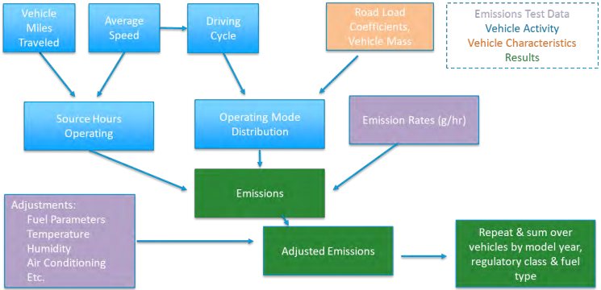

An example of MOVES running GHG emission factor data as a function of speed is shown in Figure 3 below, which shows curves for light-duty (LD), medium-duty (MD), and heavy-duty (HD) vehicle classes. Note that MOVES speed dependent GHG emission factors follow a decreasing trend both as vehicle speed increases and as vehicle engine technology is closer to the modeled calendar year. It is also important to note that because MOVES account for delays and stops using source bin drive cycles (e.g., average speed across corridors), this methodology does not require the user to calculate start or idling emissions and should be sufficient on its own to capture impact of GHG emissions. As mentioned earlier, as the project team would like to keep the original fuel-based approach, the tailpipe exhaust emissions are converted to fuel consumptions instead, as shown in Figure 4, using carbon intensities of gasoline and diesel fuels provided by EPA. Tailpipe CO₂ emissions from a gallon of gasoline is roughly 8,887 grams CO₂/ gallon and CO₂ emissions from a gallon of diesel is 10,180 grams CO₂/ gallon.
Figure 3. Running Exhaust Emissions Based on Vehicle Class and Speed

Figure 4. Fuel Consumption Based on Vehicle Class and Speed

The fuel consumption rates can be approximated using polynomials for LD, MD, and HD vehicles, respectively:
$$F_{Gas,LD}=0.000019137×{cruise speed}^{2}-0.0020660×cruise speed+0.088916$$
$$F_{Dsl,MD}=0.00011112×{cruise speed}^{2}-0.012354×cruise speed+0.37891$$
$$F_{Dsl,HD}=0.000059042×{cruise speed}^{2}-0.0063769×cruise speed+ 0.33220$$
Similar to idling emissions, the running exhaust will also depend on regional fleet mix. Given the majority of vehicles operated in the region are gasoline LD vehicles, the default parameters for the recommended methodology are based on LD gasoline only, as shown in Table 19. However, similarly to the discussion on idling emissions, the project team would recommend Met Council to consider using regional fleet mix information and refining this number with the average fractions of vehicles of different classes and fuels.
Table 19. Recommended Methodology for Corridor Speed Increases Quantification
Current Methodology
Measured Fuel Consumption = Measured-Route-Distance-in-Miles × k1
Where:
- k1 = 0.075283 - 0.0015892 × cruise-speed + 0.000015066 × cruise-speed²
Air Quality
- CO Reduced (kg) = Fuel Consumption Reduced* 0.0699
- NOx Reduced (kg) = Fuel Consumption Reduced * 0.0136
- VOC Reduced (kg) = Fuel Consumption Reduced * 0.0162
Recommended Methodology
Fuel Consumption Reduced (Gallons) = Corridor Distance (miles) × AADT_{no build} [k1_{speed no build} – (1 + E_{ID}) × k1_{speed build}]
Where:
- AADT_{no build} = Annual average daily traffic under the no-build condition
- E_{ID} = Elasticity of induced VMT due to improved corridor speed; default value can be found in Table 22, with justification further explained the following section.
- K1 = running fuel use factor, in gallon/hour. The default assumes LD gasoline vehicles only: 000019137 × cruise-speed² -0.0020660× cruise-speed +0.088916
GHG Reduced (kg) = Fuel Consumption Reduced (Gallons) * 9.915

Synchro/SimTraffic Emissions Estimation
For comparison purposes, the team has also analyzed the emission estimates from Synchro against those from SimTraffic. The emission estimation in Synchro is based on established emission factor models/formulas from Highway Capacity Manual (HCM). It provides macroscopic fuel and emission estimates based on aggregated traffic flow data. The emissions include CO, NOx, and VOC and the emission factors can be adjusted.
Emission estimates in SimTraffic are more detailed as it simulates the movements of individual vehicles based on car-following and lane change models. It captures variations in speed, acceleration, and idling times. These detailed vehicle movements are then used to calculate fuel and emissions, including CO, NOx, and VOC, based on factors for different vehicle fleets. The fuel and emission factors are in CSV formats and can be adjusted to reflect specific conditions.
Synchro uses static emission factors that may not account for all real-world variations, while SimTraffic can incorporate dynamic emission factors that reflect changes in vehicle operations. Synchro model emission results are suitable for high-level planning and optimization of traffic signals and intersection performance analysis, while SimTraffic model results are deal for detailed operational analysis and scenarios where understanding the impact of vehicle dynamics is crucial.
Significant discrepancies are often observed in the fuel usage and emission estimates between Synchro and SimTraffic modeling results. Table 20 below summarizes the fuel and emission results. The significant differences in fuel use and VOC/HC emissions between Synchro and SimTraffic highlight the impact of modeling approaches. Synchro's aggregated method might not capture all the variations in vehicle behavior, leading to higher estimates for some parameters and lower for others, like CO emissions.
Table 20. Sample Project Synchro/SimTraffic Model Fuel and Emission Results (PM Peak Hour)
Fuel/Emissions | Synchro | SimTraffic
Fuel Used (Gallon) | 625 | 193.8
VOC/HC Emissions (kg) | 10.13 | 2.640
CO Emissions (kg) | 43.71 | 122.835
NOx Emissions (kg) | 8.50 | 9.243
Total Delay (Hr) | 524 | 70.1
Total Delay (s/veh) | 76 | 59.1
Total Stops | 7213 | 6783
Stop/Veh | 0.29 | 1.59

Similar discrepancies are often observed in the measures of effectiveness (MOEs) in traffic operations analyses between the two models. Reporting MOE outputs for Synchro is relatively straightforward once it is set up. The SimTraffic modeling process starts with a Synchro model but usually requires additional calibration to accurately reflect driver behavior, vehicle types, and traffic conditions before reporting MOE outputs. The calibration can sometimes be simplified, or it can be a labor-intensive process, depending on project purposes. It may also take significantly more time to process SimTraffic outputs than Synchro outputs.
In summary, while Synchro provides a quicker and broader estimation of emissions and traffic operations based on average conditions, SimTraffic offers a more detailed and dynamic analysis by considering individual vehicle movements. The choice between the two depends on the level of detail and effort required and the specific objectives of the traffic and emission analysis.

Basis for Induced VMT Calculations
Projects that expand highway capacity where conditions are congested will induce additional vehicle travel. The phenomenon of induced vehicle travel is widely accepted and well documented. In the short term, expansion of highway capacity can cause new vehicle trips that would otherwise would not be made, longer vehicle trips to more distant destinations, shifts from off-peak to peak travel hours, and shifts from other modes to driving. Longer term changes can include an increase in more dispersed, low density development patterns that are dependent on automobile travel.
There has been little to no research regarding the induced vehicle travel impacts of improvements to minor arterial and local roadways. In theory, any project that reduces roadway congestion (i.e., improves travel speeds) will lead to an increase in vehicle travel and VMT. This includes physical expansion to roadway capacity as well projects that improve the operational capacity of the roadway, such as signal timing adjustments. However, the magnitude of the induced vehicle travel impacts is likely to be smaller for arterial and local roadways than for highway projects. Highways carry a larger proportion of longer trips during peak periods, including traditional home-based work trips, so highway travel speed increases are more likely to affect development patterns than similar speed increases on the local roadway system.
Researchers typically seek to identify induced vehicle travel effects in terms of an “elasticity”, which is the ratio of the percentage change in one variable associated with the percentage change in another variable. For example, an elasticity value of 0.5 suggests that a 1% increase in roadway capacity is associated with a 0.5% increase in VMT, or a doubling (100% increase) in roadway capacity is associated with a 50% increase in VMT. Table 5 summarizes the results of research on induced vehicle travel. The research has found elasticity values ranging from 0.1 to 0.6 in the short term (typically defined as one year or less) and 0.4 to 1.06 in the long term (5 to 10 years or more).
Table 21. Research on the Impact of Capacity Expansion on Induced Vehicle Travel
Study | Study Location  (and Type) | Study Years | Time Period | Elasticity (change in VMT / Change in Lane- Miles)
Hymel (2019) | U.S (States) | 1981-2015 | long-term | 0.89 to 1.06
Duranton and Turner (2011) | U.S. (MSAs – Interstates) | 1983-2003 | 10 years | 0.93 to 1.03
Cervero (2003) | California  (Freeway Corridors) | 1980-1994 | short-term  long-term | 0.10  0.39
Cervero and Hansen (2002) | California | 1976-1997 | short-term  intermediate term | 0.59  0.79
Noland (2001) | U.S.  (States – all roadway types) | 1984-1996 | short-term  long-term | 0.30 to 0.60  0.70 to 1.00
Noland  and Cowart (2000) | U.S.  (Metro Areas – Freeways and arterials) | 1982-1996 | short-term  long-term | 0.28  0.90
Hansen and Huang (1997) | California | 1973-1990 | short-term  long-term | 0.20  0.60 to 0.90

The induced vehicle travel literature has been used to create on-line calculators for estimating the additional VMT that will result from a highway capacity expansion project. The SHIFT Calculator, created by the Rocky Mountain Institute, enables these calculations for every metropolitan area in the U.S. The SHIFT calculator applies an elasticity value of 1.0 for Interstate highway projects and 0.75 for expansions on other freeways, expressways, and principal arterial roads.
Because there is no published research that provides an induced vehicle travel elasticity for minor arterial and local roadway projects, we recommend that Met Council estimate an appropriate value based on the highway-oriented research, as follows:
- Assume that the difference between “short-term” and “long-term” elasticity in the literature is associated with changes in land development patterns.
- Assume that the induced vehicle travel effects of minor arterial and local roadway projects include only vehicle travel changes like mode shift, longer trips, and more frequent trips, and not changes in land development patterns.
- Based on the literature shown in Table 5, assume the average short-term elasticity is 40% of the long-term elasticity value.
- Applying 40% to the 0.75 elasticity value used in the RMI SHIFT tool, assume an elasticity of 0.3 for capacity expansion to minor arterial and local roadway projects.
The elasticity of 0.3 can be applied for projects that expand by physical capacity of minor arterial and local roadway projects. However, many Regional Solicitation Roadways projects focus on operational improvements that increase effective capacity, without physical lane additions. These projects can be expected to cause induced vehicle travel to the extent that they improve travel speeds in a corridor. A study titled "Testing for the Significance of Induced Highway Travel Demand in Metropolitan Areas" investigated the change in travel miles as a result of reduced travel time, which is correlated to speed increases. The study collected data from over 27,000 households, and the findings indicate that travel-time elasticities range from −0.350 to −0.582. This implies that a 10% reduction in average household travel time will result in at least 3.5% increase in annual household VMT. The following assumptions can thus be made for estimating induced vehicle travel from speed increases:
Table 22. Suggested Induced VMT Elasticity for Minor Arterial and Local Roadway Projects with no Capacity Expansion.
Recommended Methodology
Speed Increases (%) = [cruise-speed _{build} - cruise-speed _{no build}]/ cruise-speed _{no build}
Induced VMT Elasticity = 0.35 × Speed Increases (%)
Figure 5. Induced VMT as a function of speed increases.

RS - Electrification
While the current RS does not provide any guidelines to quantify GHG emission reductions from electrification projects, the project team, in collaboration with Met Council staff and the Electrification WG participants, has determined a list of potential types of projects that may be seen in applications in the future, including electric vehicle (EV) education and outreach programs and public charging infrastructure installation projects.

Electric Vehicle (EV) Education and Outreach
This project type applies to events and activities targeted to improve EV awareness for local residents or fleet managers that may lead to increasing regional EV adoption. The proposed methodology accounts for the well-to-wheel (WTW), lifecycle emissions of transportation fuels (e.g., gasoline, diesel, and electricity); note that GHG manufacturing emissions for EVs and ICEVs are not considered, since the disparity between the two is expected to decrease in the future and ICEV WTW emissions are significantly higher than EV WTW emissions.

Survey information based on Drive Electric Minnesota
Drive Electric Minnesota's recent Ride and Drive event has provided valuable insights into public perception and awareness of EVs. The event featured 4,266 test drives/rides and displayed a total of 33 electric vehicles. Notably, 18 percent of survey respondents had their first encounter with EVs through this experience. Acknowledging the self-selecting nature of the study, 86 out of 100 for the test drive/ride experience, indicates a positive reception of EVs among these attendees.
The survey revealed that 90 percent of respondents do not currently own an EV, yet 67 percent believed they could easily charge an EV using existing electrical outlets. This perception demonstrates a readiness to integrate EVs into their daily lives. The event positively influenced perceptions, with 17 percent of respondents revising their opinion about EVs, now viewing them as equal or superior to traditional gasoline vehicles. Furthermore, there was a 4 percent increase, from 18 percent to 22 percent, in respondents who stated they would definitely consider purchasing or leasing an EV for their next vehicle, suggesting a potential for increased EV adoption.
Additionally, the survey showed that 66 percent of respondents have a daily commute of 1 to 30 miles, a range well within the capabilities of most EVs. Prior to the event, attendees' average familiarity with EVs was rated at 57 out of 100, indicating a moderate level of prior knowledge and highlighting the role of hands-on experiences in enhancing understanding and acceptance of new technologies.
The following section incorporates several statistics from the Drive Electric Minnesota survey, conducted during their recent Ride and Drive event. These figures provide a snapshot of public perception and awareness regarding EVs. However, it's important to note that these statistics represent preliminary findings. As such, they should be interpreted with caution and considered as a starting point for understanding public attitudes towards EVs. It will be important to continue to update and improve this data as new local survey results become available, ensuring a more comprehensive and accurate understanding over time.

Recommendations for Education and Outreach Projects Quantification
The outcome of EV education and outreach may vary by activity type, scale, and audience, and it is difficult to estimate the impact of GHG emissions prior to program implementation. In order to quantify project emission benefits, applicants need to provide information that may require significant efforts to retrieve, including number of targeted participants, conversion rate (e.g., fraction of participants who would indeed purchase an EV), etc. Certain information, as discussed in the Ride and Drive event statistics, may be valuable to acquire and to track the impact of funded projects during project implementation. Once there is enough data to demonstrate typical regional trends, future applicants may opt to use default values derived from these projects instead.
Table 23 presents the methodology to estimate vehicle miles traveled (VMT) savings from internal combustion engines (ICE) and their associated GHG impact, assuming either required information can be retrieved during project application phase or Met Council may provide a default estimate based on information from funded projects. Note that this methodology requires applicants to specify whether the events or activities are targeted to light-duty (LD) or heavy-duty (HD) drivers.
Table 23. Recommended Methodology for EV Education and Outreach
Recommended Methodology
Auto VMT Displaced (annual) = ACC_{L or H} × N × R
Where:
- ACC_{L or H} = Average annual accrual rate of a typical LD or HD vehicle; default values can be retrieved from regional studies (e.g., the annual VMT per capita in Minneapolis in 2018 is 5,567 miles) or the latest EPA’s MOtor Vehicle Emission Simulator (MOVES) model.
- N = Number of participants
- R = Conversion rate of participants

For example, in the case of the 2023 Twin Cities Auto Show Ride and Drive event, the program has attracted a total of 4,266 participants, with 4% more participants indicating they would consider purchasing or leasing an EV for their next vehicle. If the 4% conversion rate can be proved to be consistent across multiple events, the total annual VMT saving form a typical Ride and Drive event that aims to target 4,000 local residents is:
$$5,567×4,000×4\%= 890,720 miles$$
GHG Emissions Impacts (annual) = Auto VMT Displaced × (CI_{L or H} – CI_{E})
Where:
- CI_{L or H} = Carbon intensity (CI) that accounts for LD (gasoline) or HD (diesel) vehicle WTW emissions; default values can be retrieved from the latest Greenhouse gases, Regulated Emissions, and Energy use in Technologies (GREET) model, developed by the Argonne National Laboratory (ANL), as shown below.
- CI_{E}= Carbon intensity of electricity grid; default values can be retrieved from the GREET model. This value can be further refined to differentiate between LD and HD using Minnesota grid carbon intensity or the Annual Energy Outlook (AEO).
Fuel | Gasoline/LD | Diesel/HD | Electricity
WTW CI (gCO₂e/mi) | 409.73 | 342.66 | 175.45

Public Charging Infrastructure
This project type applies to projects that install LD and HD charging infrastructure that is either publicly accessible or shared by a group of EV drivers who may not have easy at-home charging access (e.g., workplace, multi-unit dwellings or MUDs, etc.). The proposed methodology accounts for the WTW lifecycle emissions of transportation fuels (e.g., gasoline, diesel, and electricity).

How Does Public Infrastructure Influence Regional EV Adoption?
The impact of public infrastructure on regional EV adoption is a multi-faceted issue, intricately linked to the availability and type of charging infrastructure. Further, it is evident that the type of charging stations plays a crucial role in influencing EV adoption. For example, Levenson & West highlight that large-scale deployment of DC fast chargers is more effective than Level 2 chargers in boosting sales of EVs and increasing electrified mileage. According to the authors, however, the effectiveness starts to diminish after approximately 30,000 stations, indicating a threshold for optimal infrastructure deployment. Additionally, imposing an electricity surcharge above approximately 12¢/kWh can counteract the benefits in BEV sales and GHG emissions reduction. The article also emphasizes the importance of targeted infrastructure deployment. In states with zero-emission vehicle (ZEV) mandates, targeted injections of charging infrastructure yield more significant benefits for smaller-scale deployments compared to national distribution. This suggests that regional strategies tailored to local needs and vehicle patterns can be more effective than a one-size-fits-all approach.
On the other hand, in an article by Greene et al., the pivotal role of charging infrastructure availability and efficiency in accelerating EV adoption is underscored. As EV range and attractiveness improve, the focus shifts to the adequacy of charging facilities as a key determinant in consumer decisions. The article points out the growing necessity for an expansion in charging infrastructure, especially in urban areas with diverse residential patterns.
Both articles converge on the conclusion that developing and deploying an effective public EV charging infrastructure is crucial for supporting regional EV adoption. This development requires substantial investment, thoughtful planning, and collaboration among various stakeholders to meet local demands and preferences effectively. Therefore, public infrastructure plays a pivotal role in influencing regional EV adoption, with its impact varying based on the type, location, and accessibility of these charging facilities.
While there is a notable gap in literature exploring the impact of EV charging station locations in rural areas, existing research provides valuable insights into urban settings. See the table below for a summary of assumptions gathered from literature.
Table 24. Role of Charging Infrastructure in Encouraging EV Adoption.
Source | Applicable Conclusions
Greene et al., 2019 | One standard deviation increase in charging station availability leads to approximately 13 percent increase in EV sales in the next month.
Li et al., 2017 | The elasticity of EV adoption with respect to the availability of charging stations is approximately 0.84.
In another study, based in China, a significant relationship between the availability of public EV charging stations and the sales of EVs is found. It was observed that an increase in the number of charging stations correlates with a rise in EV sales. Specifically, a notable increase (one standard deviation) in charging infrastructure leads to an approximate 1.5 percent growth in EV sales in the subsequent month. Furthermore, this increase in charging stations also positively affects the rate of EV sales in relation to production, with a substantial enhancement in charging infrastructure resulting in about a 13 percent increase in the proportion of EVs sold compared to those produced. This data underscores the importance of charging infrastructure in promoting EV adoption.
In a different study, researchers estimated key elasticities relating to EV adoption and charging station investments. The analysis revealed that the elasticity of EV adoption with respect to the availability of charging stations is approximately 0.84. This suggests a strong, almost proportional relationship, where a 1% increase in charging station availability could potentially lead to about an 0.84% increase in EV adoption. Furthermore, the elasticity of investment in charging stations with respect to the existing base of EVs was found to be 0.61. This indicates that a 1% increase in the number of EVs already in use is likely to result in a 0.61% increase in the investment towards new charging stations. These findings provide valuable insights into the interdependent growth dynamics between EV adoption and charging infrastructure development.
In a New York State study covering 2014 to mid-2021, researchers explored how the placement of EV charging stations influences EV adoption in urban settings. By analyzing data on EV registrations, station locations, and county demographics, the study concentrated on the importance of station proximity to highways, city centers, and various facilities like car dealerships and office buildings. The results highlighted a strong correlation between strategically placed charging stations and increased EV adoption, particularly when stations were near city centers and highways. Notably, stations in office buildings significantly impacted EV adoption, more so than those at other locations. This urban-focused study underscores the importance of strategically locating charging infrastructure to enhance EV adoption in cities, suggesting that future policies and incentives should prioritize accessible station placements in urban areas.

Recommendations for Infrastructure Projects Quantification
As discussed above, in the current state, access to infrastructure still plays a pivotal role in encouraging and accelerating EV adoption. Therefore, one can assume that any newly installed infrastructure will encourage conversion of vehicle miles from conventional fuel-burning vehicles to EVs. The GHG reduction is calculated by estimating the total displaced VMT from ICEs to EVs, using total electricity or energy consumed by electric vehicle charging stations (EVCS). Note that this methodology requires applicants to specify whether the infrastructure is designed to support LD or HD charging activities.
Table 25. Recommended Methodology for Infrastructure Installation
Recommended Methodology
Auto VMT Displaced (annual) = $\sum{N_{i}P_{i}U_{i}H_{i}}$ ÷ EVEF_{L or H} × FICE _{L or H}
Where:
- N_{i} = Number of chargers of a certain power level
- P_{i} = Charger power level (e.g., 50 kW, 150 kW)
- U_{i} = Average charger utilization rate; the percentage of time when a charger is actively in use. Default values can be retrieved from literatures and existing station utilization reports,,.
- H_{i} = Annual total hours that the chargers are online and available for charging.
- EVEF_{L or H} = Average energy efficiency values (in Wh per mile) for LD or HD EV; default values can be retrieved using commercially available EV information.
- FICE _{L or H} = Current LD or HD fraction of ICE vehicles in the fleet; default values can be retrieved from the latest MOVES model or regional studies.
GHG Emissions Impacts (annual) = Auto VMT Displaced × (CI_{L or H} – CI_{E})
Where:
- CI_{L or H} = Carbon intensity that accounts for LD (gasoline) or HD (diesel) vehicle WTW emissions; default values can be retrieved from the GREET model.
- CI_{E}= Carbon intensity of local electricity grid; default values can be retrieved from local utilities, the GREET model, or the AEO projections.
Fuel | Gasoline | Diesel | Electricity
WTW CI (gCO₂e/mi) | 409.73 | 342.66 | 175.45

Other Considerations for Electrification Projects

Lifecycle Vehicle and Manufacturing Emissions for EVs
In addition to WTW emissions, the project team has also investigated the vehicle manufacture emissions from ICEVs and EVs. As shown in Figure 6 and Figure 7, while the GHG emissions from EV manufacturing are higher than those from ICEV, the disparity is expected to decrease in the future. Moreover, as mentioned earlier, the WTW GHG emissions from transportation fuel for gasoline (409.73 g/mile) and electricity (175.45 g/mile) are also significantly higher than manufacturer emissions.
As shown in Table 26, given the magnitude of the difference between vehicle manufacturing and fuel consumption, the project team recommended that it is not necessary to include emissions from vehicle manufacturing in the GHG calculations. It is also noteworthy that the geographic boundary of the vehicle manufacture emissions is also difficult to define because vehicle manufacturing may take place outside the Met Council region, or even the state of Minnesota.
Figure 6. GREET Vehicle Manufacturing Emissions
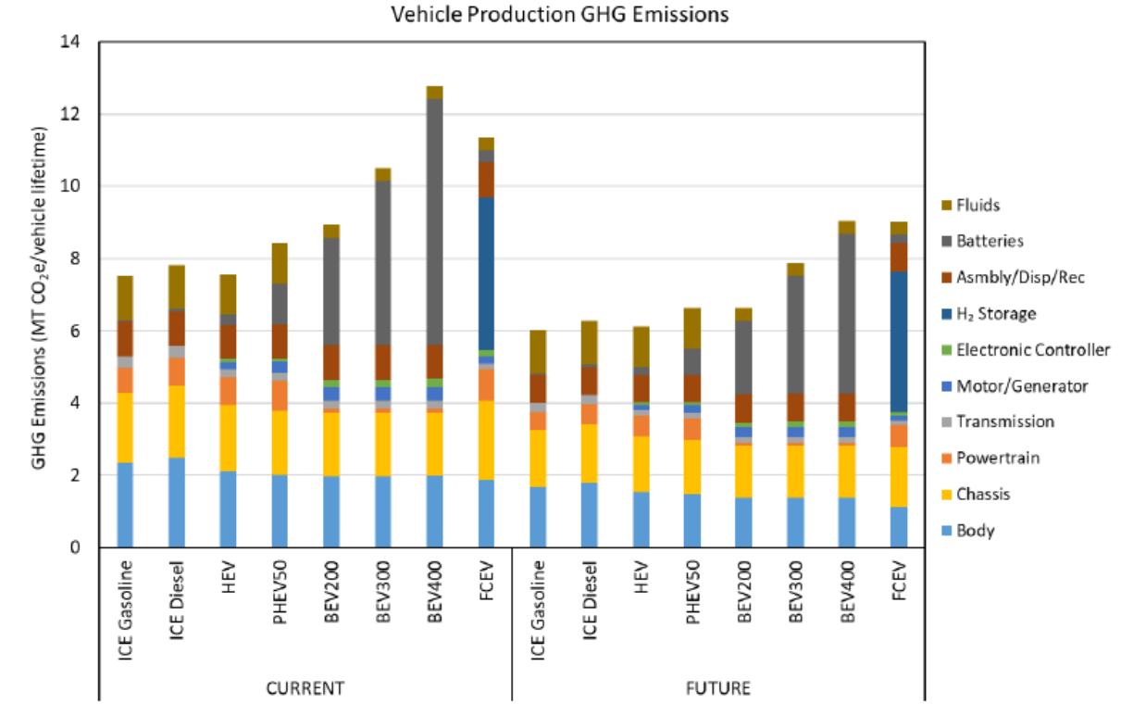

Figure 7. Current and Future Lifecycle GHG Emissions (g CO2e/mile)
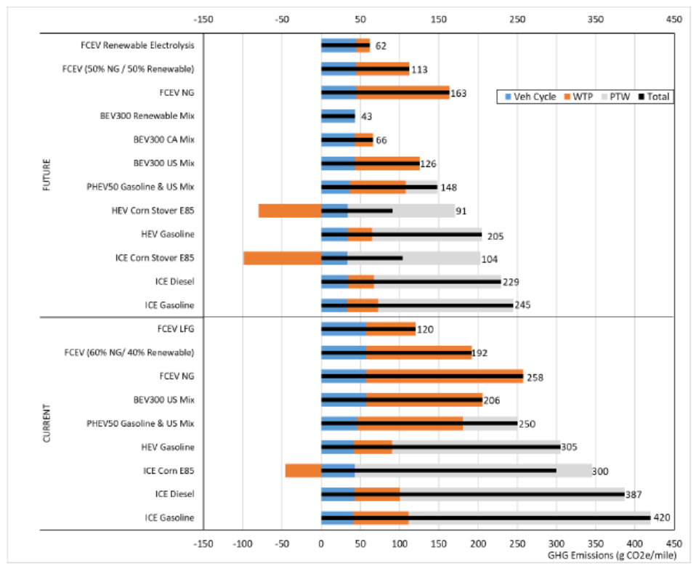
Table 26. Total Lifecycle GHGs from ANL's GREET model.
 | ICEV - Conventional Material | ICEV - Lightweight Material | EV - Conventional Material | EV - Lightweight Material
Lifetime Vehicle Manufacturing (gCO2e) | 6,398,393 | 7,886,579 | 11,639,444 | 11,692,704
Unit Vehicle Manufacturing (gCO2e/mile) | 36.95 | 45.55 | 67.22 | 67.53
Fuel Consumption (gCO2e/mile) | 409.73 | 409.73 | 175.45 | 175.45
%, Manufacturing Compared to Fuel | 8.3% | 10.0% | 27.7% | 27.8%
Manufacturing + Fuel (gCO2e/mile) | 446.68 | 455.28 | 242.67 | 242.98
EV-ICEV Difference % | N/A | N/A | -45% | -46%

Transportation Policy Plan
The TPP is the Met Council region’s long-range transportation plan and covers at least 20 years of transportation investments. The current 2040 TPP was originally adopted in 2014 and updated in 2018 and 2020. This section addresses crucial topics in three primary areas: induced demand, construction emissions, and electrification.
The induced demand section explores how expanding or improving transportation infrastructure can increase travel demand, and it compares different tools and models used to estimate induced demand. The electrification section will focus on the methodologies and tools for accurately capturing electrification efforts in transportation. The construction section emphasizes the need for methodological improvements and consistent treatment of emissions. It discusses the potential tools that can be used to quantify construction-related emissions. The electrification section summarizes the electric vehicle (EV) penetration scenarios, highlighting various applicable scenarios for electrification assessment and outlining Metro Transit's efforts and targets for reducing emissions. These discussions aim to enhance the accuracy and comprehensiveness of GHG impact assessments in the TPP, supporting the Met Council's broader sustainability goals.

Induced Demand
Induced demand in transportation refers to the phenomenon where the expansion or improvement of transportation infrastructure leads to an increase in travel demand beyond what would have occurred without the intervention. Forecasting induced demand resulting from transportation projects is inherently challenging due to uncertainties surrounding future behaviors, land use changes, and other external factors.
Travel demand models are widely used in transportation planning to forecast future travel demand and assess the impact of various transportation and policy scenarios. In the Twin Cities, the Met Council has been developing and updating its travel demand models, using them in the Transportation Policy Planning (TPP) process for many years. The model has evolved from its traditional four-step model to a more advanced Activity-Based-Model (ABM). Traffic volumes and VMT outputs from the travel demand models are available for different vehicle types at individual roadway link levels within the model limits. These outputs can be aggregated into corridors, subregions, and entire metropolitan areas. Aggregated VMTs from different scenarios are usually used for benefit-cost analysis in transportation improvement projects.
While travel demand models can incorporate behavioral components that simulate how individual travelers respond to changes in transportation infrastructure, they often require lengthy computation runtime and can pose significant complexity in calibration and validation, as well as limited abilities in predicting future behavior and land use changes. Alternatively, the State Highway Induced Frequency of Travel (SHIFT) tool, developed by the Rocky Mountain Institute (RMI), is currently widely known for estimating induced demand in terms of vehicle miles traveled (VMT) and emissions in transportation planning due to its ease of use.
While the Met Council’s ABM doesn’t capture all induced demand, it does capture it to some degree. It was determined that a sensitivity test was conducted to explore how induced VMTs would respond when using the ABM for freeway expansion projects in the Twin Cities metropolitan area. This analysis also aimed to assess the differences between results obtained from ABM and those from the RMI’s tool - a much simpler estimation method. The objective is to identify potential enhancements to either the RMI or ABM methods for more accurate induced demand estimation based on insights gained though this sensitivity test analysis. This section below documents the sensitivity analysis methodology, modeling scenarios and assumptions, as well as the result findings.

Sample Project Corridors Selection
We utilized the ABM to conduct induced VMT sensitivity tests based on three corridors within the Twin Cities Metropolitan area. These corridors have been assessed individually and considered for improvements in the Met Council’s TPP. The three corridors are:
- P1: I-35 between the 35E/W Split and 185th St in the city of Lakeville (interstate, ~3.6 miles in the southern metro)
- P2: TH 36 between 35W and US 61 (non-interstate highway, ~7 miles, in the center of the metro)
- P3: I-35W between CR C and Mississippi River Bridge (interstate, ~5.5 miles, in the center of the metro, connected with the TH 36 segment)

RMI’s Tool Overview and VMT Estimation Results for Sample Corridors
RMI has developed and calibrated the SHIFT calculator to assess the net impacts of class 1 (interstate) road expansions in US Metropolitan Statistical Areas (MSAs) and of class 2 or 3 roadways in urbanized counties within MSA2. This includes their effect on state-wide VMTs and their emissions impacts.
The calculator allows users to estimate long-run induced VMT (reaching a steady state in 5 to 10 years) from capacity expansions of large roadways in MSAs or urbanized counties based on existing lane mileage and VMT data.
The Reference links are as follows:
- Methodology: https://rmi.org/wp-content/uploads/2021/10/rmi_shift_calculator_methodology.pdf
- Online Calculator: https://shift.rmi.org/
The online tool is user-friendly, providing easy input requirements and generating clear outputs as listed below.
Online RMI Tool’s Inputs:
- Choose a state in the USA.
- Choose a type of road: Interstate (Class 1) OR other freeways or principal arterials (Class 2 or 3).
- Choose a MSA if the interstate option is chosen in Step 2; Or choose a county if the other freeways or principal arterials option is chosen in Step 2.
- Input total lane miles added.
Tool’s Outputs:
- Additional VMTs/year
- Cumulative direct and lifecycle emissions added through 2050 for NDC-Aligned scenario and BAU Scenario (emissions are not used in this study).
The online tool was used to estimate induced demands for five interstate and highway project scenarios based on the three corridors identified in the previous section. The results are summarized in Table 27
Table 27. Estimated Induced Demands for Freeway Expansion Projects using RMI Tool
While the RMI’s tool is easy to use, there are major issues in induced demand estimation:
- Undifferentiation of project congestion locations:
The tool may not adequately differentiate the degree of congestion, potentially underestimating the induced demand for congested areas and overestimating the induced demand for less congested areas.
- Lack of VMTs different roadway classifications and vehicle types:
The tool lacks differentiation in VMTs for various roadway classifications and vehicles, even though emissions factors typically vary among them.
- Undifferentiated Interactions between projects:
The induced demand resulting from a 20-lane-mile expansion project may differ significantly from that of four separate 5-lane-mile expansion projects, yet the tool treats them similarly.
- Undifferentiated project types:
The tool may not distinguish between induced demand resulting from a general-purpose lane expansion project and that resulting from an EZ-Pass Lane expansion project of the same length, potentially overlooking their important variations.

ABM Induced Demand Sensitivity Test Scenarios
To address the issues with VMT estimates from the RMI’s tool, we used a more sophisticated travel demand modeling tool - the Met Council’s ABM. We developed six freeway expansion project networks based on the current 2018 network as the base and conducted modeling runs for a total of fourteen scenarios, using both 2018 and 2040 Socioeconomic data. These scenarios included one 2018 base scenario and one 2040 base scenario to calculate the induced VMTs for various freeway expansion project scenarios.
The modeling scenarios are described below:
Base Year 2018 Land Use Scenarios (2018 SE Data)
- S0: 2018 base network (No Build)
- S1: 2018 base network + I-35 project (P1)
- S2: 2018 base network + TH 36 project (P2)
- S3: 2018 base network + I-35W project (P3)
- S4: 2018 base network + I-35 and TH36 projects (P1 + P2)
- S5: 2018 base network + TH36 and I-35W projects (P2 + P3)
- S6: 2018 base network + all three projects (P1 + P2 +P3)

2040 Land Use Scenarios (2040 SE Data)
- S7: 2018 base network (using as a base for 2040 Land Use Scenarios)
- S8: 2018 base network + I-35 project (P1)
- S9: 2018 base network + TH 36 project (P2)
- S10: 2018 base network + I35W project (P3)
- S11: 2018 base network + I-35 and TH36 projects (P1 + P2)
- S12: 2018 base network + TH36 and I-35W projects (P2 + P3)
- S13: 2018 base network + TH 36 project (P1 + P2 + P3)

VMTs from these scenarios were extracted for all roadways within the metro and project influence areas for induced demand sensitivity analysis. Additionally, VMTs from freeways only were summarized separately and compared with the results from the RMI’s tool, as the RMI’s tool only includes the freeway results.

The primary considerations for project and scenario selection were as follows:
- Full modeling loop runs were conducted to capture mode shifts.
- General-purpose lanes were assumed to produce comparable results to those obtained from the RMI tool.
- Both interstate (P1 and P3) and non-interstate highways (P2) were included to assess differences of the elasticities from the RMI tool.
- Project 1 (P1) and Project 2 (P2) were chosen far apart. Results from S1, S2, and S4 (or S8, S9, and S11) were compared to determine if the induced VMTs show a multiplicative relationship with added lane miles.
- Nearby projects P2 and P3 were chosen to explore the interaction of induced VMTs from the two projects.
- Scenarios for 2018 and 2040 SE were included to test how different congestion conditions affect induced VMTs (2040 being more congested).
- Average daily VMTs from both the metro area and project sub-areas were extracted to explore the varying ranges of project influence areas. Yearly VMTs were calculated by multiplying the average daily VMTs by 365 days.

ABM Sensitivity Test Results and Findings
All ABM modeling scenarios were conducted according to the methodology and assumptions outlined in the previous sections. VMTs for each scenario were summarized for all roadways and freeways only in both the metropolitan area and project influence areas. Additionally, VHTs and network-wide speeds were included for reasonableness checks. Figure 8 below illustrates the metro-wide highway network and the project subareas.
The boundaries of the subareas are defined as below:
- Subarea # 1(I-35 Project): Bounded by Minnesota River(N), TH 3(E), CR 19(S), and TH 13(W)
- Subarea # 2(TH 36 Project): Bounded by I-694(N, E), I-94 (S), and I-35W/TH280(S)
- Subarea # 3(I-35W Project): Bounded by I-694(N), I-35E(E), and I-94 (S/W)
- The overlapped subarea #2 and #3: Bounded by I-694(N), I-35E(E), I-94 (S), and I-35W (W)
Figure 8. Project and Subarea Locations in the Metro
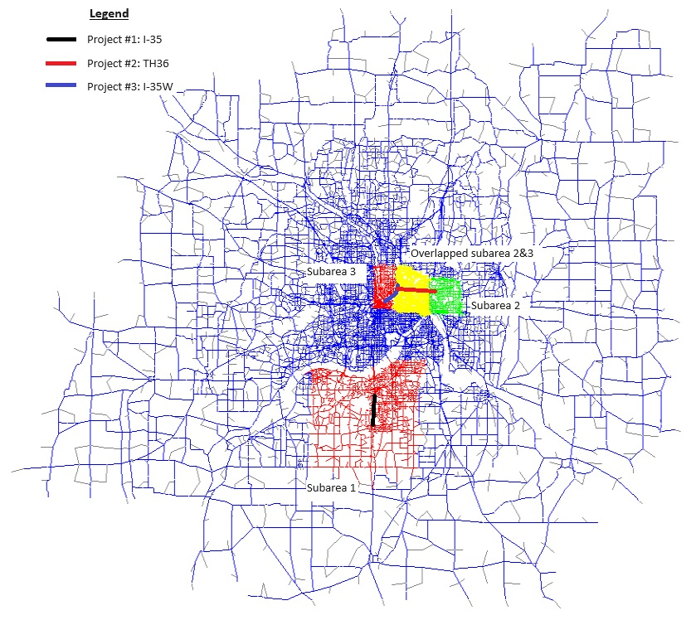
Results for all Roadways in the ABM
Table 28 below summarizes the induced VMT results for all roadways in the ABM model in the Twin Cities metropolitan area, while Table 29 provides a summary of the results for the project subareas.
Table 28. Induced VMT Sensitivity Test Results Summary (Metro-Wide, all Roadways in the ABM)
Table 29. Induced VMT Sensitivity Test Results Summary (Project Subarea, all Roadways in the ABM)
To facilitate comparison, the yearly VMT and per lane-mile results from both the RMI tool and the ABM are tabulated side-by-side and further summarized in Table 30.
Table 30. RMI and ABM Induced VMT Results Comparison (all Roadways in the ABM)
It is worth noting that the RMI’s tool results are for freeways only, while the results from the ABM are for all roadways in the model (functional class collector roadways and above). Nevertheless, below are the key findings regarding the overall induced VMTs from the ABM and the freeway results from the RMI tool:
- The ABM results for all roadways are generally lower, yet they have a similar magnitude to the results for freeways only obtained from the RMI’s tool. In the RMI tool, elasticity factors are assumed to be 1.00 for interstates and 0.75 for non-interstate trunk highways. However, the ABM results indicate the elasticity factors are less than 1.0, ranging from 0.15 for a single I-35 project to 0.09 for metro-wide induced VMTs from three combined projects under 2018 conditions. These elasticity factors are even lower for subject areas and under 2040 conditions.
- Induced VMTs display a non-linear relationship with the addition of lane-miles. Factors such as network congestion levels and project locations can influence induced demands.
- Project influence areas may vary over time due to network congestion changes. Researchers or engineers should exercise caution when defining the project influence area for induced demand analysis.
- Metro-wide induced VMTs in 2040, with higher congestion levels, are generally lower than those in 2018. The ABM modeling analysis shows that transportation improvements in more congested networks are anticipated to yield fewer induced VMTs. This is because the added capacity is initially absorbed by traffic in congested networks before addressing latent induced demand. Capacity improvement projects in free-flow corridors typically do not introduce induced demand if the land uses are not influenced by these improvements. It is worth noting that the current ABM modeling process used for this analysis doesn’t include automatic feedback to land use plans. Therefore, there may exist a critical congestion threshold where project capacity improvements lead to the highest induced demand. As the corridor's congestion level surpasses this critical point, induced demand is expected to decrease in response to capacity improvement projects, indicating greater efficiency from the perspective of induced VMTs.

Results for Freeways Only in the ABM
To investigate how the ABM captures the induced VMTs on the freeways, the VMT results from the freeways in the ABM are summarized for the entire metro area in Table 31 and for the project areas in Table 32. Similarly, Table 33 summarizes the yearly total and induced VMT results on the freeways from both the RMI tool and the ABM, along with their respective elasticity factors. Below are key findings regarding the induced VMTs on the freeways from the ABM and the RMI tool.
- The metro wide yearly VMTs per lane-mile in the 2018 ABM are generally in agreement with the results from the RMI tool, especially for interstates. The ABM results fall between 5.6 and 5.7 million VMTs per lane-mile for all project scenarios, while it is assumed to be 5.5 million VMTs per lane-mile in the RMI tool.
- While the overall VMTs on the freeways are consistent between the ABM and the RMI tool, there are noticeable differences in their respective elasticity factors. Elasticity factors are assumed to be 1.00 for interstates and 0.75 for non-interstate highways in the RMI tool. The elasticity factors for single interstate projects from the 2018 metro-wide results vary from 0.53 (P1: I-35) to 0.40 (P3: I-35W), while it is 0.32 for the non-interstate TH 36 project. The induced freeway VMTs in the ABM thus are lower than those estimated from the RMI tool.
- Compared with the results from the previous section, the induced VMTs on freeways are generally higher than the induced VMTs on all roadways, indicating some VMTs are diverted from non-freeways to freeways in response to freeway improvement projects. This diversion is generally consistent with expectations. It is noted that the diverted VMTs from non-freeways to freeways are not available from the RMI tool.
- Like the overall results, elasticity factors decrease as congestion levels increase from existing to 2040.

Key Findings Summary and Recommendations
While the Met Council’s ABM doesn’t capture all induced demand, it does capture it to some degree. Based on the extensive induced VMT sensitivity analysis conducted in this study, the key findings and recommendations are summarized below:
- The metro wide yearly VMTs on freeways in the 2018 ABM, particularly around 5.6~5.7 million VMTs per freeway lane-mile, generally align with the results from the RMI tool (5.5 million VMTs per freeway lane-mile). However, the ABM shows varying elasticity factors for induced VMTs in response to freeway improvement projects. These elasticity factors are influenced by different corridors, land uses, transportation environments, and congestion levels over different years. Unlike the fixed factors of 1.0 for interstate and 0.75 for non-interstate highways in the RMI tool, they are dynamic and responsive to different corridor conditions. Lower elasticity factors are recommended when using the RMI tool for induced VMT estimation.
- While the current focus of induced VMT estimation for freeway improvement projects is on the freeways, the ABM modeling analysis indicates that diverted VMTs from non-freeways are noticeable and should be considered depending on study purposes. The ABM serves as a valuable tool and is recommended for evaluating comprehensive impacts of transportation improvement plans on both freeways and non-freeways.
Table 31. Induced VMT Sensitivity Test Results Summary (Metro-Wide, Freeways only in the ABM)
Table 32. Induced VMT Sensitivity Test Results Summary (Project Subarea, Freeways only in the ABM)
Table 33. RMI and ABM Induced VMT Results Comparison (Freeways only in the ABM)

Construction Emissions
A significant point of the TPP discussion was the treatment of construction emissions. The TPP currently evaluates on-road emissions, while it is understood that construction emissions can reflect a high proportion of a project’s emissions across the entire lifetime. Notably, construction emissions are often associated with non-road vehicles, equipment, and materials, making them distinct from the on-road sector and evaluation methodologies used to determine emissions.

The Minnesota Infrastructure Carbon Estimator (MICE) Tool
The current methodologies used to inform the Met Council TPP cannot produce estimates of the component parts of GHGs, especially as it pertains to construction, manufacturing, and disposal. However, construction emissions can still be quantified offline using the Minnesota Infrastructure Carbon Estimator (MICE) tool, which is a Minnesota-specific version of the Federal Highway Administration (FHWA) Infrastructure Carbon Estimator (ICE) tool, incorporating local vehicle emissions rates, the capability for build/no-build analysis, and other enhancements. The tool, maintained by the Minnesota Department of Transportation (MnDOT), aims to provide lifecycle estimates of energy and GHG emissions based on national emission and energy use factors for materials and construction activities. Projects of which constructions emissions can be quantified use MICE include bridges and overpasses (new construction or reconstruction), bus rapid transit, culverts and storm sewers, light and heavy rail, lighting, parking, pathways (trails and sidewalks), roadways (including roadways resurfacing and reconstruction), and signage. Starting on January 7th, 2020, MnDOT committed to analyze GHG emissions from transportation projects as part of the environmental review process, which requires all eligible state and federally funded projects on MnDOT facilities to evaluate construction and maintenance emissions using MICE. Projects exempted from this requirement include those that have an Early Notification Summary Memo for the environmental document, those with a total construction cost of less than $1,000,000, and those that cannot be quantified using the MICE tool.

FTA Evaluation of Construction Emissions for Transit Projects
In addition to initiative taken by MnDOT, the Federal Transit Administration’s (FTA) has also studied the importance of considering construction emissions for project evaluation and GHG mitigation. The FTA published its 2024 Programmatic Assessment to quantify five such projects: light rail, street car, bus rapid transit, commuter rail, and heavy rail. The results are based off 68 transit project scenarios modeled using the FTA GHG Emission Estimator tool. This study assessed both downstream and upstream emissions over the construction, maintenance, vehicle operative and emission displacement phases of these transit projects, inclusive of the properties as described in Table 34.
Table 34. FTA Estimator GHG Emissions Sources Included in Programmatic Assessment (2024)
Phase | GHG Emissions Sources Included
Construction | Transitway track construction  Paving of separated rights-of-way  Station construction  Parking construction  Catenary system (construction/copper)
Maintenance | Routine maintenance of transitway  Routine maintenance of pavement  Routine maintenance of vehicles
Vehicle Operations | Transit vehicle miles traveled (VMT)
Displaced Emissions | Automobile VMT  Transit VMT
The FTA Estimator tool’s primary data source for construction related emission factors and maintenance emission factors are from the FHWA’s ICE tool. For vehicle operations, the Estimator uses Argonne National Laboratory’s GREET model for available vehicle and fuel type combinations, including electric variants. The FTA Estimator also assumes a certain level of “ridership affect”, which affects the estimated net GHG emissions associated with transit modes. Some of the assessment’s findings include:
Light rail projects, regardless of length, alignment, and number of stations, generally result in net reductions in annual GHG emissions over the minimum useful light rail lifespan of 50 years. Annual displaced GHG emissions due to light rail’s “ridership effect” are greater than the GHG emissions from construction, maintenance, and vehicle operation phases.
  - Annual GHG emissions from the sample of light rail projects averaged approximately 9,900 metric tons of CO2e annually. Here, the net volume of annual GHG emissions from light rail projects largely depended on the fuel source used for electricity generation.
  - Detailed results are presented in Figure 9.
Bus rapid transit projects generally result in relatively low but net increases in annual GHG emissions over the minimum useful bus rapid transit lifespan of 40 years. The annual GHG emissions from construction, maintenance, and vehicle operation phases are greater than the GHG emissions displaced as a result of ridership effect.
  - Here, the majority of the GHG emissions generated from bus rapid transit projects in the sample are estimated to be construction-related upstream emissions; annual volume of displaced emissions was typically less than the annual volume of GHG emissions bus rapid transit projects were expected to generate when construction was also considered.
  - Detailed results are presented in Figure 10.
The commuter rail projects result in annual net increases in GHG emissions over the minimum useful lifespan of 50 years. The annual GHG emissions from construction, maintenance, and vehicle operation phases are greater than the GHG emissions displaced as a result of the ridership effect.
  - The majority of the GHG emissions that commuter rail projects generate are expected to be from construction-related upstream emissions.
  - Detailed results are presented in Figure 11
Figure 9. FTA Estimator Light Rail Sample Results, Lifecycle Components
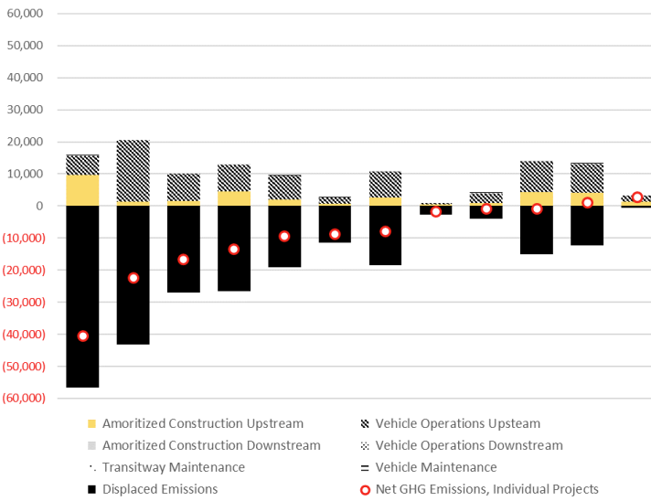
Figure 10. FTA Estimator Bus Rapid Transit Sample Results, Lifecycle Components
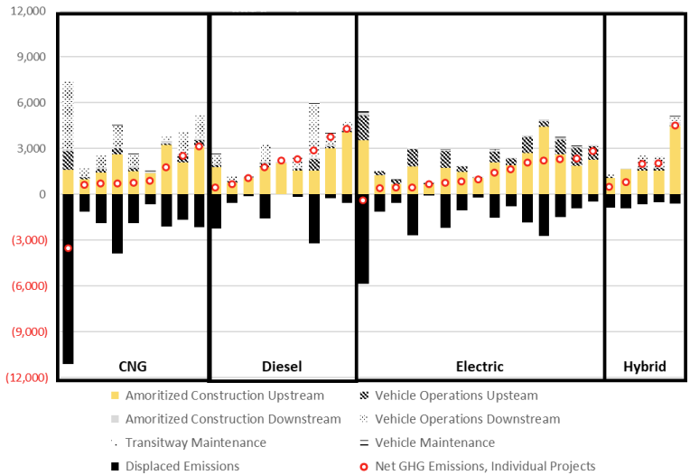
Figure 11. FTA Estimator Commuter Rail Sample Results, Lifecycle Components
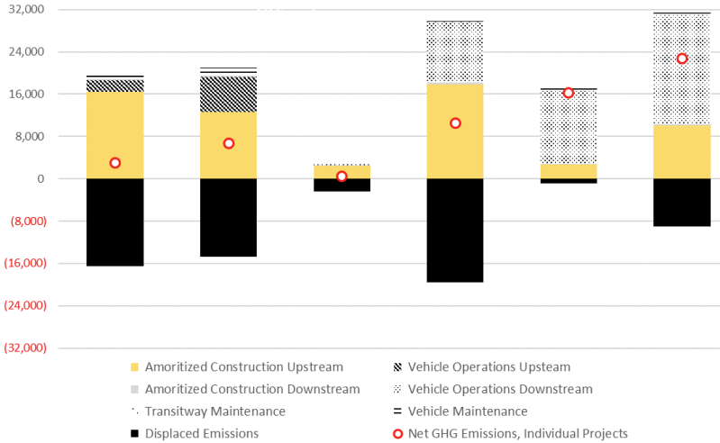

Other Considerations
Accounting for lifecycle assessments (LCA) for transportation projects has indeed been long discussed. In 2009, a study by the University of California, Berkeley has already compared the GHG emissions across different stages and components of transportation projects, as shown below in Figure 12. Consistent with findings from the FTA, infrastructure related emissions, especially construction emissions, are substantial among transit rail projects. Besides, constructions emissions also account for a significant portion (~10%) of total lifecycle GHG emissions for all gasoline passenger travel.
Figure 12. GHG emissions per passenger kilometer traveled (PKT). Infrastructure components are colored in shades of red and orange.
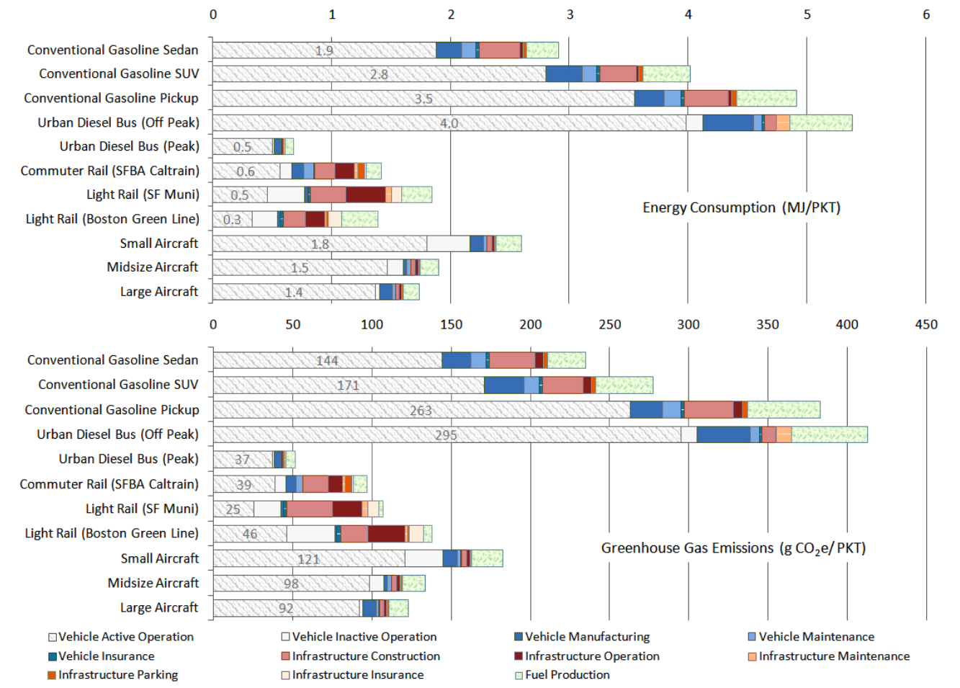
A key takeaway from this discussion is the necessity for accounting for infrastructure-related construction emissions. Given that the MICE tool is easily accessible for the Met Council, the project team recommended the Council staff start using MICE tool for project construction emissions quantifications (with same exemption terms applied). While the fraction of construction emissions as compared to vehicle tailpipe or project lifecycle emissions may vary, it is critical to consider consistency in how construction emissions are treated across different project types. Regardless of the relative emissions between roadway and bicycle or pedestrian projects, if construction emissions are included in one type of project, they should also be included in the other to ensure consistent emissions estimates.

Electrification in TPP

The EPA Motor Vehicles Emissions 4 (MOVES4)
To date, there is not a methodology to account for vehicle electrification and zero-emission technology penetration in the TPP. Electric vehicle (EV) penetration could be modeled using projections from different sources, such as the Motor Vehicles Emissions 4 (MOVES4), the official tool by the U.S. Environmental Protection Agency (EPA) that simulates regional vehicle population, fleet turnover and transportation emissions. The MOVES4 model includes electric vehicle types as part of its projections, based on assumed technology mix portfolios used as input, and considers the impact of the Inflation Reduction Act. The MOVES4 national default EV penetration rates by model year (MY), which are based on the EPA Automotive Trends Report, the Optimization Model for reducing Emissions of Greenhouse Gases from Automobiles (OMEGA) model, energy outlook from the U.S. Energy Information Administration (EIA), and vehicle compliance data, are shown in Figure 13. Note that the penetration rates do not specify or separate different ZEV technologies and battery-electric, plug-in hybrid electric, and fuel-cell electric technologies are all combined.
Figure 13. MOVES4 National Default Vehicle Technology Penetration Rates

Latest EPA Emissions Standards
Since the release of MOVES4, EPA has also finalized the new Multi-Pollutant and Greenhouse Gas emissions standards for light-, medium-, and heavy-duty (LD, MD, HD) on-road vehicles and engines for MY 2027 to 2032 in March 2024. The new standards require auto and truck manufacturers to meet more stringent GHG and criteria pollutant emission standards. To comply with the stringent requirements of those regulations, vehicle manufacturers are expected to increase sales-percentages of ZEVs. While the regulations remain technology-neutral and performance-based, allowing each manufacturer to choose what set of emissions control technologies is best suited for them and the needs of their customers, the regulations did provide compliance scenarios that heavily rely on zero-emission technologies. As shown in Figure 14, the ZEV penetration rates under the new regulations are above and beyond what’s included in MOVES4. Given the rule has been officially adopted by the EPA, the project team recommends Met Council to consider including the new emission standards as a scenario for further emissions and compliance studies.
Figure 14. ZEV Penetration Rates Proposed under the EPA Multi-Pollutant and Greenhouse Gas Emissions Standards.

Region Wide Targets and Programs
Alternatively, the Met Council may also consider leveraging the U.S. EPA MOVES4 projections as a baseline to be modulated by Statewide Multimodal Transportation Plan (SMTP)..The SMTP contains regional electrification targets which are based off the Next Generation Energy Act and the Paris Agreement. MnDOT captures the range of targets offered by these sets of goals, summarized in Figure 15.
According to MnDOT, there were approximately 24,000 EVs registered in MN as of December 2021. More than 80% of EVs are registered within the major seven-county metro area, however, this reflects less than 1 percent of all vehicles registered in the state. There is a large discrepancy between the current number of EVs registered and the staggered targets for electrification, the first of which is 5% EV penetration by 2025. Reportedly, having 5-year targets out of the total number of all vehicles sold for 2030, 2035 and 2040 provides indicators to the shift in overall transportation sector GHG emission reduction. These goals can be applied against U.S. EPA projections or other local targets to produce wider ranges of change to the state’s vehicle population.
Figure 15. SMTP Climate Action Performance Measures
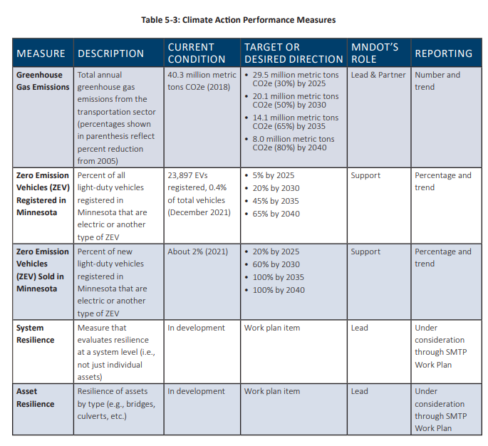
For transit electrification, Metro Transit has made significant strides in electrification, currently operating eight battery electric buses. In 2023, Metro Transit received a Low or No Emission grant to procure 12 new battery electric buses and supporting chargers. In addition, the Council created their Zero-Emission Bus Transition plan, laying out their plans and goals to decarbonize their transit fleet. Metro Transit has set a target for at least 20% of 40-foot bus replacements purchased between 2022 and 2027 to be electric. This approach is further evidenced by the fact that approximately 33.3% of all transit rides in 2023 were on electrically powered transit vehicles, including the Green Line and Blue Line light rail lines. Given the adaptability of MOVES4, transit electrification targets specific to the region shall also be considered and quantified.

Appendix A – Emission Factors Baseline
To create a baseline for emissions within the Met Council region, the team used the Scenario Planning (SP) tool to gather tailpipe emissions data for diesel and gasoline vehicles as well as lifecycle emissions data for electric vehicles. For estimating the lifecycle emissions of diesel and gasoline vehicles, emission factors were refined using the GREET model. According to the GREET model, the lifecycle emissions of gasoline are 1.24 times its tailpipe emissions, and for diesel, it is 1.21 times. SP emission factors were then adjusted accordingly. The summary of lifecycle emission factors is presented in Table A1.
Table A1. Lifecycle Emission Factors (g/mile) by Fuel Type for Passenger Vehicle.
Calendar Year | Diesel School Bus | BEV | Diesel | Gasoline
2020 | 2625.60 | 127.46 | 424.91 | 413.01
2025 | 2617.94 | 113.89 | 427.55 | 409.32
2030 | 2612.86 | 104.85 | 429.14 | 406.90
2035 | 2587.16 | 72.85 | 429.43 | 400.89
2040 | 2548.93 | 61.02 | 429.39 | 394.96
2045 | 2498.79 | 67.82 | 428.75 | 389.13
2050 | 2437.47 | 49.32 | 427.72 | 383.38

Appendix B – Social Cost of Carbon
The project team also recommends to monetize GHG emissions benefits using the Social Cost of Carbon (SCC), a measure that is often required by the U.S. EPA and other federal agencies to demonstrate climate impacts of their rulemaking efforts. SCC estimates the long-term damage from GHG emissions, including impacts on agricultural productivity, human health, property damages and changes in energy system costs. The project team used the latest SCC values from the EPA’s Report on the Social Cost of Greenhouse Gases: Estimates Incorporating Recent Scientific Advances. SCC are provided annually between 2024 to 2050, and it represents the future damages associated with one additional metric ton of GHG emissions. The EPA SCC provides three different discount rates using the Ramsey (1928) discounting formula, and the current tool uses a 2.0% discount rate, as shown in Table B1. Multiplying the change in emissions for a future year (MT CO2e/year) by the discounted SCC value ($/MT CO2e) for that year yields the monetized value of future emission changes from the perspective of that year. The total present value of benefits from an action or measure is thus the sum of the discounted, monetized values for each year the measure produces emission changes.
Table B1. Annual Scocial Cost of Carbon ($/MT) Provided by the U.S. EPA.
Year | 2.5% Ramsey | 2.0% Ramsey | 1.5% Ramsey
2024 | 128 | 208 | 356
2025 | 130 | 212 | 360
2026 | 133 | 215 | 365
2027 | 136 | 219 | 370
2028 | 139 | 223 | 375
2029 | 141 | 226 | 380
2030 | 144 | 230 | 384
2031 | 147 | 234 | 389
2032 | 150 | 237 | 394
2033 | 153 | 241 | 398
2034 | 155 | 245 | 403
2035 | 158 | 248 | 408
2036 | 161 | 252 | 412
2037 | 164 | 256 | 417
2038 | 167 | 259 | 422
2039 | 170 | 263 | 426
2040 | 173 | 267 | 431
2041 | 176 | 271 | 436
2042 | 179 | 275 | 441
2043 | 182 | 279 | 446
2044 | 186 | 283 | 451
2045 | 189 | 287 | 456
2046 | 192 | 291 | 462
2047 | 195 | 296 | 467
2048 | 199 | 300 | 472
2049 | 202 | 304 | 477
2050 | 205 | 308 | 482

For project types that may include a variety of applications and project components, such as Safe Routes to School Infrastructure, Traffic Management Technologies, and Spot Mobility and Safety, it is rather difficult to use a single methodology for quantification. Therefore, they are not included in this document.
BLS, Employee Tenure Summary, September 22, 2022, available at: https://www.bls.gov/news.release/tenure.nr0.htm
MnDOT, Carbon Reduction Strategy, available at: https://edocs-public.dot.state.mn.us/edocs_public/DMResultSet/download?docId=36928262
USDOT, Benefit-Cost Analysis Guidance for Discretionary Grant Programs, December 5, 2023, available at: https://www.transportation.gov/mission/office-secretary/office-policy/transportation-policy/benefit-cost-analysis-guidance
FTA, Default Useful Life Benchmark (ULB) Cheat Sheet, October 25, 2021, available at: https://www.transit.dot.gov/TAM/ULBcheatsheet
Via communication with MnDOT staff.
Saint Paul Highland Park Transit Service Study, available at https://www.metrotransit.org/Data/Sites/1/media/about/improvements/highland-park-transit-study-082919.pdf
https://ww2.arb.ca.gov/sites/default/files/auction-proceeds/sgc_ahsc_qm_022521.pdf
https://ww2.arb.ca.gov/sites/default/files/auction-proceeds/transit_factors_technical_081319.pdf
https://metrocouncil.org/Council-Meetings/Committees/Transportation-Committee/2019/April-22,-2019/Info-3-_-Customer-Survey.aspx
https://metrocouncil.org/Transportation/Performance/Emerging-Trends/Mobility-Hub-Planning-Guide/Planning-and-Implementation-Guidebook.aspx
Most of the methodologies have also been documented in the Task 3 memo. The VMT reduction associated with each mobility option depends on the adoption of trip reduction policies, the level of investment at the mobility hub, surrounding land uses, frequency of use, and the types of trips it offsets. The more transit-oriented the hub and the broader policy environment, the higher the VMT reduction potential.
½ mile for biking projects and ¼ mile for pedestrian projects.
https://octa.net/pdf/MobilityHubsStudyFinalReport.pdf
Mobility hub service areas were selected based on a selection of transportation analysis zones (TAZs) within approximately 3 miles of the identified hub location.
Little is known about how the effect might vary across urban or rural areas, as the evidence in this literature is largely from urban places. More information available at: https://ww2.arb.ca.gov/sites/default/files/2020-06/Impacts_of_Tra nsit_Access_%28Distance_to_Transit%29_Based_on_a_Review_of_the_Empirical_Literature_Policy_Brief.pdf
https://go.minneapolismn.gov/draft-plan-overview/how-people-move. This value could also be updated using the Met Council regional travel model or the travel behavior inventory (TBI).
https://www.sciencedirect.com/science/article/abs/pii/S1361920920306337
Consistent with the OCTA buffer distance.
This value could also be updated using the Met Council regional travel model or the travel behavior inventory (TBI).
https://ww2.arb.ca.gov/sites/default/files/auction-proceeds/transit_factors_technical_081319.pdf
Additional elasticities assess the relationship between ridership and transit fare and gasoline prices. More can be found in Iseki and Ali (2015), available at: https://journals.sagepub.com/doi/10.3141/2537-08
According to Metro Transit, BRT service is up to 25% faster than local buses, thanks to signal priority, wider stop spacing, off-board fare payments, all-door boarding, and bus lanes in some locations. All stations have light, on-demand heat, emergency telephones, NexTrip real-time signs, and security cameras.
https://nacto.org/docs/usdg/tcrp118brt_practitioners_kittleson.pdf
https://ww2.arb.ca.gov/sites/default/files/2020-06/Impacts_of_Transit_Service_Strategies_on_Passenger_Vehicle_Use_and_Greenhouse_Gas_Emissions_Policy_Brief.pdf
Diving-Deeper-Understanding-Disparities-Between-B.aspx (metrocouncil.org): https://metrocouncil.org/getdoc/03bd679d-21a4-455b-af7a-15309b0c71ae/Diving-Deeper-Understanding-Disparities-Between-B.aspx
Commutes Across America - Where Are The Longest Trips To Work? Available at https://www.streetlightdata.com/wp-content/uploads/2018/03/Commutes-Across-America_180201.pdf
County-level average commute trip distance: Anoka 9.7 miles, Carver 11.3 miles, Dakota 10.3 miles, Hennepin 11.3 miles, Ramsey 10.8 miles, Scott 10.6 miles, Washington 10.7 miles.
In Task 3, the team has reviewed the CARB methodology published in 2020 (available at https://ww2.arb.ca.gov/sites/default/files/auction-proceeds/carb_cmo_qm_final_090120.pdf); a new draft version became available after the Task 3 review (available at https://ww2.arb.ca.gov/sites/default/files/auction-proceeds/carb_clean-mobility-qm_draft_july2023.pdf) and team has considered the updates of parameters in the new version.
Includes electric scooter or bikes.
4th Annual Shared Micromobility State of the Industry Report, available at https://nabsa.net/about/industry/
It includes the trips that would have happened in a passenger auto if the project was not available, and it excludes the trips that would have happened on transit or as walking and biking trips in the absence of the project.
The vehicle occupancy should exclude drivers for ride-hailing and other services.
SB 1014 Clean Miles Standard 2018 Base-year Emissions Inventory Report. Available at https://ww2.arb.ca.gov/sites/default/files/2019-12/SB%201014%20-%20Base%20year%20Emissions%20Inventory_December_2019.pdf
In the current methodology, electric scooters and electric bikes are assumed to be zero as well, with further justification provided later in this memo.
Available online: https://www.sciencedirect.com/science/article/abs/pii/S0965856417308832?via%3Dihub
Available online: https://metrocouncil.org/Transportation/Performance/Travel-Behavior-Inventory/Data/Maximum-Mode-Shift/Maximum-Mode-Shift-Study-Presentation.aspx
Data and research results available online: https://metrocouncil.org/Transportation/Performance/Travel-Behavior-Inventory/Data.aspx
The mode shift potential to all alternative modes is limited to competitive trips that utilize multiple non-car modes to complete the trip, i.e., trips that can be competitively completed using combinations of non-car modes.
https://metrans.org/assets/research/psr-19-15_goulias_final-report.pdf
https://globalworkplaceanalytics.com/work-at-home-after-covid-19-our-forecast
https://news.gallup.com/poll/510785/remote-work-stable-higher-rate-post-pandemic.aspx
https://enveurope.springeropen.com/articles/10.1186/s12302-020-00307-8
https://ww2.arb.ca.gov/sites/default/files/auction-proceeds/Clean_Mobility_QM_FINAL_November2023.pdf
Consistent with the Minnesota Carbon Reduction Strategy assumption, which is developed based on traffic count information that suggests facilities are in regular use in Minnesota from April to October every year. More information available at: https://www.dot.state.mn.us/bike-ped-counting/reports/2018-2019%20MinnesotaPedBikeCountReport.pdf
https://www.replicahq.com/ Based on Spring 2023 weekday trips that start and end in the seven counties: Anoka, Washington, Ramsey, Hennepin, Carver, Scott, and Dakota. This value could also be updated using the Met Council regional travel model or the travel behavior inventory (TBI).
The original CARB methodology uses California bikeway classifications. More information available at: https://ww2.arb.ca.gov/sites/default/files/auction-proceeds/bicycle_facilities_technical_041519.pdf and https://www.dot.state.mn.us/bike/bicycle-facility-design-manual.html
Wallace, C.E., K.G. Courage, D.P. Reaves, G.W. Schoene, G.W. Euler, and A. Wilbur, “TRANSY-7F User’s Manual”, US Department of Transportation, Office of Traffic Operations, 1984.
https://greet.anl.gov/results
https://afdc.energy.gov/data/10310
https://www.epa.gov/automotive-trends/download-automotive-trends-report
https://www.anl.gov/sites/www/files/2018-02/idling_worksheet.pdf
https://www.epa.gov/moves#:~:text=EPA's%20MOtor%20Vehicle%20Emission%20Simulator,greenhouse%20gases%2C%20and%20air%20toxics.
https://www.bts.gov/content/number-us-aircraft-vehicles-vessels-and-other-conveyances
https://www.epa.gov/greenvehicles/greenhouse-gas-emissions-typical-passenger-vehicle
Handy, Susan and Boarnet, Marlon, G., "Impact of Highway Capacity and Induced Travel on Passenger Vehicle Use and Greenhouse Gas Emissions," prepared for the California Air Resources Board, 2014. https://ww2.arb.ca.gov/sites/default/files/2020-06/Impact_of_Highway_Capacity_and_Induced_Travel_on_Passenger_Vehicle_Use_and_Greenhouse_Gas_Emissions_Policy_Brief.pdf
Source: Handy, Susan and Boarnet, Marlon, G., "Impact of Highway Capacity and Induced Travel on Passenger Vehicle Use and Greenhouse Gas Emissions," prepared for the California Air Resources Board, 2014; Duranton, G., & Turner, M. A., “The Fundamental Law of Road Congestion: Evidence from US Cities,” American Economic Review, 101 (6), 2011; Hymel, Kent, “If You Build It, They Will Drive: Measuring induced demand for vehicle travel in urban areas,” Transport Policy. Volume 76, pp. 57-66, 2019.
See: https://shift.rmi.org/
Barr, L. C. (2000). Testing for the Significance of Induced Highway Travel Demand in Metropolitan Areas. Transportation Research Record, 1706(1), 1-8. https://doi.org/10.3141/1706-01
2023 Twin Cities Auto Show (March 31 – April 8, 2023), Pre- and Post-Drive Survey Data Analysis
https://go.minneapolismn.gov/draft-plan-overview/how-people-move. This value could also be updated using the Met Council regional travel model or the travel behavior inventory (TBI).
https://greet.anl.gov/
https://www.eia.gov/outlooks/aeo/
https://www.sciencedirect.com/science/article/abs/pii/S136192091630757X?fr=RR-2&ref=pdf_download&rr=831178a3082a08c5
https://www.sciencedirect.com/science/article/am/pii/S1361920919305309
https://www.mdpi.com/2071-1050/12/16/6369#:~:text=We%20found%20that%20insufficient%20public,rate%20in%20the%20next%20month.
https://www.journals.uchicago.edu/doi/full/10.1086/689702
https://ecommons.cornell.edu/server/api/core/bitstreams/c0ffbf78-1751-422b-b84a-9c0a53493c73/content
https://www.sciencedirect.com/science/article/abs/pii/S136192092200390X
https://theicct.org/sites/default/files/publications/charging-up-america-jul2021.pdf
https://www.energetics.com/evwatts-station-dashboard
https://unece.org/sites/default/files/2022-06/5_GREET.pdf
More information can be found at: https://metrocouncil.org/Transportation/Planning-2/Key-Transportation-Planning-Documents/Transportation-Policy-Plan/2040.aspx
https://shift.rmi.org/
https://www.dot.state.mn.us/sustainability/ghg-analysis.html Detailed instructions for using the MICE tool can also be found on the MnDOT website.
https://www.dot.state.mn.us/project-development/subject-guidance/greenhouse-gas-analysis/process.html
FTA Greenhouse Gas Emissions from Transit Projects: Programmatic Assessment
https://www.transit.dot.gov/sites/fta.dot.gov/files/2022-04/FTA-GHG-Emissions-Estimator-v3-User-Guide.pdf The primary data sources for construction-related GHG emissions and energy use factors in the FHWA ICE v2.1 and research by Hanson et al (2015). Greenhouse gas emissions associated with materials used in commuter rail lines, International Journal of Sustainable Transportation, 10:5, 475-484, DOI: 10.1080/15568318.2014.985859
Mikhail V Chester and Arpad Horvath 2009 Environ. Res. Lett. 4 024008. Available online: https://iopscience.iop.org/article/10.1088/1748-9326/4/2/024008/pdf
https://www.epa.gov/moves/latest-version-motor-vehicle-emission-simulator-moves
https://www.epa.gov/automotive-trends
https://www.epa.gov/regulations-emissions-vehicles-and-engines/optimization-model-reducing-emissions-greenhouse-gases
https://www.epa.gov/regulations-emissions-vehicles-and-engines/final-rule-multi-pollutant-emissions-standards-model
https://www.epa.gov/regulations-emissions-vehicles-and-engines/final-rule-greenhouse-gas-emissions-standards-heavy-duty
https://www.minnesotago.org/final-plans/smtp-final-plan-2022
https://www.metrotransit.org/electric-buses
U.S. EPA, EPA's “Report on the Social Cost of Greenhouse Gases: Estimates Incorporating Recent Scientific Advances”, November 2024. https://www.epa.gov/environmental-economics/scghg

