Synthesizing the impact of extreme heat waves on the Twin Cities region

01 August 2022

Table of Contents

# 1 Action items

1. Do we want to get on a meeting schedule? Joel says yes, just pick a date.

* COW meeting: big question is “with the Council’s convening ability, could we pull together some shared definitions, consider developing a stakeholder group to guide this work?
* LUAC meeting: big question is “what tools/data would help you commit to and act on mitigating extreme heat? Thinking about resource allocations, planning decisions, etc.
* Council Climate Workgroup: they are focusing on Climate Action Plan right now, may not be best fit

1. Move away from thinking about the hottest land temperature going up, and instead think about areas where heat risk has changed over time.

# 2 Introduction

The Metropolitan Council provides local planning assistance for communities across the Twin Cities region. As part of this assistance, the Council provides an “Extreme Heat Mapping Tool” for the Twin Cities. This tool shows the land surface temperature during the historic July 2016 heat wave and was created from remote-sensing data (Landsat 8). This dataset has proved particularly valuable as communities evaluate and plan for climate change adaptation techniques, future development and land use planning, and also undertake immediate interventions to reduce heat-related health consequences.

Something about connections between heat and urban planning.

The goal of this project is to do a major addition to the existing body of work. We hope to better integrate the consequences of climate change into city planning and policy decisions, give stakeholders tools to act on mitigating the risk of extreme heat, and ultimately help inform a more sustainable and healthier future for the Twin Cities region.

# 3 Methods

## 3.1 Remote sensing temperature

Temperature sensing has been a component of the Landsat satellite missions since 1982 by measuring infrared (long) wavelengths which are emitted from the Earth’s surface and are a function of surface temperature. Landsat missions 4 and 5 used a thematic mapper instrument to measure infrared reflectance at 120 meter resolution (which underwent a re-sampling process to 30 meter resolution). Landsat 7 used an enhanced thematic mapper plus instrument which increased the spatial resolution to 30 meters. Landsat 7 had an equipment malfunction (scan line corrector) in 2003 which means that not all land area was measured by the satellite. Landsat missions 8 and 9 have thermal infrared sensors (TIRS and TIRS-2, respectively) which detect long wavelengths of light emitted using Quantum Well Infrared Photodetectors (QWIPs). This is a lower-cost and newer alternative to conventional infrared technology used in previous Landsat missions ([NASA](https://landsat.gsfc.nasa.gov/article/thermal-infrared-sensor-tirs/), [USGS](https://www.usgs.gov/faqs/what-are-band-designations-landsat-satellites)).

While broad patterns in land temperature can be studied back to 1982 using all Landsat satellite data, more detailed patterns in temperature are best explored from with Landsats 8 and 9 (2013 - present), primarily because of improvements in spatial resolution. Both satellites image the Twin Cities region every 16 days. Since the launch of Landsat 9 in the fall of 2021, this means that high quality temperature data is available for our region every 8 days.

The entire Twin Cities region is covered by Landsat path 27, row 28-29. The east metro is also on path 26, and the west metro is also on path 28. Because the entire region is not measured every day, this means that extreme heat events don’t always line up with when we get satellite data. Additionally, cloudy days (water vapor between the satellite and the ground make the pixels seem much cooler, so we can’t rely on data with clouds) or days with heavy smoke cover do not produce useable temperature data.

## 3.2 Land surface temperature versus air temperature

Not the same thing, but well correlated.

During the summer months, LandSat land surface temperatures and air temperatures line up pretty well at the airport (Figure 3.1).

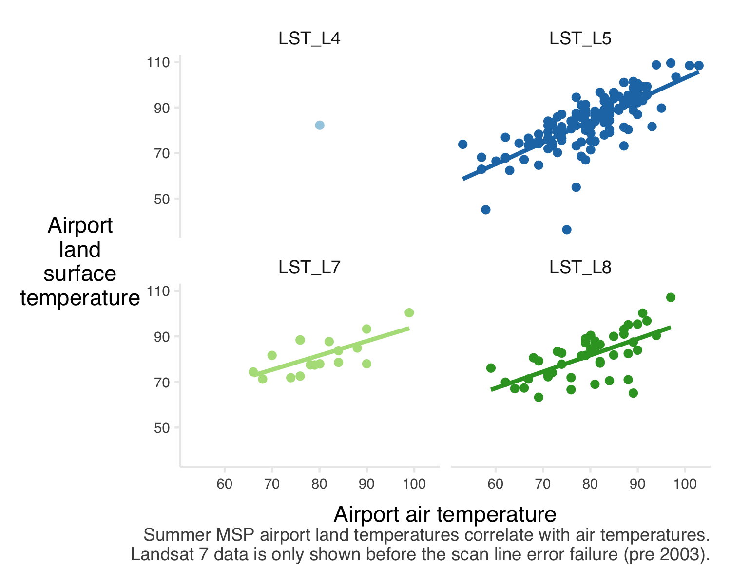

Figure 3.1: Average temperatures in Minnesota from 1895-2021. Source NOAA and <https://showyourstripes.info>.

## 3.3 Demographic data

The demographic data comes from a combination of 2020 decennial census and 2016-2020 five-year American Community Survey (ACS) estimates. The 2020 decennial census is a full count of the population, but has few variables (currently limited to race and total population counts). On the other hand, the ACS five-year estimates offer more detailed demographic variables (for instance income, age, and language variables), but reflects only a sample (survey) of the total population.

The 2020 decennial census data was accessed from the [MN Geospatial Commons](https://gisdata.mn.gov/dataset/us-mn-state-metc-society-census2020population) and used only for race variables. The 2016-2020 ACS data was accessed using the [tidycensus](https://github.com/walkerke/tidycensus) wrapper for the [Census Bureau’s API](https://www.census.gov/programs-surveys/acs/data/data-via-api.html).

## 3.4 Data processing details

### 3.4.1 Temperature

* Google Earth Engine
* reference points, standard deviations
* statistical methods?

### 3.4.2 Demographics / other social variables

* demographic methods
* zillow ztrax
* other?

# 4 Results

## 4.1 Changing *RISK* of extreme heat

### 4.1.1 Historic temperature trends

Minnesota’s temperatures have been warming over the past century, with warming trends accelerating since 2000 (Figure 4.1). Warmer winters and rising daily low temperatures strongly contribute to this trend.

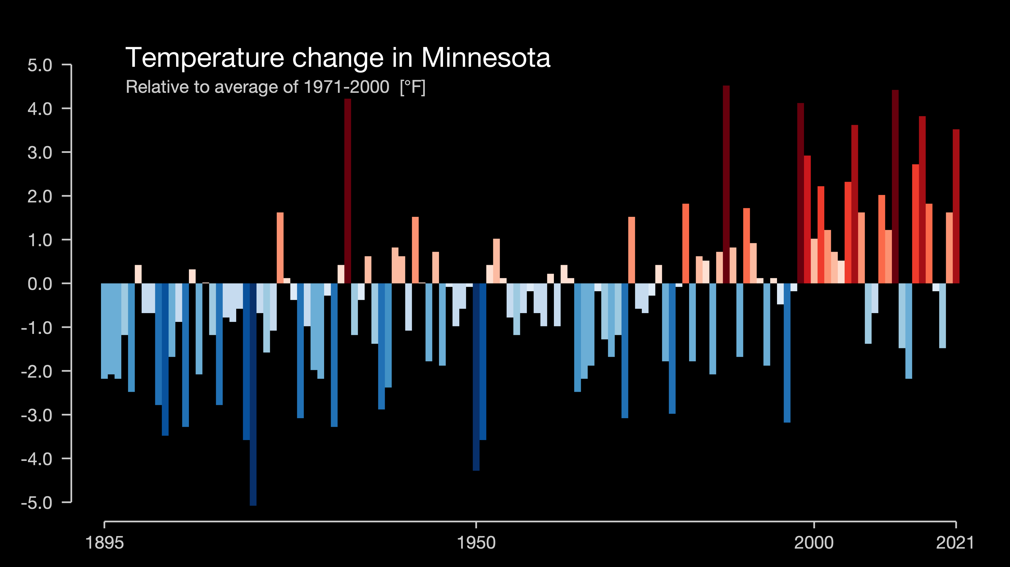

Figure 4.1: Average temperatures in Minnesota from 1895-2021. Source NOAA and <https://showyourstripes.info>.

Hotter summer temperatures are also a component of a warming world, and heat waves have direct consequences on human health. In Minnesota, warming summer trends (probably) include (Figure 4.2):

* neither annual maximum temperatures nor average summer highs have changed much, but
* heat waves (multiple days of extreme heat) are more common
* daily minimum temperatures are warmer

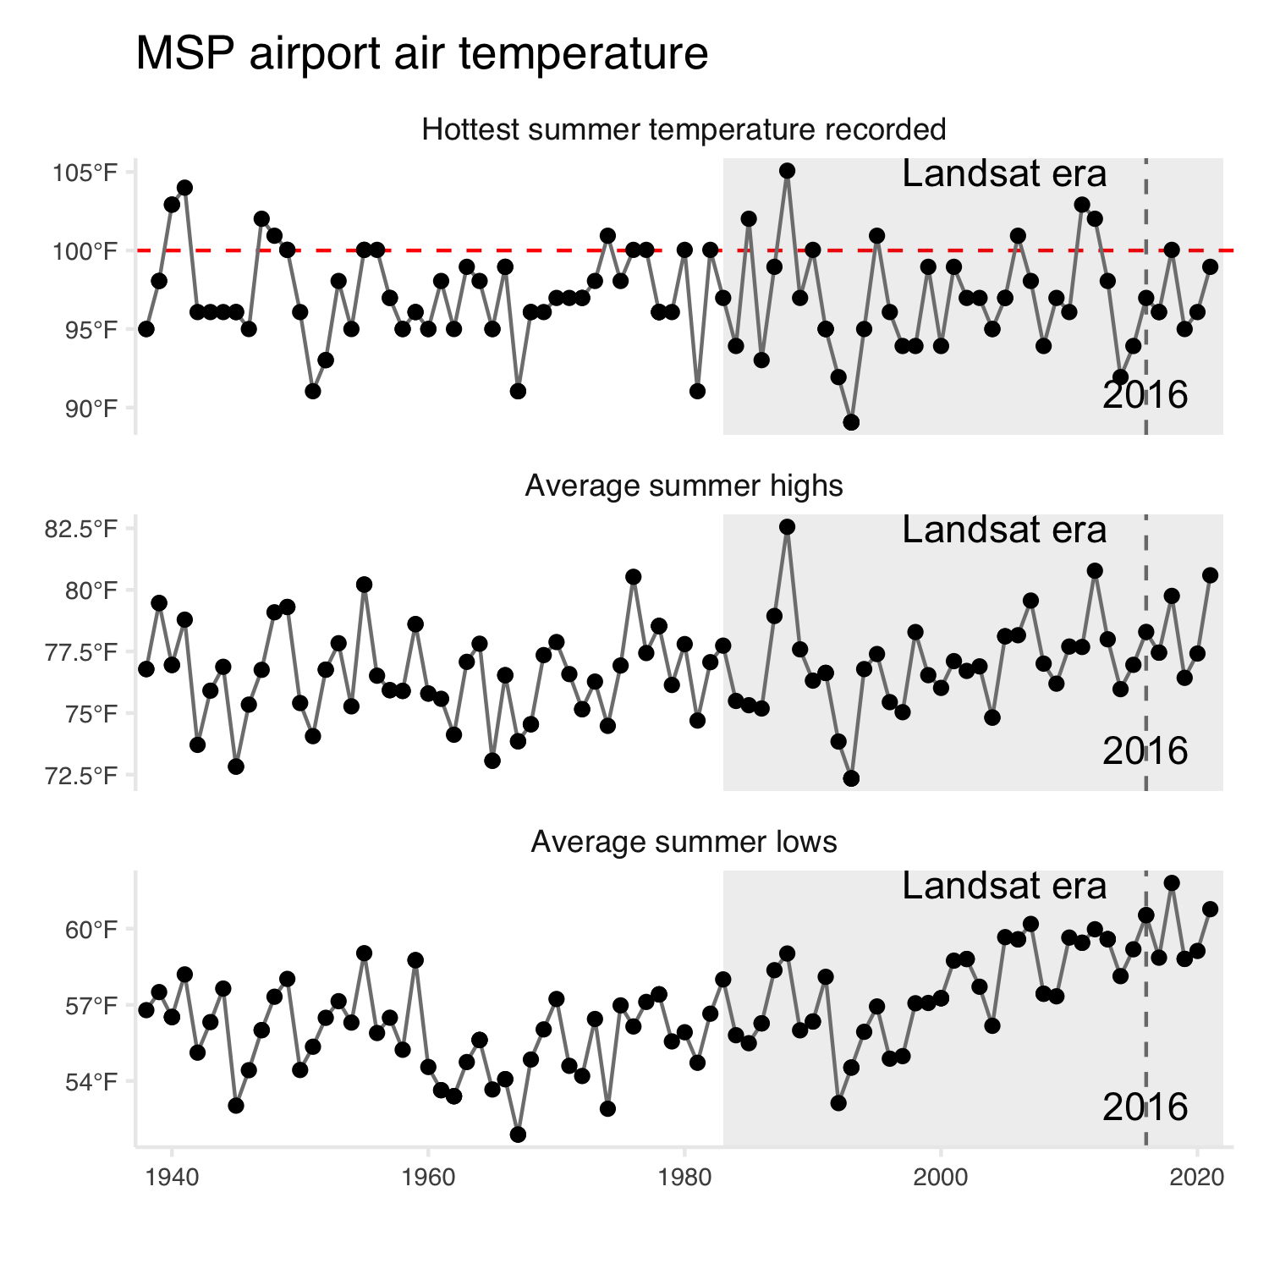

Figure 4.2: Summer air temperatures (May 1 - Oct 1) at MSP airport since records began at that station. The shaded box shows the years which overlap with Landsat satellite data availability. The horizontal red dashed line shows 100 degrees F, and the vertical grey dashed line indicates year 2016 which is currently used to quanify the risk of extreme heat across the Twin Cities region.

### 4.1.2 Extreme heat map

Maybe not updating the 2016 map with 2021/2022 data, but instead adding more information? Decision can get made at the end of summer - we just need to see what heat events line-up with Landsat measurements this year.

## 4.2 Social and economic *IMPACT* of extreme heat on residents

Our [website indicates](https://metrocouncil.org/Communities/Planning/Local-Planning-Assistance/CVA/Extreme-Heat.aspx) “Human vulnerability to extreme heat is of concern for many stakeholders in the region, particularly county public health departments and agency partners.” Let’s explicitly connect the dots between demographic data and land surface temperature!

Indeed, certain populations have disproportionate exposure to extreme heat across our region. In particular:

*Would also be interested in thinking about total numbers of people, not just percents. Are there logical heat “bins” we can break the region into and then show the total number of people who are at risk (or who fall into those different bins).*

### 4.2.1 Age

Neither younger (under age 18) or older (65 or above) age groups who have increased sensitivity to extreme heat appear to be at an increased risk of exposure (Figure 4.3). About 25% of the region’s total population of a sensitive age lives in a block group with temperatures over 95 degrees.

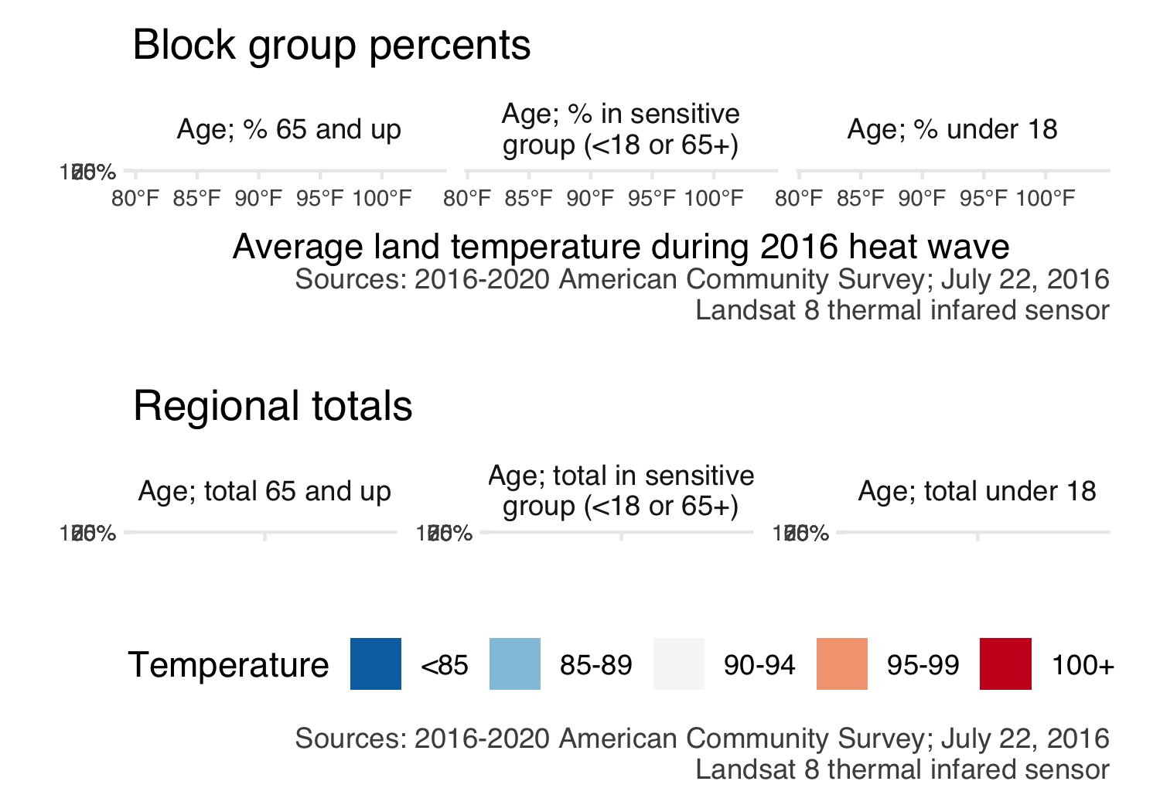

Figure 4.3: Relationship between resident age and land surface temperature during a heat wave for census block groups across the 7-county Twin Cities metropolitan region. The blue line shows the trend line from a generalized additive model.

### 4.2.2 Communications (language and internet)

Hotter areas have greater percentages of residents who do not speak English at home. Hotter areas also have greater percentages of residents without internet at home. This indicates the value of communicating about heat warnings and mitigation strategies (e.g., location and hours of cooling centers) in multiple languages and via multiple platforms (Figure 4.4).

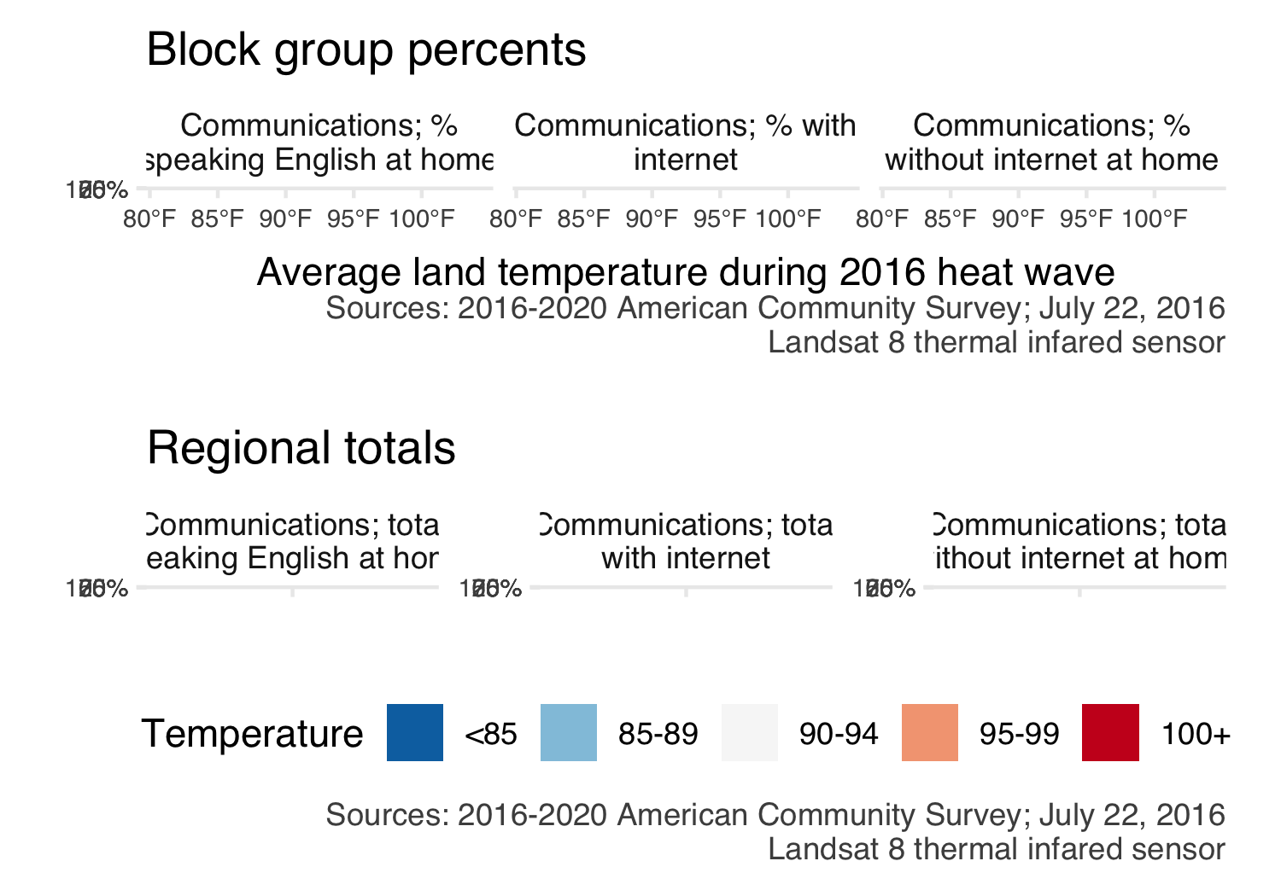

Figure 4.4: Relationship between languages spoken by residents and land surface temperature during a heat wave for census block groups across the 7-county Twin Cities metropolitan region. The blue line shows the trend line from a generalized additive model.

### 4.2.3 Household size

People are more likely to be living alone (household size of 1) in areas with greater exposure to extreme heat (Figure ??). Over 25% of our region’s 1-person households live in areas which can experience heat of 95 degrees or more. Social cohesion/connections can impact human vulnerability to extreme heat. From a safety perspective, people are always advised to check in on family and friends living alone during heat waves. Living alone may put people at an elevated risk. Fortunately, it does not seem that elders living alone have greater risk.

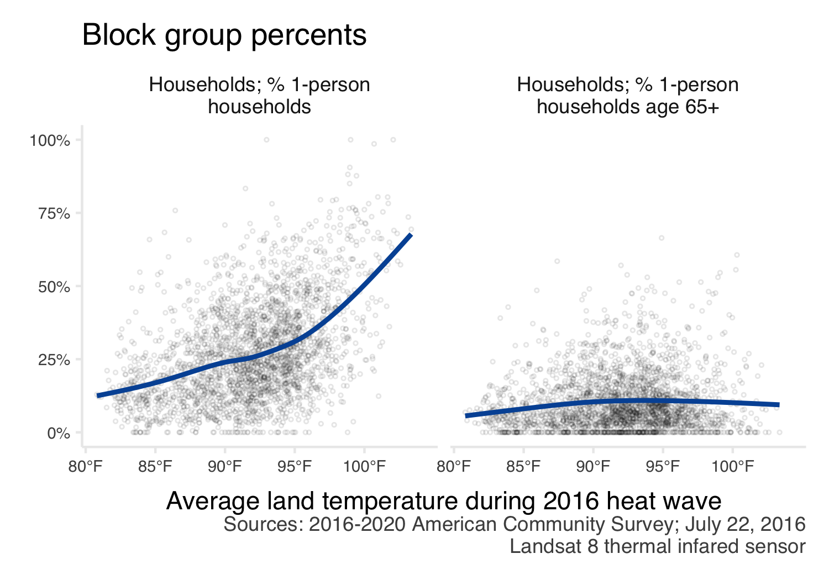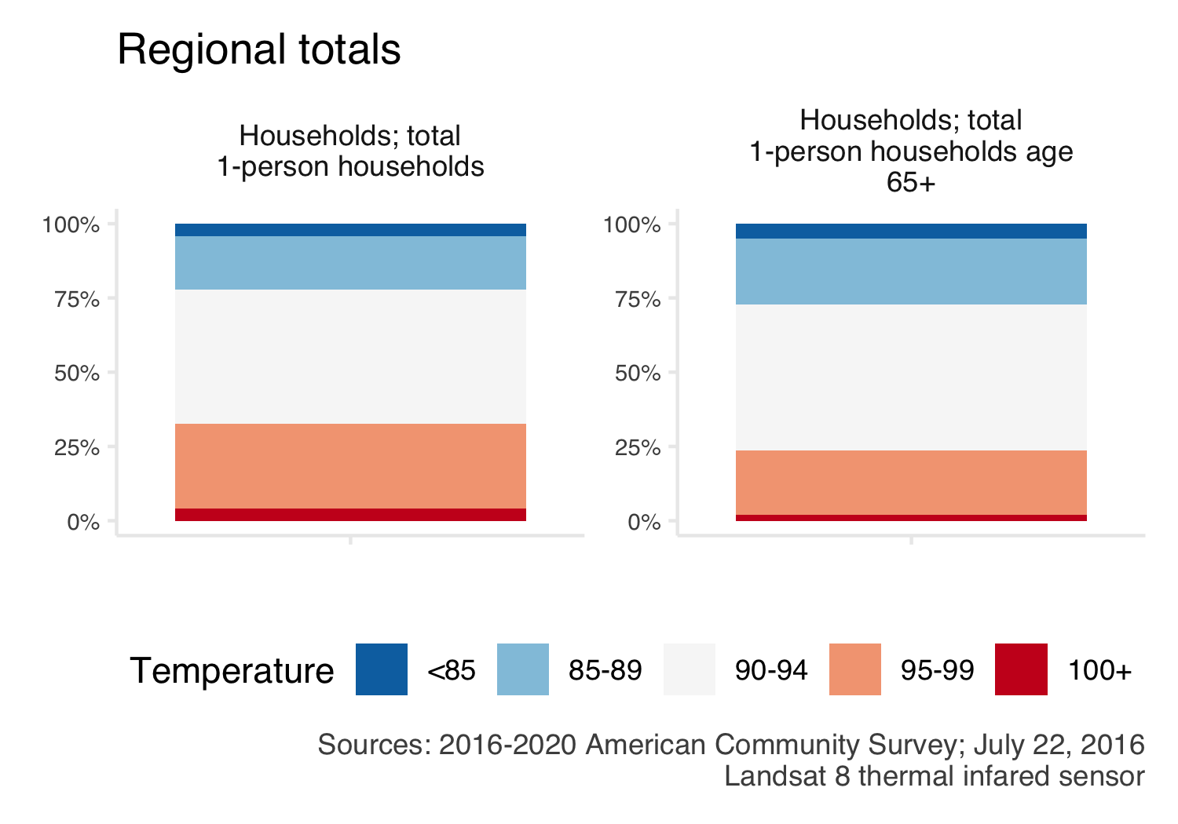

### 4.2.4 Income

There are disparities in exposure to extreme heat with income. Lower income areas (median household income) tend to be exposed to hotter temperatures. Areas where a larger share of residents make less than 185% of the poverty rate are also exposed to hotter temperatures (Figure 4.7).

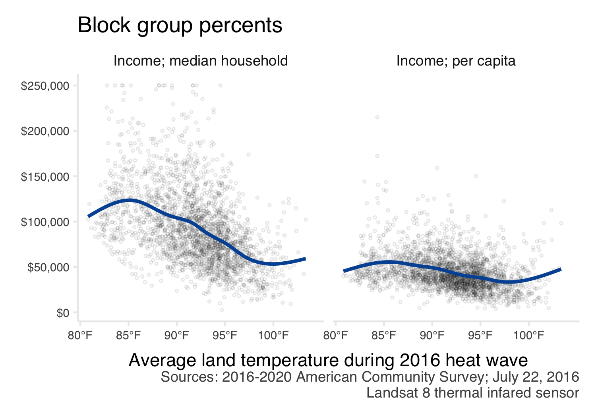

Figure 4.7: Relationship between income and land surface temperature during a heat wave for census block groups across the 7-county Twin Cities metropolitan region. The blue line shows the trend line from a generalized additive model.

### 4.2.5 Race

Areas where a greater percent of residents identify as a person of color tend to be hotter. Native American (American Indian) residents seem to be disproportionately impacted with nearly 75% of the regions population who identifies as Native American living in block groups with temperatures capable of exceeding 100 degrees (Figure 4.8).

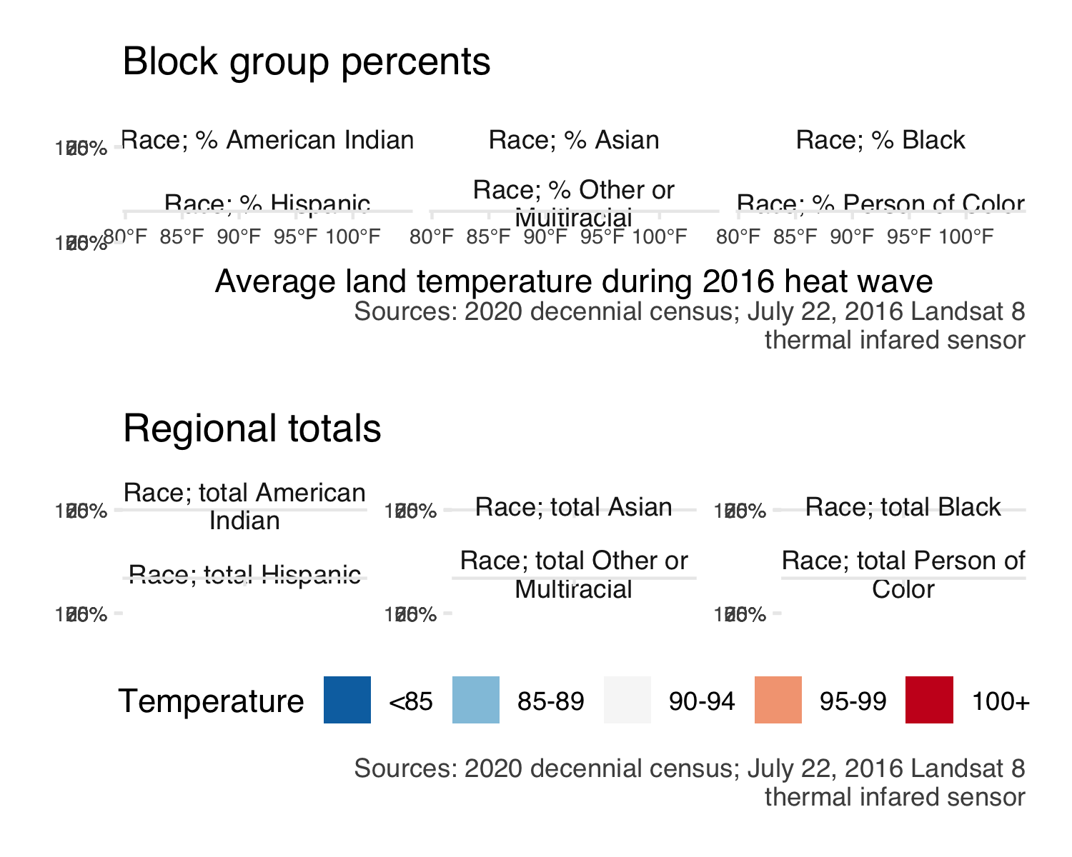

Figure 4.8: Relationship between resident’s racial identity and land surface temperature during a heat wave for census block groups across the 7-county Twin Cities metropolitan region. The blue line shows the trend line from a generalized additive model.

### 4.2.6 Tenure

Areas were more residents are renters are disproportionately hotter. This may indicate the need for particular types of mitigation strategies if renters have less agency to make structural (i.e., installing air conditioning units) or environmental (i.e., planting trees or landscaping interventions) changes to reduce heat exposure (Figure 4.9).

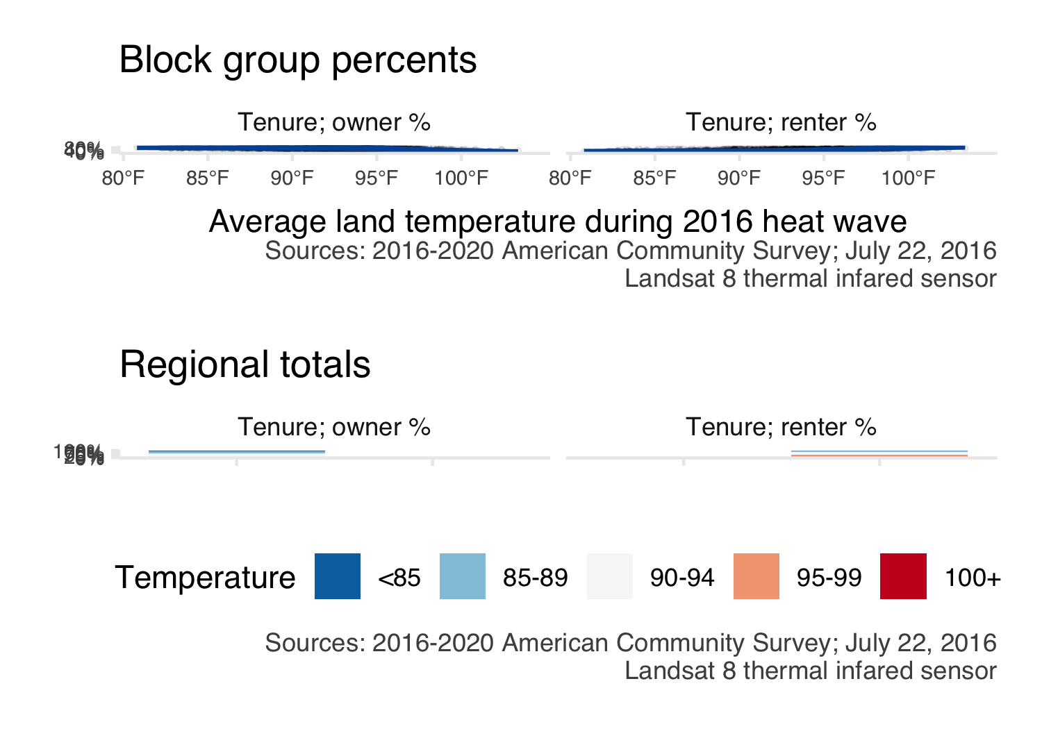

Figure 4.9: Relationship between resident housing tenure and land surface temperature during a heat wave for census block groups across the 7-county Twin Cities metropolitan region. The blue line shows the trend line from a generalized additive model.

# 5 *MITIGATION* and *ADAPTATION* strategies for extreme heat

If rising temperatures are inevitable, how are residents/cities going to adapt/mitigate impact? Aka Link variables about the built and natural environments

* tree canopy (link with growing shade) / impervious surfaces (link with surface with purpose and/or localized flooding); **show how land use decisions impact local temperatures**
* housing metrics from ztrax zillow data; is there an “adaptation gap” to extreme heat? (idea = systemic structural/economic/racial issues may also manifest as no cooling available to residents to mitigate extreme heat). with ztrax consider if we can get cooling data directly from county assessors or parcel data (and keep in mind that county-to-county might be challenging to compare.) maybe consider age of housing stock too (thinking about energy efficiency, etc.)

**ADD OVERLAY MAPS** to the storymap! (kind of like how land use is there now, but try to be more explicit? think about how the data could be compelling to inform landscape architecture, etc.)

## 5.1 Methods

## 5.2 Results

### 5.2.1 Air conditioning in residences

These data come from ztrax. The percent of residences which have some type of cooling system.

There are still issues with Zillow ZTRAX data (for instance, the whole city of Minneapolis and all of Dakota county are currently missing)! But this is the emerging (and tentative) pattern (Figure 5.1).

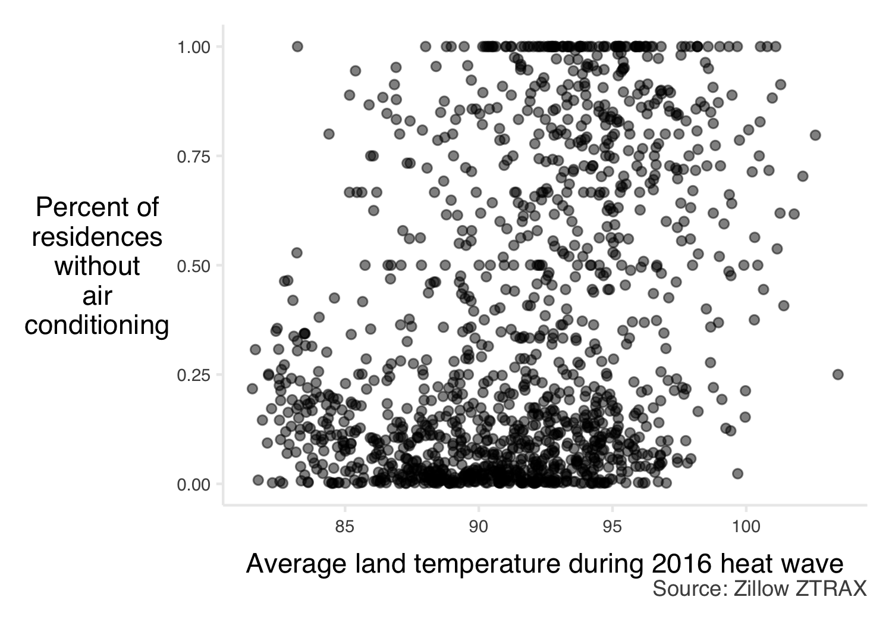

Figure 5.1: Relationship between air conditioning presence in residences and land surface temperature during a heat wave for census block groups across the 7-county Twin Cities metropolitan region.

### 5.2.2 Greenspace

Plants can cool areas via shade and/or evapotranspiration (Figure 5.2).

Tree canopy is a little stranger. It falls apart only in deeply agricultural areas, where greenness is high (thanks to corn/soybeans) and temps are pretty low…but tree canopy is also very low (because it’s cropland and not forest). Could probably show the relationship between trees and temperatures for urban/suburban areas and just exclude agricultural areas.

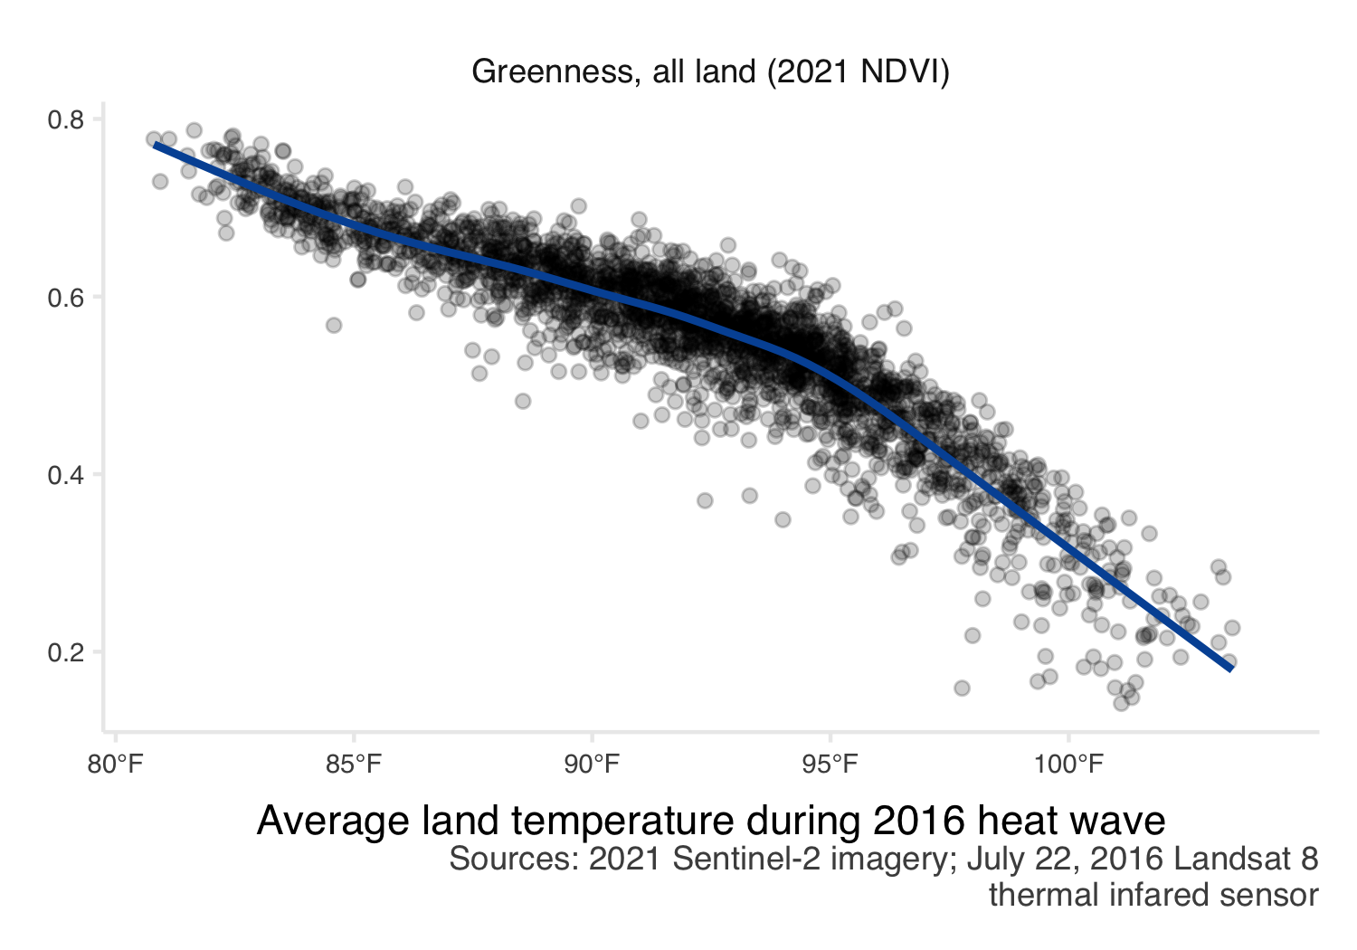

Figure 5.2: Relationship between greenspace and land surface temperature during a heat wave for census block groups across the 7-county Twin Cities metropolitan region.

# 6 Narrative

Update StoryMap. Consider UofM RCP program - could students do some of this qualitative data gathering?

Idea: is it possible to capture a personal/neighborhood experience of heat (aka break down what **human vulnerability to heat** is/means/manifests around the region).

## 6.1 Cooling centers

Is it possible to map them? Or have definitions become standardized? Paid versus free cooling options, etc. Splash pads? Is there a “cooling desert” (like food desert)?

## 6.2 Landscaping

How does landscaping impact heat? Consider:

* EAB and tre removal
* commercial landscaping opportunities
* green roofs, etc.

## 6.3 Health outcomes

Anything with co-morbidities.

Check out that study in Baltimore about heat and deaths - are there cool links we can make for our region?

## 6.4 Grassroots efforts

What are the grassroots efforts related to heat? Could include:

* green roofs
* heat pumps/cooling
* programs $ nonprofits providing relief
* building social connections/safety in extreme heat

# 7 Disemination

* How to engage stakeholders and provide educational opportunities around the update?
* Plan for COW presentation?
* Update MN Geospatial commons data
* Would communications folks want to be engaged?
* Should we bring drought into the picture here (aka temperature + precipitation)?