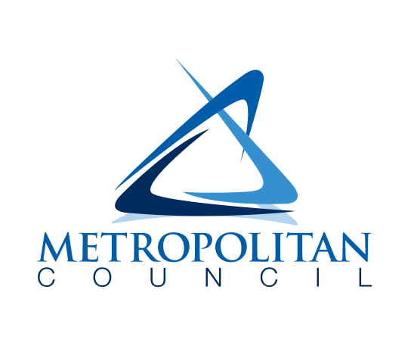

internal memorandum

**DATE:**  February 22, 2023

**TO:** LisaBeth Barajas, Terri Dresen

**CC:** Michelle Fure

**FROM:** Ellen Esch, Eric Wojchik, Joel Huting

**SUBJECT:** Honorarium request regarding Resolution No. 2022-22

To help the Twin Cities region plan for a resilient, health, and sustainable future, the Metropolitan Council maps extreme heat. The 2023 update to the extreme heat toolkit (Esch and Wojchik as project leads) strives to help the region better integrate the consequences of climate change into city planning and policy decisions, give stakeholders tools to act on mitigating the risk of extreme heat, and ultimately help inform a more sustainable and healthier future. Importantly, this update aims to place equal value on quantitative and qualitative data in addition to centering climate justice and environmental justice. Conducting interviews with community members, advocates, and subject matter experts is fundamental to the success of this project. Including diverse voices is a priority.

In recognition of Thrive MSP 2040’s equity commitment and as established by Metropolitan Council Resolution 2022-22, providing an honorarium (incentive) will acknowledge interviewees’ valuable intellectual contributions and time commitment. We are requesting a total of $600 to be distributed in $60 increments. If fewer than 10 requests for interviews are accepted, the remaining lump sum will be returned to the annual budget no later than June 1, 2023. The Research Department budget (21005) will be the source of the funds over which Joel Huting has signing authority. The $60 incentive was determined to be appropriate for an anticipated one-hour commitment from interviewees commensurate with rounded range-maximums for current AFSCME pay grids in grades H-J, which roughly corresponds to the expertise and background of intended interviewees. Michelle Fure will assist in the procurement and distribution of any honorarium.

Identified experts may include the following. More than one individual may be interviewed at each location, and new experts may additionally be identified over the next several months. Not all interviewees may accept the honorarium.

* Staff at [Energy CENTS Coalition](https://www.energycents.org/), a 501(c)3 non-profit organization based out of St. Paul, MN working to provide energy solutions for low-income residents
* Staff at the [Native American Community Clinic](https://nacc-healthcare.org/), a community health center in Minneapolis, MN working to address racial health equity and social determinants of health
* Sam Olbekson at [Full Circle Indigenous Planning](https://www.fullcircleplanning.com/), a Minneapolis-based, Native American-owned planning and design firm specializing in linking the built and natural environment
* Staff at the [Native American Community Development Institute](https://www.nacdi.org/), a Twin Cities-based organization with a signature program focused on urban greening (Four Sisters Farm)
* Staff at the [Hmong American Farmers Association](https://www.hmongfarmers.com/), a Minnesota-based organization advocating for challenges faced by agricultural workers including occupational exposure to extreme heat
* Staff at [Minnesota Department of Health’s Climate and Heath Program](https://www.health.state.mn.us/communities/environment/climate) who additionally strive to help communities prepare for the consequences of extreme heat
* Staff at the [Korey Stringer Foundation](https://ksi.uconn.edu/), a 501(c)3 non-profit founded after former MN Vikings player Korey Stringer died of exertional heat stroke, now aiming to reduce heat-related deaths

Signed,

Joel Huting