Nama : Metta Shanti

Kelas: MI5A

UTS Web 2

1. Get

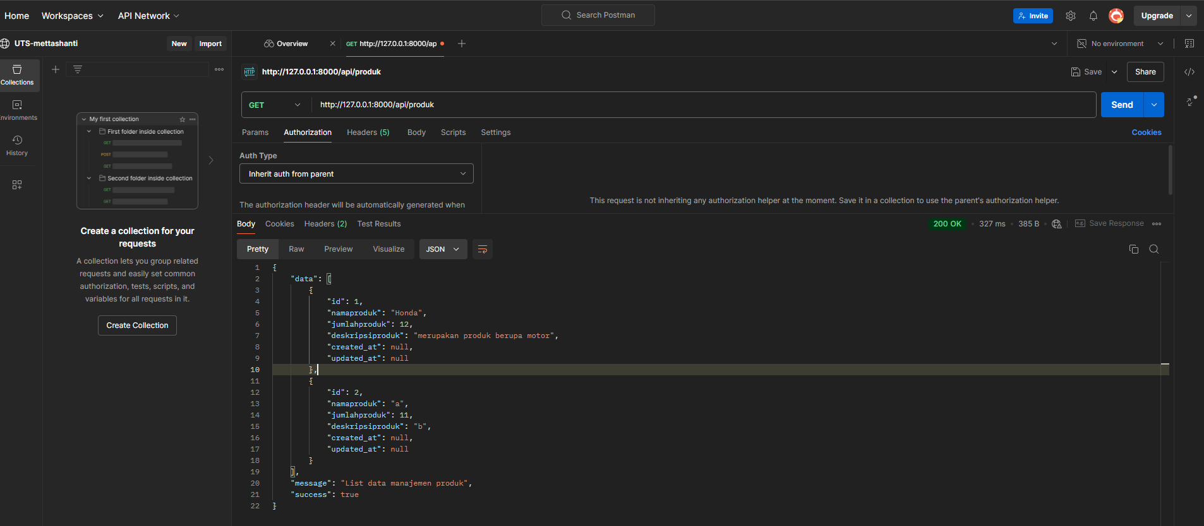

1. Post

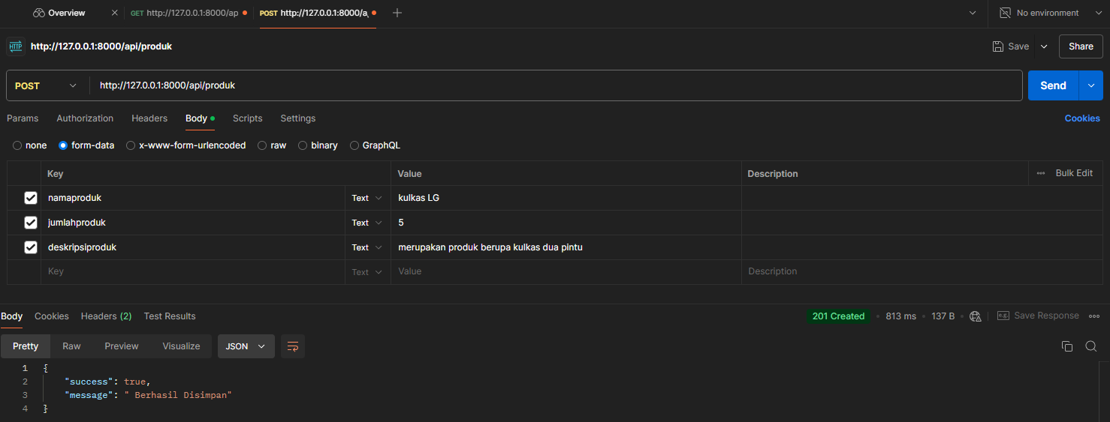

1. delete