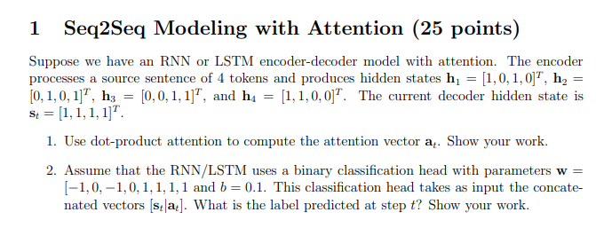

- Dot product attention vector
E1 = [1, 0, 1, 0]^T * [1,1,1,1] = 1 + 0 + 1 + 0 = 2
E2 = [0, 1, 0, 1]^T * [1,1,1,1] = 0 + 1 + 0 + 1 = 2
E3 = [0, 0, 1, 1]^T * [1,1,1,1] = 0 + 0 + 1 + 1 = 2
E4 = [1, 1, 0, 0]^T * [1,1,1,1] = 1 + 1 + 0 + 0 = 2

$a_{i}=$Softmax ( $E_{i}$) -> 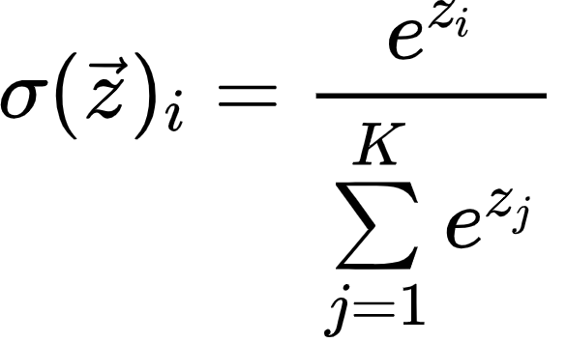
All $a_{i}$ = ¼

$a_{t}$= $\sum_{i}^{4}{}$$a_{i}E_{i}$ = [0.5,0.5,0.5,0.5]^T

- Binary classifier head on RNN/LSTM w = [−1, 0, −1, 0, 1, 1, 1, 1 and b = 0.1.
Concatenated input = [1,1,1,1,0.5,0.5,0.5,0.5] (connect them together
Z = w^T * [st | at] + b

Multiply it out (−1)(1) + (0)(1) + (−1)(1) + (0)(1) + (1)(0.5) + (1)(0.5) + (1)(0.5) + (1)(0.5) + 0.1 = 0.1
Since 0.1 > 0, predicted label = 1

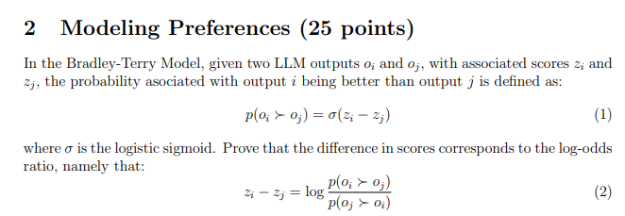

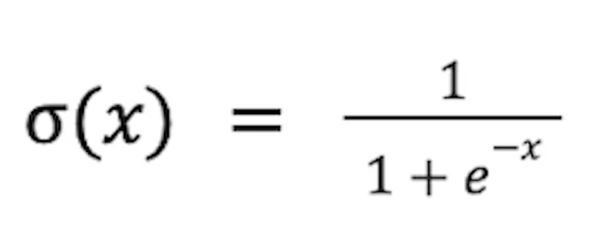
- Finding: p(oj ≻ oi)

Let x = zi - zj
σ(zi - zj) = σ(x)

σ(x) = 1/ (1+ $e^{-x}$)
Zj - zi = -x
σ(-x) = 1/ (1+ $e^{x}$)
σ(zj - zi) = 1/ (1+ $e^{x}$)
- The ratio
log(1/ (1+ $e^{-x}$) /1/ (1+ $e^{x}$)):
- 1/ (1+ $e^{-x}$) /1/ (1+ $e^{x}$) = (1+ $e^{x}$)/ (1+ $e^{-x}$)
- (1+ $e^{-x}$) = 1 + 1/e^x = (1+ $e^{x}$) / $e^{x}$
- (1+ $e^{x}$)/ (1+ $e^{-x}$) = (1+ $e^{x}$)/((1+ $e^{x}$) / $e^{x}$) = $e^{x}$
- log($e^{x}$) = x = zi - zj
- Zi - zj = 1/ (1+ $e^{-x}$) /1/ (1+ $e^{x}$)

