**Aim**

The primary aim of the experiment is to understand and practically demonstrate the various host discovery methods (Ping Scans) that Nmap employs to reliably determine which IP addresses in a target range correspond to active (live) hosts on a network, while also learning how to bypass common security measures like firewalls that block standard pings.

**Subnetworks:**

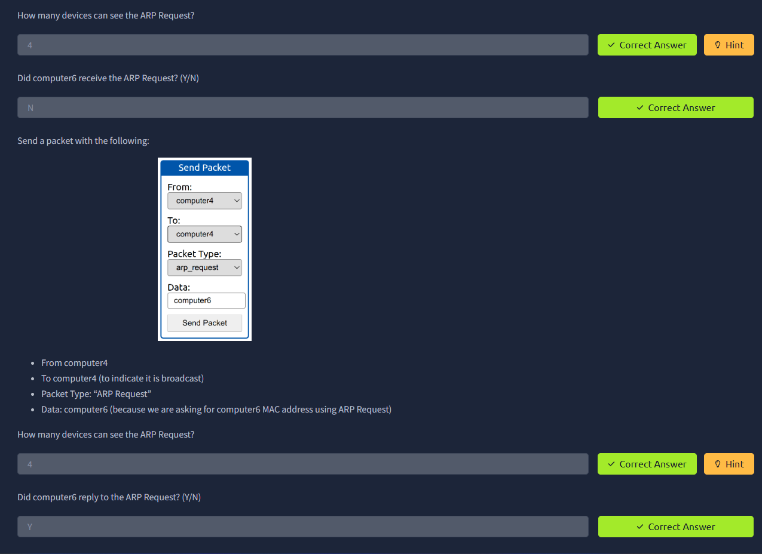

**Enumerating Targets:**

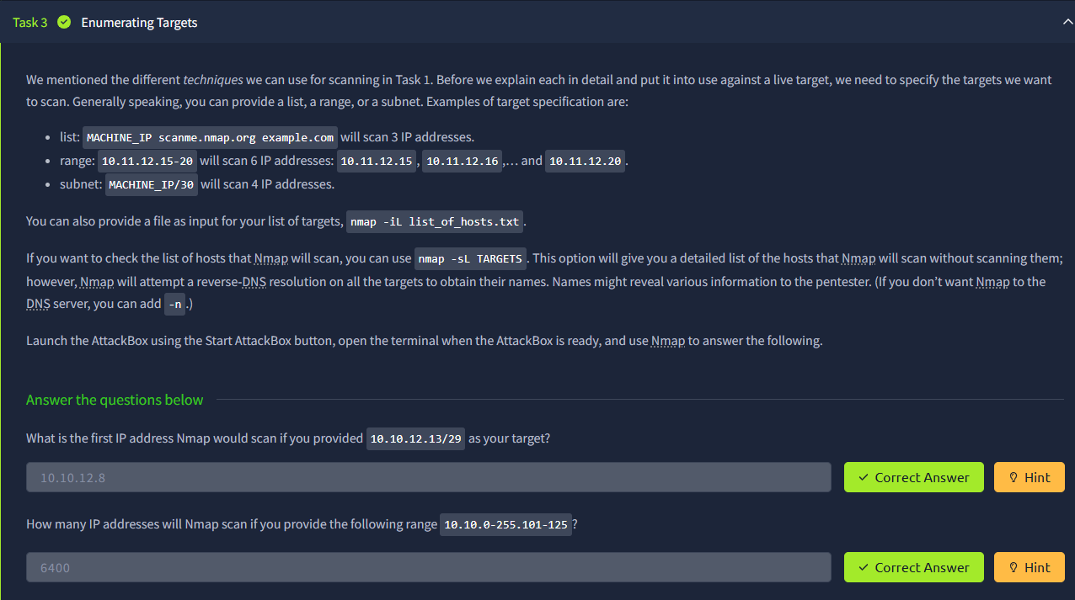

**Discovering Live Hosts:**

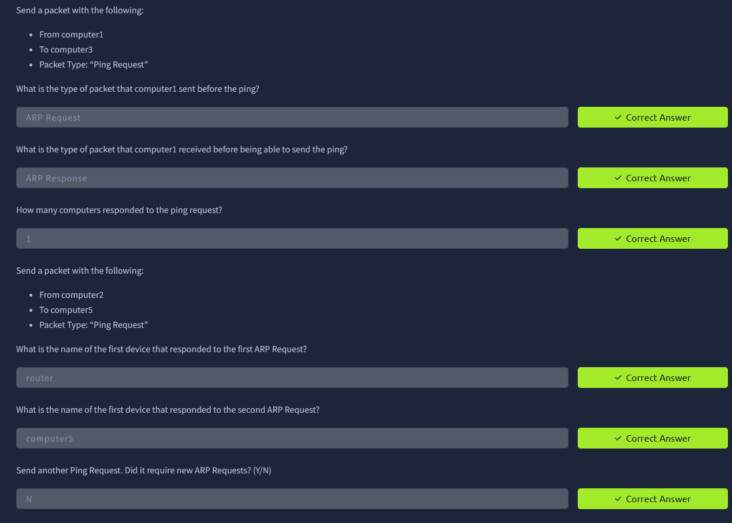

**Nmap Host Discovery Using ARP:**

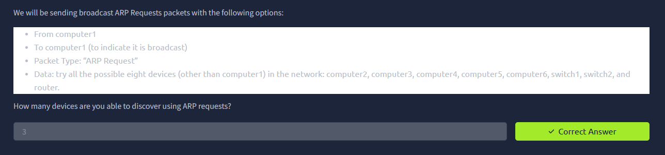

**Nmap Host Discovery Using ICMP:**

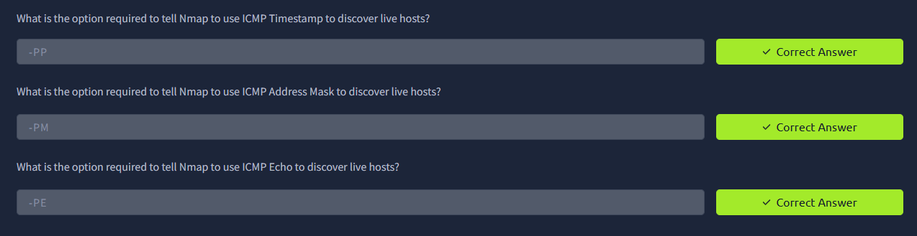

**Nmap Host Discovery Using TCP and UDP:**

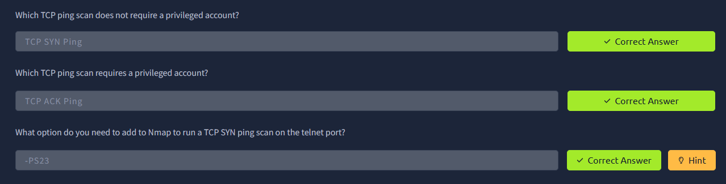

**Using Reverse-DNS Lookup:**

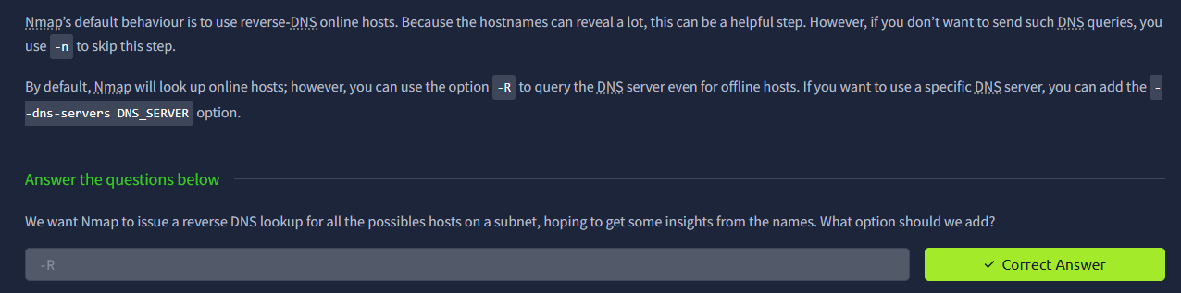

**Result**

The successful result of this experiment is a list of live/up hosts derived from running Nmap with different host discovery techniques, along with a clear understanding of why certain techniques succeed or fail against different target network conditions (e.g., firewall presence, local vs. remote network).