**Aim**

The aim of this script is to **test a given hostname for anonymous access via the File Transfer Protocol (FTP)**. It attempts to connect to the specified FTP server using the standard 'anonymous' username and password. If the login succeeds, the script prints the server's welcome message and lists the contents of the root directory; otherwise, it reports the failure.

**Short Algorithm**

1. **Import the ftplib module**.
2. **Define anonymousLogin(hostname) function**: This function takes the server address as input and handles the connection attempt.
3. **Attempt connection (Try block)**:
   * Create an ftplib.FTP object using the provided hostname.
   * Attempt to **login** using the default **'anonymous'** username and password.
   * Store the server's **response** to the login attempt.
   * Print the raw login response.
   * **Check for Success**: If the response contains the success code **"230 Anonymous access granted"**:
     + Print a success message.
     + Print the server's welcome banner using ftp.getwelcome().
     + List the root directory contents using ftp.dir().
4. **Handle Failure (Except block)**: If any error occurs during connection or login:
   * Print the error message (str(e)).
   * Print an anonymous login failure message.
5. **Execution**: Define the target hostname (e.g., 'ftp.be.debian.org') and call the anonymousLogin function to execute the test.

**Source Code**

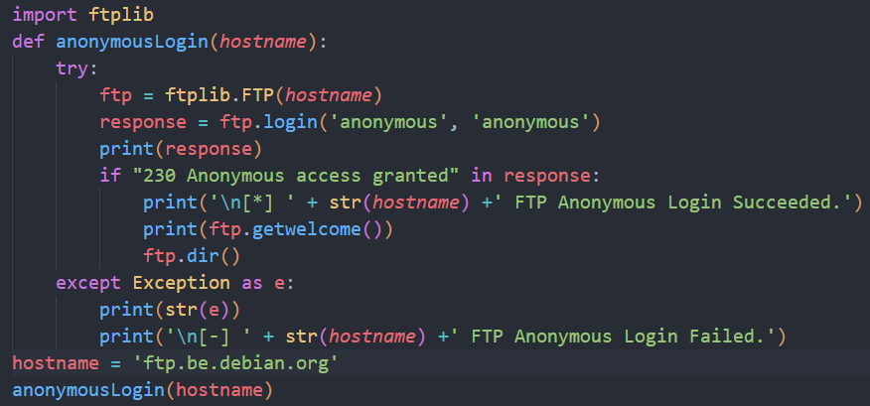

**Result (Sample Output)**

This is a simulated output demonstrating a **successful** anonymous login to a public FTP server, such as a distribution site.

