Proposal for OneStop -Property
Problem Statement
Managing different aspects of property needs—such as finding a home, arranging inspections, securing financial support, or requesting repairs—is currently disorganized and spread across multiple unrelated platforms. People searching for housing or property services often struggle because:
- There is no single system where they can view property options, schedule inspections, access maintenance support, and explore financial guidance.
- Comparing loan options, builders, or renovation services becomes time-consuming and unclear.
- Handling post-rental or post-purchase tasks like maintenance or repairs requires contacting multiple service providers separately.
This scattered approach results in inefficiency, delays, uneven service experiences, and overall dissatisfaction for users trying to manage their property needs smoothly.

Solution
The One Stop Property addresses these challenges by offering a comprehensive platform that consolidates property-related services under one roof. The system will enable users to:
- Search for and book properties for rent or purchase.
- Request property inspections.
- Access maintenance services for rented or owned properties.
- View and compare loan schemes from financial institutions.
- Explore builder services for renovation or new construction.
The platform integrates various stakeholders, including landlords, buyers, property managers, maintenance workers, and financial institutions, creating a seamless ecosystem that simplifies property management and enhances user experience.

Use Case Diagram:
Below is the high-level component diagram for the Property Management System:
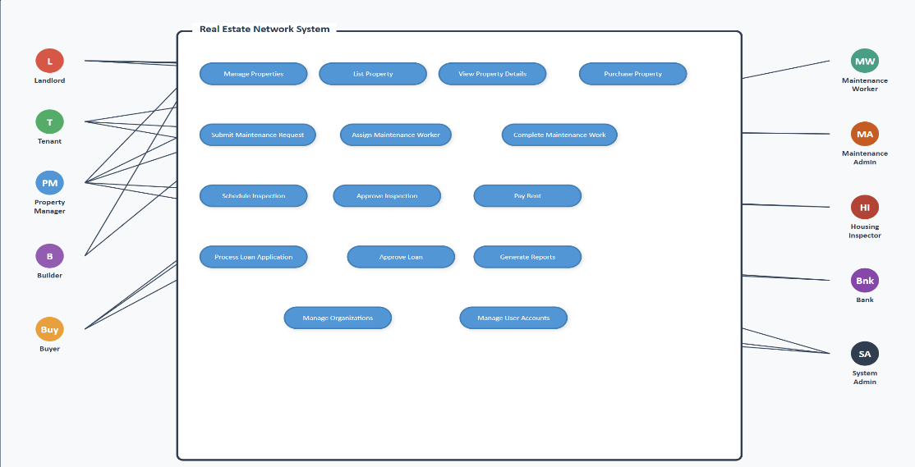

UML Diagram :
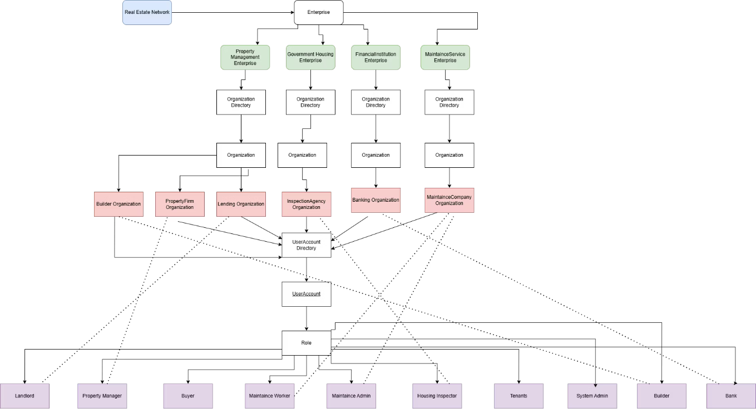

Enterprise and their Roles:
Management Enterprise:
- Organizations:
- Property Firms Organization: Manage property listings.
- Lending Organization: Has details about landlords.
- Builder Organization: Contains details about builder and their offerings.
- Roles:
- Property Manager
- Landlords
- Builders

Maintaince Service Enterprise:
- Organizations:
- Maintaince Service Organization: Handle repair and Maintaince requests.
- Roles:
- Maintaince Workers
- Maintaince Admin

Financial Institution Enterprise:
- Organizations:
- Banking Organization: Offer loan schemes for property purchase.
- Roles:
- Bank Representatives.
Government Housing Enterprise:
- Organizations:
- Inspection Agency Organization: Conduct property inspections.
- Roles:
- Housing Inspectors.
User Account Directory:
- User Account Directory holds all the user accounts with each role in it.
- Roles: Buyer, System Admin, Tenants
System Architecture :
The system is built as a multi-enterprise ecosystem, where each enterprise handles a key property service area:
- Property Management Enterprise: Manages property listings, landlords, buyers, and builder services.
- Maintenance Service Enterprise: Handles repair requests and assigns maintenance workers.
- Financial Institution Enterprise: Provides loan scheme details from banks and helps users compare options.
- Government Housing Enterprise: Manages property inspections and assigns housing inspectors.
Each enterprise contains specific roles such as administrators, service staff, builders, bank officers, and inspectors to ensure smooth workflows and clear responsibilities.
Use Cases:
- Property Search and Booking:
  - A buyer logs into the platform to search for properties.
  - The system provides a list of available properties with details and booking options.
  - User can reserve a viewing, request details or proceed with a booking
- Request for Maintenance Services:
  - A tenant submits a request for maintenance (e.g., plumbing or electrical work).
  - The platform assigns the request to an available maintenance worker.
  - Tenant can track the status of the request and receive updates when work is done
- Schedule Inspection:
  - A landlord schedules an inspection for their property.
  - The inspection agency reviews the request and assigns a housing inspector.
  - The inspection agency reviews the request, assigns an inspector, and schedules the visit, with updates visible to the landlord.
- View Loan Schemes:
  - A buyer explores loan options from various banks.
  - The platform displays comparative loan schemes, enabling the user to select the best fit.
  - The user can compare options side-by-side and select a suitable loan pathway.
- Book Builder Services:
  - A landlord plans to renovate their property.
  - They search for builders, view their profiles and reviews, and book their services through the platform.
  - After selecting a builder or contractor, the user can request quotes, schedule services, and track project progress.
Data Input / Output
Data Input
The system accepts the following inputs:
- User information (buyers, tenants, landlords, inspectors, builders).
- Property details (location, price, features, availability).
- Maintenance requests and descriptions.
- Inspection scheduling requests.
- Loan scheme data from banks.
- Builder service offerings and pricing.
Data Output
The platform generates and displays:
- Search results for available properties.
- Status of maintenance and inspection requests.
- Loan comparisons and recommendations.
- Builder profiles, quotes, and service timelines.
- Role-specific dashboards for each stakeholder.

Two-Week Timeline:
- Week 1

Day 1–2: Finalize requirements, scope, and architecture
Day 3–4: Implement user onboarding + basic UI screens
Day 5–6: Integrate property search and listing module
Day 7: Develop maintenance request submission flow

- Week 2

Day 8–9: Implement inspection scheduling module
Day 10–11: Add loan scheme comparison pages
Day 12: Add builder services and booking flow
Day 13: Testing, bug fixes, and data validation
Day 14: Final integration, polishing, and documentation
Limitations
- The platform does not handle legal property documentation (e.g., contracts).
- High-traffic performance optimization may require future scaling.
- Inspection and maintenance completion times rely on worker availability, not the system.
Assumptions
- Users have stable internet access to operate the platform.
- Property, loan, and builder data provided is accurate and kept updated by respective stakeholders.
- All enterprises agree to use a unified system workflow.
- External APIs (banks, housing agencies) respond reliably.

Project Goals:
1. Create a Unified Digital Ecosystem for All Property Services
Develop a single, centralized platform that seamlessly integrates property search, inspections, maintenance, financial assistance, and builder services. This eliminates the need for users to navigate multiple websites or service providers, ensuring a consistent and convenient experience.
2. Improve Operational Efficiency for Stakeholders
Enable landlords, tenants, property managers, financial institutions, and government agencies to coordinate through one system. Automation of service routing, scheduling, and notifications reduces delays and minimizes manual intervention.
3. Accelerate Maintenance and Inspection Turnaround Times
Streamline the submission, assignment, and completion of maintenance and inspection requests. Real-time tracking, automated role assignment, and status updates ensure faster resolution and improved user satisfaction.
4. Enhance Decision-Making for Buyers and Renters
Provide users with comprehensive and transparent information—including property details, loan schemes, builder offerings, and service comparisons—enabling informed and confident decisions during the property purchase or rental process.
5. Increase Transparency and Service Accountability
Implement end-to-end visibility into service progress, technician assignments, inspection schedules, and builder tasks. This ensures that users always know the status of their requests, improving trust and reducing communication gaps.
6. Build a Scalable and Extensible Architecture
Design the platform in a modular way that supports new features over time—such as insurance services, smart home integration, rental agreements, automated rent tracking, or analytics dashboards—allowing long-term growth and innovation.
7. Strengthen User Engagement and Satisfaction
By reducing friction in every property-related task and providing a seamless experience, the platform aims to significantly improve user engagement, retention, and satisfaction across all service categories.

Submitted by :
Niharika Thippeswamy
Meghana Thota
Krishi Parekh
Mrudul Maruthi Kumar Reddy Mettukuru

Approved by :
Nitish Ahuja ,TA

